NAME: ______________________________________________ADM NO: __________CLASS: ________
DATE: ______________________________ SIGN: _______________________
FORM: 3 GEOGRAPHY
PAPER ONE (312/1)
MID TERM 2 2026 EXAMINATION
TIME: 2 HOURS 45 MINUTES

INSTRUCTIONS TO CANDIDATES

- This paper has two sections: A and B
- Answer all the questions from section A.
- Answer question 6 and any other two questions from section B.
- All answers to be written in English in the foolscaps provided

SECTION A
  - State four proofs which show that the earth is spherical. (4 marks)

  - (a) i. State two conditions considered in choosing a suitable site for a weather station. (2 marks)
ii. Name two weather recording instruments that are placed in a Stevenson’s screen. (2 marks)
    - Give two reasons why weather forecasting is important. (2 marks)

  - (a) Name the type of rocks which results from the metamorphism of: (2 marks)
      - Granite,
      - Clay.
(b) Give two reasons why sedimentary rocks are widespread in the coastal plain of Kenya. (2 marks)

- (a) What is mass wasting? (2 marks)
  - State four factors which influence mass wasting. (4 marks)

- The diagram below represents zones of natural vegetation on a mountain in Africa.
Use it to answer questions (a) and (b)

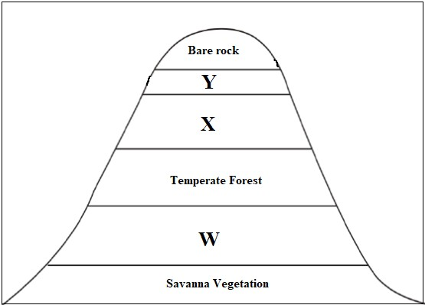

(a) Name the vegetation zones marked X and Y. (2 marks)
  - Describe the characteristics of vegetation zone marked W. (3 marks)

SECTION B.
Answer question 6 and any other two questions from this section

6. Study the map of Kipkabus 1:50,000 (Sheet/ 104/1) provided and answer the following questions.
(a). (i) What type of a map is Kipkabus extract? (1mark)
(ii) Identify two methods that have been used to represent relief in the area covered by the map
(2 marks)
(iii) Give the two types of scale used in the map. (2marks)
(iv) What is the vertical interval of the map? (1 mark)
(b) (i) Name three types of natural vegetation found in the area covered by the map. (3marks)
(ii) Give three physical features found at grid square 8232. (3 marks)
(iii) Identify two districts represented in the area covered by the map. (2marks)
(c) Draw a rectangle 10cm by 14cm to represent the area enclosed by Easting 79 and 85 and nothing
28 and 35. On the rectangle mark and name the following: (5 marks)
• Natural forest
• Lake
• Bridge
• Dry weather road
(d) Citing evidence from the map, state three functions of Kipkabus town. (6 marks)

7. (a) i) Give three examples of non-metallic minerals. (3 marks)
ii) Why is industrial diamond used in shaping hard stones and metals? (1 mark)
(b) i) Give two examples of hypabyssal igneous rocks. (2 marks)
ii) State two reasons why sedimentary rocks are wide spread in the coastal plain of Kenya. (2 marks)
(c) Describe the following processes of formation of metamorphic rocks:
- Thermal Metamorphism (4 marks)
- Dynamic Metamorphism (4 marks)
(d) Suppose you were to carry out a field study on rocks within the vicinity of your school.
- Name three secondary sources of information you would use for preparation of the study. (3 marks)
- State three activities you would carry out during the field study. (3 marks)
- State three problems you are likely to experience during the study (3 marks)

8. The map below shows major fold mountains of the world. Use it to answer the questions that follows
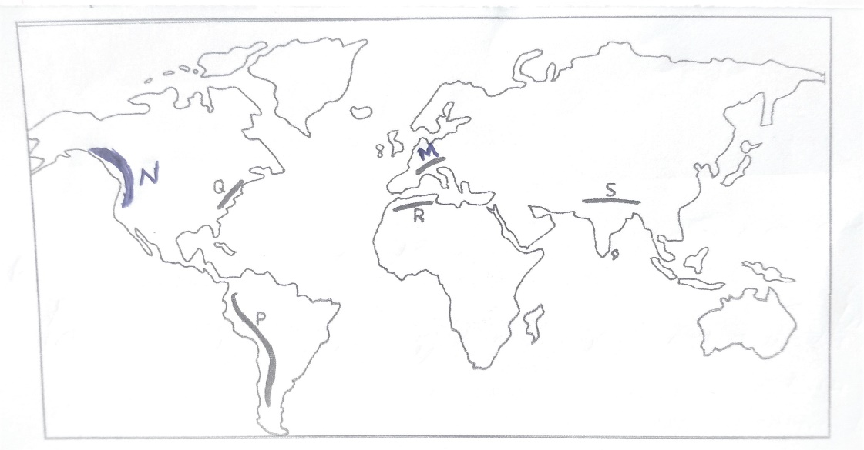

a)(i) Name the mountain ranges marked M,N,P and Q. (4 marks)
(ii)Identify two countries through which the mountain marked R is found. (2 marks)
(iii) Apart from Fold Mountains name other three features resulting from folding (3 marks)
b) With the aid of well labelled diagrams, describe how fold Mountains are formed (8 marks)
c) Explain the significance of fold mountains to human activities (8 marks)

9. (a) (i) Define weathering. (2marks)
(ii) Apart from plants, give two other agents of weathering. (2marks)
(iii) Explain how the following factors influence the rate of weathering. (6marks)
- Temperature
- Nature of the rock
- Angle of the slope
(b) Mention three types of weathering. (3marks)
(c) Describe how block disintegration occurs. (6marks)
(d) Explain three significance of weathering. (6marks)

10. (a) Give three types of river erosion. (3marks)
(b) Describe each of the following processes of river erosion.
i) Abrasion. (4marks)
ii) Solution. (4marks)
(c) Explain four ways in which a river transports its load. (8marks)
(d) You are required to carry out a field study on materials deposited by a river.
i) Name three methods you would use to collect data (3marks)
ii) Give three follow up activities you would be involved in. (3marks)

