CHEMISTRY FORM FOUR
MID-TERM 2 EXAM 2026
TIME: 2 HOURS 30 MINUTES

NAME………………………………………ADM NO………………………

DATE…………………………………………SIGN……………………………

INSTRUCTIONS TO CANDIDATES
- Answer all questions in Section A and Section B.
- Write your answers in the spaces provided.
- All working must be shown clearly.

SECTION A (40 MARKS)
1. State the meaning of the term allotropy. (2 marks)

2. Differentiate between strong acids and weak acids. (2 marks)

3. Name two uses of ammonia in industries. (2 marks)

4. Calculate the number of moles in 11.2 dm³ of carbon dioxide gas at s.t.p. (3 marks)

5. A hydrocarbon contains 85.7% carbon and 14.3% hydrogen. Determine its empirical formula. (3 marks)

6. State Charles’ Law. (2 marks)

7. Give one observation made when dilute hydrochloric acid is added to zinc granules. (2 marks)

8. Calculate the concentration of a solution containing 5.85 g of sodium chloride dissolved in 500 cm³ of solution. (3 marks)

9. Name the process used to separate crude oil into useful fractions. (2 marks)

10. State two factors that affect the rate of reaction. (2 marks)

11. The diagram below shows an electrolysis setup.
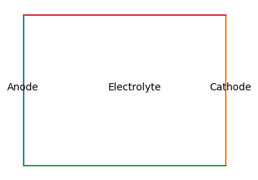
a) Name the gas produced at the cathode during electrolysis of acidified water. (1 mark)

b) State one use of electrolysis in industries. (1 mark)

SECTION B (60 MARKS)
12. a) Define molar heat of combustion. (2 marks)

b) 2.5 g of ethanol was completely burnt and raised the temperature of 200 g of water from 20°C to 55°C.
Calculate:
i) Heat energy released. (3 marks)

ii) Molar heat of combustion of ethanol. (4 marks)

13. The flow chart below shows the preparation of nitrogen gas.
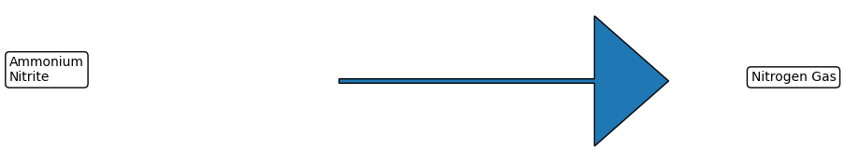
a) Write the balanced chemical equation for the reaction. (2 marks)

b) State two physical properties of nitrogen gas. (2 marks)

c) Explain why nitrogen gas is used in food packaging. (2 marks)

14. a) Describe how a standard solution of sodium carbonate can be prepared in the laboratory. (5 marks)

b) 25 cm³ of sodium carbonate solution required 20 cm³ of 0.1 M hydrochloric acid for complete neutralization.
Na₂CO₃ + 2HCl → 2NaCl + H₂O + CO₂
Calculate the concentration of sodium carbonate solution. (5 marks)

15. a) Explain the following observations:
i) Iron rusts faster in salty water than in distilled water. (2 marks)

ii) Aluminium does not corrode easily despite being reactive. (2 marks)

b) State three methods used to prevent rusting of iron. (3 marks)

c) Draw and label a simple setup that can be used to investigate rusting. (3 marks)

16. a) Name the homologous series represented by the general formula CnH2n+2. (1 mark)

b) Draw the structural formula of but-2-ene. (2 marks)

c) State two uses of ethanoic acid. (2 marks)

d) A hydrocarbon contains 92.3% carbon and 7.7% hydrogen. Determine its molecular formula if its molar mass is 78 g/mol. (5 marks)

END

