NAME: ______________________________________________ADM NO: __________CLASS: ________
DATE: ______________________________ SIGN: _______________________
FORM: 3 CHEMISTRY
PAPER TWO
MID TERM 2 2026 EXAMINATION
TIME: 2 HOURS

INSTRUCTIONS TO CANDIDATES

ANSWER ALL THE QUESTIONS IN THE SPACES PROVIDED
1. The table below shows elements in the periodic table. Use it to answer the questions that follow. The letters are not the actual symbols of the elements.
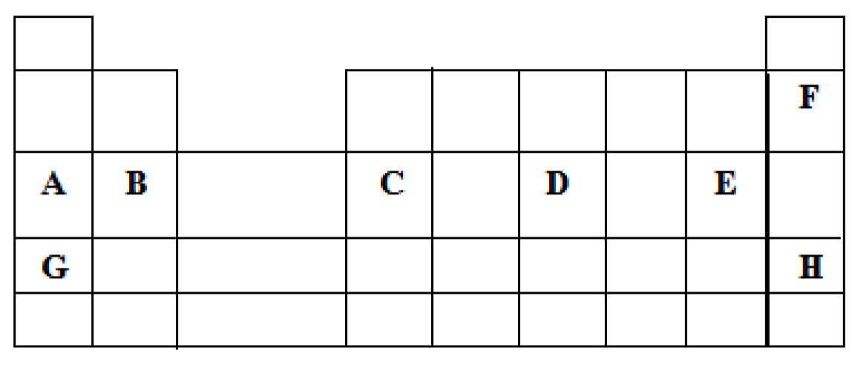
a) I) write the electron arrangement of elements; B and A (2mks)

ii) Write the formula of the compound formed between the elements B and E. (1mk)

- Element K has atomic number 14. Indicate by use of tick ( ) the position of this element in the table above (1mk).

- I) the ionization energy of A is higher than that of G. Explain. (2mks)

- The atomic radius of C is larger than that of D. (2mks)

- Compare the reactivity of elements A and B.
Explain your answer. (2mks)

d) I) State the name of the group to which elements F and H belong. (1mk)

ii) Give one use of any of the elements of in group in d (I) above. (1mk)

e) The chloride of B is ionic, while the chloride of C is covalent. Explain this observation. (2mks)

2. The flow chart below is for the manufacture of sodium carbonate using Solvay process. Use it to answer the questions that follow.
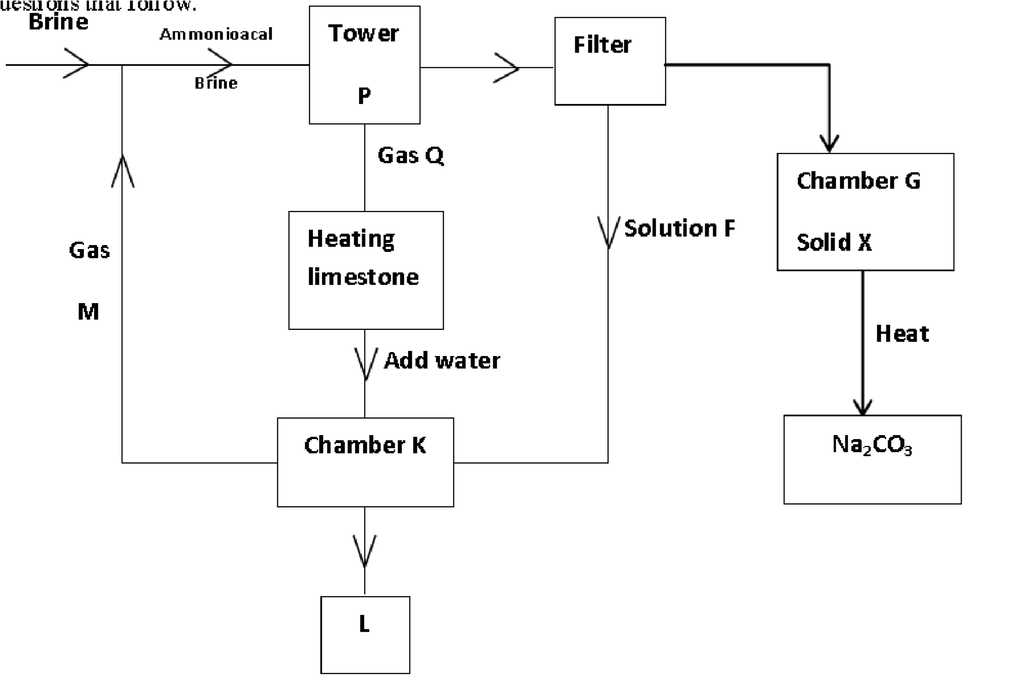
(a) Name (3mks)
- Gas M……………………………………………………

- Solution F ……………………………………..…….….

- Solid X ……………………………………………….…

- The product L……………………………………………

- Write an equation for the reaction in chamber K. (2mks)

- Name two raw materials used in Solvay process. (2mks)

- (I) Name one substance recycled in Solvay process. (1mk)

- Give two reasons why carbon (IV) oxide is used as fire extinguisher. (2mks)

- Explain why lead carbonate is not reacted with dil. H₂SO₄ in preparation of carbon (IV) oxide in the laboratory. (2mks)

3. A) State Graham's law of diffusion. (1 mark)

b) An experiment was carried out to compare the rates of diffusion of chlorine gas and hydrogen supplied gas. (H=1, S=32, Cl=35.5)

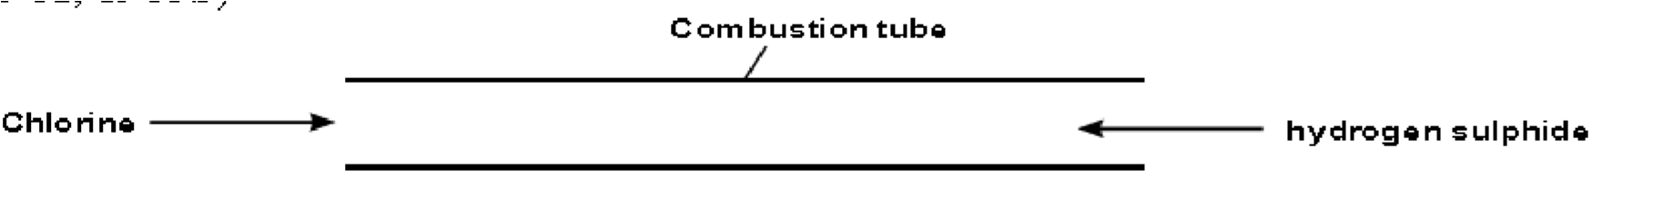

I) what observation was made in the combustion tube? (1 mark)

Ii) Indicate where the observation in (I) above would occur. (1 mark)

iii) It takes 15 seconds for 45cm³ of chlorine to diffuse through the combustion tube. How long will it take?
135cm³ of hydrogen supplied to diffuse under similar conditions? (3 marks)

4.A) State Charles's law. (1 mark)

b) The table below shows the relationship between the volume of a fixed mass of a gas and its temperature (°C) at constant pressure.
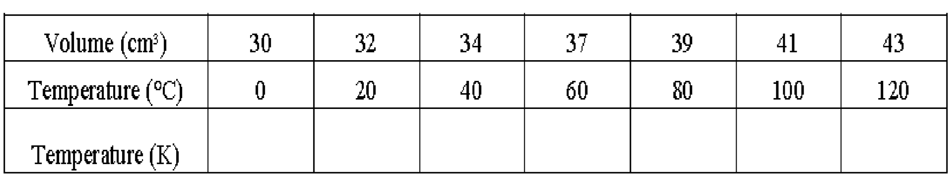
- Complete the table by filling the corresponding temperature in Kelvin. (3½ marks)

- Plot a graph of volume (cm³ ) on the vertical axis against temperature in Celsius on the Horizontal axis using a temperature range : -300°C to 120°C (3 marks)

- Extrapolate the graph in (ii) above to cut the horizontal axis and read the temperature value. (1 mark)

- Determine from the graph, the volume of the gas when the temperature is -225°C. (1 mark)

c) A balloon contains 100cm³ of air at 25°C. The balloon was put outside in the sun where the temperature was 40°C. Calculate the new volume of air. (2½ marks)

5. 1. The diagram below shows a set-up of apparatus used to separate a mixture of ethanol (B.P=78.0°C) and water (B.P = 100.0°C)
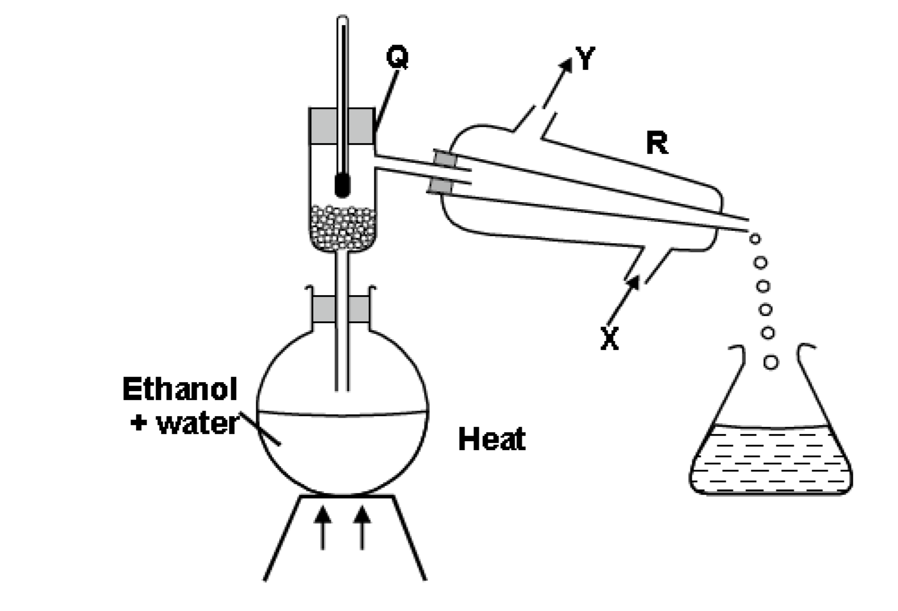
- Name the parts labelled Q and state its function. (2 marks)

- Name the apparatus R. (1 mark)

- At what point should apparatus R be connected with water? (1 mark)

- Name the distillate that was collected first. (1 mark)

- State the purpose of the thermometer. (1 mark)

6. In an experiment to determine the percentage of impurity in sodium carbonate .1.8g of impure sodium carbonate was reacted with excess2M hydrochloric acid. 340cm³of dry cabin (IV) oxide gas was collected during experiment at room temperature and pressure. (Na=23’O=16, C=12)Molar gas volume at rtp=24dm³

(a)Why 2M hydrochloric acid used was in excess. (1mk)

(b)Write an equation for the reaction that produced carbon (IV) oxide (1mk)

(c) Calculate

(I) the number of moles of CO2 produced (2mks)

(Ii) The number of moles of sodium carbonate that reacted with the acid (2mks)

(Iii) The mass of sodium carbonate that reacted with the acid. (2mks)

(iv) The percentage of impurities in the sample of sodium carbonate. (2mks)

- (I)state the Avagadros’ law (2mks)

(ii)in an experiment 20cm3 of sulphur(ii)oxide are found to react completely with 10cm3 of oxygen to produce 30cm3 of sulphur(iv)oxide. Determine the equation for reaction. (3mks)

7. (a) Write an equation for the following reactions
(I) solution of lead nitrate with ammonium sulphate (2mks)

(ii) Magnesium reacting with dilute hydrochloric acid (2mks)

(b)YOU are provided with zinc powder and dilute nitric acid .Describe how a solid sample of zinc nitrate can be prepared in the lab. (3mks)

(c) Write a chemical equation for the action of heat of the following salts.

(I) silver nitrate (2mks)

(ii) Sodium hydrogen carbonate (2mks)

(iii) Lead (ii) carbonate (2mks)

(iv) Lead (ii) nitrate (2mks)

