BIOLOGY FORM FOUR
MID TERM 2 EXAM 2026
TIME: 2 HOURS

NAME……………………………………ADM NO……………………………

DATE…………………………………………………SIGN……………………

INSTRUCTIONS:
- Answer ALL questions in Section A
- Answer any THREE questions from Section B.

SECTION A (40 MARKS)
Answer ALL questions in this section
1.The diagram below shows a plant cell as seen under an electron microscope.

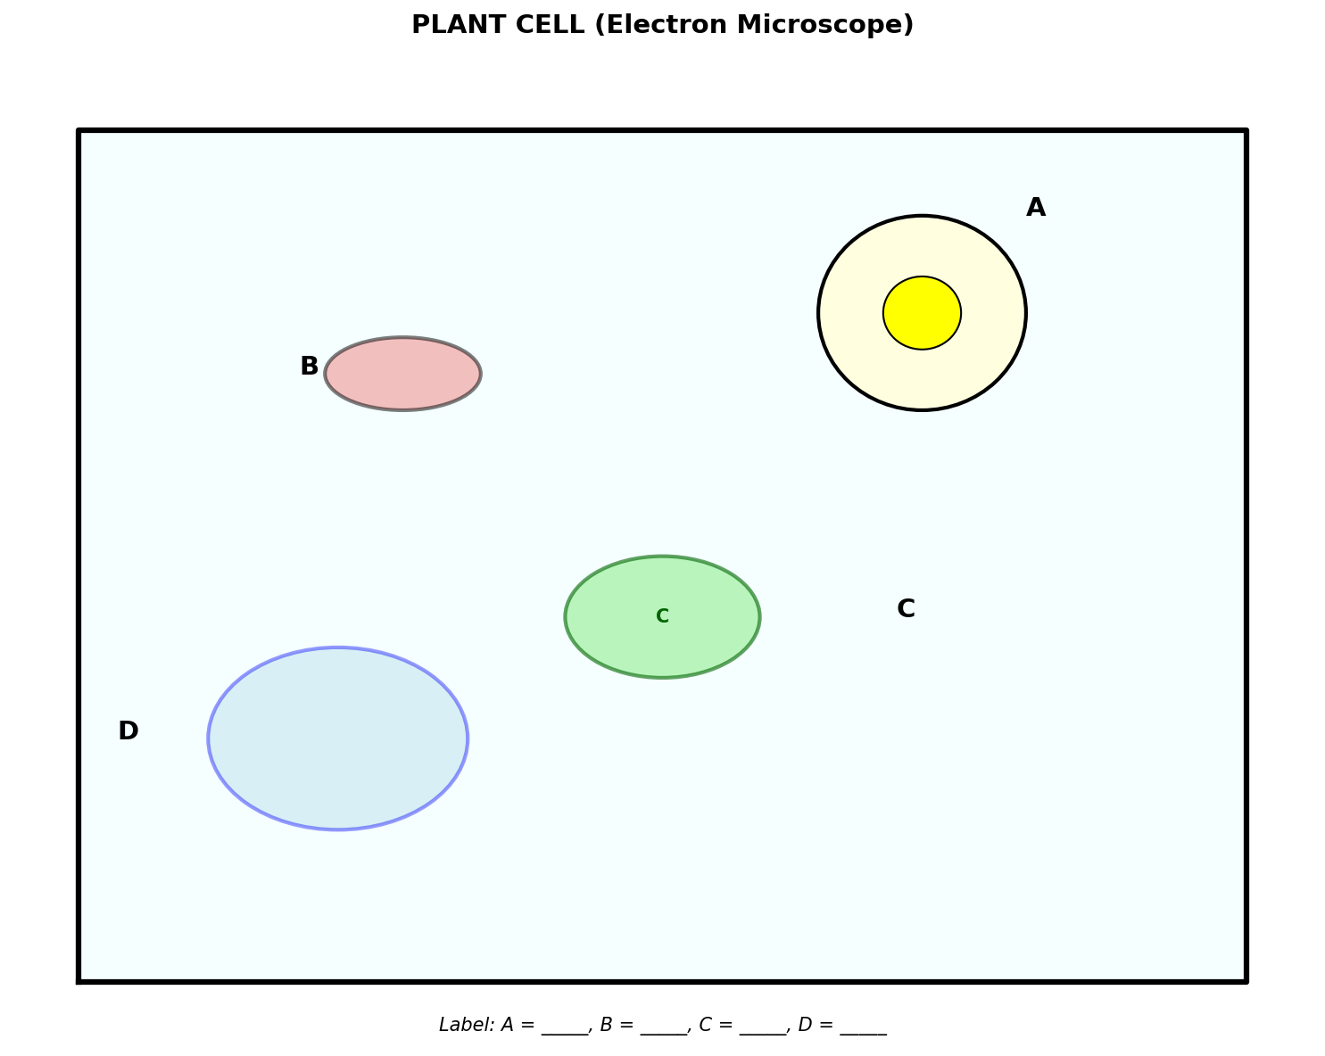

(a) Name the structures labeled A, B, C and D. (4 marks)

(b) Name the structure that would NOT be found in an animal cell. (1 mark)

(c) State the function of the structure named in (b) above. (3 marks)

2.The diagram shows a mitochondrion as seen under an electron microscope.

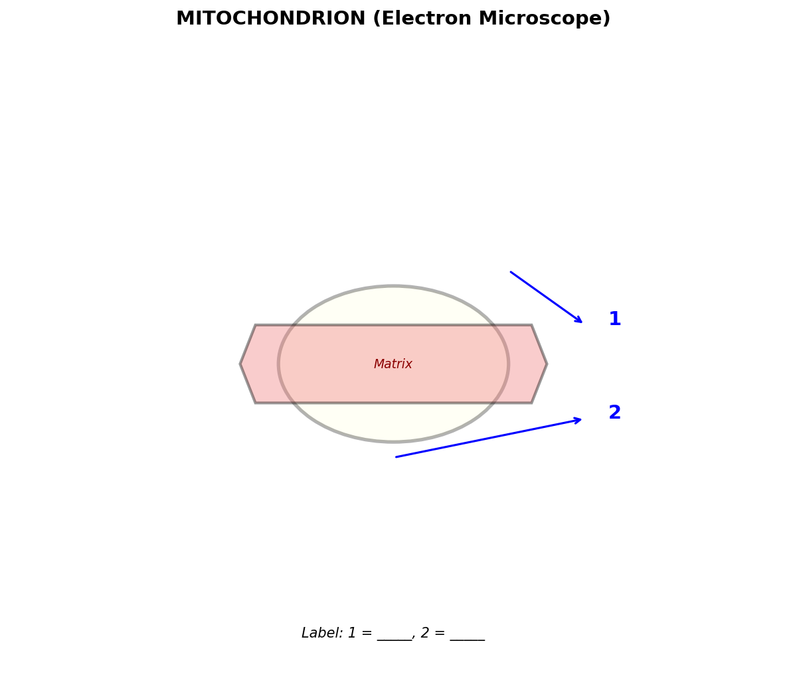

(a) Label the parts marked A and B. (2 marks)

(b) State two ways in which a mitochondrion is adapted for respiration. (2 marks)

(c) Explain the relationship between the structure of a mitochondrion and its function. (4 marks)

3.Below is a diagram of a transverse section of a leaf blade.

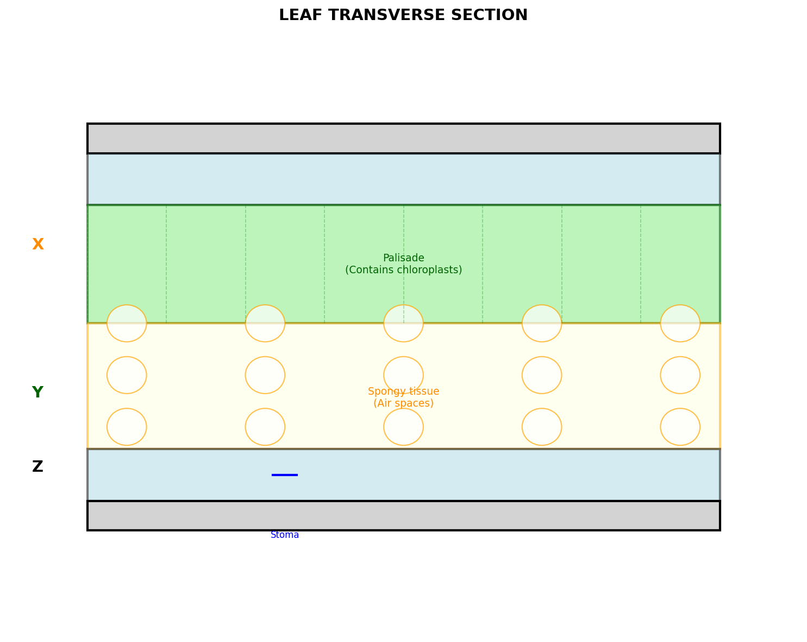

(a) Name the tissues labeled X, Y and Z. (3 marks)
X
Y
Z

(b) Identify two adaptations of the tissue labeled Y for photosynthesis. (2 marks)

(c) What is the function of the structure labeled Z? (3 marks)

4.An experiment was carried out to investigate the effect of enzyme concentration on the rate of enzyme activity. The results are shown in the table below.

Enzyme concentration (%) | Time taken to break down substrate (seconds)
10 | 120
20 | 60
30 | 40
40 | 30
50 | 25

(a) Explain why increasing enzyme concentration increases the rate of enzyme activity. (3 marks)

(b) What would happen to the rate of enzyme activity if enzyme concentration was increased beyond 50%? Give a reason. (2 marks)

(c) Name one other factor that affects enzyme activity. (1 mark)

(d) State the meaning of the term "enzyme". (2 marks)

5.The diagram below shows a reflex arc.

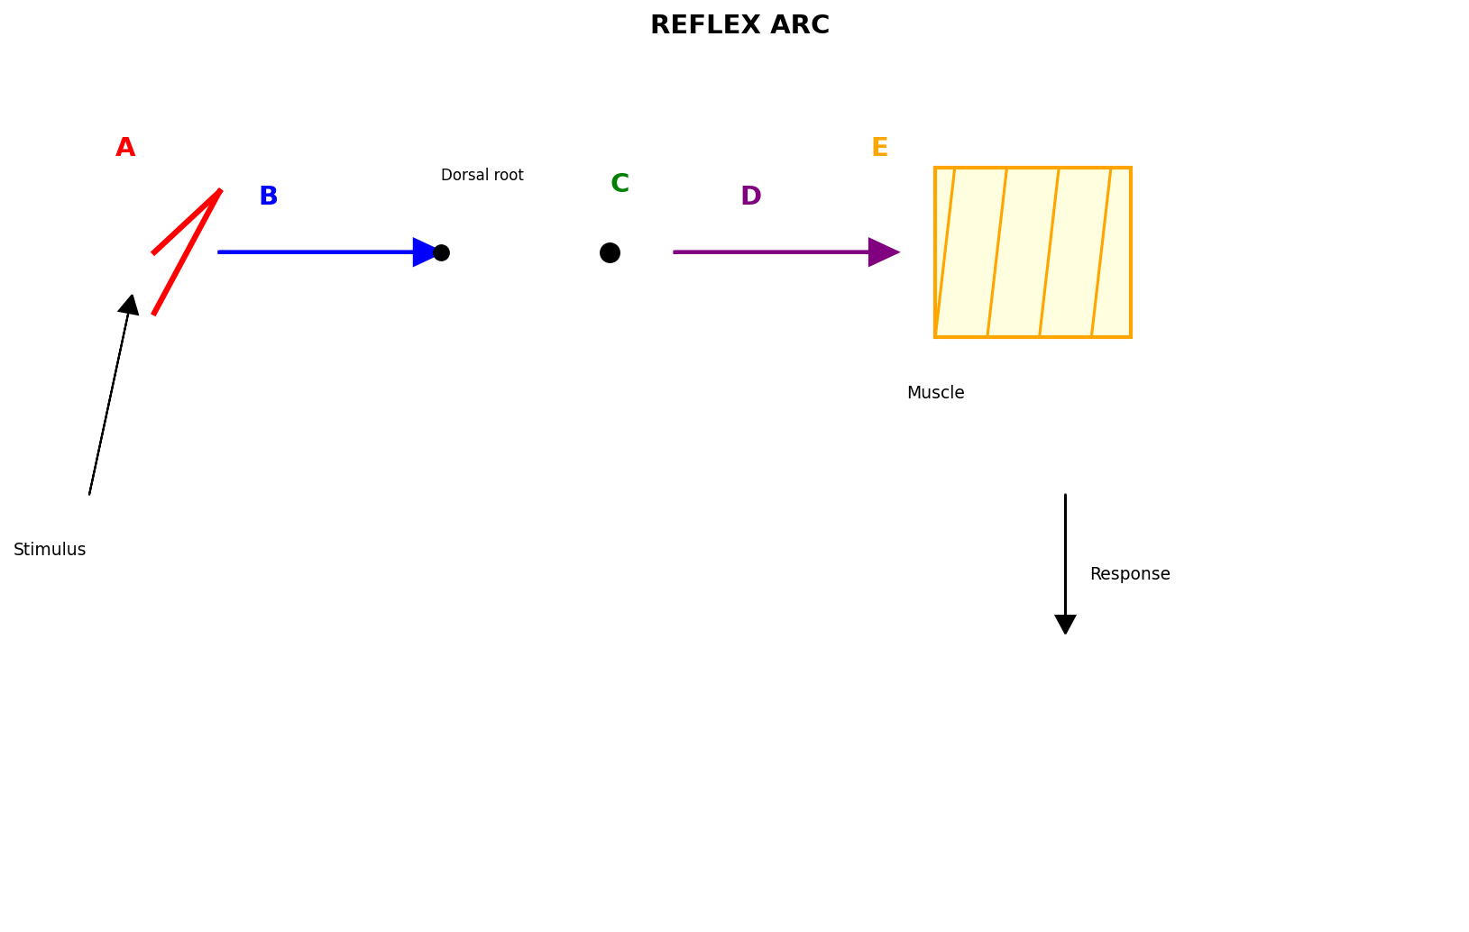

(a) Identify the parts labeled A, B, C, D and E. (5 marks)

(b) State one advantage of reflex arcs. (3 marks)

SECTION B (40 MARKS)
Answer any THREE questions from this section
6.The diagram below shows a chloroplast.

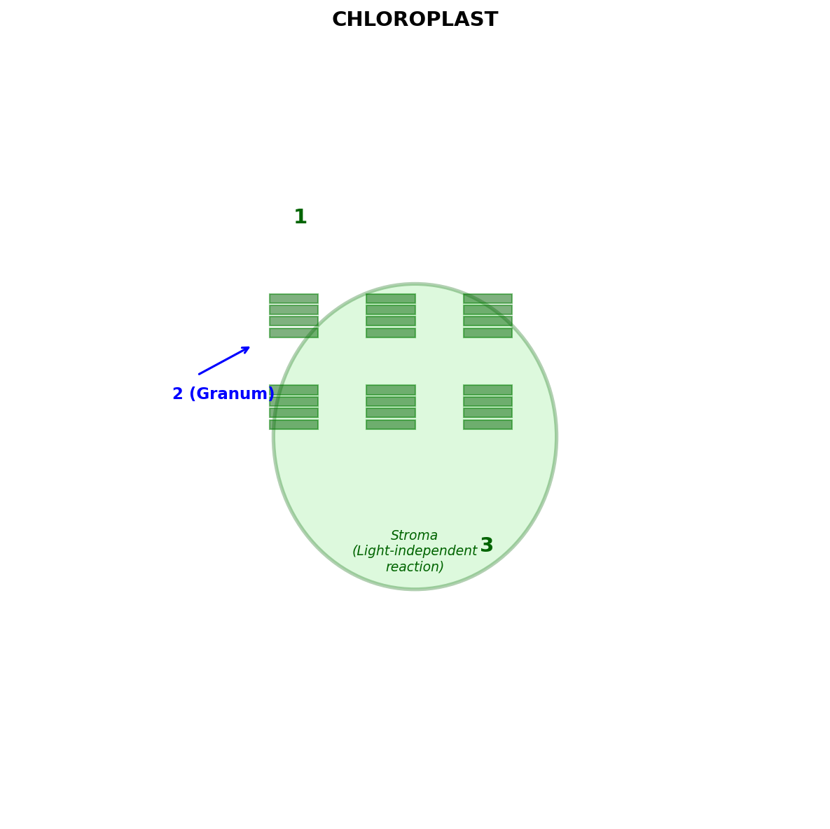

(a) Name the structures labeled A, B and C. (3 marks)

(b) In which structure does the light-dependent reaction occur? (1 mark)

(c) Explain how the structure labeled C is adapted for photosynthesis. (4 marks)

(d) Name the products of the light-independent reaction. (2 marks)

7.The diagram below shows a vertical section through a flower.

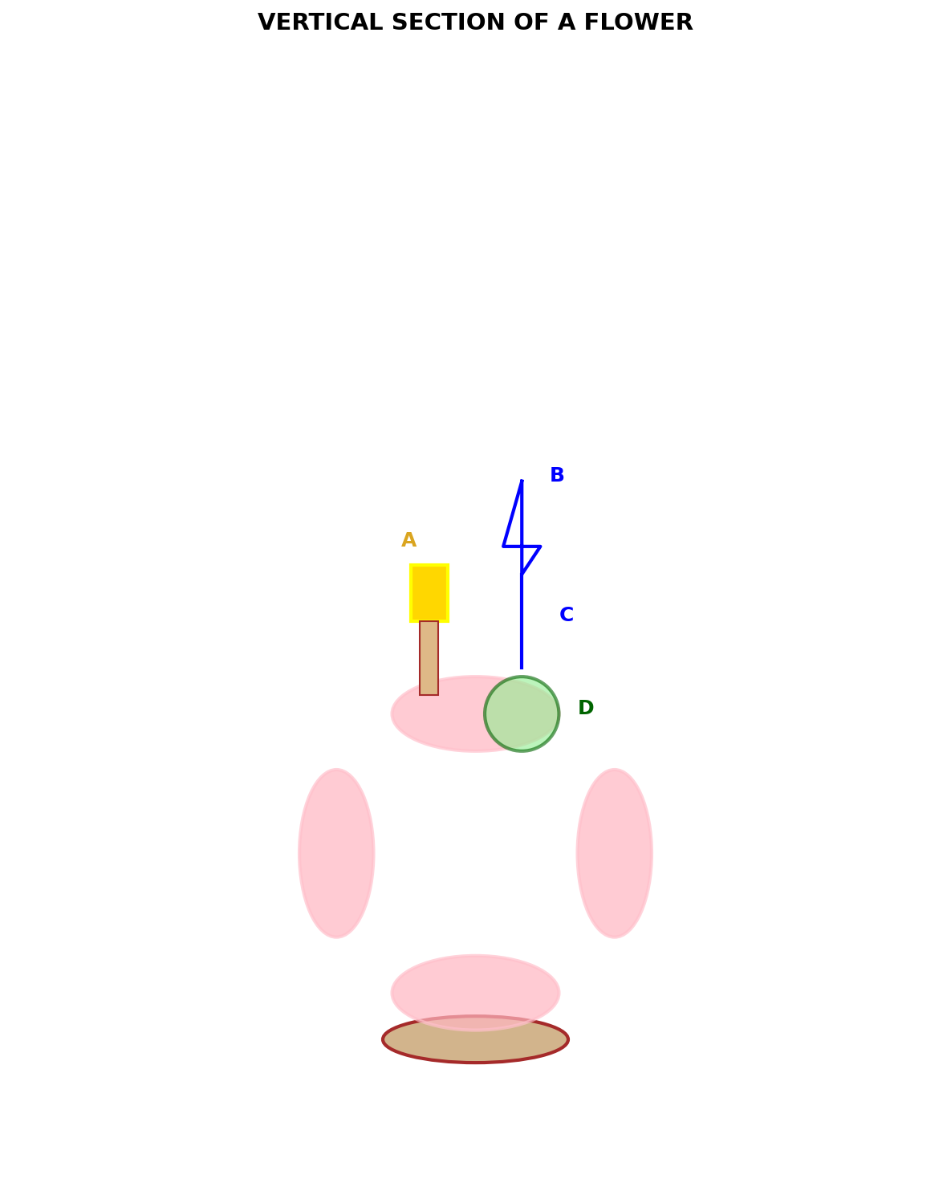

(a) Identify the parts labeled A, B, C and D. (4 marks)

(b) Which part produces male gametes? (1 mark)

(c) Describe the process of double fertilization in flowering plants. (5 marks)

8.(a) Define excretion. (2 marks)

(b) Name three substances that are excreted from the human body and state the organ responsible for their excretion. (6 marks)

(c) Explain why plants produce less nitrogenous waste compared to animals. (2 marks)

9.(a) Distinguish between aerobic and anaerobic respiration. (4 marks)

(b) Write the word equation for anaerobic respiration in yeast. (2 marks)

(c) Explain why the respiratory quotient (RQ) of a plant using carbohydrates and fats differs. (4 marks)

