NAME: ______________________________________________ADM NO: __________CLASS: ________
DATE: ______________________________ SIGN: _______________________
FORM: 3 BIOLOGY
PAPER (231/2)
MID TERM 2 2026 EXAMINATION
TIME: 2 HOURS

INSTRUCTIONS TO CANDIDATE
- Write your name, Admission and Class
- This paper consists of Two sections; Section A and B
- Answer All questions in section A in the spaces provided
- In section B answer question (6) compulsory and either question 7 or 8

SECTION A (40 MARKS)

Answer all the questions in this section in the spaces provided.

- The diagram below shows an organelle that is found in most cells. Study it and answer the questions that follow

H
  - (i) Name the organelle (1mk)

(ii) State the function of the organelle in (a) (i) above (1mk)

  - (i) Give the full name of the major chemical compound that is found in the organelle (1mk)

(ii) Identify the gas that is required in order to form the compound you have stated in (b) (i) above (1mk)

- Give the name of the structure labeled H and state its function (2mks)

- (i) In which cells between spermatozoa or ova would you expect to find a high number of the organelle named in (a) (i) above? (1mk)

(ii) Give a reason for your answer in (d) (i) above (1mk)

- (a) Name the gaseous exchange structure in the following organisms

(i) Amoeba (1mk)

(ii) Grasshopper (1mk)

(b) The diagram below illustrates the structure of a gill from a bony fish

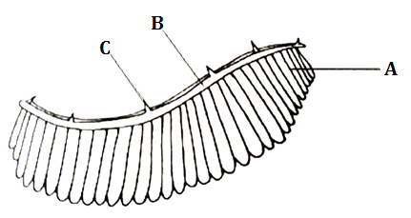
(i) Name the parts labeled A, B, and C (3mks)

(ii) State the function of the part labeled C (1mk)

(iii) How is part A adapted to carry out its functions (2mk)

- Study the illustration below

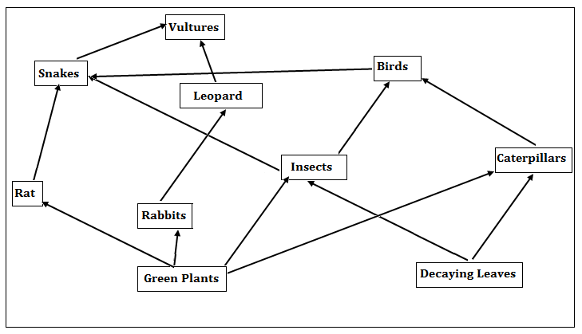
  - Identify the ecosystem (1mk)

  - (i) Which organism has the least biomass in the food web? (1mk)

(ii) Explain your answer in (b) (i) above (1mk)

- Name the tropic level occupied by the following organisms
(i) Insects (1mk)

(ii) Leopards (1mk)

d) Construct a food chain in which the vulture is a quaternary consumer (1mk)

e) (i) Name one group of organism not shown in the food web but play an important role in the ecosystem (1mk)

(ii) What is the role of the organism you named in (d) (i) above (1mk)

- During a biology practical lessons, the teacher provided students with the following apparatus.
-Apooter

-A scalpel

-Specimen bottle

-A pair of forceps

-Sweep net

-Chloroform

(a) Give the precautions the biology teacher gave the student before the practical when collection of specimen begun (3mks)

(b) What was the function of the following apparatus?
(i) Pooter (1mk)

(ii) Sweep net (1mk)

(iii) Chloroform (1mk)

(b) Other than observation, name other two scientific skills developed by studying biology (2mks)

- Complete the table below by placing the organism, tick, shrimp, millipede, praying mantis, tsetsefly,crab and spider in the right class and giving a reason in each case (8mks)
Class | Organisms | Reasons
Diplopoda
Insecta
Crustacea
Arachnida

SECTION B

Answer question 6 (compulsory) and either question 7 or 8

- An experiment was carried out to investigate the effect of temperature on the rate of a reaction catalysed by salivary amylase. The Ph was slightly alkaline. The results are shown in the table below
Temperature | 5 | 10 | 20 | 25 | 30 | 35 | 38 | 45 | 50
Rate of reaction | 0.3 | 0.5 | 1.25 | 2.0 | 3.5 | 4.8 | 4.8 | 2.5 | 0.8

- On a grid draw a graph of rate reaction against temperature (6mks)

- What is the optimum temperature of the enzyme (1mk)

- At what temperature was the rate of the reaction 1.4 (2mks)

- Account for the shape of the graph between
(i) 5$°$C and 35$°$ C (2mks)

(ii) 38$°$ C and 50$°$ C (3mks)

- How is the hydrochloric acid from the stomach neutralized and where does this occur (2mks)

- Name one digestive enzyme in humans that works best in acidic conditions (1mk)

- Apart from temperature and pH name other 3 factors that affect enzyme controlled reactions (3mks)

- (a) Describe the adaptation of hydrophytes to their photosynthetic function (10mks)

(b) Explain how mammalian ileum is adapted to perform its function (10 marks)

- Describe how the mammalian heart is adapted to its function. (20 marks)

…………………………………………………………………………………………………………………………………………………………………………………………………………………………………………………………………………………………………………………………………………………………………………………………………………………………………………………………………………………………………………………………………………………………………………………………………………………………………………………………………………………………………………………………………………………………………………………………………………………………………………………………………………………………………………………………………………………………………………………………………………………………………………………………………………………………………………………………………………………………………………………………………………………………………………………………………………………………………………………………………………………………………………………………………..……………………………………………………………………………………………………………………………………………………………………………………………………………………………………………………………………………………………………………………………………………………………………………………………………………………………………………………………………………………………………………………………………………………………………………………………………………………………………………………………………………………………………………………………………………………………………………………………………………………………………………………………………………………………………………………………………………………………………………………………………………………………………………………………………………………………………………………………………………………………………………………………………………………………………………………………………………………………………………………………………………………………………………………………………………………………………………………………………………..………..
……………………………………………………………………………………………………………………………………………………………………………………………………………………………………………………………………………………………………………………………………………………………………………………………………………………………………………………………………………………………………………………………………………………………………………………………………………………………………………………………………………………………………………………………………………………………………………………………………………………………………………………………………………………………………………………………………………………………………………………………………………………………………………………………………………………………………………………………………………………………………………………………………………………………………………………………………………………………………………………………………………………………………………………………………………………………………………………………………………………………....
………………………………………………………………………………………………………………………………………………………………………………………………………………………………………………………………………………………………………………………………………………………………………………………………………………………………………………………………

