AGRICULTURE FORM FOUR
MID TERM 2 EXAM 2026
TIME: 2 HOURS

NAME…………………………………………ADM NO…………………………
DATE………………………………………………………SIGN……………….

SECTION A: (30 MARKS)
Answer all questions in this section.
1. List three major sources of farm power used in modern agriculture. (3mks)

2. State two main differences between a two-stroke and a four-stroke cycle engine. (2mks)

3. Name three types of harrows used for secondary cultivation. (3mks)

4. Define the following terms as used in agricultural economics: (2mks)
a) Marginal Product
b) Fixed Input

5. State two reasons for carrying out 'steaming up' in dairy cattle. (2mks)

6. List three factors that affect the selection of a tool for a specific farm operation. (3mks)

7. Give two advantages of artificial incubation over natural incubation in poultry. (2mks)

8. Identify three parts of a tractor's lubrication system. (3mks)

9. Mention two indicators of a broody hen. (2mks)

10. State four functions of a tractor’s cooling system. (4mks)

11. Define "Agroforestry." (2mks)

12. List two advantages of using animal-drawn implements. (2mks)

SECTION B: (30 MARKS)
Answer all questions in this section.
13. 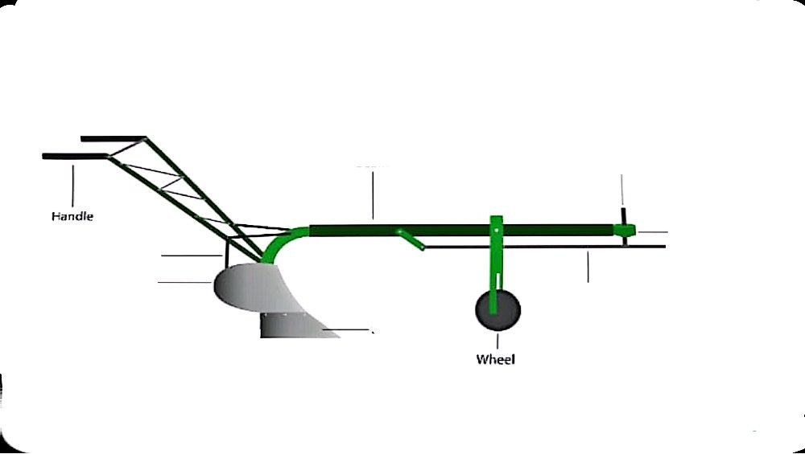
a) Identify the labeled parts of the mouldboard plough shown above. (3mks)
A_
B_
C_
D_
b) Explain two maintenance practices for a mouldboard plough. (2mks)

14.

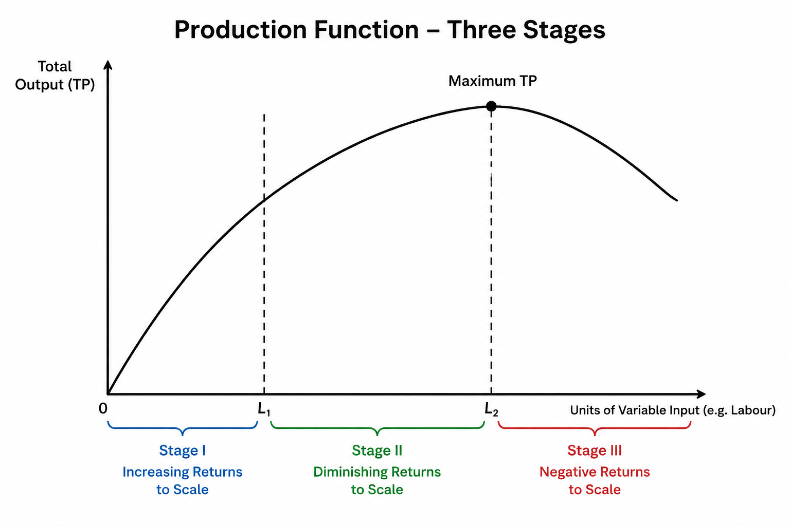

a) Identify the three stages of the production function shown in the diagram. (3mks)

b) At which stage should a rational farmer operate? Explain why. (2mks)

15. A farmer wants to apply fertilizer to maize. If the recommended rate is 150 kg of DAP (18:46:0) per hectare, calculate the amount of Nitrogen, Phosphorus, and Potassium (K) applied per hectare. Show your working. (5mks)

16.

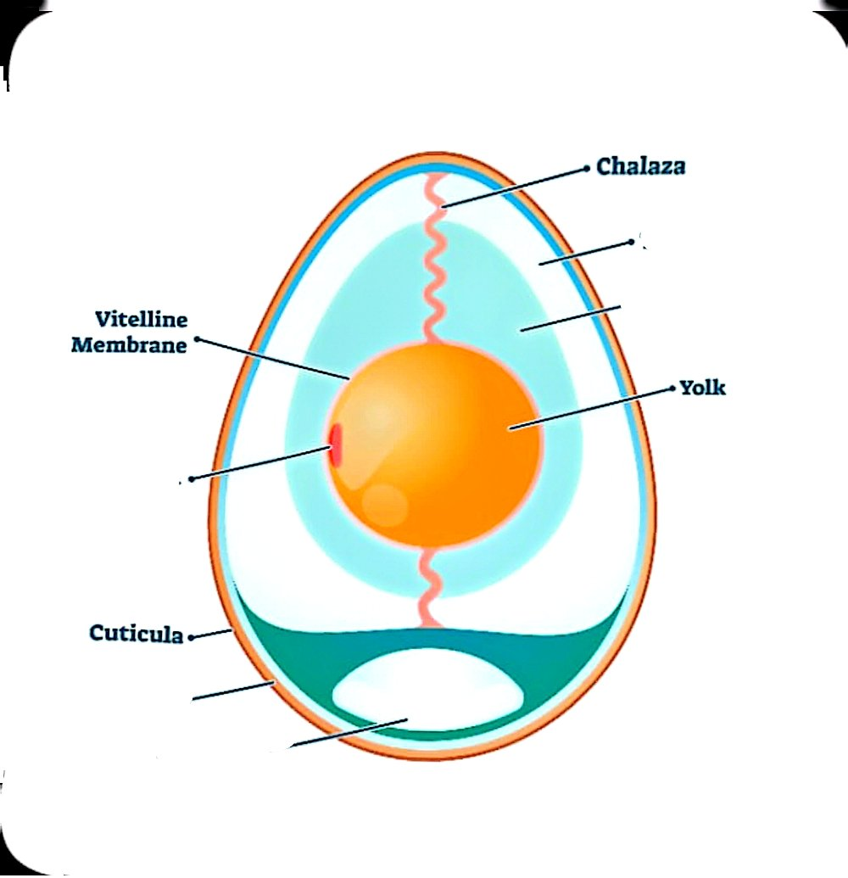
a) Name the following parts. (4mks)
A_
B-
C_
D_
E_
b) Describe the importance of the air sac in an incubating egg. (2mks)

17. Explain three factors that influence land as a factor of production. (6mks)

18. Briefly describe the process of 'egg candling' and its purpose in poultry management. (3mks)

SECTION C: (40 MARKS)
Answer any two questions from this section.
19. a) Explain five factors that determine the quality of Farm Yard Manure (FYM). (10mks)
b) Describe five ways in which a farmer can improve soil fertility. (10mks)
20. a) Discuss five advantages of using a tractor over animal power in large-scale farming. (10mks)
b) Explain five maintenance practices carried out on a tractor's battery. (10mks)
21. a) A farmer decides to invest in a dairy project. Discuss five factors that influence the choice of a livestock enterprise. (10mks)
b) Explain five causes of low milk production in dairy cattle. (10mks)

