AGRICULTURE FORM THREE
MID TERM 2 2026

TIME: 2 HOURS
Name: Class:
Signature: Date: Admission Number:
Instructions to students
- Write your Name, Class, Adm No and Date in the spaces provided.
- This paper consists of three sections A, B and C.
- Answer all the questions in sections A and B.
- Answer any two questions in section C
- All answers should be written in the spaces provided.
- This paper consists of 7 printed pages.
- Students should answer all the questions in English.
SECTION A
1. Name one breed of livestock under each of the following categories.
a) Dairy cattle …………………………………… $(1/2mk)$
b) Dual purpose cattle …………………………….. $(1/2mk)$
c) Dual purpose sheep…………………………………. $(1/2mk)$
d) Hair goat ……………………………………………… $(1/2mk)$
2. State four egg abnormalities observed during egg candling. (2mks)
i)……………………………………………………………………………………………..
ii)…………………………………………………………………………………………….
iii)……………………………………………………………………………………………
iv)…………………………………………………………………………………………...

3. Give four reasons for livestock breeding. (2mks)
i)……………………………………………………………………………………………..
ii)…………………………………………………………………………………………….
iii)……………………………………………………………………………………………
iv)…………………………………………………………………………………………...
4. Give two reasons for hoof trimming. (1mk)
i)……………………………………………………………………………………………..
ii)…………………………………………………………………………………………….
5. State four signs of Anthrax disease. (2mks)
i)……………………………………………………………………………………………..
ii)…………………………………………………………………………………………….
iii)…………………………………………………………………………………………….
iv)………………………………………………………………………………………………
6. Name four methods of dehorning. (2mks)
i)……………………………………………………………………………………………..
ii)…………………………………………………………………………………………….
iii)…………………………………………………………………………………………….
iv)………………………………………………………………………………………………
7. Give four reasons for keeping dairy animals healthy. (2mks)
i)……………………………………………………………………………………………..
ii)…………………………………………………………………………………………….
iii)…………………………………………………………………………………………….
iv)………………………………………………………………………………………………
8. State four features of a clean milkman. (2mks)
i)……………………………………………………………………………………………..
ii)…………………………………………………………………………………………….
iii)…………………………………………………………………………………………….
iv)………………………………………………………………………………………………
9. Name four maintenance practices for a wire fence. (2mks)
i)……………………………………………………………………………………………..
ii)…………………………………………………………………………………………….
iii)…………………………………………………………………………………………….
iv)………………………………………………………………………………………………
10. State four reasons why dorper breed of sheep is good for mutton production. (2mks)
i)……………………………………………………………………………………………..
ii)…………………………………………………………………………………………….
iii)…………………………………………………………………………………………….
iv)………………………………………………………………………………………………
11. State four control measures for tsetse flies. (2mks)
i)……………………………………………………………………………………………..
ii)…………………………………………………………………………………………….
iii)…………………………………………………………………………………………….
iv)………………………………………………………………………………………………
12. Explain how each of the following is measured in cattle. ($1_{2}^{1} mks$)
a) Blood temperature
b) Respiratory rate
c) Pulse rate
13. State the gestation period for each of the following: (2mks)
a) Cow –

b) Sow –
c) Ewe –
d) Rabbit –

14. State four features of large white breed of pigs. (2mks)
i)………………………………………………………………………………………………
ii)……………………………………………………………………………………………..
iii)……………………………………………………………………………………………..
iv)………………………………………………………………………………………………
15. State four functions of worker bees in a bee colony. (2mks)
i)……………………………………………………………………………………………..
ii)…………………………………………………………………………………………….
iii)…………………………………………………………………………………………….
iv)………………………………………………………………………………………………
16. State three ways of caponisation in poultry. ($1_{2}^{1} mks$)
i)……………………………………………………………………………………………..
ii)…………………………………………………………………………………………….
iii)…………………………………………………………………………………………….
SECTION B (20 MARKS)
17. The diagram below represent farm tools and equipment.

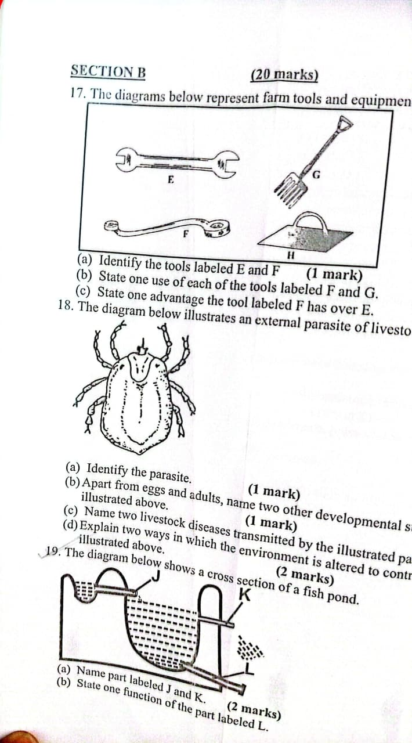

a) Identify the tools labeled E and F. (1mk)

b) State one use of each of the tools labeled F and G. (1mk)
c) State one advantage the tool labeled F has over E. (1mk)

18. The diagram below illustrates an external parasite of livestock.
a) Identify the parasite. (1mk)
b) Apart from eggs and adults, name two other developmental stages of the parasite illustrated above. (1mk)

c) Name two livestock diseases transmitted by the illustrated parasite. (1mk)

d) Explain two ways in which the environment is altered to control the parasite. (2mks)

19. The diagram below shoes a cross section of a fish pond.

a) Name part labeled J and k. (2mks)

b) State one unction of the part labeled L. (1mk)

c) Give one reason why a pond should have a deep end. (1mk)

d) Explain how fingerlings are introduced into a pond. (1mk)

20. The diagram shows a calf presentations during parturition.

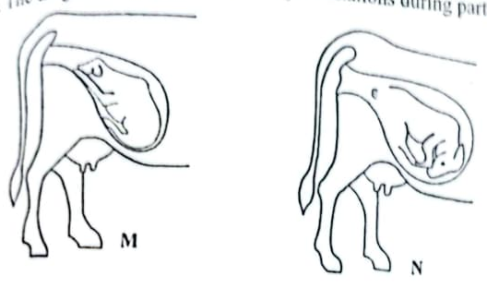
a) Name the presentation labeled M and N. (2mks)

b) Which one of the two presentation requires the services of a
qualified stockman? (1mk)
c) State two signs of parturition observed on the vulva. (2mks)

SECTION C
Answer ALL questions.
21. a) Give five reasons for keeping livestock healthy. (5mks)
b) Explain five factors that should be considered when siting a farm store. (10mks)
c) State five structural requirements for a good grain store. (5mks)

22. a) State five disadvantages of artificial insemination. (5mks)
b) State five differences between ruminant & non – ruminant digestive system. (5mks)
c) Describe five factors to consider when siting an apiary. (10mks)

