Term 1 - 2026
PHYSICS (232/3)
FORM FOUR (4)
PAPER 3
Time: $2 Hours$

Name: …………………………………………………………. Adm No: ……………….
School: ……………………………………………………….. Class: …………………..
Signature: ……………………………………………………. Date: …………………...

INSTRUCTIONS:
- Answer all the questions in this paper.
- You are supposed to spend the first 15 minutes of the $2\frac{1}{2}$ hours allowed for this paper reading the whole paper carefully before starting your work.
- Marks are given for clear record of the observations made, their suitability and accuracy and the use made of them.
- Candidates are advised to record observations as soon as they are made
- Mathematical table and electronic calculators may be used.
- The earth’s gravitational pull, $g=10N{kg}^{-1}$

For Examiner’s use only:
QUESTION | TOTAL MARKS | CANDIDATE’S SCORE
1 | 20
2 | 20
GRAND TOTAL | 40

This paper consists of 7 printed pages. Candidates should check the question paper to ensure that all the pages are printed as indicated and no questions are missing.

QUESTION ONE
You are provided with the following:
- A micro-metre screw-gauge (maybe shared)
- Eight connecting wires (two with crocodile clips at one end)
- An -ammeter (range: 0-1A)
- Voltmeter (0-1V)
- A wire mounted on a mm scale
- A switch
- A long wire with a crocodile clip at one end. (to be used as a jockey)
- New size ‘D’ dry-cell and cell-holder

Proceed as follows:
- Measure the diameter, d of the mounted wire (1mark)

$d=$ ..................................mm d = ............................. m

- Determine the cross-sectional area, A of the mounted wire (2marks)

- Now set-up the apparatus as shown in the figure below:
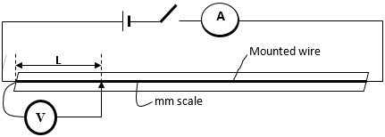Figure 1
- Close the switch and tap the mounted wire with the crocodile clip as shown in the figure 1, above. Ensure the both meters show positive deflection. Open the switch.
- Tap the wire at L = 20 cm. close the switch so that you read and record the ammeter and volt-meter readings.

- Repeat the procedure above for other values of L shown in the table 1 below and complete the table. (7 marks)

Table 1
L (cm) | L (m) | Voltage, V | Current, I (A) | $$R=\frac{V}{I}$$
20

30

40

50
60
70

- Plot a graph of R (y-axis) against L in metres (5marks)

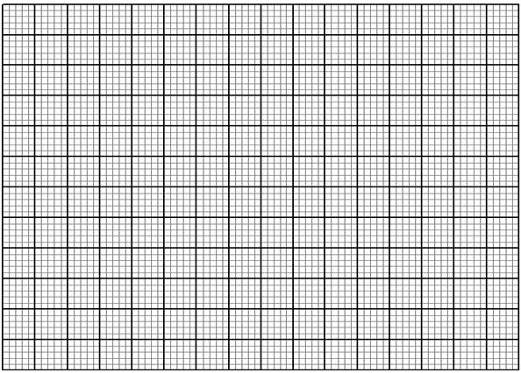

- Determine the slope, S of the graph (3marks)

- Given that $R=\frac{ρL}{A}$ , determine the constant, $ρ$ (2marks)

QUESTION TWO

You are provided with the following apparatus:
- A soft board,
- an equilateral glass prism,
- 4 optical pins and 4 drawing pins,
- plain white paper
Proceed as follows:
- On a plain white paper draw a line XY and mark its midpoint Q. At Q draw a normal NQM at right angles to XY. Draw a line PQ such that the angle of incidence, i, (PQN) is 25⁰ (figure below). Fix the paper on the soft-board with the drawing pins.
- Place the triangular prism vertically with the triangular base down, on the paper such that the midpoint of the edge CA of the prism coincides with the midpoint, Q, of the line XY, as shown. Draw the outline CAB of the prism.
(The plain paper to be collected with the answer sheet) (3marks)
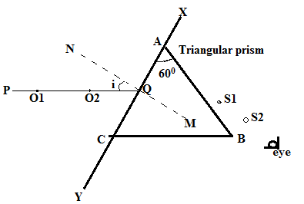
- Stick two pins, O1 and O2 (object pins), on the line PQ vertically into the soft-board, about 5cm apart. View from the side AB of the prism and look for the images of the pins O1 and O2, as shown in the figure. Keeping the eye along the plane of the paper, fix two pins S1 and S2 (search pins), one after the other between your eye and the prism so that S1 and S2 and the images of O1 and O2, seen through the prism, appear one behind the other in a straight line. Mark the positions of the four pins and remove the pins, the prism and the paper.

- Draw a line joining the points S1 and S2 to meet the line AB at R. Draw the line QR. Measure the angle of refraction, r (MQR). Record the values of the angles i and r in the table below.
- Repeat the experiment for the other values of $i$. and entre your results in the table 2 below. Complete the table. (6 marks)
i (⁰) | r (⁰) | Sin i | Sin r | $$\frac{\sin{i}}{\sin{r}}$$
25
30
35
40
45

- Plot a graph of $\sin{i} against\sin{r }$ (5marks)

- Determine the slope of the graph (3marks)

- Calculate the $∩_{av}$ the average value of $\frac{\sin{i}}{\sin{r}}$ (2marks)

- Comment on the significance of the slope of the graph (1mark)

This is the last printed page.

