Term 1 - 2026
PHYSICS (232/2)
FORM FOUR (4)
PAPER 2
Time: $2 Hours$

Name: …………………………………………………………. Adm No: ……………….
School: ……………………………………………………….. Class: …………………..
Signature: ……………………………………………………. Date: …………………...

Instructions to Candidates
- Write your name, admission number, class and signature in the spaces provided at the top of the page. This paper consists of two sections: A and B.
- Answer ALL the questions in the spaces provided.
- Mathematical tables and electronic calculator may be used.
- All working MUST be clearly shown.
- This paper consists of 13 printed pages.
- Candidates should answer the questions in English and check to ensure that no question(s) is missing.
FOR EXAMINER’S USE ONLY

SECTION | QUESTIONS | MAXIMUM SCORE | CANDIDATE’S SCORE
A | 1 – 12 | 25
B | 13 | 11
B | 14 | 15
B | 15 | 11
B | 16 | 8
B | 17 | 10
TOTAL SCORE |  | 80

This paper consists of 13 printed pages. Candidates should check and ascertain that all questions are printed as indicated and that no questions are missing. TURN OVER

SECTION A: 25 MARKS
Answer all questions in this section
- Figure 1 shows two mirrors inclined at an angle of 30º to each other. A ray of light is incident on one mirror as shown
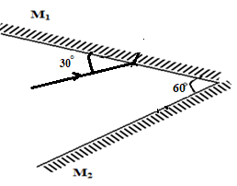
Figure 1
Sketch the path of the ray to show its reflection on the two mirrors (2mks)
- Figure 2 shows the path of a ray of light CB passing from glass to air.
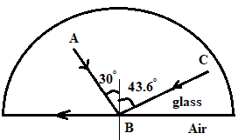
Figure 2

Complete the diagram to show the path of the ray of light AB after it emerges from the glass showing the angle calculated. (3mks)
………………………………………………………………………………………………………………………………………………………………………………………………………………………………………………………………………………………………………………………

- Figure 3 shows water waves moving towards barrier.
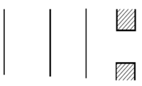
Figure 3
- State the property of wave under investigation. (1mk)

…………………………………………………………………………………………
- Show the emergence of the reflected wave after passing the opening (1mk)

- State why passing of light through narrow opening is a very rare phenomenon (1mk)

……………………………………………………………………………………………………………………………………………………………………………………
- Figure 4 shows an object in front of a concave mirror and its image.
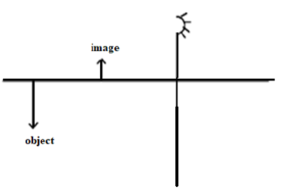
Figure 4
Locate position of its principal focus and label it as F (2mks)

- Figure 5 shows a wave profile.
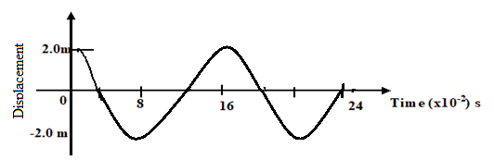
Figure 5

Determine the frequency of the wave (3mks)
………………………………………………………………………………………………………………………………………………………………………………………………………………………………………………………………………………………………………………………………………………………………………………………………………………………………

- Figure 6 shows a bar of soft iron placed near a magnet.

Figure 6
SOFT IRON
N S

On the same diagram, sketch the magnetic field pattern due to the set up (2mks)
- State two uses of a charged gold leaf electroscope. (2mks)
………………………………………………………………………………………………………………………………………………………………………………………………………………………………………………………………………………………………………………………………………………………………………………………………………………………………
- State two physical quantities that can be measured to determine whether a secondary chemical accumulator requires to be charged. ( 2 mks )
………………………………………………………………………………………………………………………………………………………………………………………………………………………………………………………………………………………………………………………………………………………………………………………………………………………………
- Explain why the walls of studios are padded with woolen materials. ( 1 mk)
………………………………………………………………………………………………………………………………………………………………………………………………………………………………………………………………………………………………………………………………………………………………………………………………………………………………
- State one similarity between the working of the human eye and the lens of a camera. ( 1 mk)
………………………………………………………………………………………………………………………………………………………………………………………………………………………………………………………………………………………………………………………………………………………………………………………………………………………………
- Give any two ways of increasing the capacitance of a parallel plate capacitor (2 mks)
………………………………………………………………………………………………………………………………………………………………………………………………………………………………………………………………………………………………………………………………………………………………………………………………………………………………
- Three resistors of 3 Ω, 6 Ω and 9 Ω are connected in parallel. Determine the total resistance.
( 2 mks)
………………………………………………………………………………………………………………………………………………………………………………………………………………………………………………………………………………………………………………………………………………………………………………………………………………………………

SECTION B. (55 MARKS)
Answer all questions in this section
- a) Figure 7 shows an object, a screen and light sources X, Y and Z.
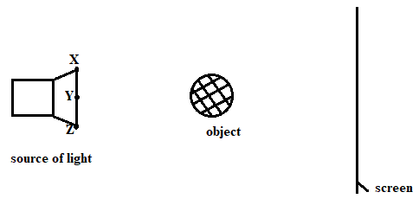
Figure 7
- Complete the diagram to show the formation of a shadow (2mks)
- Explain why it is impossible to obtain a sharp-edged shadow of the object (1mk)
..............................................................................................................................................................................................................................................................................................................................................................................................................................
- State one property of the object that makes it possible for its shadow to be formed (1mk)
.............................................................................................................................................................................................................................................................................................................................................................................................................................
b) (i) The length of a pinhole camera is 20cm. Determine the height of a sloppy building 300m away from a pinhole camera which forms an image 2.5cm high on the screen of the camera. (3mks)
...........................................................................................................................................................................................................................................................................................................................................................................................................................................................................................................................................................................................................................................................................................................................................................................................................

(ii) A student decided to use a nail to make the hole of the camera mentioned above. State two possible characteristics of the image formed (2mks)
...............................................................................................................................................................................................................................................................................................................................................................................................................................................................................................................................................................................................................................................
c) Give two differences between the images formed by the pin-hole camera and the plane mirror ( 2 mks)
................................................................................................................................................................................................................................................................................................................................................................................................................................................................................................................................................................................................................................................

- a) What is meant by the term electromotive force of a cell? (1mk)

............................................................................................................................................................................................................................................................................................................................................................................................................................................................................................................................................................................................................................................
b) Battery of e.m.f. 12 V supplies a current of 10 A flows through it for 5 minutes. Determine the amount of electrical energy produced. (2mks)
................................................................................................................................................................................................................................................................................................................................................................................................................................................................................................................................................................................................................................................

c) Figure 8 shows a graph of resistance against reciprocal of current. Use it to answer the questions that follow.
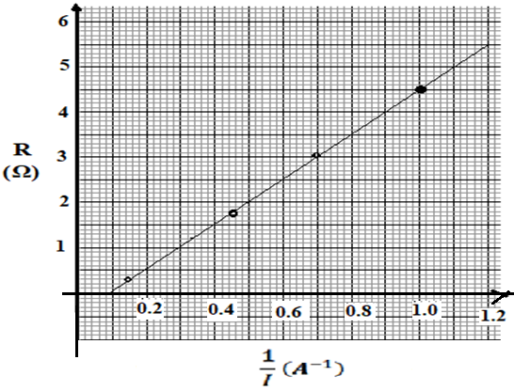
Figure 8
- Find the internal resistance, r. (2mks)
..............................................................................................................................................................................................................................................................................................................................................................................................................................................................................................................................................................................................................................................
- Determine the e.m.f, E of the cell. (2mks)
...............................................................................................................................................................................................................................................................................................................................................................................................................................................................................................................................................................................................................................................

- Draw a circuit diagram to show the set-up used to generate the above graph (2mks)

- i) Draw a circuit diagram to show how a 12V battery may be used to operate efficiently 3 headlamp bulbs each marked 6V, 24W. (2mks)

ii) Calculate the current supplied by the battery in (d) above. (2mks)
................................................................................................................................................................................................................................................................................................................................................................................................................................................................................................................................................................................................................................................
iii) Calculate the total effective resistance of the bulbs in (i) above. (2mks)
..............................................................................................................................................................................................................................................................................................................................................................................................................................................................................................................................................................................................................................................

- ​a) State the meaning of the term principal focus as applied in lenses (1 mk)
...................................................................................................................................................................................................................................................................................................................................................................................................................................................................................
b) A real object of height 1 cm placed 50mm from a converging lens forms a virtual image 100mm from the lens. Determine the following;
I. Focal length of the lens (3 mks)
..................................................................................................................................................................................................................................................................................................................................................................................................................................................................................
II. The magnification ( 2 marks)
......................................................................................................................................................................................................................................................................................................................
c) State two optical instruments that produce a magnified real image using a convex lens
(2 mks)
.......................................................................................................................................................................................................................................................................................................................
d) The diagram below shows a compound microscope with objective and eyepiece of principal foci Fo and Fe respectively. Complete the ray diagram to illustrate how the eye sees the final image. (3 mks)
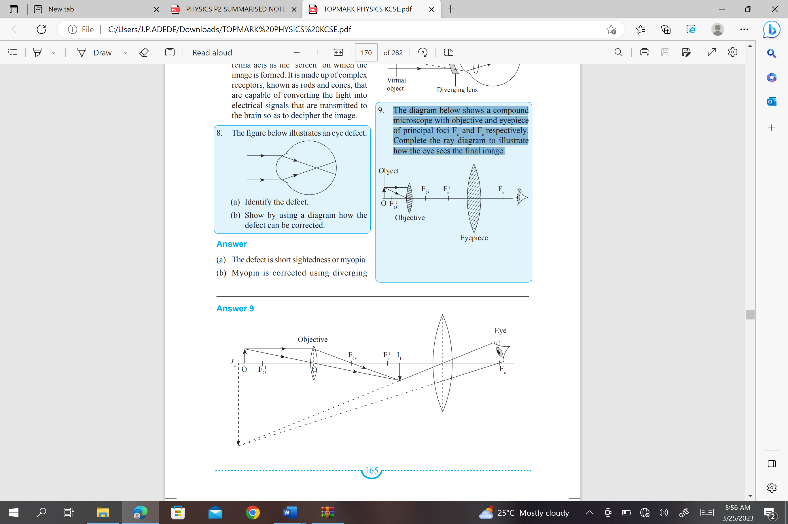
Figure 9

- a) State Flemings left hand rule (1 mark)
..................................................................................................................................................................................................................................................................................................................................................................................................................................................................................

b) A small electromagnet for lifting and releasing a small steel ball is made in the laboratory as shown in figure 10 below

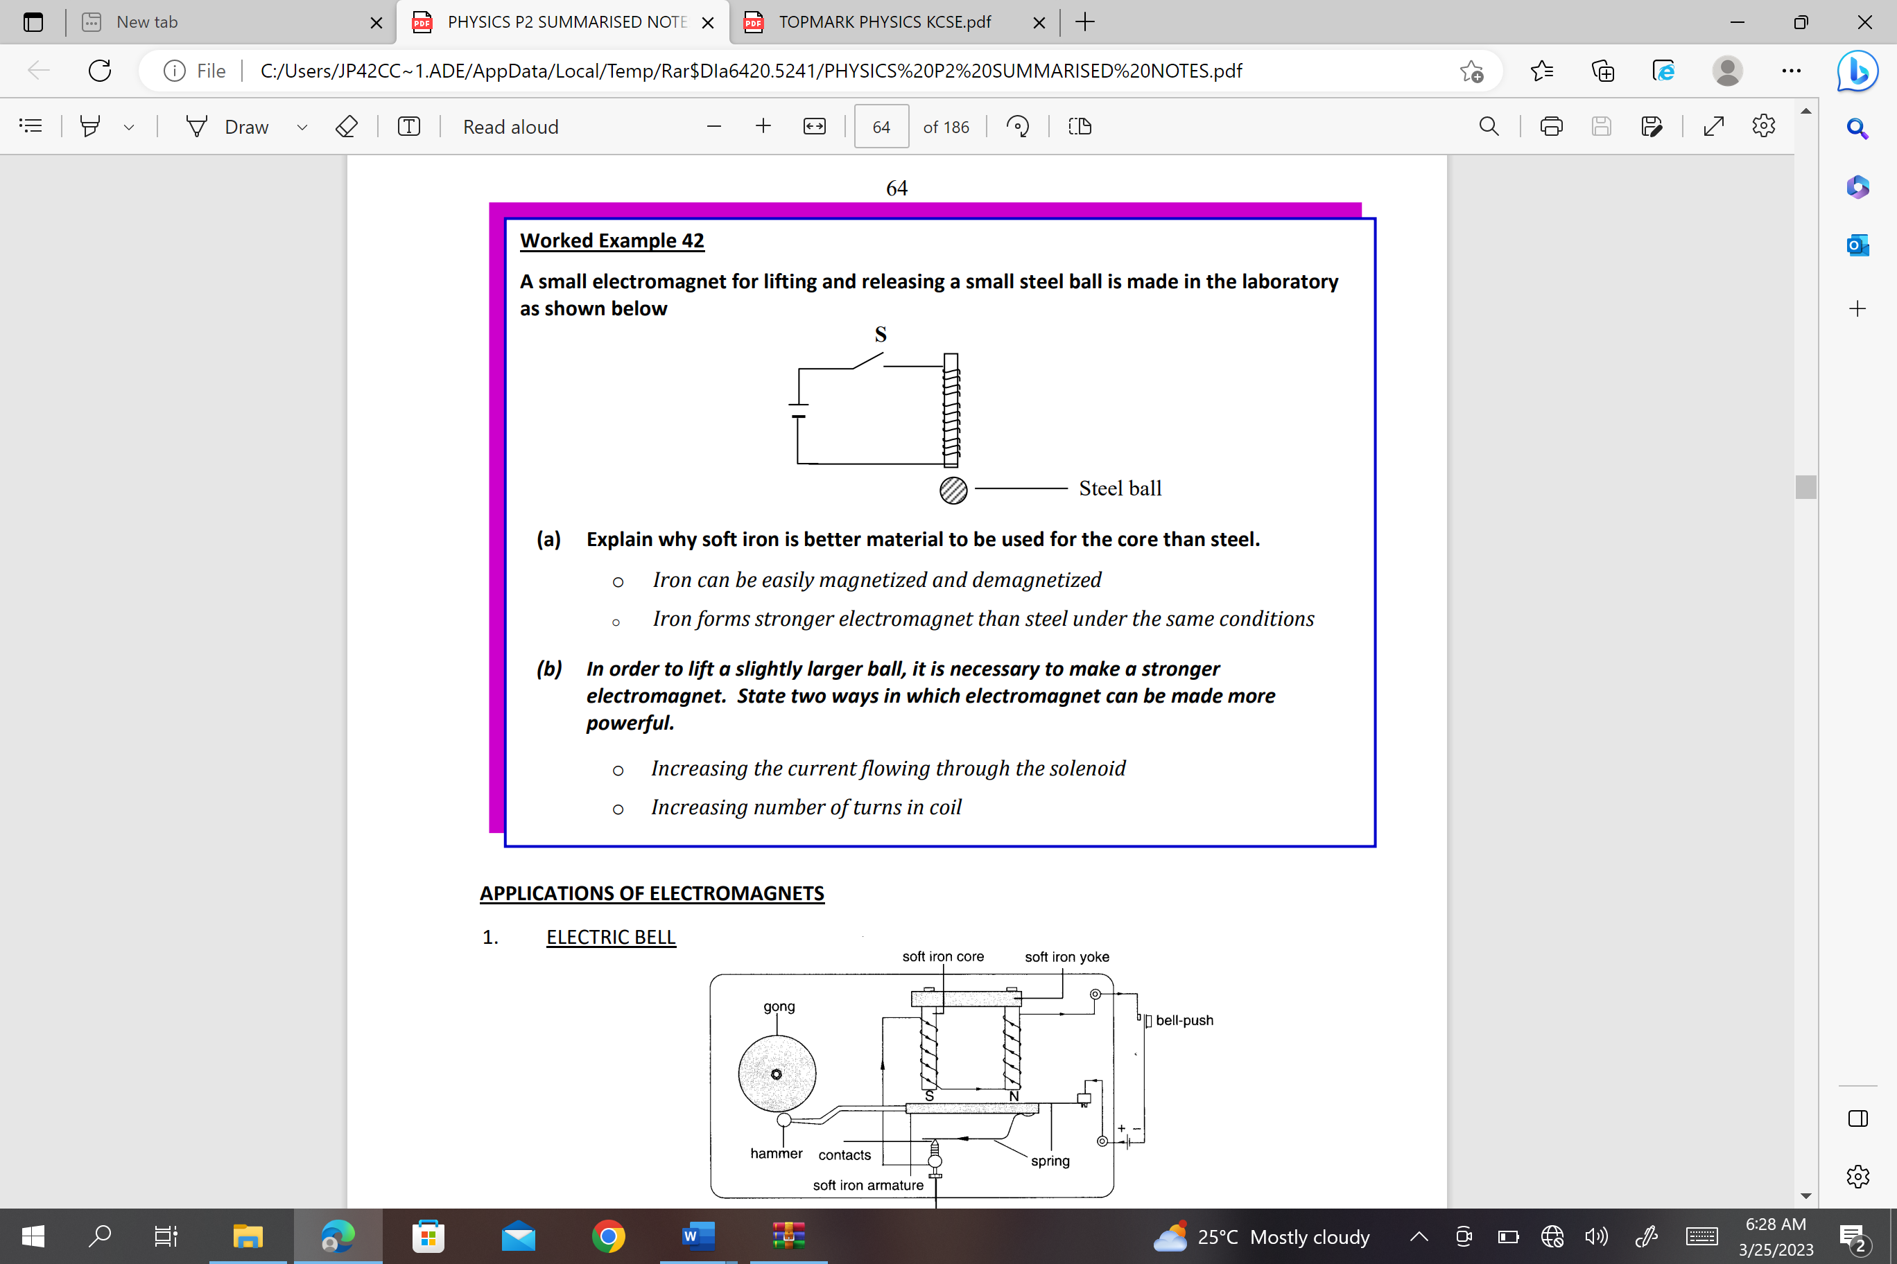
Figure 10

- Explain why soft iron is better material to be used for the core than steel. (1 mk)
.......................................................................................................................................................................................................................................................................................................................................................................................................................................................................................................................................................................

- In order to lift a slightly larger ball, it is necessary to make a stronger electromagnet. State two ways in which electromagnet can be made more powerful. (2 mks)
........................................................................................................................................................................................................................................................................................................................................................................................................................................................................................................................................................................

c) The figure 11 below illustrates a circuit diagram of an electric bell.
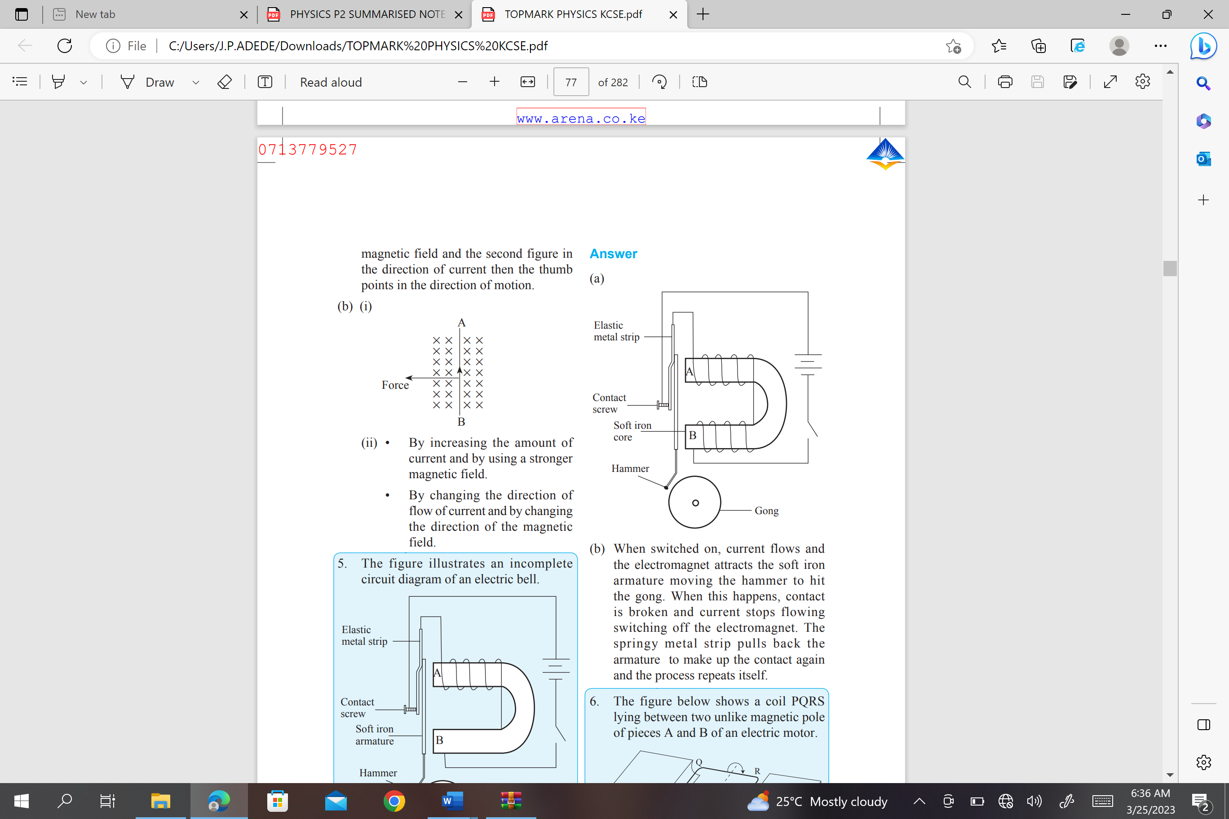
Figure 11
Explain how the bell works. (4 marks)
..................................................................................................................................................................................................................................................................................................................................................................................................................................................................................
..................................................................................................................................................................................................................................................................................................................................................................................................................................................................................
- a) A spoon partly submerged in a glass of water appears bent. Explain. (1 mk)
.......................................................................................................................................................................................................................................................................................................................................................................................................................................................................................................................................................................

b) A coin is placed at the bottom of a tall gas jar. When the jar is filled with paraffin to a depth of 32.4 cm, the coin is apparently seen displaced 9.9 cm from the bottom. What is the refractive index of paraffin? (3mks)
.......................................................................................................................................................................................................................................................................................................................................................................................................................................................................................................................................................................

c)State two conditions necessary for total internal reflection (2 mks)
.......................................................................................................................................................................................................................................................................................................................................................................................................................................................................................................................................................................

d) The speed of light in air is 3.0 x 108 m/s. What is the speed of light in glass? Take refractive index of glass = 1.5 ( 3 mks)
.......................................................................................................................................................................................................................................................................................................................................................................................................................................................................................................................................................................

e) State the laws of refraction ( 1 mk)
.......................................................................................................................................................................................................................................................................................................................................................................................................................................................................................................................................................................

