Term 1 - 2026
PHYSICS (232/1)
FORM FOUR (4)
PAPER 1
Time: $2 Hours$

Name: …………………………………………………………. Adm No: ……………….
School: ……………………………………………………….. Class: …………………..
Signature: ……………………………………………………. Date: …………………...

Instructions to candidates

- This paper consists of two sections A and B.
- Answer all the questions in the two sections in the spaces provided after each question.
- All working must be clearly shown.
- Electronic calculators and mathematical tables may be used.
- All numerical answers should be expressed in the decimal notations.
- You may use ‘gravitational acceleration, g, as 10m/s²

For Examiner use only
SECTION | QUESTION | MAX MARKS | CANDIDATE’S SCORE
A | 1 – 13 | 25
B | 14 | 12
B | 15 | 11
B | 16 | 10
B | 17 | 12
B | 18 | 10
 | TOTAL | 80

This paper consists of 13 printed pages. Candidates should check to ascertain that all pages are printed as indicated and that no questions are missing.

SECTION A (25 MARKS)
- A form one student measured the length of a wire four times using a metre-rule and obtained the following readings: 10.2 cm, 10.3cm, 10.1cm and 10.0 cm. determine the length the student should record (2 marks)

- The figure 1 below shows a reading of micrometer screw gauge with a positive zero error of 0.06mm.
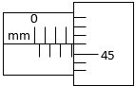 Figure 1
State the actual reading of the micrometer screw gauge (2marks)

- It is not correct to quote weight of an object in kilogram. Explain (1mark)

- Figure 2 shows a section of a curved surface ABCD. Point A is higher than point B while BCD is horizontal. Part ABC is smooth while CD is rough. A mass M is released from rest at A and moves towards D.
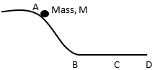Figure 2

State the changes in velocity of M between:
- BC (1mark)

- CD (1mark)

- A student wearing sharp pointed heeled shoes is likely to damage soft wooden floor. Explain.
(2marks)

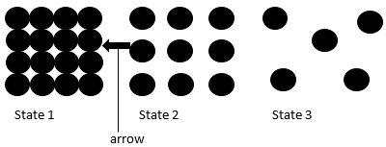
- Figure 3, shows the arrangement of molecules in the three states of matter

Figure 3

- Name the process represented by the arrow (1mark)

- State the reason for the arrangement of molecules in state 3 (1mark)

- Figure 4 shows a uniform metal rod balanced at its centre by different forces.

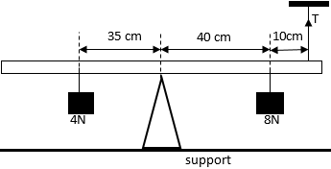Figure 4
Determine the value of T (3marks)

- A balloon is filled with hydrogen gas and then released into the air. It is observed that as it rises up into the air, it expands. Explain. (2marks)

- A person carrying a heavy luggage using one hand leans is body away from the luggage. Give a reason for this. (1mark)

- Figure 5 shows a glass tube with water and fitted with two identical thermometers A and B. it is heated as shown.
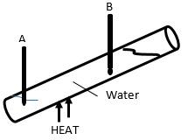Figure 5
State and explain which of the two thermometers shows a higher reading (2marks)

- Mechanics is one of the branches of physics. State what it deals with (1mark)

- Figure 6 shows parts A, B and C of a non-uniform glass tube
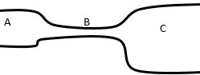 Figure 6
State with reason the part of the tube where the pressure will be lowest when air is blown through the tube from A to C (2marks)

- In an experiment to determine the density of a liquid R, a student obtained the following data:
Mass of an empty density bottle = 55.0 g
Mass of the density bottle + water = 80.0 g
Mass of the density bottle + liquid R = 70.0 g

Determine the density of liquid, R (density of water is 1000 kg/m³) (3marks)

SECTION B (55 MARKS)

- Define the following terms:
- Displacement (1mark)

- Acceleration (1mark)

- A tape attached to an accelerating trolley passes through a ticker timer that makes dots on it at a frequency of 50 Hz. The ticker timer makes 10 dots on a 10 cm long tape such that; the distance, a, between the first two dots is 0.5 cm and the distance b, between the last two dots is 1.5 cm. Determine the velocity of the trolley at:
- Distance, a (3marks)

- Distance, b (2marks)

- Determine the acceleration of the trolley (3marks)

- State and explain what would be observed on the spacing of the dots on the tape when the trolley is made to move on a horizontal surface (2 marks)

- State the law of flotation (1mark)

- Figure 7 shows two solids A and B made of the same material and immersed in water.
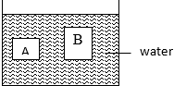

Figure 7
State and explain which of the two containers experience greater upthrust (2marks)

- Solid A weighs 12 N in air and 2N in water, 4N in another liquid. Determine the density of the other liquid (3 marks)

- Figure 8 shows two identical wooden blocks each of mass 0.2 kg suspended in water by two strings M and N.
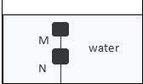
Figure 8
Given that the upthrust on each block is 3.2 N, determine the tension in string:
- M (2marks)

- N (2marks)

- State any one application of hydrometers (1mark)

- When a bus goes round a bend on a flat road, it experiences centripetal force. State what provides this centripetal force. (1 mark)

- State the purpose of banking roads at bends (1mark)

- A student whirls a stone of mass 0.2 kg tied to a string of length 0.4 m in a vertical plane at a constant speed of 2 revolutions per second. (acceleration due to gravity is 10m/s²).
- State two forces acting on the stone when it is at its highest point (2marks)

- Determine the angular velocity of the stone (3marks)

- Determine the tension in the string when the stone is at the highest point (3marks)

- Figure 9 shows a graph of pressure against temperature for a fixed mass of gas at constant volume.
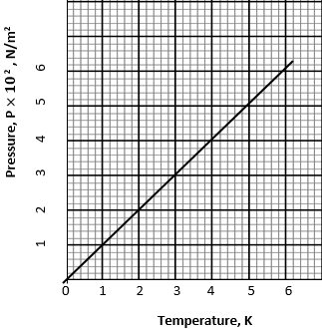

Figure 9
From the graph, determine the values of n and C given that: $P=nT+C$; where n and C are constants (4marks)

- It is not possible to obtain a zero pressure of gas in a real gas situation. Explain (2marks)

- A fixed mass of a gas occupies $1.5×{10}^{-3}m^{3}$ at a pressure of 760mmHg and a temperature of 273K. determine the volume the gas will occupy at a temperature of 290K and a pressure of 720mmHg (3 marks)

- State any three assumptions made in the kinetic theory of gases (3marks)

- State two differences between boiling and evaporation (2marks)

- State two ways in which heat loss by conduction is minimized in a vacuum flask
(2 marks)

- In a certain experiment, 50 g of dry steam at 100 ⁰C was directed into some crushed ice at 0 ⁰C. (latent heat of vaporization of water is $2.26×{10}^{6}$J/kg, latent heat of fusion of ice is $3.34×{10}^{5}$J/kg and specific heat capacity of water is $4200$J/kgK). Determine the:

- Quantity of heat lost by steam to change to water at 100 ⁰C (2marks)

- Quantity of heat lost by water formed to cool to 0 ⁰C (2marks)

- Mass of ice melted at 0 ⁰C (2marks)

This is the last printed page.

