Term 1 - 2026
PHYSICS (232/1)
FORM FOUR (4)
PAPER 1
Time: 2 Hours

Marking Scheme

Instructions to the teacher
This marking scheme is a guide to the teacher. The author acknowledges that there could be various perspectives of facts to the questions. It is therefore encouraged that the teacher concerned should adapt this marking scheme in order to capture all the relevant alternative facts.

SECTION A (25 MARKS)
- A form one student measured the length of a wire four times using a metre-rule and obtained the following readings: 10.2 cm, 10.3cm, 10.1cm and 10.0 cm. determine the length the student should record (2 marks)
$average length=\frac{10.2+10.3+10.1+10.0}{4}=10.15cm$ ;

Recorded length = 10.1 cm
Also accept 10.2 cm ; either reading must be to 1 d.p

- The figure 1 below shows a reading of micrometer screw gauge with a positive zero error of 0.06mm.
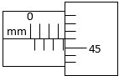 Figure 1
State the actual reading of the micrometer screw gauge (2 marks)
Reading = $3.5+\left(46×0.01\right)=3.96 mm$ ;

Actual reading = $3.96-0.06=3.90 mm$ ; 2 dp a must

- It is not correct to quote weight of an object in kilogram. Explain (1 mark)
Kilogram is the unit for mass and does not depict gravitational force ;

- Figure 2 shows a section of a curved surface ABCD. Point A is higher than point B while BCD is horizontal. Part ABC is smooth while CD is rough. A mass M is released from rest at A and moves towards D.
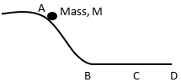Figure 2

State the changes in velocity of M between:
- BC (1 mark)
Constant velocity ;

- CD (1 mark)
Decreasing velocity ;

- A student wearing sharp pointed heeled shoes is likely to damage soft wooden floor. Explain.
(2 marks)
The sharp heeled shoes exert great pressure; due to a small area of contact with the wooden surface;

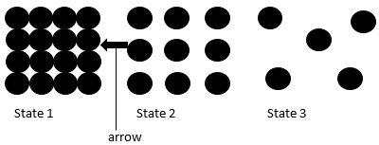
- Figure 3, shows the arrangement of molecules in the three states of matter

Figure 3

- Name the process represented by the arrow (1 mark)
Freezing ;

- State the reason for the arrangement of molecules in state 3 (1 mark)
Weaker intermolecular forces ;

- Figure 4 shows a uniform metal rod balanced at its centre by different forces.

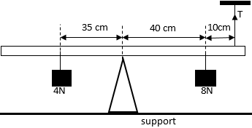Figure 4
Determine the value of T (3 marks)
$sum of clockwise moments=sum of anti clockwise moment$ ;
$8×0.4=\left(T×0.5\right)+(4×0.35)$
$3.2-1.4=0.5T$ ; $→T=\frac{1.8}{0.5}=3.6N ;$

- A balloon is filled with hydrogen gas and then released into the air. It is observed that as it rises up into the air, it expands. Explain. (2 marks)
Atmospheric pressure reduces as the balloon rises into the air; intermolecular distance of the hydrogen gas increases hence the increased volume;

- A person carrying a heavy luggage using one hand leans is body away from the luggage. Give a reason for this. (1 mark)
To maintain stability ;

- Figure 5 shows a glass tube with water and fitted with two identical thermometers A and B. it is heated as shown.
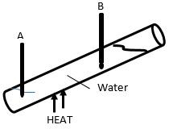Figure 5
State and explain which of the two thermometers shows a higher reading (2 marks)
B;
During heating, convectional currents rise upwards causing thermometer B to record higher temperature; the warm water stays at the top due to its lower density.

- Mechanics is one of the branches of physics. State what it deals with (1 mark)
It deals with the motion of bodies under the influence of force ;

- Figure 6 shows parts A, B and C of a non-uniform glass tube
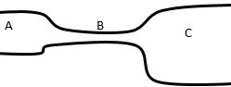 Figure 6
State with reason the part of the tube where the pressure will be lowest when air is blown through the tube from A to C (2 marks)
Point B;
The velocity is higher at this point hence pressure decreases ;

- In an experiment to determine the density of a liquid R, a student obtained the following data:
Mass of an empty density bottle = 55.0 g
Mass of the density bottle + water = 80.0 g
Mass of the density bottle + liquid R = 70.0 g

Determine the density of liquid, R (density of water is 1000 kg/m³) (3 marks)
$mass of water=80.0-55.0=25.0 g$
Volume of bottle (Vol of water in bottle) = $\frac{25}{1}=25{cm}^{3}$ ;
Mass of liquid, R = $70.0-55.0=15.0g$ ;
Density of liquid, R = $\frac{mass}{volume}=\frac{15}{25}=0.6g{cm}^{-3} or 600kgm^{-3}$ ;

SECTION B (55 MARKS)

- Define the following terms:
- Displacement (1 mark)
Distance covered in a particular direction;

- Acceleration (1 mark)
Rate of change of velocity of with time;

- A tape attached to an accelerating trolley passes through a ticker timer that makes dots on it at a frequency of 50 Hz. The ticker timer makes 10 dots on a 10 cm long tape such that; the distance, a, between the first two dots is 0.5 cm and the distance b, between the last two dots is 1.5 cm. Determine the velocity of the trolley at:
- Distance, a (3 marks)
Period, T = $\frac{1}{50}=0.02seconds$ ;

$V_{a}=\frac{0.5}{0.02} ;$ = 25 cm/s ;

- Distance, b (2 marks)
$V_{b}=\frac{1.5}{0.02} ;=75$cm/s ;

- Determine the acceleration of the trolley (3 marks)
Acceleration = $\frac{V_{b}-V_{a}}{t}$ = $\frac{75-25}{0.02 \left(8\right)}$ ;
$=\frac{50}{0.16};=312.5$ cm/s ;

- State and explain what would be observed on the spacing of the dots on the tape when the trolley is made to move on a horizontal surface (2 marks)
The spacing reduces; with time. This is because the trolley would decelerate on a horizontal surface;

- State the law of flotation (1 mark)
A floating body displaces its own weight of the fluid on which it floats ;

- Figure 7 shows two solids A and B made of the same material and immersed in water.
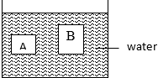

Figure 7
State and explain which of the two containers experience greater upthrust (2 marks)
B ;
B has a larger volume so it displaces a larger volume of water hence the higher upthrust ;

- Solid A weighs 12 N in air and 2N in water, 4N in another liquid. Determine the density of the other liquid (3 marks)
Upthrust in water = $12-2=10N$
Upthrust in liquid = $12-4=8N$
$relative density=\frac{8}{10}=0.8$ ;
Therefore, $0.8=\frac{ρ}{1000}$ ;
so density, $ρ=0.8×1000=800kgm^{-3}$ ;

- Figure 8 shows two identical wooden blocks each of mass 0.2 kg suspended in water by two strings M and N.
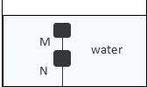
Figure 8
Given that the upthrust on each block is 3.2 N, determine the tension in string:
- M (2 marks)
$U=T+W$ $3.2=T+2$ ;
Therefore, T =$3.2-2=1.2 N$ ;

- N (2 marks)
$U=T+W$ $3.2=T+2$ ;
Therefore, T =$\left(3.2-2\right)+1.2 =2.4 N$ ;

- State any one application of hydrometers (1 mark)
Measuring the relative densities of liquids ;

- When a bus goes round a bend on a flat road, it experiences centripetal force. State what provides this centripetal force. (1 mark)
Friction between road and tyre ;

- State the purpose of banking roads at bends (1 mark)
It increases the centripetal force acting on the body negotiating the banked bend of the road;

- A student whirls a stone of mass 0.2 kg tied to a string of length 0.4 m in a vertical plane at a constant speed of 2 revolutions per second. (acceleration due to gravity is 10m/s²).
- State two forces acting on the stone when it is at its highest point (2 marks)
- Tension ;
- Weight ;

- Determine the angular velocity of the stone (3 marks)
$ω=2πf$ ;
$ω=2×3.142×2;=12.568rads^{-1}$ ;

- Determine the tension in the string when the stone is at the highest point (3 marks)
At the highest point, $F_{c}=W+T →T=F_{c}-W$ ;
Therefore, tension T = $mrω^{2}-W=\left(0.2×0.4×{12.568}^{2}\right)-2;=10.64N$ ;

- Figure 9 shows a graph of pressure against temperature for a fixed mass of gas at constant volume.
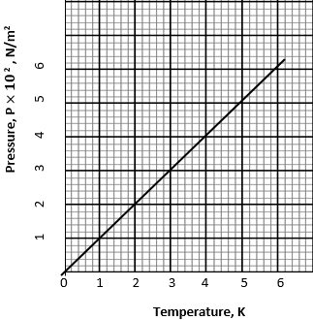

Figure 9
From the graph, determine the values of n and C given that: $P=nT+C$; where n and C are constants (4 marks)
- $n$
$n=gradient$ ;
Gradient = $\frac{500-200}{5-2};=100$N/m²K ;
- C
C = y intercept = 0 N/m² ;

- It is not possible to obtain a zero pressure of gas in a real gas situation. Explain (2 marks)
A real gas has real volume and pressure; it is therefore not possible for a gas to exist and yet fails to exert pressure;

- A fixed mass of a gas occupies $1.5×{10}^{-3}m^{3}$ at a pressure of 760mmHg and a temperature of 273K. determine the volume the gas will occupy at a temperature of 290K and a pressure of 720mmHg
$\frac{P_{1}V_{1}}{T_{1}}=\frac{P_{2}V_{2}}{T_{2}}$ ;
$\frac{(1.5×{10}^{-3})×760}{273}=\frac{720×V_{2}}{290}$ ;
Therefore, V₂ = 0.001682 m³ ;

(3 marks)

- State any three assumptions made in the kinetic theory of gases (3 marks)
- Size of gas particles is assumed to be negligible ;
- Intermolecular forces between the gas particles is zero ;
- The gas is ideal ;

- State two differences between boiling and evaporation (2 marks)
boiling | evaporation
- Takes place at a fixed temperature | - Takes place at all temperatures
- Takes place at the surface | - Takes place throughout the liquid

- State two ways in which heat loss by conduction is minimized in a vacuum flask (2 marks)
- Presence of vacuum ;
- Stopper is made of a poor conductor of material ;
- Use of glass (poor conductor of heat)

- In a certain experiment, 50 g of dry steam at 100 ⁰C was directed into some crushed ice at 0 ⁰C. (latent heat of vaporization of water is $2.26×{10}^{6}$J/kg, latent heat of fusion of ice is $3.34×{10}^{5}$J/kg and specific heat capacity of water is $4200$J/kgK). Determine the:

- Quantity of heat lost by steam to change to water at 100 ⁰C (2 marks)
$Q=ML_{v}$ = $Q=0.05×2260000$ ;
Therefore, Q = 113,000 J ;

- Quantity of heat lost by water formed to cool to 0 ⁰C (2 marks)
$heat lost=mc∆θ$
$=0.05×4200×(100-0)$ ;
$=21,000$J ;

- Mass of ice melted at 0 ⁰C (2 marks)
Heat gained by melting ice = heat lost by steam + heat lost by water ;
$ML_{v}=113,000+21,000$ $M×334000=134000$
Therefore, mass M = $\frac{134000}{334000}=0.4012$kg ;
Accept 401.2 g

