Term 1 - 2026
MATHEMATICS (121/2)
PAPER 2
FORM FOUR (4)
Time: 2 ½ Hours
MARKING SCHEME

NO. | WORKING | MARKS | REMARKS
 | Maximum Area$=10.5×14.5=152.25$  Actual Area$=10×14=140$  Absolute error in area $=152.25-140=12.25$  $$\%error=\frac{12.25}{140}×100$$  $$=8.75\%$$ | M1  M1  A1 | Maximum A.E. in the area
 | Total | 3
 | $$\frac{{2x}^{2}+{2y}^{2}+8x-10=0}{2}=x^{2}+4x+y^{2}=5$$  $$x^{2}+4x+4+y^{2}=5+4$$  $${\left(x+2\right)}^{2}+{\left(y-0\right)}^{2}=3^{2}$$  Centre $(-2, 0)$ and radius $-$ 3 units  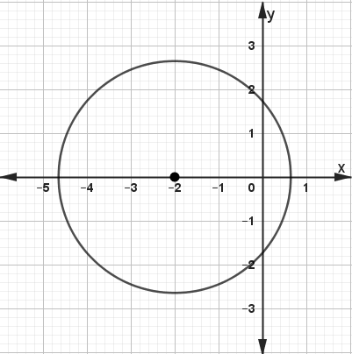 | B1  B1  B1  B1 | Completing the square in x  Centre and radius obtained  Cartesian plane  Circle drawn
 | Total | 4
 | $$\frac{\tan{{60}^{0}}}{1-\cos{{30}^{0}}}=\frac{\sqrt{3}}{1-\frac{\sqrt{3}}{2}}$$  $$\frac{\sqrt{3}\left(1+\frac{\sqrt{3}}{2}\right)}{\left(1-\frac{\sqrt{3}}{2}\right)\left(1+\frac{\sqrt{3}}{2}\right)}$$  $$\frac{\sqrt{3}+\frac{3}{2}}{1-\frac{3}{4}}=\frac{\sqrt{3}+\frac{3}{2}}{\frac{1}{4}}=\left(\sqrt{3}+\frac{3}{2}\right)×4$$  $$=4\sqrt{3}+6→6+4\sqrt{3}$$  $a=6, b=4$ and $c=3$ | B1  M1  A1 | Identifying tan 60⁰ and cos 30⁰ in terms of surds  Rationalizing the denominator
 | Total | 3

NO. | WORKING | MARKS | REMARKS
 | $$\log_{3}9^{2}-\log_{3}{144}^{\frac{1}{2}}+\log_{3}972$$  $$\log_{3}81-\log_{3}12+\log_{3}972$$  $$\log_{3}\left(\frac{81×972}{12}\right)=\log_{3}6561$$  $$\log_{3}3^{8}=8\log_{3}3$$  $$=8$$ | M1  M1  A1
 | Total | 3
 | $$\frac{Tn}{2m}=\sqrt{\frac{L-A^{2}}{3k}}$$  $$\frac{T^{2}n^{2}}{4m^{2}}=\frac{L-A^{2}}{3k}$$  $$3kT^{2}n^{2}=L4m^{2}-A^{2}4m^{2}$$  $$3kT^{2}n^{2}+A^{2}4m^{2}=L4m^{2}$$  $$A^{2}4m^{2}=L4m^{2}-3kT^{2}n^{2}$$  $$A^{2}=\frac{L4m^{2}-3kT^{2}n^{2}}{4m^{2}}$$  $$A=±\sqrt{\frac{L4m^{2}-3kT^{2}n^{2}}{4m^{2}}}$$ | M1  M1  A1 | Removal of square root/squaring both sides  Term in A on one side
 | Total | 3
Binomial coefficients 1, 7, 21, 35, 35, …
$${\left(1+2x\right)}^{7}=1^{7}+7×2x+21×{\left(2x\right)}^{2}+35×{\left(2x\right)}^{3}+35×{\left(2x\right)}^{4}+…$$
$${\left(1+2x\right)}^{7}=1+14x+84x^{2}+280x^{3}+560x^{4}+…$$
$${\left(1+2x\right)}^{7}={\left(0.98\right)}^{7}→1+2x=0.98$$
$$2x=0.98-1→2x=-0.02→x=-0.01$$
$${\left(0.98\right)}^{7}=1+14\left(-0.01\right)+84{\left(-0.01\right)}^{2}+280{\left(-0.01\right)}^{3}+560{\left(-0.01\right)}^{4}+…$$
$$=0.8681256$$
 | Total | 3

NO. |  | WORKING |  |  | MARKS |  |  | REMARKS
 |  | 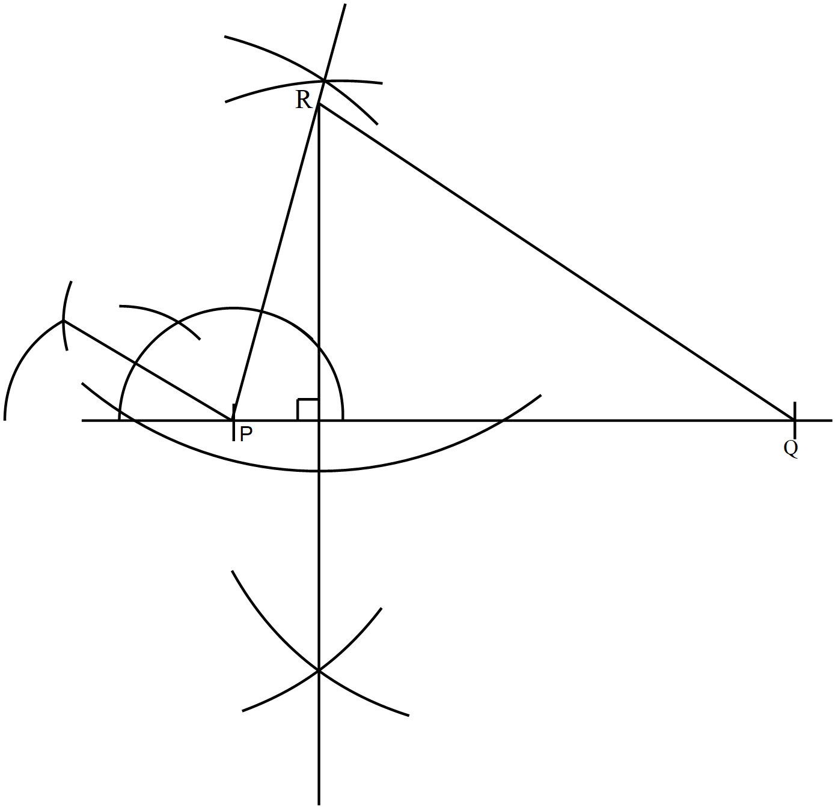 |  |  | B1  B1  B1  B1 |  |  | Construction of 75⁰ at P  5.5 cm to R and completing the triangle  Dropping a perpendicular from R to PQ  Distance 4.4 cm ± 0.1 cm
 |  | Total |  |  | 2
 |  | $$CSA=\left(80×28\right)-\left(\frac{1}{2}×2×\frac{22}{7}×{14}^{2}\right)$$  $$=2240-616=1624 {cm}^{2}$$  $$V=1624×180$$  $=292,320$ ${cm}^{3}$ |  |  | M1  M1  A1
 |  | Total |  |  | 3
 |  | From ratio theorem  $$OR=\frac{-1}{4+\left(-1\right)}\left(\begin{matrix}2 \\ -3 \\ 1\end{matrix}\right)+\frac{4}{4+(-1)}\left(\begin{matrix}3 \\ -4 \\ -3\end{matrix}\right)$$  $$OR=\frac{-1}{3}\left(\begin{matrix}2 \\ -3 \\ 1\end{matrix}\right)+\frac{4}{3}\left(\begin{matrix}3 \\ -4 \\ -3\end{matrix}\right)=\left(\begin{matrix}{10}/3 \\ {-13}/3 \\ {-13}/3\end{matrix}\right)$$  $$R→\left(3\frac{1}{3}, -4\frac{1}{3}, -4\frac{1}{3}\right)$$ |  |  | M1  A1  B1
 |  | Total |  |  | 3
 |  | $$4y=-3x+12$$  $$y=\frac{-3}{4}x+3$$  $$\tan{θ=\frac{-3}{4}}$$  $$θ=\tan^{-1}\left(\frac{-3}{4}\right)$$  $$θ=-{36.87}^{0}$$  Obtuse angle $={180}^{0}-{36.87}^{0}={143.1}^{0}$ |  |  | M1  A1  B1
 |  | Total |  |  | 3
NO. | WORKING |  |  |  |  | MARKS |  |  | REMARKS
 | $$A.s.f=\frac{54}{9}=4x-\left\{2(x-1)\right\}$$  $$6=4x-\left(2x-2\right)$$  $$6=4x-2x+2$$  $$6-2=4x-2x$$  $$2x=4→x=2$$ |  |  |  |  | M1  M1  A1 |  |  | Equating Asf to determinant of matrix  Collection of like terms
 | Total |  |  |  |  | 3
 | $$P=aQ^{n}→\log{P=\log{a+n\log{Q}}}$$  $$\log{a=1→a=\log^{-1}\left(1\right)=10}$$  $$n=\frac{20-0}{5-1}=5$$ |  |  |  |  | B1  M1, A1
 | Total |  |  |  |  | 3
 | $$5s+3m=2816$$  $$3s+5m=3360$$  $$\left(\begin{matrix}5 & 3 \\ 3 & 5\end{matrix}\right)\left(\begin{matrix}s \\ m\end{matrix}\right)=\left(\begin{matrix}2816 \\ 3360\end{matrix}\right)$$  $$\det{=5×5-3×3=16}$$  $$\frac{1}{16}\left(\begin{matrix}4 & -3 \\ -3 & 4\end{matrix}\right)=\left(\begin{matrix}5/{16} & {-3}/{16} \\ {-3}/{16} & 5/{16}\end{matrix}\right)$$  $$\left(\begin{matrix}5/{16} & {-3}/{16} \\ {-3}/{16} & 5/{16}\end{matrix}\right)\left(\begin{matrix}5 & 3 \\ 3 & 5\end{matrix}\right)\left(\begin{matrix}s \\ m\end{matrix}\right)=\left(\begin{matrix}5/{16} & {-3}/{16} \\ {-3}/{16} & 5/{16}\end{matrix}\right)\left(\begin{matrix}2816 \\ 3360\end{matrix}\right)$$  $$\left(\begin{matrix}1 & 0 \\ 0 & 1\end{matrix}\right)\left(\begin{matrix}s \\ m\end{matrix}\right)=\left(\begin{matrix}250 \\ 522\end{matrix}\right)⇒\left(\begin{matrix}250 \\ 522\end{matrix}\right)⇒\left.\begin{matrix}set=sh.250 \\ table=sh.522\end{matrix}\right\}$$ |  |  |  |  | M1  M1  M1  A1 |  |  | Matrix equation  Inverse  Pre-multiplication  Both
 | Total |  |  |  |  | 4
 | $$346.5=\frac{22}{7}×r^{2}$$  $$r=\sqrt{\frac{346.5×7}{22}}=10.5 cm$$  Area of sector  $$=\frac{1}{5}×\frac{22}{7}×10.5×10.5$$  $= 69.3 m^{2}$ |  |  |  |  | M1  M1  A1 |  |  | Expression for area of circle
 | Total |  |  |  |  | 3
 | Amount = 750,000 – 225,000$=525,000$  Amount to pay = 15×55,000=825,000  Let the rate of interest be $r\%$ per month  $$825,000=525,000{\left(1+\frac{r}{100}\right)}^{15}$$  $$\frac{825,000}{525,000}={\left(1+\frac{r}{100}\right)}^{15}$$  $$1+\frac{r}{100}=\sqrt[15]{\frac{825,000}{525,000}}=1+\frac{r}{100}=1.03059$$  $$100+r=103.059$$  $$r=103.059-100=3.059\%$$ |  |  |  |  | M1  M1  A1
 | Total |  |  |  |  | 4
NO. |  |  | WORKING | MARKS |  |  | REMARKS
 |  |  | Total mass$=20×200=4000 kg$  New mass  $$=\frac{29}{32}×20×200=3625 kg$$  $$=4000-3625$$  $$=375 kg$$ | M1  M1  A1
 |  |  | Total | 3
 |  |  | - Monthly basic pay  Let the taxable income be A  $$Gross Tax=4312+1062=5374$$  $$9680×\frac{10}{100}=968→\left(5374-968=4406\right)$$  $$9120×\frac{15}{100}=1368→\left(4406-1368=3038\right)$$  $$9120×\frac{20}{100}=1368→\left(3038-1824=1214\right)$$  $$\left(A-27920\right)×\frac{25}{100}=1214$$  $$A-27920=\frac{1214}{0.25}$$  $$A=27920+4856=32,776$$  Basic Salary  $$32,776-15,220=17,556$$  - Net salary  $$32,776-\left(4312+320+200+500\right)$$  $$32,776-5332$$  $$=27,444$$ | M1, A1  M1  M1  A1  M1, A1  M1  M1  A1
 |  |  | Total | 10

NO. | WORKING | MARKS | REMARKS
 | - $6^{2}={11}^{2}+7^{2}-2×11×7\cos{C}$  $$6^{2}-{11}^{2}-7^{2}=-154\cos{C}$$  $$\cos{C=\frac{-134}{-154}}$$  $$C=\cos^{-1}\left(\frac{134}{154}\right)$$  $$C={29.5}^{0}$$  - Radius of the circle  $$\frac{6}{\sin{{29.5}^{0}}}=2R$$  $$R=\frac{6}{2sin{{29.5}^{0}}}$$  $$R=6.1 cm$$  - Shaded area  ∠AOB$=2×{29.5}^{0}={59}^{0}$  Area of sector  $$=\frac{59}{360}×3.142×6.1×6.1$$  $$=19.16$$  Area of ΔAOB  $$=\frac{1}{2}×6.1×6.1\sin{{59}^{0}}$$  $$=15.95$$  Shaded area  $$=19.16-15.95$$  $$=3.2 {cm}^{2}$$ | M1  M1  A1  M1  A1  B1  M1  M1  M1  A1 | Application of cosine rule  Attempt to get C  Equating sine rule to radius of circumcircle  Angle at the centre  Area of sector  Area of triangle
 | Total | 10

NO. | WORKING | MARKS | REMARKS
 | - (i) Geometric series  $$\frac{16}{8}=\frac{8}{4}=\frac{4}{2}=2=common ratio$$  (ii) $16384=2×2^{n-1}$  $$\frac{16384}{2}=2^{n-1}$$  $$2^{13}=2^{n-1}$$  $$13=n-1→n=14$$  (iii) Sum of first 14 terms  $$S_{14}=\frac{2\left(2^{14}-1\right)}{2}$$  $$S_{14}=32,766$$  - Last term of the sequence  $$820=\frac{n}{2}\left\{2×3+\left(n-1\right)4\right\}$$  $$1640={4n}^{2}+2n$$  $${4n}^{2}+2n-1640=0→{2n}^{2}+n-820=0$$  $$\left(n-20\right)\left(n+20.5\right)=0$$  $n=-20.5$ – discriminate  Hence $n=20$  $$820=\frac{20}{2}\left(3+l\right)$$  $$820=10\left(3+l\right)$$  $$82=3+l$$  $$l=82-3=79$$ | B1  M1  M1  A1  M1  A1  M1  A1  M1  A1
 | Total | 10

NO. | WORKING | MARKS | REMARKS
 | - Value of $a$  $$7+a+3+12+2a+13+37+11+6+3=110$$  $$92+3a=110$$  $$3a=18⇒a=6$$  - (i) Mean mark  $$Mean=45.5+10×\frac{38}{110}$$  $$Mean=48.95$$  (ii) Standard deviation  $$s=10\sqrt{\frac{294}{110}-{\left(\frac{38}{110}\right)}^{2}}$$  $$s=10×1.5979$$  $$s=15.98$$  - Pass mark if 60% passed  $${40}^{th} percentile=\frac{40}{100}×110={44}^{th} student$$  $$40.5+\left(\frac{44-28}{25}\right)×10$$  $$=46.9\%$$ | B1  M1  M1  M1  M1  A1  M1  A1  M1  A1 | 6 seen  All midpoints  All fd  All fd²
  Marks | f | $$x$$ | $$d=\frac{x-45.5}{10}$$ | $$fd$$ | $${fd}^{2}$$
  11 – 20 | 7 | 15.5 | $$-3$$ | $$-21$$ | $$63$$
  21 – 30 | 9 | 25.5 | $$-2$$ | $$-18$$ | $$36$$
  31 – 40 | 12 | 35.5 | $$-1$$ | $$-12$$ | $$12$$
  41 – 50 | 25 | 45.5 | $$0$$ | $$0$$ | $$0$$
  51 – 60 | 37 | 55.5 | $$1$$ | $$37$$ | $$37$$
  61 – 70 | 11 | 65.5 | $$2$$ | $$22$$ | $$44$$
  71 – 80 | 6 | 75.5 | $$3$$ | $$18$$ | $$54$$
  81 – 90 | 3 | 85.5 | $$4$$ | $$12$$ | $$48$$
   | 110 |  |  | Ʃfd=38 | Ʃfd²=294
  Marks | f | $$cf$$
  11 – 20 | 7 | 7
  21 – 30 | 9 | 16
  31 – 40 | 12 | 28
  41 – 50 | 25 | 53
  51 – 60 | 37 | 90
  61 – 70 | 11 | 101
  71 – 80 | 6 | 107
  81 – 90 | 3 | 110
   | 110
 | Total | 10

NO. | WORKING | MARKS | REMARKS
 | - Total rate of flow in litres  $$=120+150=270 litres/minute$$  Time taken  $$=\frac{18900}{270}$$  $$=70 minutes$$  $$=1 \frac{1}{6} hours$$  - (i) Part of tank filled after 25 minutes  $$=270×25$$  $$=6750 litres$$  Time taken to fill the remaining part  $$=\frac{18900-6750}{270-20}$$  $$=48.6 minutes$$  Time taken to fill the tank  $$=25+48.6 minutes$$  $$=73.6 minutes≅74 minutes=1 hr 14 minutes$$  $$11.15 a.m. +1 hr 14 minutes$$  $$=12.29 p.m.$$ | M1  M1  A1  M1  M1, M1  A1  M1  M1  A1
 | Total | 10

NO. | WORKING |  | MARKS |  | REMARKS
 | - (i) Image $A^{'}B^{'}C^{'}$  Matrix of shear $x-c$axis invariant $=\left(\begin{matrix}1 & k \\ 0 & 1\end{matrix}\right)$  $$k=\frac{d}{y}=\frac{5-2}{-2}=-1.5$$  Hence shear matrix$=\left(\begin{matrix}1 & -1.5 \\ 0 & 1\end{matrix}\right)$  (ii) $\left(\begin{matrix}1 & -1.5 \\ 0 & 1\end{matrix}\right)\left(\begin{matrix}A \\ 2 \\ 2\end{matrix}\right)=\left(\begin{matrix}A^{'} \\ -1 \\ 2\end{matrix}\right)→A^{'}\left(-1, 2\right)$  $$\left(\begin{matrix}1 & -1.5 \\ 0 & 1\end{matrix}\right)\left(\begin{matrix}C \\ -1 \\ -4\end{matrix}\right)=\left(\begin{matrix}C^{'} \\ 5 \\ -4\end{matrix}\right)→C^{'}\left(5,-4\right)$$  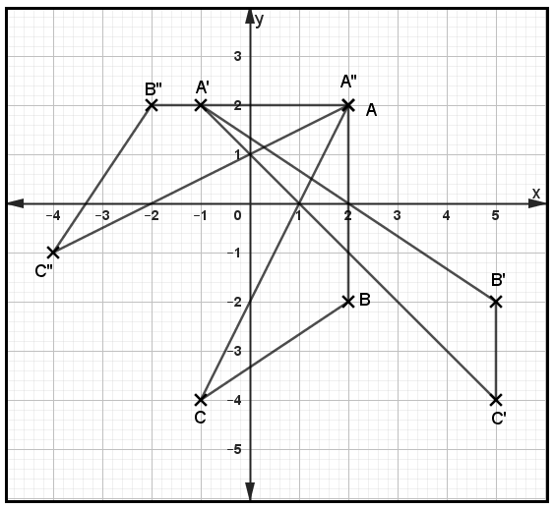  - $\left(\begin{matrix}0 & 1 \\ 1 & 1.5\end{matrix}\right)\left(\begin{matrix}A' & B' & C' \\ -1 & 5 & 5 \\ 2 & -2 & -4\end{matrix}\right)=\left(\begin{matrix}A'' & B'' & C'' \\ 2 & -2 & -4 \\ 2 & 2 & -1\end{matrix}\right)$  - (i) Let $U=\left(\begin{matrix}a & b \\ c & d\end{matrix}\right)$  $\left(\begin{matrix}a & b \\ c & d\end{matrix}\right)\left(\begin{matrix}A'' & B'' & C'' \\ 2 & -2 & -4 \\ 2 & 2 & -1\end{matrix}\right)=\left(\begin{matrix}A & B & C \\ 2 & 2 & -1 \\ 2 & -2 & -4\end{matrix}\right)$  $\left(\begin{matrix}2a+2b & -2a+2b & -4a-b \\ 2c+2d & -2c+2d & -4c-d\end{matrix}\right)=\left(\begin{matrix}2 & 2 & -1 \\ 2 & -2 & -4\end{matrix}\right)$  $2a+2b=2$ $2c+2d=2$  $-2a+2b=2$ $-2c+2d=-2$  $4a=0→a=0$ $4c=4→c=1$  $b=1$ $d=0$  Hence $U=\left(\begin{matrix}0 & 1 \\ 1 & 0\end{matrix}\right)$  (ii) Reflection along $y=x$ or $y-x=0$ |  | M1  A1  B1  B1  B1  B1  B1  M1  A1  B1
 | Total |  | 10
NO. |  | WORKING |  | MARKS |  | REMARKS
- Tree diagram
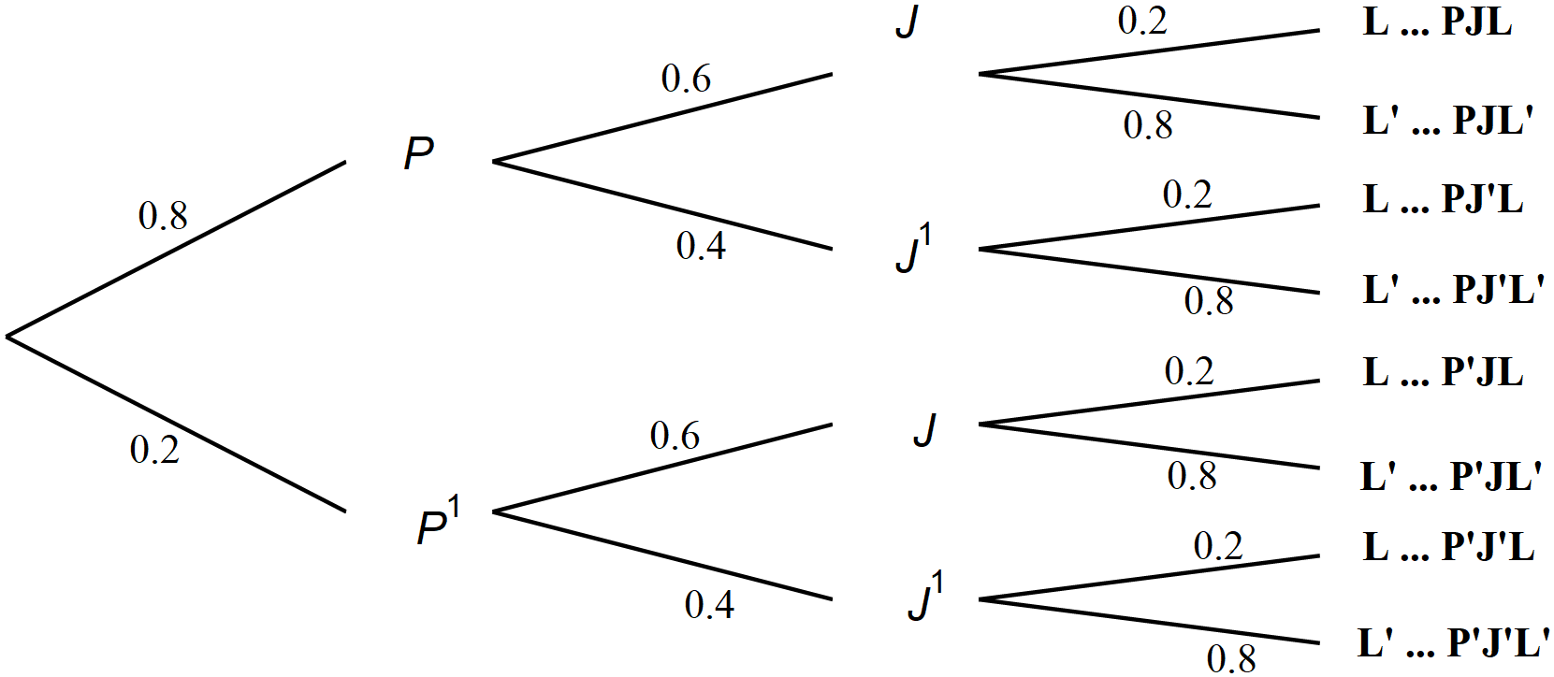

- (i) Exactly 2 students pass
$$=\left(0.8×0.6×0.8\right)+\left(0.8×0.4×0.2\right)+\left(0.2×0.6×0.2\right)$$
$$=0.384+0.064+0.024$$
$$=0.472$$

(ii) At most 2 students pass
$$=1-\left\{P\left(PJL and P^{'}J^{'}L^{'}\right)\right\}$$
$$=1-\left\{\left(0.8×0.6×0.2\right)×\left(0.2×0.4×0.8\right)\right\}$$
$$=1-\left\{0.096+0.064\right\}$$
$$=0.84$$

(iii) Only 1 passes
$$=\left(0.8×0.4×0.8\right)+\left(0.2×0.6×0.8\right)+\left(0.2×0.4×0.2\right)$$
$$=0.256+0.096+0.016$$
$$=0.368$$

(iv) At least 1 passes
$=1-$P (all fail)
$$=1-\left(0.2×0.4×0.8\right)$$
$$=1-0.064$$
$$=0.936$$
 |  | Total |  | 10

NO. | WORKING | MARKS | REMARKS
 | - 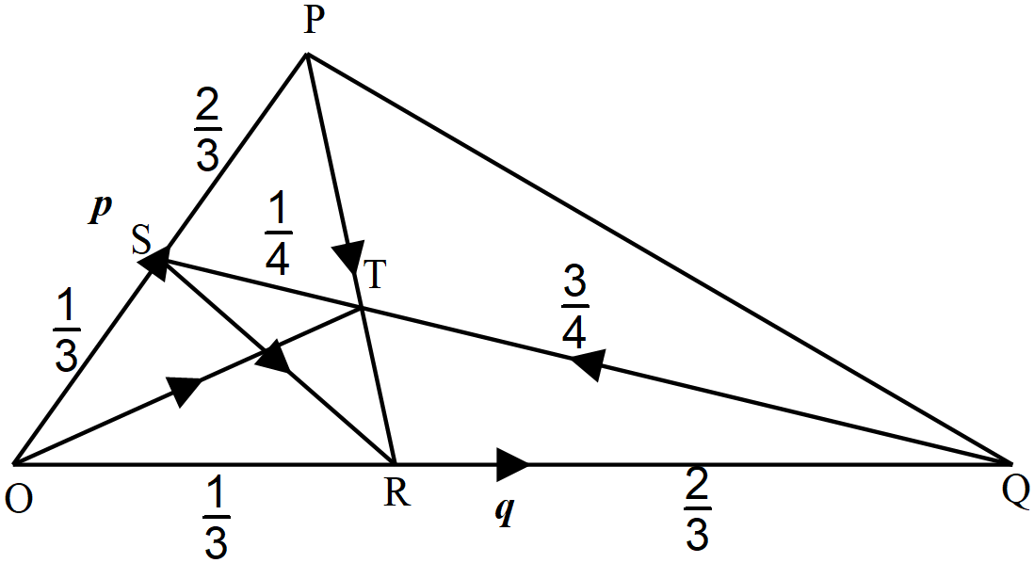(i) $SR=SO+OR$  $$=\frac{1}{3}p+\frac{1}{3}q$$  (ii) $QS=QO+OS$  $$=-q+\frac{1}{3}p$$  (iii) $PT=PS+ST$  $$=-\frac{2}{3}p+\frac{1}{4}\left(-QS\right)=-\frac{2}{3}p+\frac{1}{4}\left(q-\frac{1}{3}p\right)$$  $$=-\frac{2}{3}p+\frac{1}{4}q-\frac{1}{12}p=-\frac{2}{3}p-\frac{1}{12}p+\frac{1}{4}q$$  $$=-\frac{9}{12}p+\frac{1}{4}q=\frac{1}{4}q-\frac{3}{4}p$$  (iv) $TR=TQ+QR$  $$=-\frac{3}{4}QR-\frac{2}{3}q$$  $$=-\frac{3}{4}\left(-q+\frac{1}{3}p\right)-\frac{2}{3}q=\frac{3}{4}q-\frac{2}{3}q-\frac{1}{4}p$$  $$=\frac{1}{12}q-\frac{1}{4}p$$  - Collinearity between P, T and R  $$PT=\frac{1}{4}q-\frac{3}{4}p and TR=\frac{1}{12}q-\frac{1}{4}p$$  $$⇒TR=3\left(\frac{1}{4}q-\frac{3}{4}p\right)⇒TR=3PT$$  Hence $PT//TR$  Point T is common hence P, T and R are collinear | B1  B1  M1  M1  A1  M1  A1  B1  B1  B1
 | Total | 10

