Term 1 - 2026
MATHEMATICS (121/1)
PAPER 1
FORM FOUR (4)
Time: 2 ½ Hours
Name: …………………………………………………………. Adm No: ……………….
School: ……………………………………………………….. Class: …………………..
Signature: …………………………………………………….. Date: ……………………
INSTRUCTIONS TO CANDIDATES
- Write your name and index number in the spaces provided at the top of this page.
- Write your school name, sign and write the date of the examination in the spaces provided above.
- This paper consists of Two sections: Section I and Section II
- Answer ALL questions in Section I and any five questions from Section II
- Show all the steps in your calculations, giving your answers at each stage in the spaces provided below each question.
- Marks may be given for correct working even if the answer is wrong.
- Non-Programmable silent electronic calculators and KNEC Mathematical Tables may be used.
- This paper consists of 15 printed pages.
- Candidates should check the question paper to ensure that all the pages are printed as indicated and no questions are missing.
- Candidates should answer the questions in English.

For Examiners’ Use Only
SECTION I
1 | 2 | 3 | 4 | 5 | 6 | 7 | 8 | 9 | 10 | 11 | 12 | 13 | 14 | 15 | 16 | Total

SECTION II
17 | 18 | 19 | 20 | 21 | 22 | 23 | 24 | Total |  | Grand Total

SECTION I (50 Marks)
Answer all the questions in this section
- Find the value of $1.\dot{5}\dot{7}-0.\dot{4}\dot{2}$ leaving the answer as a mixed fraction in simplified form. (3 marks)

- Oscar refuels his car every two days; Morris refuels his car after every four days while Millicent refuels her car after every ten days. If the all refueled their cars on 20th March, on which date will they refuel their cars together again? (3 marks)

- Use logarithms only to evaluate, correct to 4 decimal places: (4 marks)
$${\left(\frac{12.78\sin{{33.45}^{0}}}{{\left(9.063\right)}^{2}}\right)}^{\frac{1}{3}}$$

- Without using a calculator, evaluate leaving the answer as a fraction in the simplest form. (3 marks)
$$\frac{2\frac{1}{4}+\frac{3}{5}÷\frac{5}{6} of 2\frac{2}{5}}{1\frac{7}{10}}$$

- In the figure below angles QPR and PSR are equal. Angle PRS is a right angle. The ratio of the PR:QR=4:3
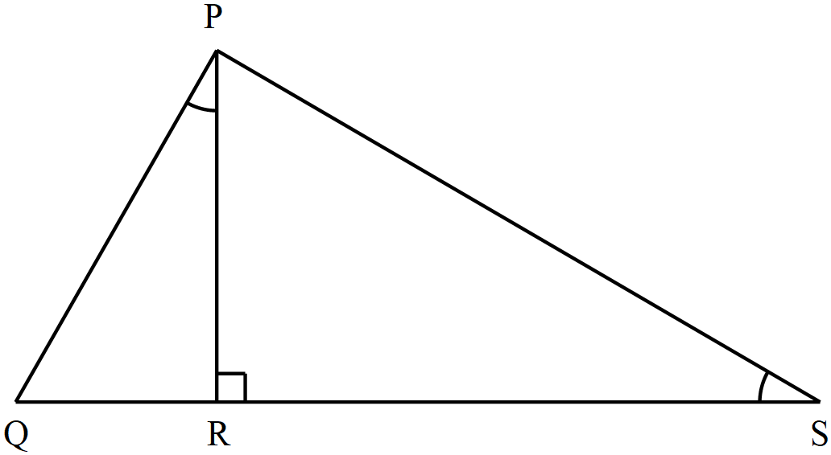

Given that the area of triangle PQR is 24 cm², find the area of triangle PRS. (3 marks)

- A suit whose marked price is sh. 8,000 is sold to customer after allowing him a discount of 13%. If the trader makes a profit of 20%, find how much the trader paid for the suit. (3 marks)

- Evans is a salesperson with Ajab Millers. He is paid on monthly basis as the agreement; basic pay of Ksh. 20,000, a commission of 2% for goods sold up to a maximum of Ksh. 200,000 and a commission of 4% for goods sold over Ksh. 200,000 in that month. In January 2023, he sold goods worth Ksh. 600,000. Calculate his total pay that month. (3 marks)

- The figure below shows a flower garden with the dimensions shown.
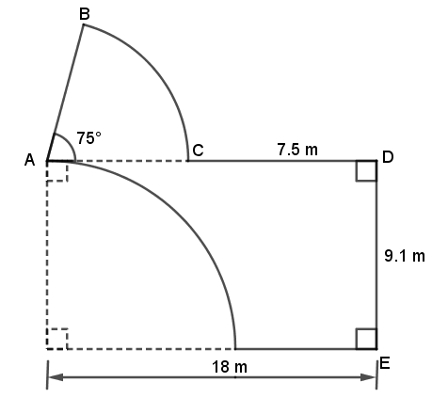
Calculate the perimeter of the garden (3 marks)

- The GCD of three numbers is 30 and their LCM is 900. Two of the numbers are 60 and 150. By expressing the GCD, LCM and the two numbers as products of their prime factors, determine the least possible value of the third number. (3 marks)

- Solve for $x$ in the equation (3 marks)
$$\frac{{27}^{x}×9^{2x}}{{\left(\frac{1}{3}\right)}^{x}}=81$$

- The sum of interior angles of two regular polygons of sides; $n$ and $n+2$ are in the ratio 3:4. Calculate the value of $n$ hence find the size of each exterior angle of the polygon with $n$ sides. (4 marks)

- Simplify the expression: (3 marks)
$$\frac{\left(x+1\right)\left({4a}^{2}-ax\right)}{x^{2}-4ax-4a+x}$$

- The sum of two consecutive even numbers is 270. Find the numbers. (2 marks)

- On the grid provided below, draw and label the region R satisfied by the following inequalities:
$L_{1;}x≥-1$, $L_{2};3y-x≥-5$ and $L_{3};3x+5y<15$ (3 marks)
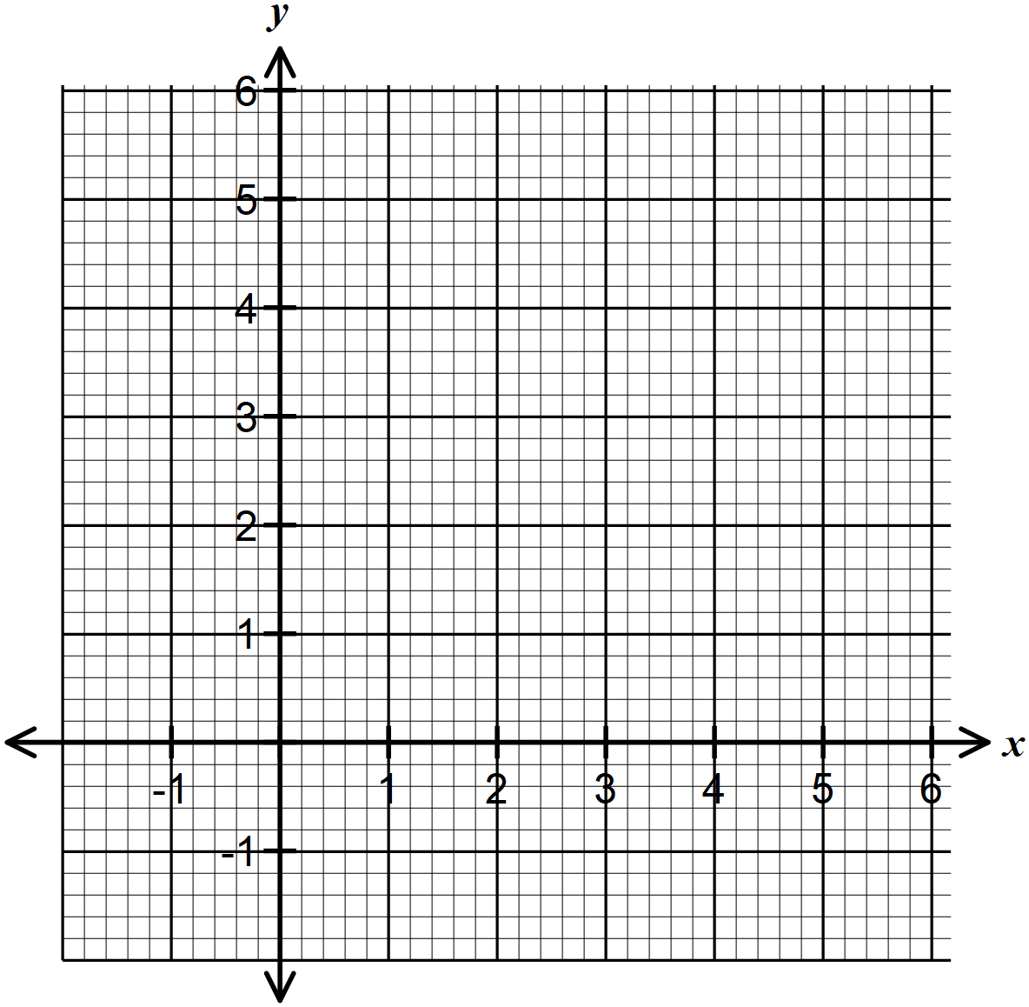

- In a theatre group, the ratio of males to females is 2:3. On one Tuesday training, ten males members were absent and six new female members joined the group as guests for the day. If on this day the ratio of males to females was 1:3, how many regular members does the group have? (3 marks)

- The figure below shows part of the net of a triangular prism whose cross-section is an equilateral triangle.

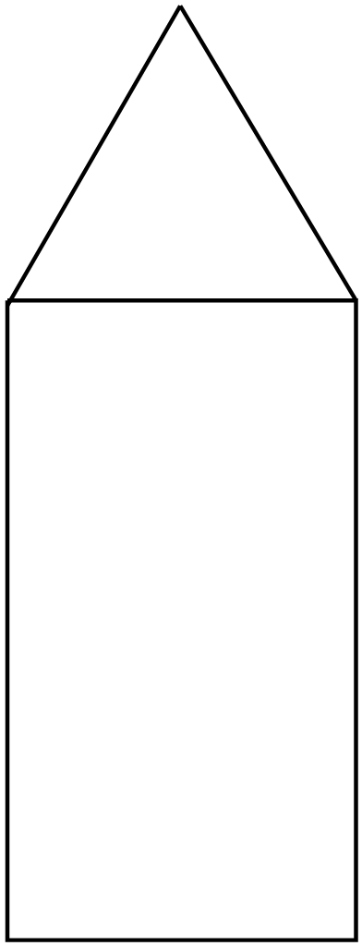

Complete the net of the solid. (4 marks)

SECTION II (50 Marks)
Answer any five questions in this section.
- The table below shows the wages in US dollars earned by technical developers in an ICT firm
Amount (USD) | 10 – 14 | 15 – 24 | 25 – 29 | 30 – 44 | 45 – 64
Number of workers | 6 | 16 | $$a$$ | 9 | 5

- Given that the mean wage is $27\frac{11}{16}$ USD, find the value of $a$. (4 marks)

- Find the median class and its frequency. (2 marks)

- On the grid provided, draw a histogram to represent the information. (4 marks)
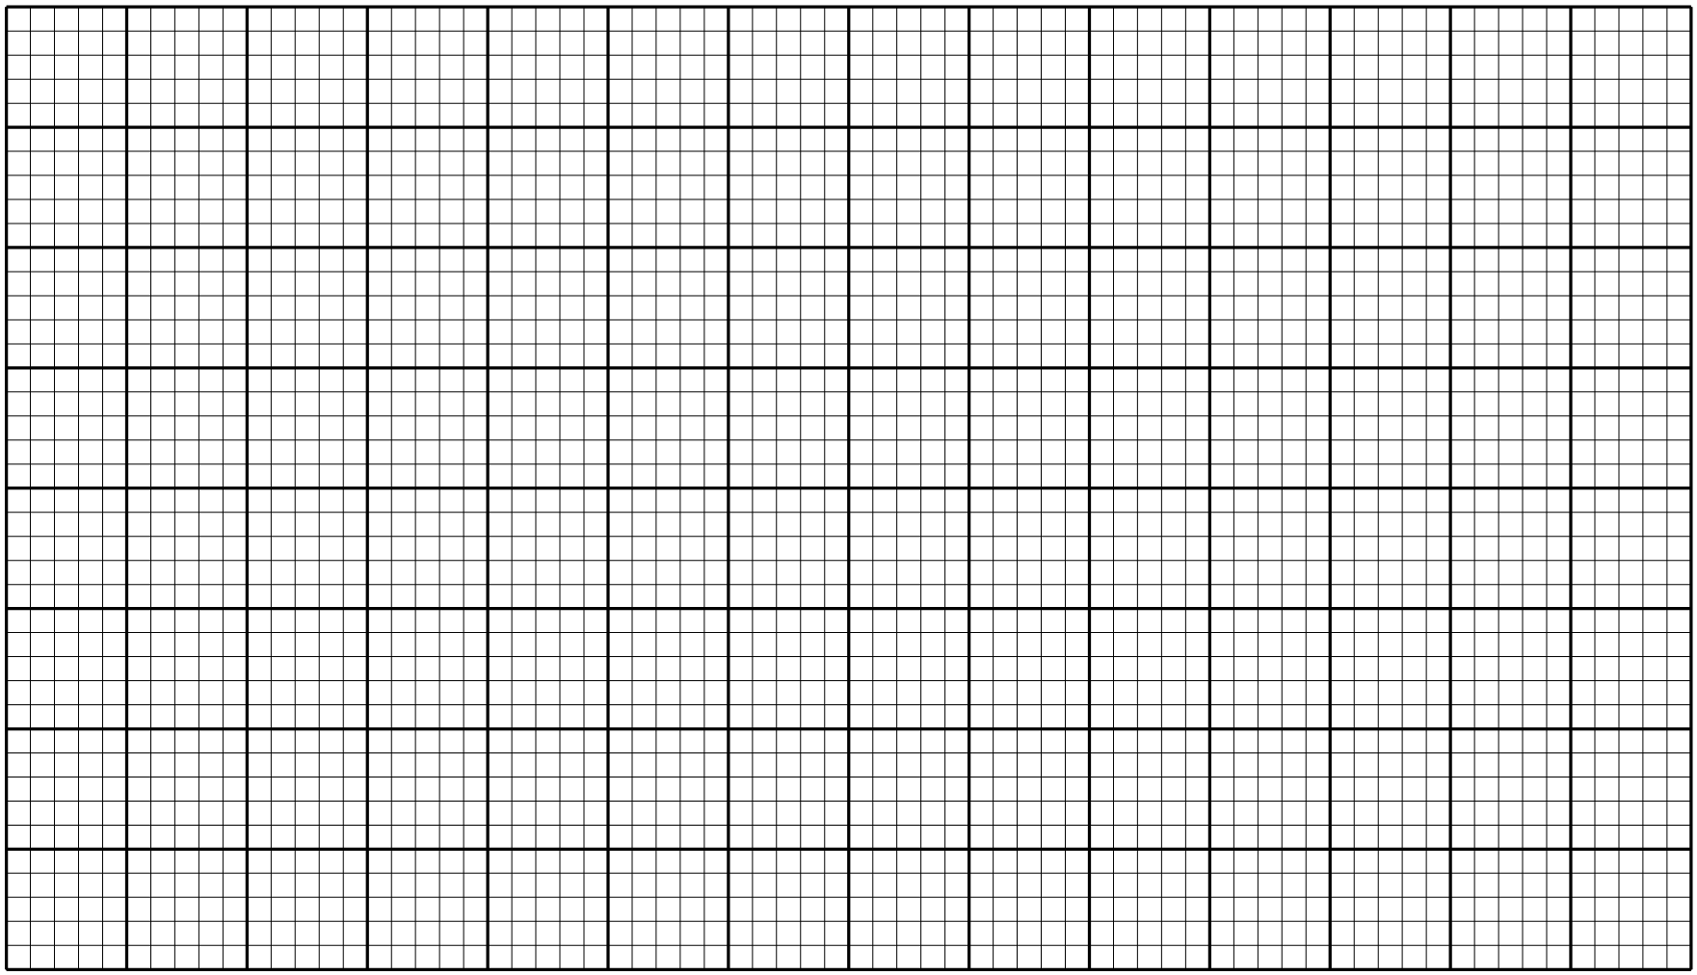

- A composite solid comprises of a frustum of a cone mounted on a hemisphere such that the diameters of the hemisphere and the bottom of the frustum both measure 30 cm. The entire solid has a vertical height of 60 cm. The radius of the top of the frustum if 10 cm.
- Calculate the volume of the solid correct to two decimal places. Use π = $\frac{22}{7}$. (7 marks)

- The solid is melted and recast into cubes of side 16 cm. How many such cubes are realized? (3 marks)

- Two lines $L_{1}:2y-3x-6=0$ and $L_{2}=3y+x=20$ intersect at a point M
- Find the coordinates of M. (3 marks)

- A third line $L_{3}$ is perpendicular to $L_{2}$ at M. Find the equation of $L_{2}$ in the form $y=mx+c$ where $m$ and $c$ are constants (3 marks)

- Another line $L_{4}$ is parallel to $L_{1}$ and passes through $(-1, 3)$. Determine the $x$ and $y$ intercepts of $L_{4}$ (4 marks)

- (a) Complete the table below for the function $y=2x^{2}+5x-12$ for $-6≤x≤3$. (2 marks)

$$x$$ | $$-6$$ | $$-5$$ | $$-4$$ | $$-3$$ | $$-2$$ | $$-1$$ | $$0$$ | $$1$$ | $$2$$ | $$3$$
$$y$$ |  |  |  | $$-9$$ |  |  | $$-12$$

(b) On the grid provided, draw the graph of $y=2x^{2}+5x-12$ for $-6≤x≤3$ (3 marks)

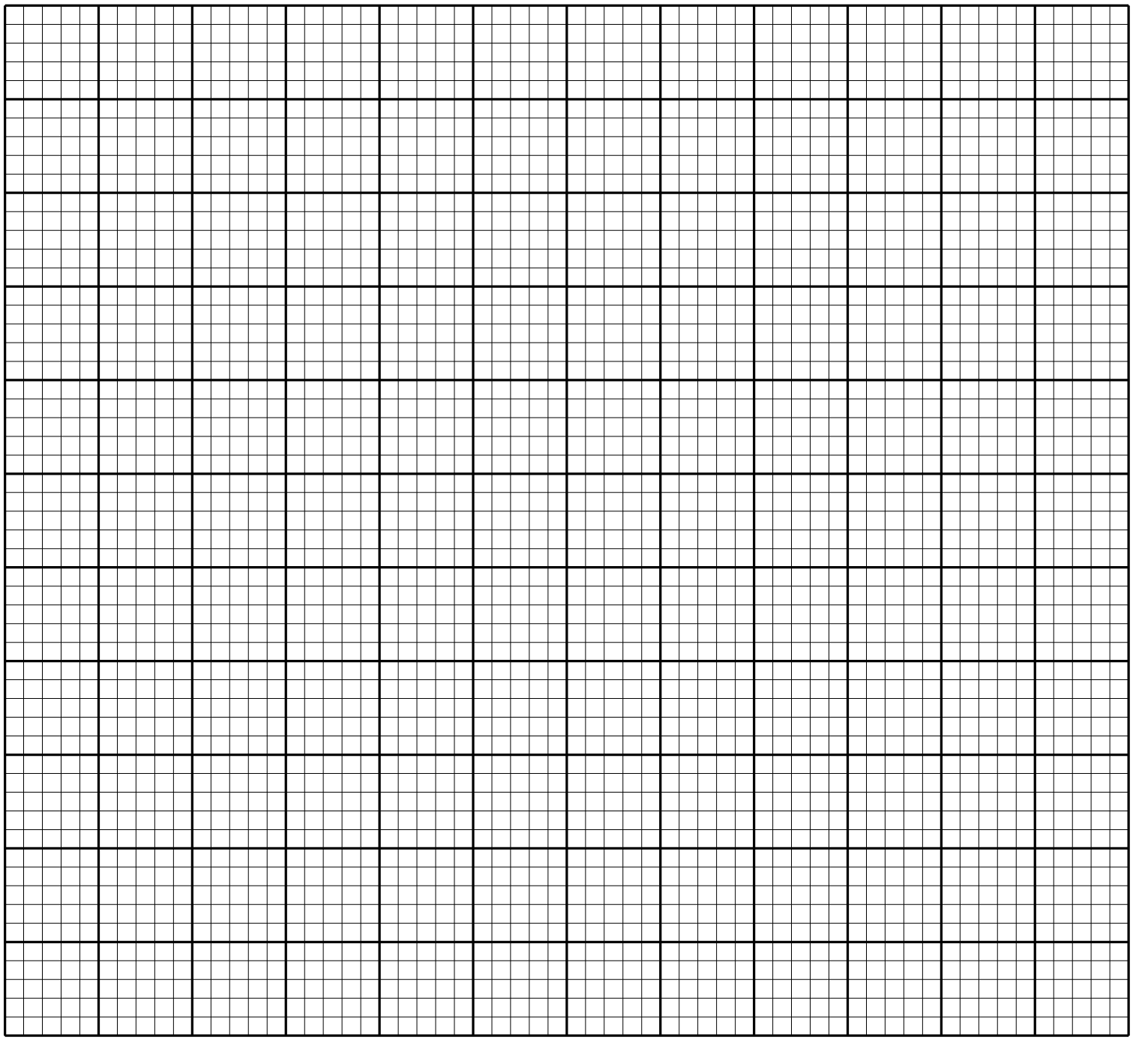

(c) Use the graph in (b) above to find the roots to the equation $2x^{2}+5x-12=0$ (2 marks)

- By drawing a suitable line on the same axes as the graph in (b), solve the equation $x^{2}+x-6=0$ (3 marks)

- On the grid provided,
- Draw ΔPQR in which P(2, 3), Q(1, 2) and R(4, 1). On the same axes, draw Δ$P''Q''R''$ such that $P''(-2, 3)$, $Q''(-1, 2)$ and $R''(-4, 1)$. (2 marks)


- On the same axes, draw Δ$P'Q'R'$, the image of ΔPQR under a reflection in the line $y+x=0$. (2 marks)
- Describe fully, a single transformation that maps Δ$P'Q'R'$ onto Δ$P''Q''R''$. (2 marks)

- Draw Δ$P'''Q'''R'''$ such that it can be mapped onto ΔPQR by a rotation of $-$90⁰ about (0, 0) and state its coordinates. (3 marks)

- State the type of congruency between $P'Q'R'$ and Δ$P'''Q'''R'''$. (1 mark)

- In the figure below, O is the centre of the circle, ∠ADO=39⁰, ∠OBC=33⁰ and ∠ECD=45⁰. EC is a tangent to the circle at C.
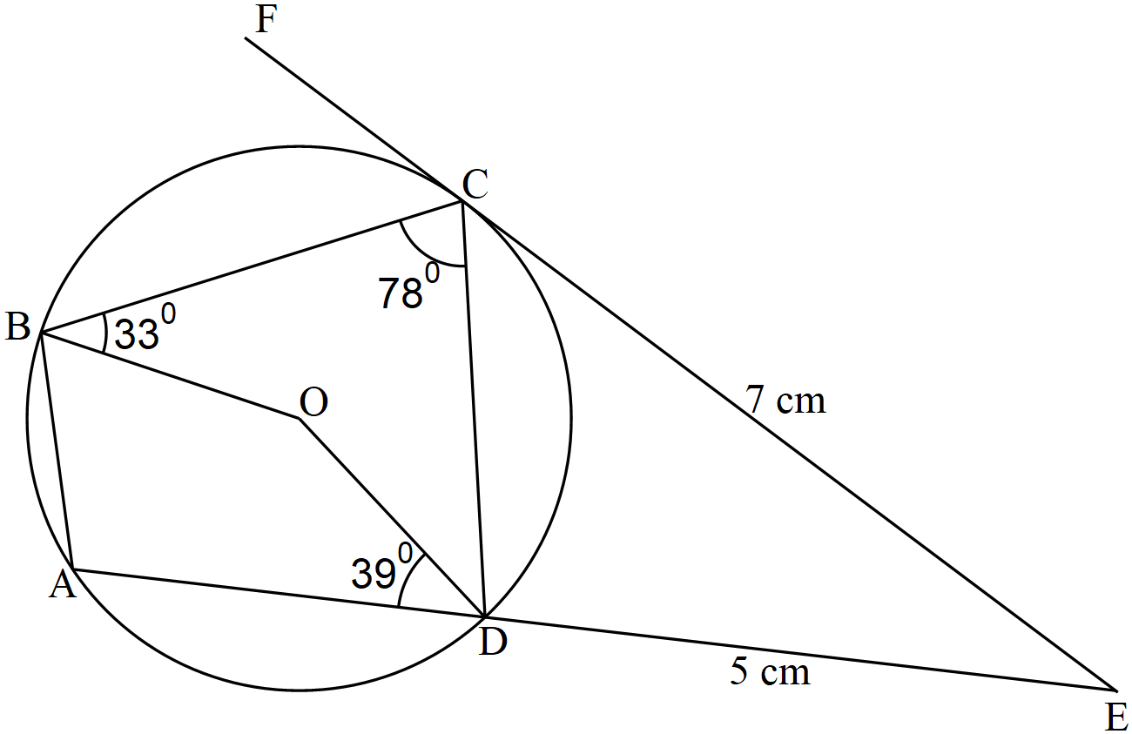

- Calculate, giving reasons
- ∠CDE (2 marks)

- ∠DEC (2 marks)

- Reflex ∠BOD (2 marks)

- Given that EC=7 cm and DE = 5 cm, calculate the length of AD correct to 4 significant figures. (4 marks)

- The distance between two towns A and B is 760 km. A bus left A at 0815 hours and traveled towards B at an average speed of 90 km/h. At 1035 hours and on the same day, a car left B and traveled towards A at an average speed of 110 km/h
- Calculate:
- the time of the day the two vehicles met; (4 marks)

- the distance from A to the meeting point. (3 marks)

- A motorist started at her home at 1030 hours on the same day and traveled at an average speed of
120 km/h. She arrived in B at the same time as the bus. Calculate the distance from her home to B. (3 marks)

- Mama Moraa, a cereals trader deals in two types of beans, Wairimu and Yellow Green. Wairimu costs Ksh. 4,000 per bag while Yellow Green costs Ksh. 3,500 per bag.
- She mixes 30 bags of Wairimu with 50 bags of Yellow Green. If she sells the mixture at a profit of 20%, calculate the selling price of one bag of the mixture. (4 marks)

- She now mixes Wairimu with Yellow Green in the ratio $a: b$ respectively. If the cost of the mixture is Ksh. 3,835 per bag, find the ratio $a: b$ (4 marks)

- Mama Moraa then mixes one bag of the mixture in part (a) with one bag of the mixture in part (b) above. Calculate the ratio of Yellow Green to Wairimu in this mixture. (2 marks)

THIS IS THE LAST PRINTED PAGE

