Term 1 - 2026
MATHEMATICS (121/1)
PAPER 1
FORM FOUR (4)
Time: 2 ½ Hours
MARKING SCHEME

NO. | WORKING | MARKS | REMARKS
 | Let $a=1.57575757…$ and $b=0.42424242…$  $$100a=157.575757…$$  $$a=1.575757…$$  $$99a=156⇒a=\frac{156}{99}=\frac{52}{33}$$  $$100b=42.424242….$$  $$b=0.42424242…$$  $$99b=42⇒b=\frac{42}{99}=\frac{14}{33}$$  $$\frac{52}{33}-\frac{14}{33}$$  $$=\frac{38}{33}=1\frac{5}{33}$$ | M1  M1  A1 | Expressing both recurring decimals as fractions
 | Total | 3
 | LCM of 2, 4 and 10  LCM = $2^{2}×5=20$ days  Next = 20th March 2023 + 20 days  = 9th April 2023 | M1  M1  A1 | LCM i.e. $2^{2}×5$ seen
  2 | 2 | 4 | 10
  2 | 1 | 2 | 5
  5 | 1 | 1 | 5
   | 1 | 1 | 1
 | Total | 3
 |  | M1  M1  M1  A1 | All logarithms  addition and subtraction of logarithms  multiplication by 2 and $\frac{1}{3}$  0.4410 seen (follow through to 4 d.p.)
  Number | Logarithm
  $$12.78$$  $$\sin{{33.45}^{0}}\left(0.5512\right)$$ | $$1.1065$$  $$-0.2587\left(\overline{1}.7413\right)$$
   | $$0.8478$$
  $$9.063$$ | $$0.9573×2$$  $$1.9146$$
   | $$\frac{-1.0668\left(\overline{2}.9332\right)}{3}$$
  $$0.4410$$ | $$-0.3556\left(\overline{1}.6444\right)$$
 | Total | 4

NO. | WORKING | MARKS |  | REMARKS
 | Numerator  $$\frac{9}{4}+\frac{3}{5}÷\frac{5}{6}×\frac{12}{5}$$  $$\frac{9}{4}+\frac{3}{5}×\frac{6}{5}×\frac{12}{5}$$  $$\frac{9}{4}+\frac{216}{125}=\frac{1125+864}{500}=\frac{1989}{500}$$  $$\frac{1989}{500}÷\frac{17}{10}=\frac{1989}{500}×\frac{10}{17}$$  $$=\frac{117}{50}=2\frac{17}{50}$$ | M1  M1  A1 |  | simplification of numerator, $\frac{1989}{500}$ seen  Operation with denominator  $2\frac{17}{50}$ seen
 | Total | 3
 | $$A.s.f={\left(\frac{4}{3}\right)}^{2}=\frac{16}{9}$$  Let the area of ΔPRS be $A$  $$\frac{16}{9}=\frac{A}{24}$$  $$A=\frac{16×24}{9}=42\frac{2}{3} {cm}^{2}$$ | M1  A1 |  | Equating areas of the two Δs to A.s.f  A0 if in decimals
 | Total | 3
 | $$100\%→8,000$$  $$87\%→\frac{87×8,000}{100}$$  $$= 6,960$$  $$120\%→6,960$$  $$100\%=\frac{100×6,960}{120}$$  $$=5,800$$ | M1  M1  A1
 | Total | 3
 | $$\frac{2}{100}×200,000=4,000$$  $$\frac{4}{100}×400,000=16,000$$  $$20,000+4,000+16,000$$  $$=40,000$$ | M1  M1  A1 |  | Both commissions obtained  Sum of basic pay and commissions
 | Total | 3
 | $$\frac{1}{4}×2×\frac{22}{7}×9.1=14.3 cm$$  $$\frac{75}{360}×2×\frac{22}{7}×10.5=13.75 cm$$  $$14.3+10.5+13.75+7.5+9.1+\left(18-9.1\right)$$  $$=55.15 cm$$ | M1  M1, M1  A1
 | Total | 3
$$30=2×3×5$$
$$900=2^{2}×3^{2}×5^{2}$$
$$60=2^{2}×3×5$$
$$150=2×3×5^{2}$$
Other number = $2×3^{2}=18$
 | Total | 3
NO. | WORKING |  | MARKS |  | REMARKS
 | $$\frac{3^{3x}×3^{4x}}{3^{-x}}=3^{4}$$  $$\frac{3^{7x}}{3^{-x}}=3^{4}$$  $$7x-\left(-x\right)=4$$  $$8x=4$$  $$x=\frac{1}{2}$$ |  | M1  M1  A1 |  | Expressing all the numbers to base 3  Equating the indices  Accept 0.5
 | Total |  | 3
 | $$180\left(n-2\right):180n=3:4$$  $$\frac{180(n-2)}{180n}=\frac{3}{4}$$  $$4\left\{180\left(n-2\right)\right\}=3×180n$$  $$180\left(n-2\right)=540n$$  $$180n-360=135n$$  $$180n-135n=360$$  $$45n=360$$  $$n=\frac{360}{45}=8 sides$$ |  | M1  M1  M1  A1
 | Total |  | 4
 | $$\frac{\left(x+1\right)a\left(4a-x\right)}{x\left(x-4a\right)+1(x-4a)}$$  $$\frac{a(x+1)(4a-x)}{(x+1)(x-4a)}$$  $$\frac{-a(x+1)(x-4a)}{(x+1)(x-4a)}$$  $$=-a$$ |  | M1  M1  A1 |  | Factorization of numerator  Factorization of denominator
 | Total |  | 3
 | Let the first even number be $n$, the second number $n+2$  $$n+n+2=270$$  $$2n=270-2$$  $$2n=268$$  $$n=134$$  Second number; $134+2=136$ |  | M1  A1
 | Total |  | 2

NO. | WORKING | MARKS | REMARKS
 | 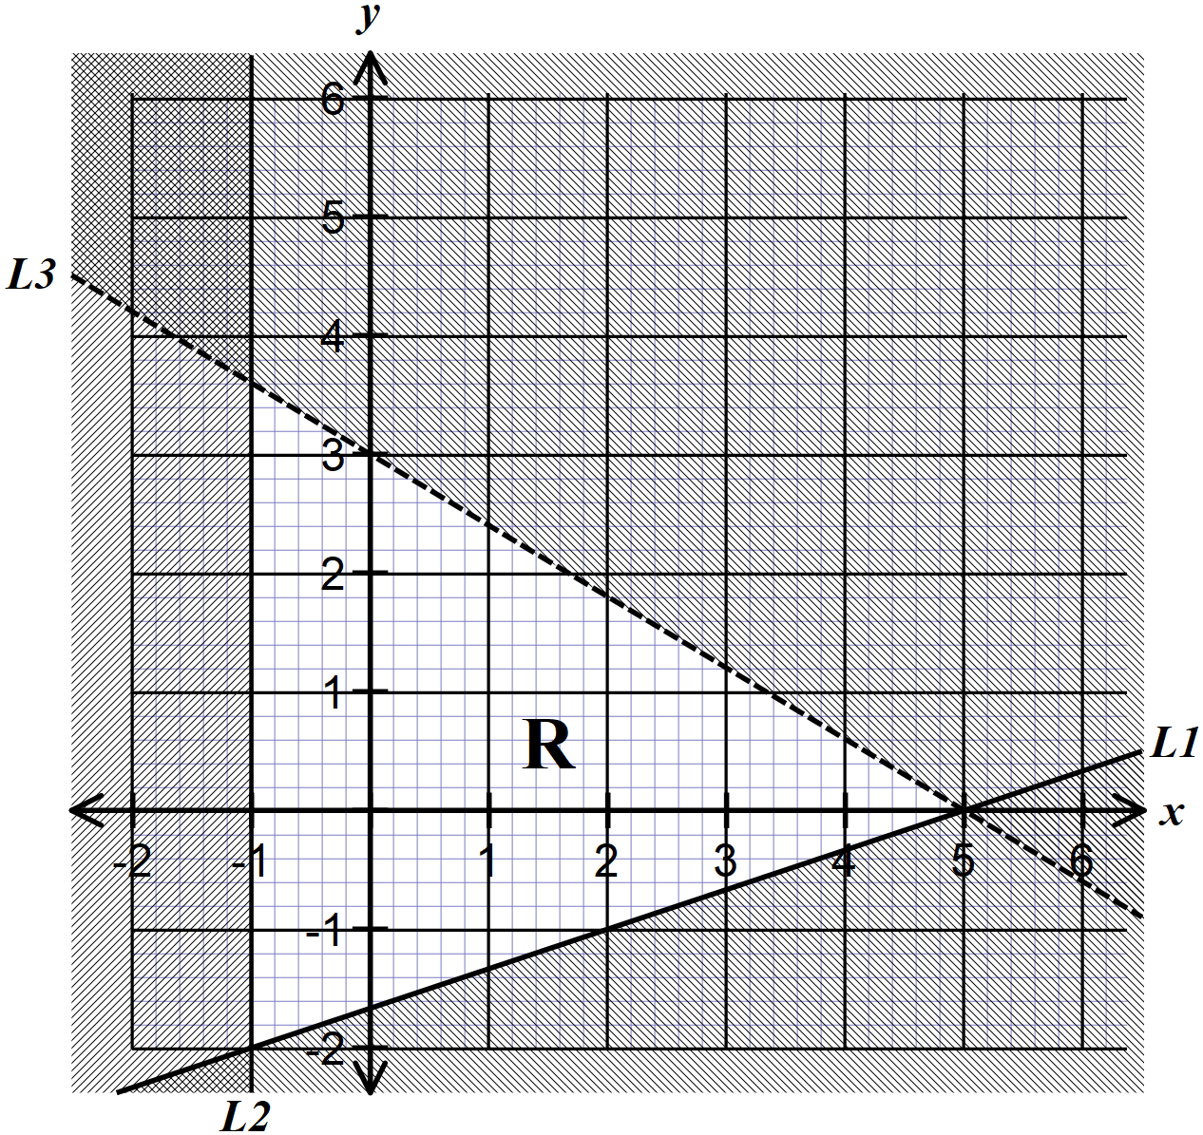 | B1  B1  B1 | $$L_{1;}x≥-1$$  $$L_{2};3y-x≥-5$$  $$L_{3};3x+5y<15$$
 | Total | 3
 | Let the number of male members be $x$  The ratio becomes $2x: 3x$  On Tuesday  Male $→2x-10$, females $3x+6$  $$2x-10:3x+6=1:3$$  $$\frac{2x-10}{3x+6}=\frac{1}{3}$$  $$3\left(2x-10\right)=3x+6$$  $$6x-30=3x+6$$  $$6x-3x=6+30$$  $$3x=36→x=12$$  Regular members $2×12+3×12=60$ members | M1  M1  A1 | Expressions for new males and fames  Equation the expressions to the new ration
 | Total | 3

NO. | WORKING | MARKS | REMARKS
 | 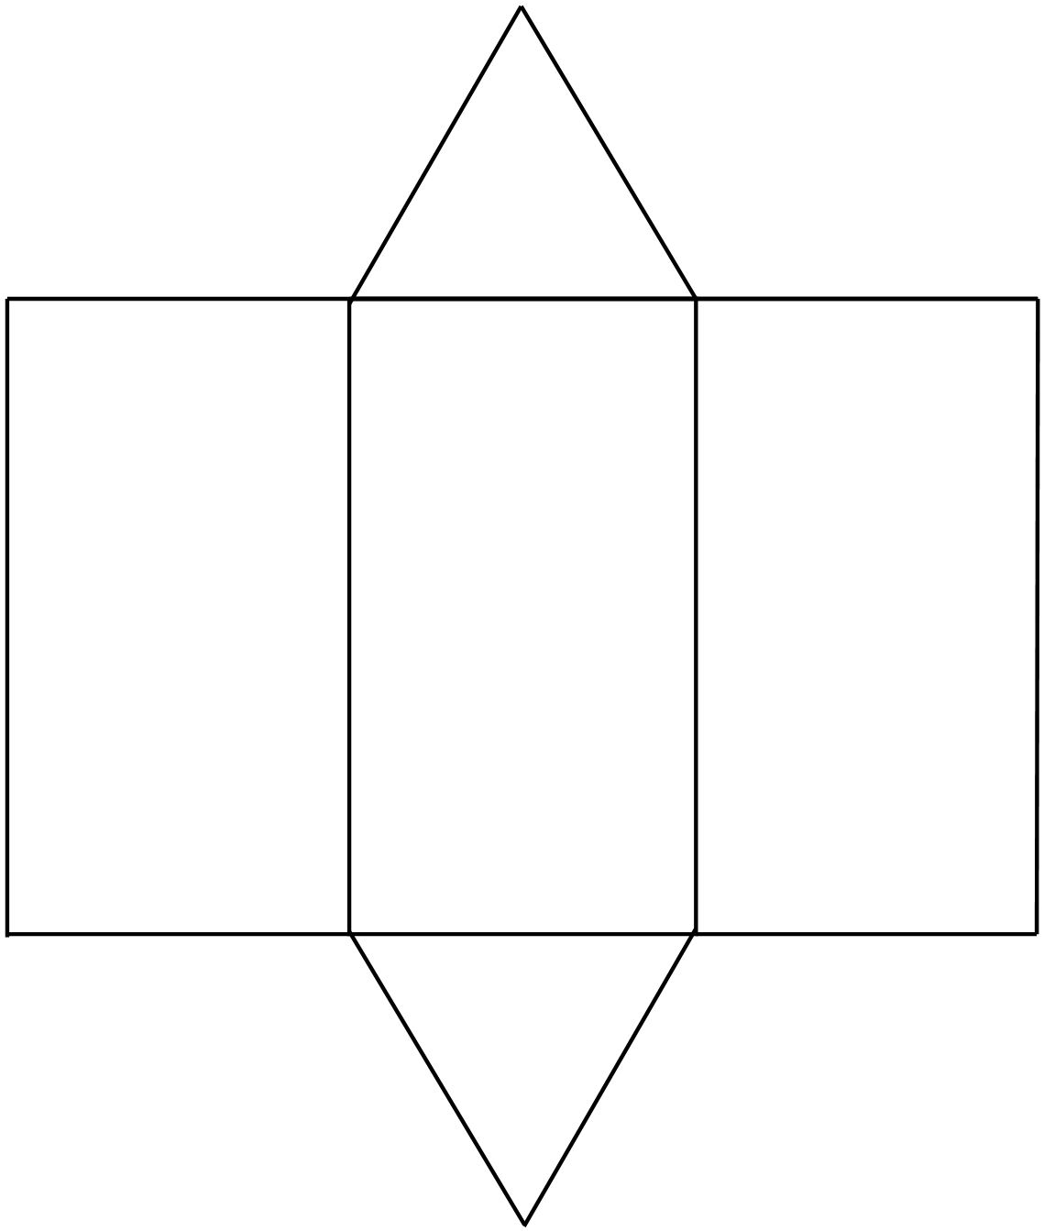
 | Total | 4

NO. | WORKING | MARKS | REMARKS
 | - Value of $a$  $$27\frac{11}{16}=\frac{1026.5+27a}{a+37}$$  $$\frac{443}{16}=\frac{1026.5+27a}{a+37}$$  $$443\left(a+37\right)=16\left(1026.5+27a\right)$$  $$443a+16391=162424+432a$$  $$443a-432a=16424-16391$$  $$11a=33→a=3$$  - Median class and its frequency  Class – 15 – 24  Frequency – 16  - Histogram | M1  M1  M1  A1 | $Ʃf=a+36$ seen  $$Ʃfx=1014.5+27a$$
  Amount | f | $$x$$ | $$fx$$ | $$cf$$
  10 – 14 | 6 | 12 | 72 | 5
  15 – 24 | 16 | 19.5 | 312 | 22
  25 – 29 | $$a$$ | 27 | $$27a$$ | 25
  30 – 44 | 10 | 37 | 370 | 35
  45 – 64 | 5 | 54.5 | 272.5 | 40
   | $$a+37$$ |  | $$1026.5+27x$$
  Class | f | $$f.d.=\frac{f}{CI}$$ | $$f.d.×100$$
  10 – 14 | 6 | 1.2 | 120
  15 – 24 | 16 | 1.6 | 160
  25 – 29 | 3 | 0.6 | 60
  30 – 44 | 10 | 0.7 | 70
  45 – 64 | 5 | 0.25 | 25
 | Total | 10

NO. | WORKING | MARKS | REMARKS
 | - Volume  $$\frac{20}{30}=\frac{h}{h+50}$$  $$30h-20h=1000$$  $$h=100$$  Volume of frustum  $$V=\frac{1}{3}×\frac{22}{7}\left\{\left({15}^{2}×150\right)-\left({10}^{2}×100\right)\right\}$$  $$V=24,880.95$$  Volume of hemisphere  $$V=\frac{2}{3}×\frac{22}{7}×{15}^{3}$$  $$V=7071.43$$  $$24,880.95+7071.43$$  $$=31,952.38$$  - Let the number of cubes be $x$  $$31,952.38=\left({16}^{3}\right)x$$  $$x=\frac{31,952.38}{{16}^{3}}$$  $$x=7.801$$  Hence number of such cubes = 7 | M1  A1  M1, M1  M1  M1  A1  M1  A1  B1 | Drawing  Dimensions
 | Total | 10

NO. | WORKING | MARKS | REMARKS
 | - Coordinates of M  $$2y=3x+6→y=\frac{3}{2}x+3$$  $$3y=-x+20→y=\frac{-1}{3}x+\frac{20}{3}$$  $$\frac{3}{2}x+3=\frac{-1}{3}x+\frac{20}{3}$$  $$\frac{3}{2}x+\frac{1}{3}x=\frac{20}{3}-3$$  $$\frac{11}{6}x=\frac{11}{3}→33x=66→x=2$$  $$y=\frac{3×2+6}{2}=6$$  $$M (2, 6)$$  - Equation of $L_{3}$  $$m_{3}×\frac{-1}{3}=-1→m_{3}=3$$  $$3=\frac{y-6}{x-2}$$  $$3\left(x-2\right)=y-6$$  $$3x-6=y-6$$  $$3x-y=0$$  - x and y intercepts of $L_{4}$  $$Gradient of L_{4}=\frac{3}{2}$$  Equation of $L_{4}$  $$\frac{3}{2}=\frac{y-3}{x+1}$$  $$3x+3=2y-6$$  $$3+6=2y-3x→2y-3x=9$$  At $x-$intercept, $0-3x=9→x=-3⇒(-3, 0)$  At y – intercept, $2y=9→y=4.5⇒(0, 4.5)$ | M1  A1  B1  M1  M1  A1  M1  A1  B1  B1 | Equating the two lines  Both values  Coordinates of M  Gradient of L₃  Equation of L₃
 | Total | 10

NO. | WORKING | MARKS | REMARKS
 | - Table  - Graph  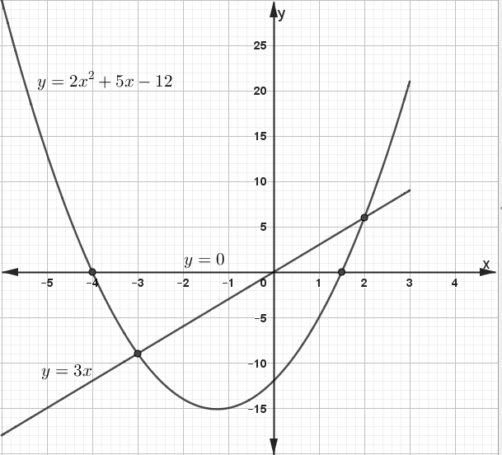  - Roots to $2x^{2}+5x-12=0$  $x=-4$ and $x=1.5$  - Solution to $x^{2}+x-6=0$  $$x^{2}+x-6=0⇒{2x}^{2}+2x-12=0$$  $$y=2x^{2}+5x-12$$  $${0=2x}^{2}+2x-12$$  $$y=3x$$  Roots $x=-3$and $x=2$ | B2  S1  P1  C1  L1  B1, B1  M1  B1 | All values of $y$  B1 for at least 6 values  Consistent and linear scale used  All points plotted ly  Smooth curve drawn through all the points  Line $y=3x$ drawn  Both points  Equation $y=3x$ obtained  Both values
  $$x$$ | -6 | -5 | -4 | -3 | -2 | -1 | 0 | 1 | 2 | 3
  $$y$$ | 30 | 13 | 0 | -9 | -14 | -15 | -12 | -5 | 6 | 21
 | Total | 10

NO. | WORKING | MARKS | REMARKS
 | 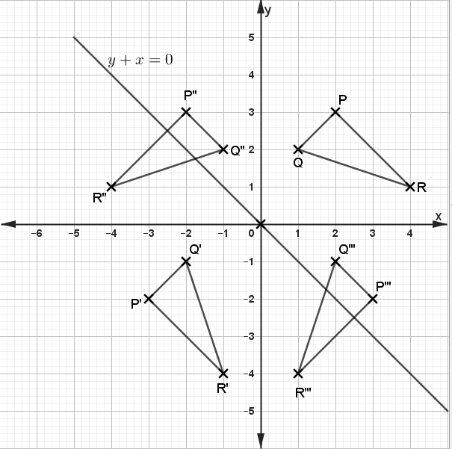  - $P^{'''}\left(3, -2\right), Q'''(2, -1)$ and $R'''(1, -4)$  - Indirect/oppositely | B1  B1  B1  B1  B1  B1  B1  B1  B1  B1 | ΔPQR drawn  Δ$P''Q''R''$.  Reflection along  $$y+x=0$$  Δ$P'Q'R'$ drawn  Rotation  About (0, 0), ${-90}^{0}$  Rotation  Δ$P'''Q'''R'''$ drawn  Coordinates
 | Total | 10

NO. | WORKING | MARKS | REMARKS
 | - (i) ∠OCD=∠ODC=${78}^{0}-{33}^{0}={45}^{0}$  ∠CDE$={180}^{0}-\left({39}^{0}+{45}^{0}\right)={96}^{0}$  Sum of angles along a straight line is 180⁰  (ii) ∠OCE=90⁰ (radius perpendicular to tangent at C)  ∠DEC$={180}^{0}-\left({45}^{0}+{96}^{0}\right)={39}^{0}$  Sum of angles in a triangle is up to 180⁰  (iii) Obtuse ∠BOD$=2×{78}^{0}={156}^{0}$  Reflex ∠BOD$={360}^{0}-{156}^{0}={204}^{0}$  Sum of angles at a point is 360⁰  - let $AD=x$  $$x\left(x+5\right)=7^{2}$$  $$x^{2}+5x-49=0$$  $$x=\frac{-5±\sqrt{5^{2}-4×\left(-49\right)}}{2}⇒x=\frac{-5±\sqrt{221}}{2}$$  $$x=\frac{-5±14.87}{2}$$  $$x=\frac{-5-14.87}{2}→x=-9.935 (discriminate)$$  $$x=\frac{-5+14.87}{2}=4.935 cm$$ | B1  B1  B1  B1  B1  B1  M1  M1  A1, B1
 | Total | 10
 | - Time difference $=1035hrs-0815hrs=2 hrs 20 min$  Bus distance by 1035 hrs  $$Distance=2\frac{20}{60}×90=210 km$$  Relative Distance $= 760-210=550$ km  Relative speed $= 90+110=200 km/h$  $$Relative time=\frac{550}{200}=2.75 hrs=2 hrs 45 minutes$$  Meeting time $= 1035 hrs + 2hrs 45 minutes$  $$=1320 hrs or 1.20 p.m.$$  - Distance from 1035 hrs to meeting point  $$=2.75×90=247.5 km$$  Distance to meeting point  $$=210+247.5=457.5 km$$  - Time bus arrives at B  $$=\frac{760}{90}=8\frac{4}{9}hrs=8 hrs 27 minutes$$  Arrival time = 0815 hrs + 8 hrs 27 minutes$=1642 hrs$  Time difference =1642 hrs – 1030 hrs=4hrs 12 minutes  Distance from B to her home  $$=4\frac{12}{60}×120=504 km$$ | M1  M1  M1  A1  M1  M1, A1  M1  M1  A1 | Bus distance at 1035 hrs  Relative distance and RS  Duration taken to meet  Bus duration to B
 | Total | 10

NO. | WORKING | MARKS | REMARKS
 | - Selling price  $$\frac{30×4,000+50×3,500}{30+50}$$  $$=3,687.50$$  $$100\%→3,687.50$$  $$120\%=\frac{120×3,687.50}{100}$$  $$=4,425$$  - Ratio of $a:b$  $$\frac{4000a+3500b}{a+b}=3,835$$  $$4000a+3500b=3835a+3835b$$  $$4000a-3835a=3835b-3500b$$  $$165a=335b$$  $$33a=67b$$  $$a:b=67:33$$  - Ratio in new mixture  $$=\left(\frac{5}{8}+\frac{33}{100}\right):\left(\frac{3}{8}+\frac{67}{100}\right)$$  $$=191:209$$ | M1  A1  M1  A1  M1  M1  M1  A1  M1  A1
 | Total | 10

