
Kenya Certificate of Secondary Education
END TERM 1 2026 EXAMINATION
312/1 GEOGRAPHY PAPER 1

April, 2026 TIME: 2 ½ Hrs

Name: ……………………………………..….… Admission No: ……….…………..…
Stream: ………..… Signature: ……..…..….........
Instructions to Candidates
- Write your Name and Admission Number in the spaces provided above.
- Indicate your Stream and Sign in the spaces provided.
- This paper consists of two sections; A and B
- Answer all the questions in section A.
- Answer question 6 and any other two questions from section B.
- Answers must be written in the spaces provided at the end of question 10.
- This paper consists of 14 printed pages.
- Candidates should check the question paper to ascertain that all the pages are printed as indicated and that no questions are missing.
- Candidates should answer the questions in English.
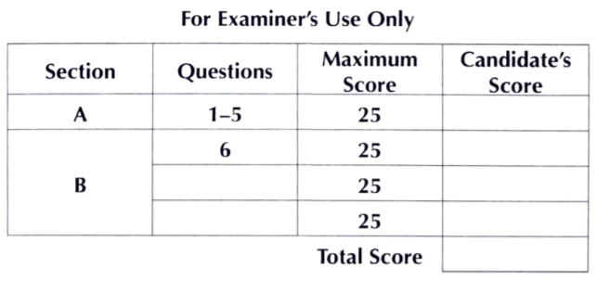
SECTION A
Answer all the questions in this section.

1. (a) What is the relationship between Geography and Biology? (2 marks)
(b) Apart from Biogeography, give three other sub branches of physical Geography. (3 marks)
2. (a) Differentiate between meteors and meteorites. (2 marks)
(b) State three characteristics of the mantle. (3 marks)
3.The table below shows rainfall and temperature for station W in one week. Use it to answer
question (a) and (b)
Day | Monday | Tuesday | Wednesday | Thursday | Friday | Saturday | Sunday
Temperature (in ºC) | 20 | 21 | 22 | 23 | 23 | 25 | 24
Rainfall (in mm) | 50 | 49 | 55 | 45 | 60 | 60 | 49

(a) Calculate the mean weekly rainfall. (2 marks)
(b) State three characteristics of weather in station W. (3 marks)
4. (a) Give two types of boundaries according to plate tectonics theory. (2 marks)
(b) State three effects of movements of tectonic plates. (3 marks)
5. (a) Define inconsequent drainage system. (2 marks)
(b) Outline three conditions necessary for the formation of a delta. (3 marks)

SECTION B
Answer question 6 and any other two questions from this section.

6. Study the map of Meru (1:50000 sheet 108/3) provided and answer the following questions.
(a) (i) What is the height of Njorivola hill at grid square 4117. (1 mark)
(ii) Find the bearing of the forest guard post in grid square 3800 from the water tower in grid square 4500. (2 marks)
(iii) Calculate the area of forest cover bound by eastings 34 and 40 and northing 01 and 06. Give your answer in square kilometres. (2 marks)
(b) (i) Draw a rectangle measuring 16cm by 12cm to represent the area bound by easting 39
and 43 and northing 00 and 03. (1 mark)
(ii)On the rectangle, mark and label:
- Mount Kenya forest (1 mark)
- Dry weather road (1 mark)
- Githongo market (1 mark)
(ii)Calculate the scale of the new map. (2 marks)
(c) Citing evidence from the map, explain:
(i) two factors that favour trading in the area covered by the map. (4 marks)
(ii) two human factors influencing agricultural activities in the area covered by the map.
(4 marks)
(d) Apart from cattle dip, identify three other man-made features in grid reference 3615.
(2 marks)
(e) Describe the relief of the area covered by the map. (4 marks)

7. (a) Give three ways in which faults develop in the crust. (3 marks)

(b) (i) With the aid of well labeled diagrams explain how compressional forces can lead to the formation of a rift valley. (7 marks)
(ii) Name three Horst Mountains in east Africa. (3 marks)
- Giving specific examples, describe three ways in which faulting may influence drainage systems. (6 marks)
(c) Explain three ways in which features resulting from faulting are of economic importance. (6 marks)
8. (a) Distinguish between valley glaciers and ice sheets. (2 marks)
(b) Name two mountains in East Africa where glaciers are found. (2 marks)
(c) Describe how each of the following glacial features are formed.

(i) Arête (5 marks)

(ii) Ribbon lake. (4 marks)
(d) The diagram below shows a glaciated lowland.
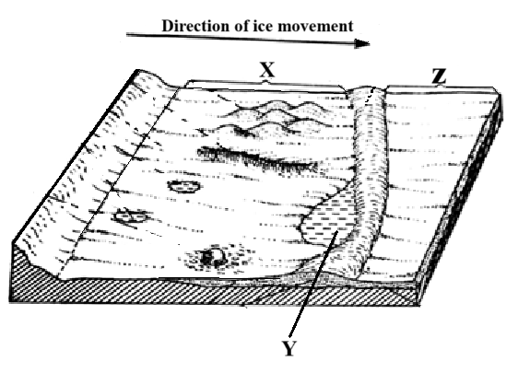
(i) Identify the parts marked X and Z. (2 marks)
(ii) Give two examples of the feature marked Y in the world. (2 marks)
(e) Explain four positive effects of glaciations in lowland area. (8 marks)

9. (a) (i) What is mass movement? (2 marks)
(ii) State three agents of weathering. (3 marks)
(b) Describe how block disintegration occurs. (4 marks)
(c) Explain how the following factors influence weathering.
- Time (2 marks)
- Nature of the rock (4 marks)
- Action of plants (4 marks)

- Your class carried out a field study on the effects of weathering around your school compound.
(i) State two objectives of your study. (2 marks)
(ii) Give two methods you would use to collect data. (2 marks)
(iii) State two effects of weathering on the physical environment you are likely to identify. (2 marks)

10. (a) (i) Differentiate between minerals and rocks. (2 marks)
(ii) Give three ways in which rocks can be classified. (3 marks)
(iii) Name one example of each of the following types of sedimentary rocks
      - Chlorides (1 mark)
      - Arenaceous (1 mark)
(b) State four characteristics of rocks forming the earth’s crust. (4 marks)
(c) (i) Describe how sedimentary rocks are formed through physical processes. (4 marks)
(ii) State five reasons why sedimentary rocks are dominant along the Kenyan coast. (5 marks)
(d) Students from Maranda High School carried a field study on rocks in Siaya County.
i) State three reasons why it would be necessary for them to conduct a reconnaissance to the study area. (3 marks)
ii) Give two follow-up activities they would engage in. (2 marks)

