Kenya Certificate of Secondary Education
END TERM 1 2026 EXAMINATION

CONFIDENTIAL
MARKING SCHEME

SECTION A
1. (a) What is the relationship between Geography and Biology? (2 marks)
- Biology is the study of living organisms, their structure and form while geography explains their distribution on earth (in a study known as biogeography)
(b) Apart from Biogeography, give three other sub branches of physical Geography. (3 marks)
- Geomorphology - Climatology/meteorology - Hydrology
- Geology - Pedology
2. (a) Differentiate between meteors and meteorites. (2 marks)
- Meteors are glowing objects that quickly pass across the sky before they burn up and disappear while meteorites are large meteors which pass through the atmosphere, glow brightly but fail to burn up.
(b) State three characteristics of the mantle. (3 marks)
- Lies between the crust and the core
- Is about 2900km thick
- Has an average density of 3.0-3.3gm/cc
- In the upper mantle, the rocks in this region are more elastic than those of sima and are hard and rigid
- The temperature increases from about 1000°C-3000°C as the depth increases
- In the lower mantle, the rocks are viscous/ultra-basic
- Most of the heating in the mantle is due to radioactive decay
- The dominant mineral is olivine (ferro-magnesium silicate)
3.The table below shows rainfall and temperature for station W in one week. Use it to answer
question (a) and (b)
Day | Monday | Tuesday | Wednesday | Thursday | Friday | Saturday | Sunday
Temperature (in ºC) | 20 | 21 | 22 | 23 | 23 | 25 | 24
Rainfall (in mm) | 50 | 49 | 55 | 45 | 60 | 60 | 49

(a) Calculate the mean weekly rainfall. (2 marks)
- 50+49+55+45+60+60+49 =368
- 368/7=52.57mm
(b) State three characteristics of weather in station W. (3 marks)
- Friday and Saturday received the highest amount of rainfall, 60mm
- There was rainfall throughout the week
- The lowest rainfall was recorded on Thursday while the least temperature was recorded on Monday
- The highest temperature was recorded on Saturday
4. (a) Give two types of boundaries according to plate tectonics theory. (2 marks)
- Extension/divergent/constructive boundary
- Compression/convergent/destructive boundary
- Transform/transcurrent/conservative boundary
(b) State three effects of movements of tectonic plates. (3 marks)
- Sea floor spreading
- Folding/ bending/ crumbling/ shortening of crustal rocks
- Causes earthquakes/ volcanic eruptions
- Cause rock metamorphism
5. (a) Define inconsequent drainage system. (2 marks)
- Refers to a drainage system which is not related to the rock structure and slope of the area where it is found
(b) Outline three conditions necessary for the formation of a delta. (3 marks)
- River should have a large load to be deposited at its mouth
- River velocity must be low at its mouth to allow deposition
- River load should be deposited faster than it can be removed by currents and tides
- River’s course should be free of obstacles like vegetation that would act like filters reducing the quantities of sediments
- A shallow continental shelf or shore around the river mouth to allow deposition
- The area should experience a low tidal range

SECTION B

6. Study the map of Meru (1:50000 sheet 108/3) provided and answer the following questions.
(a) (i) What is the height of Njorivola hill at grid square 4117. (1 mark)
- 2000m
(ii) Find the bearing of the forest guard post in grid square 3800 from the water tower in grid square 4500. (2 marks)
- 269° ± 1°
(iii) Calculate the area of forest cover bound by eastings 34 and 40 and northing 01 and 06. Give your answer in square kilometres. (2 marks)
- Full squares = 20
- Incomplete squares = 10
- Total area = 20+10/2
= 25 km² ± 0.5km²
(b) (i) Draw a rectangle measuring 16cm by 12cm to represent the area bound by easting 39
and 43 and northing 00 and 03. (1 mark)
(ii)On the rectangle, mark and label:
- Mount Kenya forest (1 mark)
- Dry weather road (1 mark)
- Githongo market (1 mark)
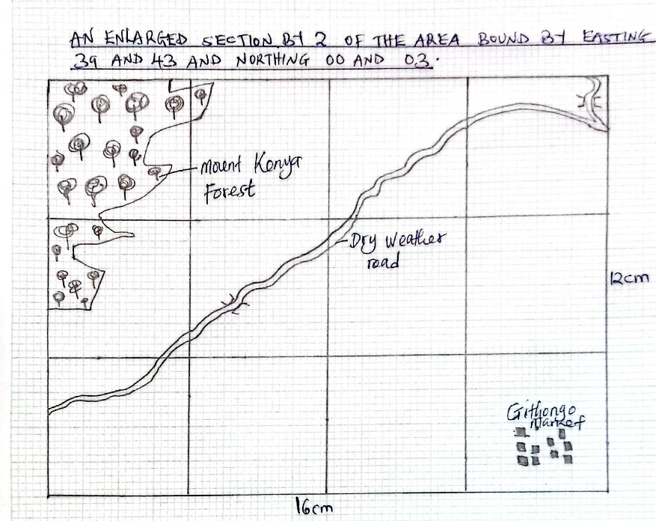
(ii)Calculate the scale of the new map. (2 marks)
- 1/50000×2=1/25000 or 1:25000
(c) Citing evidence from the map, explain:
(i) two factors that favour trading in the area covered by the map. (4 marks)
- The dense settlements show that there is high demand/market for goods
- Presence of dense road network that provide means of transport for goods
- Presence of many markets/trading centres/shops provide opportunities for trade
- The area is economically productive as evidenced by numerous cattle dips and murram pits
(ii) two human factors influencing agricultural activities in the area covered by the map.
(4 marks)
- Presence of numerous roads to provide means of transport for agricultural products
- The dense settlements provide cheap labor for production of agricultural products/ provides demand/ market for agricultural products
- Availability of veterinary services evidenced by many cattle dips for treatment of cattle
- The north western part is sparsely settled with numerous scrubs to provide vast land for grazing of livestock
(d) Apart from cattle dip, identify three other man-made features in grid reference 3615.
(2 marks)
- Main/motorable track
- Settlements/houses/buildings
- Power line
(e) Describe the relief of the area covered by the map. (4 marks)
- There are several hills in the area coved by the map e.g Njorivola and Njuruta
- There are many steep slopes on the hills,southern and central parts of the area
- There are gentle slopes in the northern part of the area
- The highest point is in the south western part, 2700m while the lowest point is in the south eastern part, 1120m
- The area is generally a highland due to the presence of mount Kenya and many hills
- There are many river valleys in the area covered by the map
- There is a depression occupied by Sacred lake on mount Kenya forest
- There are several passes in the area covered by the map e.g in the west and south east
- The area has a dissected relief.

7. (a) Give three ways in which faults develop in the crust. (3 marks)
- When rocks are subjected to tensional forces
- When rocks are subjected to compressional forces
- When rocks are subjected to tear/ shear

(b) (i) With the aid of well labeled diagrams explain how compressional forces can lead to the formation of a rift valley. (7 marks)
- Layers of rocks are subjected to compressional forces
- Two parallel/ reversed faults develop
- Outer blocks are thrust upwards
- Middle block sinks / remains at a lower level
- The protruding parts are eroded by erosion / collapse
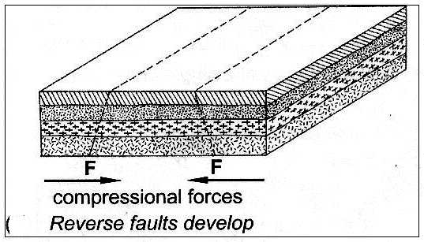
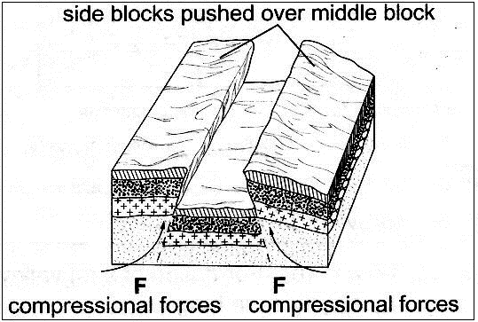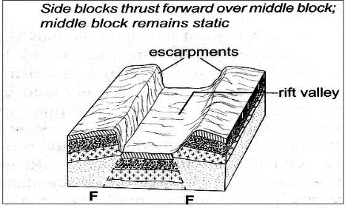
Diagram = 3 marks Explanation 4 x 1 = 4
(ii) Name three Horst Mountains in east Africa. (3 marks)
- Pare
- Usambara
- Ruwenzori
- Giving specific examples, describe three ways in which faulting may influence drainage systems. (6 marks)
- If rift faulting occurs in an enclosed area, a basin may be formed which are occupied with water to form lakes e.g. Lake Turkana, Baringo, Nakuru.
- Some rivers e.g. Mara and Kerio flow along fault lines, thus forming a fault-guided drainage pattern.
- Uplifting of land at Elgeyo Escarpment caused it to reverse or change its direction of flow of R. Sosiani.
- When faulting occurs across a river valley, it may cause the river to disappear into the ground through a fault line e.g River Kerio.
- When faulting occurs across a river valley, vertical displacement of land may occur forming a waterfall e.g. Thomson’s falls.
- Faulting may lead to the formation of escarpments with springs forming at the base due to exposure of the water table e.g. springs at the base of Mau and Nguruman escarpments.
(c) Explain three ways in which features resulting from faulting are of economic importance. (6 marks)
- Blocks / horst mountains are a source of rivers which provide water for industrial/ agricultural / domestic use / HEP production.
- Rift valley formation has led to exposure of minerals such as diatomites/ soda ash which are mined on the rift valley floor.
- Mountains formed through faulting attract rain which favour agriculture activities / settlements
- Rift valley lakes are important fishing grounds/provide water for irrigation / transportation.
- Faulted features provide scenery which promotes tourist industry.
8. (a) Distinguish between valley glaciers and ice sheets. (2 marks)
- Valley glaciers are formed on highlands above the snow line while ice sheets are found in lowlands in the high latitude regions.
- Valley glaciers are confined in valleys while ice sheets cover extensive landscapes.

(b) Name two mountains in East Africa where glaciers are found. (2 marks)
- Mt. Kenya
- Mt. Kilimanjaro
- Mt. Ruwenzori
(c) Describe how each of the following glacial features are formed.

(i) Arête (5 marks)
- Two adjacent cracks/ hallows exist on a mountain side.
- The two hollows/ cracks are filled with ice.
- The ice erodes the sides through plucking and deepens the hollow through abrasion.
- Through erosion, the back walls of the hollows slowly recede.
- Eventually the hollows/ cirques are separated by a knife -edged ridge.
- The ridges are called an arête.

(ii) Ribbon lake. (4 marks)
- This is a depression within a glacial trough where differential erosion has taken place especially areas that have less resistant rocks.
- At the point where two glaciers converge, erosion is greater resulting in the formation of a glacial depression called a rock basin.
- They also form in areas with less resistant rocks where the glacier removes these (less resistant rocks) through abrasion and plucking; leaving behind a shallow depression called a rock basin
- Later, during the post glacial period, water may accumulate in the rock basin/depression/hollow to form lakes called finger or ribbon lakes
(d) The diagram below shows a glaciated lowland.
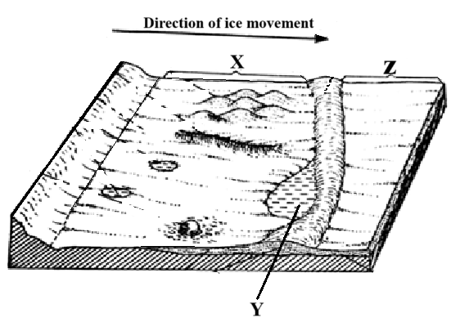
(i) Identify the parts marked X and Z. (2 marks)
X – Ice eroaded plain/ Boulder train plain.
Y – Outwash plain.
(ii) Give two examples of the feature marked Y in the world. (2 marks)
- L. Superior, Michigan, L. Ontario, L. Huron, and L. Erie (in USA and Canada)
- L. Ellice, L. Tydall and L. Alice (in Kenya)
(e) Explain four positive effects of glaciations in lowland area. (8 marks)
- Glacial till provides fertile soils for arable farming.
- Ice sheets, in their scouring effect reduce the land surface and depth to expose mineral seams which become easy to extract.
- Outwash plains comprises of sands and gravel which are used as materials for building and construction.
- Lakes formed through glaciations can be exploited for various economic uses such as fishing, transportation or as tourist attraction.
- Ice melts into rivers which is exploited for domestic use.
- Glaciated features are tourists attractions.
- Glaciated lowlands are generally flat due to erosion and deposition and are ideal for construction of building and communication lines
9. (a) (i) What is mass movement? (2 marks)
- Downslope movement of weathered material under the influence of gravity and lubrication by water.
(ii) State three agents of weathering. (3 marks)
- Rainfall/ moisture
- Temperature/heat
- Action of plants.
- Action by animals.
- Human activities such as mining, quarrying.
- Dissolved substances/ chemicals
(b) Describe how block disintegration occurs. (5 marks)
- This occurs in well-jointed rocks found in arid and semi-arid areas having large diurnal temperature ranges. During the day, temperatures are high heating the rocks causing expansion. During the night, temperature drops causing the rocks to cool and contract. Continued expansion and contraction makes the rocks to develop large cracks/joints. The cracks enlarge/widen out the rocks breaks along the cracks into small angular block, process called block disintegration.
(c) Explain how the following factors influence weathering.
- Time (2 marks)
- The resistance of the rocks determines the time taken to weather such that hands/resistant rock will take longer time to weather and less resistant rocks take shorter time to weather.
- Nature of the rock (4 marks)
- Dark rock absorbs and loses heat easily thus expansion and contracting breaking easily.
- Shinny rocks reflect heat easily hence less weathering.
- Well jointed rocks weathers easily through block disintegration.
- Rock structure determines permeability/porosity influencing chemical weathering.
- Rock having soluble minerals easily breaks /decays due to the chemical and physical weathering.
- Rock texture determines the resistance of the rock to weathering.
- Action of plants (4 marks)
- Plant roots penetrate rock cracks/joint widening them causing weathering.
- Plant decay on roots producing humus acid which reach with rock minerals causing chemical weathering.
- Some plants may grow on rocks making the rock surface moist encouraging chemical weathering.
- Plant roots create air and water spaces which aids in chemical weathering
- Your class carried out a field study on the effects of weathering around your school compound.
(i) State two objectives of your study. (2 marks)
- To find out the type of weathering.
- To establish effect of weathering.
- To determine dominant agent of weathering.
- To identify the effects of weathering.
(ii) Give two methods you would use to collect data. (2 marks)
- Administering questionnaires.
- Taking photographs/ video recording.
- Interviewing respondents.
- Observing the field.
(iii) State two effects of weathering on the physical environment you are likely to identify. (2 marks)
- Weathering leads for formation of soil promoting plant growth.
- Breaking of rocks along lines of weakness.
- Facilitates water infiltration/ percolation leading to underground water.
- Loosen soils/ rocks leading to faster erosion.
10. (a) (i) Differentiate between minerals and rocks. (2 marks)
- Minerals are inorganic substances which occur naturally at or beneath the surface of the earth while rocks are naturally occurring agglomeration (group) of minerals forming part of the earth’s crust.
(ii) Give three ways in which rocks can be classified. (3 marks)
- By origin/mode of formation
- By physical and chemical characteristics
- By age
(iii) Name one example of each of the following types of sedimentary rocks
      - Chlorides (1 mark)
- Rock salt/ Herlite
      - Arenaceous (1 mark)
- Sandstone, Grit
(b) State four characteristics of rocks forming the earth’s crust. (4 marks)
- Crustal rocks are solid.
- Rock of oceanic crust contain silica and magnesia.
- Density of oceanic crust rocks ranges between 2.8 – 3.0 g/cm³
- Oceanic crust mainly has igneous rocks.
- Rocks of continental crust is made of silica and alumina.
- Continental crust mainly consists of granitic rocks
- Density of rocks forming continental crust is about 2.7g/cm³
(c) (i) Describe how sedimentary rocks are formed through physical processes. (4 marks)
- Pre-existing rocks undergo weathering and erosion.
- Eroded materials are transported by water/ wind/ ice and deposited in lowlands/ waterbodies
- Smaller particles are deposited in between larger ones/ cementation
- Continued deposition causes pressure to be exerted by upper layers to lead to compaction of lower layers with time to form physically formed sedimentary rocks.
(ii) State five reasons why sedimentary rocks are dominant along the Kenyan coast. (5 marks)
- Much of the coastal plain emerged from the sea where sedimentation occurred.
- The coastal plain is lowland which has facilitated deposition of weathered rock materials.
- The shallow continental shelf has a conducive for growth of the coral polyps.
- Periodic flooding by rivers.
- Mixing of river and ocean waters at river mouths causing sedimentation.
- High temperature leads to evaporation of ocean water hence crystallization of salts at the shore
(d) Students from Maranda High School carried a field study on rocks in Siaya County.
i) State three reasons why it would be necessary for them to conduct a reconnaissance to the study area. (3 marks)
- It acquaints the researcher to the study area’s authorities and respondents.
- It assists the researchers to familiarize the with the study area to help in saving time/preventing accidents during the study.
- It assists the researchers to determine how suitable the study area is i.e. does the study area have adequate and sufficient data.
- It assists in budgeting for the study i.e. estimating cost of the study.
- It helps the researcher in identifying problems that are likely to be experienced during the field study and suggest their possible solutions.
- It helps the researchers in developing a working schedule.
ii) Give two follow-up activities they would engage in. (2 marks)
- Displaying charts and photographs.
- Playing audio/visual tapes.
- Displaying filled in questionnaires.
- Drawing charts and graphs.
- Giving a talk/lecture.
- Writing and displaying reports.
- Drawing sketch maps and diagrams.

