Term 1 - 2026
DRAWING AND DESIGN (449/1)
PAPER 1
FORM FOUR (4)
Time: 2½ Hours
MARKING SCHEME
SECTION A (50MKS)
Answer all questions in this section.
- State four general properties of mild steel. (2mks)
- High tensile strength
- Easily machined.
- Soft and ductile
- Cannot be case harden by heating and quenching.

- Construct an equilateral triangle whose sides are 40mm and circumscribe it with a circle. (5mks)

- Explain how to read the indicated length in the diagonal scale given below . (6mks)
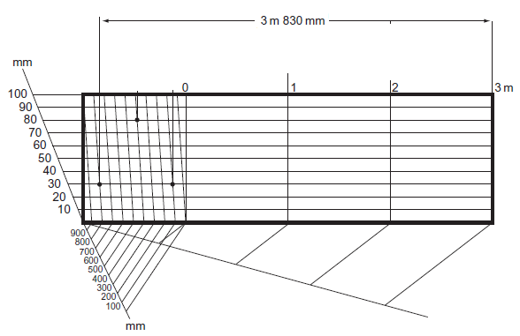

Read main units to the right of zero =3 metres-------1
Read the subunits to the left of zero=800--------------1
Read the diagonal =30--------------2
Add 3metres +800mm +30=3.830metrs---------------2
TOTAL 6 MARKS

- Construct a trapezium whose parallel sides are 60mm and 30mm and are 50mm apart one included angle being 60⁰ (5mks)

- Sketch the two views given below in oblique (6mrks)

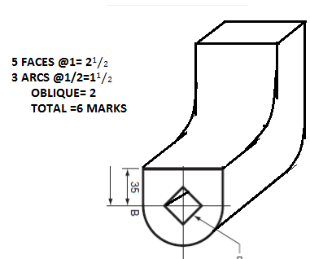

- (a) identify and correct six dimensioning errors in the figure below. (3 Marks)

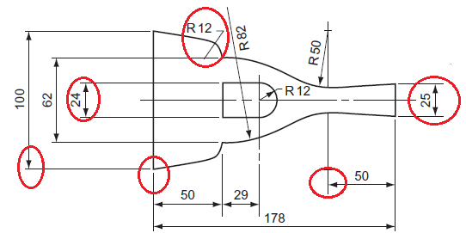

- To views of a machine part are shown below. Project the auxiliary view in the direction of arrow A (6mks)
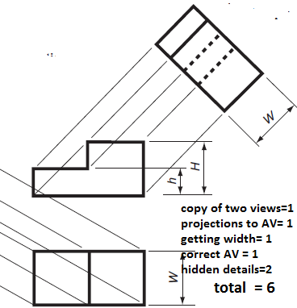

- Fig. 2 shows a shaped block drawn in first angle projection.
Draw isometric projection of the block (5mks)
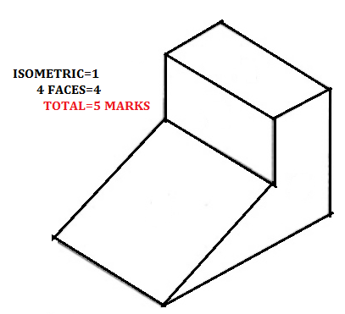
- Figure below shows a block drawn in isometric, draw the three views. (6 marks) 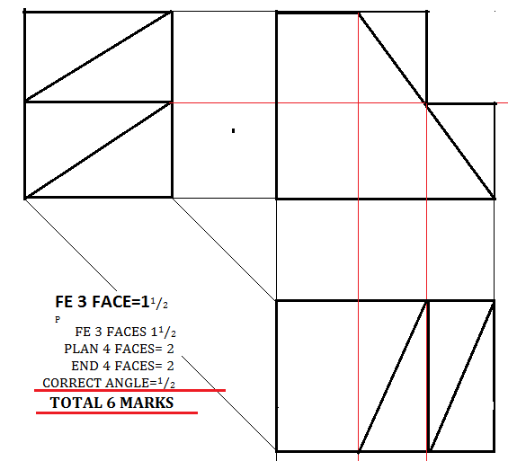

- Sketch the views given below in two point perpective. Take X as the lowest point. (6 marks)

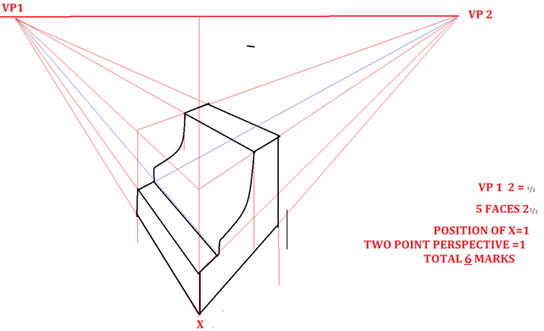

- SECTION B :(20MKS)
This question is COMPULSORY.
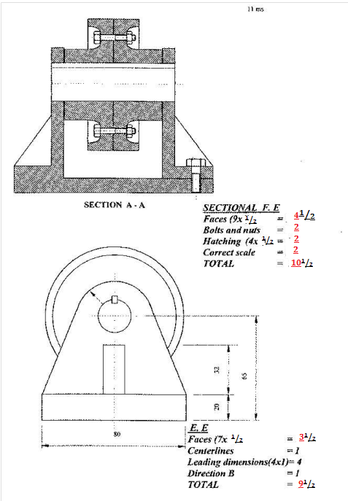

SECTION C (30 MARKS)
- . Figure 5 below shows a block drawn in isometric. (15 marks)
Draw full size in first angle the following views of the block
- The front Elevation
- End elevation
- The plan
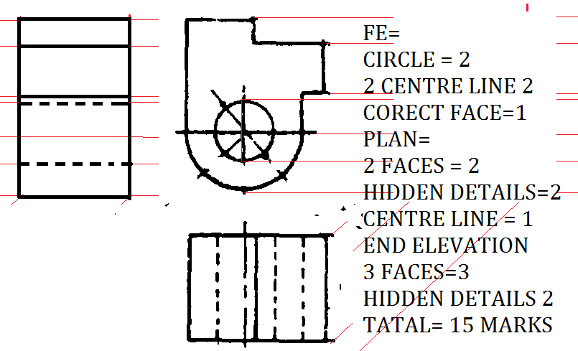

- Figure below shows elevation of a truncated hexagonal prism tilted at 45⁰ .
Copy the given view and draw the following in third angle projection.
  - End elevation in the direction of arrow E
  - The plan.
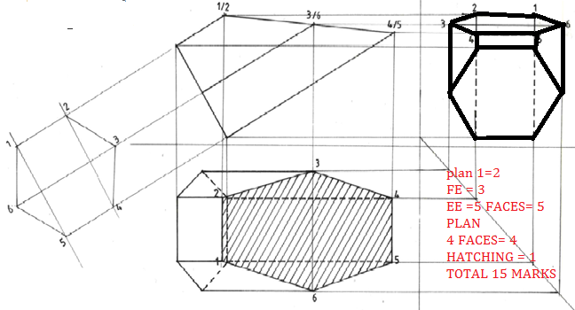

A roller of diameter 50mm rolls on a flat surface without slipping for one complete revolution. Trace the path of a point on its circumference for one complete revolution and draw a tangent to a point on the path generated. (15 MARKS)

