Term 1 - 2026
CHEMISTRY(233/2)
FORM FOUR(4)
Time: 2 Hours

Name: …………………………………………………………. Adm No: ……………….
School: ……………………………………………………….. Class: …………………..
Signature: …………………………………………………….. Date: …………………...

INSTRUCTIONS TO CANDIDATES:

- Answer all the questions in the spaces provided.
- Write your Name and Index Number in the spaces provided above.
- Mathematical tables and electronic calculators may be used for calculations.
- All working must be clearly shown where necessary

For Examiner’s Use only.

QUESTION | MAXIMUM SCORE | CANDIDATE’S SCORE
1 | 12
2 | 14
3 | 11
4 | 12
5 | 11
6 | 11
7 | 09
Total score | 80

This paper consists of 13 printed pages. Candidates should check the questions to ascertain that all the pages are printed as indicated and no questions are missing.

1. (a) Give the systematic names of the following compounds;
(i) CH₂ = C – CH₂CH₃ (1 mark)

Cl

..................................................................................................................................................
.................................................................................................................................................
(ii) CH₃CH₂CH₂ CH₂C≡ CH (1 mark)
.................................................................................................................................................
................................................................................................................................................
(b) State the observations made when propan-2-ol is reacted with;
(i) Acidified potassium manganate (VII) solution (1 mark)
......................................................................................................................................................
(ii) sodium metal (1mark)
.....................................................................................................................................................
(c) Ethanol may be obtained from sugarcane and converted to ethene as shown below;
Step I
Step II
Sugarcane Ethanol Ethene

(i) Give the name of the process that takes place in step I (1 mark)
.................................................................................................................................................
(ii) Name the reagent and condition in step II (2 marks)
Reagent.........................................................................................................................
Condition......................................................................................................................
(iii) Give two uses of ethanol other than as a solvent. (2 marks)
.................................................................................................................................................
.................................................................................................................................................

(d) Compounds P and Q have the same molecular formula C₄H₈O₂. Compound P liberates
Carbon (IV) Oxide on addition of solid sodium hydrogen carbonate while compound Q does not. Compound Q has a pleasant smell. Draw the possible structures of;

Compound P (1 mark)
.................................................................................................................................................
.................................................................................................................................................
.................................................................................................................................................

Compound Q (1 mark)
.................................................................................................................................................
.................................................................................................................................................
.................................................................................................................................................
(e) Disposal of polymers such as polyethene by burning pollutes the environment.
Explain how this happens. (2 marks)
.............................................................................................................................................................
.............................................................................................................................................................

2. (a) (i) Name the two crystalline forms of sulphur (2 marks)
......................................................................................................................................................
......................................................................................................................................................
(ii) Sulphur is extracted from underground deposits through Frasch process. Describe how this process works. (3 marks)

.....................................................................................................................................................
............................................................................................................................................................................................................................................................................................................
............................................................................................................................................................................................................................................................................................................
......................................................................................................................................................

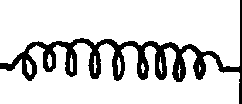
SO₂
Air
Purifier
Dry SO₂ and air
Heat exchanger
Cooler
Absorption Tower
SO₃
Substance A
Catalytic converter
SO₃
SO₂
Air
Oleum
Conc. H₂SO₄
Conc. H₂SO₄

(b) The scheme below represents the steps followed in the contact process. Study it and answer the questions that follow.

(a) Name substance A (1 mark)
...............................................................................................................................................................
(b) Name one impurity removed by the purifier (1 mark)
...............................................................................................................................................................
(c) Give a reason why vanadium (V) oxide is preferred to platinum rhodium in the above process (1 mark)
.............................................................................................................................................................

(d) Write down the equation of the reaction taking place in the catalytic converter. (1 mark)
...............................................................................................................................................................
(e) Give the role of the heat exchanger (1 mark)
.............................................................................................................................................................
............................................................................................................................................................
(f) When sulphur (VI) oxide is dissolved in water, acid fumes are formed. Explain the effect of exposure to these fumes. (1 mark)

..........................................................................................................................................................
.........................................................................................................................................................

(g) (I) Name the main pollutant in the contact process. (1 mark)
...................................................................................................................................................
(II) How can the pollution in (g) (I) above be prevented? (1 mark)
..................................................................................................................................................
(h) Give two uses of sulphuric (VI) acid. (2 marks)
..............................................................................................................................................................
...............................................................................................................................................................

3. (a) The table below shows some alkaline earth elements and halogens. Use the table to answer
the questions that follow.

 | Alkaline earth elements |  |  | Halogens
Element | Be | Mg | Ca | F | Cl | Br
Atomic radius (nm) | 0.089 | 0.136 | 0.174 | 0.064 | 0.099 | 0.144
Ionic radius (nm) | 0.031 | 0.065 | 0.099 | 0.136 | 0.181 | 0.195

(i) Atomic radius increases from Be to Ca and from F to Br. Explain (2 marks)
......................................................................................................................................................
......................................................................................................................................................
......................................................................................................................................................
(ii) Explain the difference in the atomic and ionic radii of halogens. (2 marks)
.....................................................................................................................................................
......................................................................................................................................................

(iii) Give the formula of the hydrogen carbonate of Ca (1 mark)
......................................................................................................................................................
......................................................................................................................................................

(iv)Give the type bond and structure formed when Mg and Cl react (2 marks)
Bond.................................................................................................................................
Structure...........................................................................................................................

(v) Starting with the least reactive, arrange the halogens in the order of
reactivity. (1 mark)

......................................................................................................................................................
......................................................................................................................................................
(vi) Write the equation for the reaction between Be and Cl. (1 mark)
......................................................................................................................................................
......................................................................................................................................................
(b) The graph below shows the relationship between the boiling point of beryllium and magnesium.

Boiling point (K)

Be
Mg

State and explain the trend shown in the graph above. (2 marks)
.....................................................................................................................................................
.....................................................................................................................................................

4. (a) (i) What is fractional crystallization? (1 mark)
……………………………………………..............................................................……………
…………………..…………………...…………………………….…………………………………................................………...................................................................................………
(ii) The table below shows the solubility of two salts K and L at various
Temperatures

Salt | Solubility at 50 (ºC) | Solubility at 20 (ºC)
K | 86 g | 31 g
L | 18 g | 8 g

A mixture of the salts contains 28 g of salt K and 17.5 g of salt L at 50 ºC. The mixture is cooled to 20 ºC.

(I) State the salt that crystallizes (1 mark)

.....................................................................................................................................

(II) Determine the mass of the salt that crystalizes
(2 marks)

……………………………………………………………………………………………….……………………………………………………………………………………………………………………………………………………………………………………………………………………………………………………………………………………………………………………………………………………………………
(b) (i) What is hard water? (1 mark)
.....................................................................................................................................................
.....................................................................................................................................................
(ii) Give one use hard water (1 mark)
.....................................................................................................................................................
.....................................................................................................................................................
(iii) Explain how use of sodium carbonate removes water hardness. (2 marks)
....................................................................................................................................................
.....................................................................................................................................................
.....................................................................................................................................................

(c) Study the flow chart below and answer the questions that follow.
Dil. hydochloric acid
Solution F and colourless gas G
Solid E
Step I
Step II
3drops of aqueous ammonia

Blue precipitate
Step III
Excess aqueous ammonia

Deep Blue solution H

(i) identify
I solid E (1 mark)
............................................................................................................................................
II gas G (1 mark)
............................................................................................................................................
(ii) Give the formula of the compound in solution H (1 mark)
.......................................................................................................................................................
.......................................................................................................................................................
(iii) Write the ionic equation for the reaction in step II (1 mark)
.......................................................................................................................................................
.......................................................................................................................................................

5 (a) What is enthalpy of solution? (1 mark)
...............................................................................................................................................................
..............................................................................................................................................................
..............................................................................................................................................................
(b) In an experiment to determine the molar heat of solution of substance M, 50.0 cm³ of water was placed in a plastic beaker. The temperature was measured after every half a minute. At the second minute, 8.2 g of substance M was added at once and temperature recorded up to the fourth minute. The table below shows the results obtained.

Time (minutes) | 0.0 | 0.5 | 1.0 | 1.5 | 2.0 | 2.5 | 3.0 | 3.5 | 4.0
Temperature (ºC ) | 25.0 | 25.0 | 25.0 | 25.0 | X | 17.0 | 18.0 | 19.0 | 20.0

(i) Draw a graph of temperature against time. (3 marks)


(ii) Using the graph, determine the temperature change, ∆T (2 marks)
...............................................................................................................................................................
..............................................................................................................................................................
..............................................................................................................................................................
(iii) Calculate the;
I heat change for the reaction (2 marks)
.....................................................................................................................................................
.....................................................................................................................................................
.....................................................................................................................................................
II molar heat of solution of substance M.
(specific heat capacity of solution = 4.2Jg⁻¹K⁻¹, molar mass of substance M =82 (3 marks)
......................................................................................................................................................
......................................................................................................................................................
......................................................................................................................................................
.....................................................................................................................................................

6. The scheme below shows various reactions starting with ammonia. Study it and answer the questions that follow.
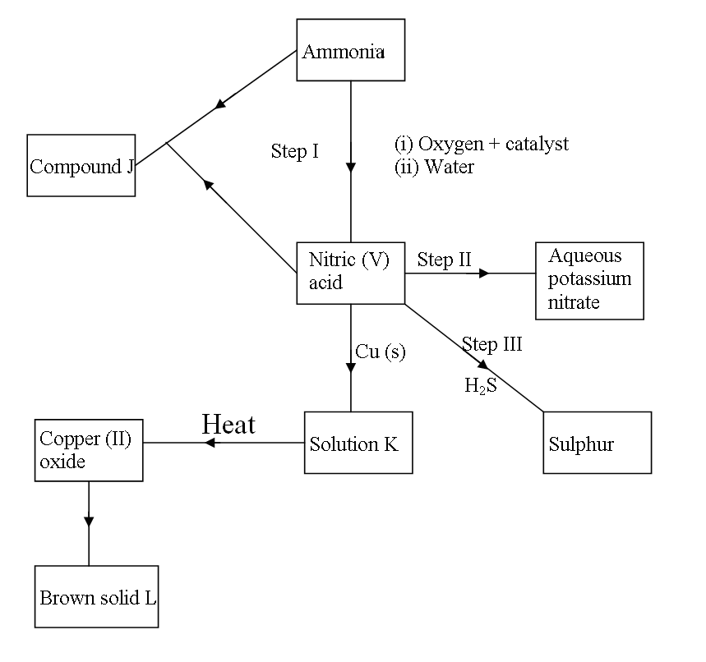
Substance M
Step V
Step IV
KOH
(i) Name the catalyst used in the conversion of ammonia to nitric (V) acid. (1 mark)
…………………………………………………………………………………………………………………………………....................................…..…………………………………….
(ii) Name the process that takes place in step II. (1 mark)
……………………………………………………………………………………………………………………………………………………………………………………...........……….
(iii) Write the equation for the reaction that takes place in step III. (1 mark)
…………………………………………………………………………………………………………………………………………………………………………………………………
(iv) Explain why silver cannot be used in step V. (2 marks)
……………………………………………………………………………………………………………………………………………………………………………………………………
…………………………………………………………………………………………………

(v) Give two uses of substance M. (2 marks)
……………………………………………………………………………………………………………………………………………………………………………………………………
(vi) Calculate the percentage of nitrogen by mass that is present in compound J. (N=14, H=1, O=16) (3 marks)
……………………………………………………………………………………………………………………………………………………………………………………………………
…………………………………………………………………………………………………
…………………………………………………………………………………………………

(vii) Give one advantage that urea has over ammonium nitrate as a fertilizer. (1 mark)
……………………………………………………………………………………………………………………………………………………………………………………………………

7 (a) state the particle responsible for electric carriage in
(i) aqueous sodium chloride (1 mark)
.......................................................................................................................................
(ii) graphite rod (1 mark)
........................................................................................................................................
(b) Name the product at the anode when brine is electrolysed using graphite electrodes
(1 mark)
................................................................................................................................................

(c) During electrolysis of aqueous silver nitrate using inert electrodes, a current of 0.75A was passed through the solution for 210 minutes.

I Write the equation at the anode (1 mark)
........................................................................................................................................
........................................................................................................................................

II Determine the mass of the product at the cathode. (Ag=108, 1 Faraday = 96 500 coulombs) (3 marks)
.......................................................................................................................................
........................................................................................................................................
.......................................................................................................................................
......................................................................................................................................
(d) (i) What is electroplating? (1 mark)
..........................................................................................................................................
(ii) Give one importance for the process in d (i) (1 mark)
..........................................................................................................................................

......................................THIS IS THE LAST PRINTED PAGE..............................................

