Term 1 - 2026
CHEMISTRY(233/1)
FORM FOUR(4)
Time: 2 Hours

Name: …………………………………………………………. Adm No: ……………….
School: ……………………………………………………….. Class: …………………..
Signature: …………………………………………………….. Date: ……………………

INSTRUCTIONS TO CANDIDATES
- Write your Name, Index Number and School in the spaces provided above.
- Answer all the questions in the spaces provided after each question.
- KNEC Mathematical tables and silent non-programmable electronic calculators may be used.
- ALL working must be clearly shown where necessary.
- Candidate should check the question paper to ascertain that all the pages are printed and that no questions are missing.
- Candidates should answer the questions in English.
FOR EXAMINER’S USE ONLY
QUESTIONS | MAX SCORE | CANDIDATE’S SCORE
1 – 25 | 80
This paper consists of 11 printed pages. Candidates should check to ascertain that all pages are printed as indicated and that no questions are missing.

- (a) What is the meaning of the term homologous series? (1 mark)

………………………………………………………………………………….…………

(b) Describe the procedure of preparing a soapless detergent from dodecene (4 marks)
………………………………………………………………………………………………………………………………………………………………………………………………………………………………………………………………………………………………………………………
- State three factors that affect the rate of a chemical reaction. (3 marks)
………………………………………………………………………………………………………………………………………………………………………………………………………………………………………………………………………………………………………………………
- In an industrial process, ammonia is produced by reacting nitrogen gas and hydrogen gas in the presence of a catalyst.
- Sate Le Chatelier's principle. (1 mark)
………………………………………………………………………………………………………………………………………………………………………………………………………………
- Write the equation for the formation of ammonia gas. (1 mark)
………………………………………………………………………………………………………………………………………………………………………………………………………………
- State how an increase in temperature affects the position of equilibrium. (1 mark)
………………………………………………………………………………………………………………………………………………………………………………………………………………
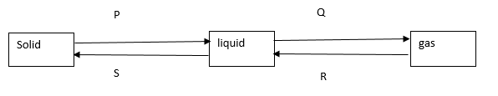
- The diagram below shows the relationship between the physical states of matter. Study it and answer the questions that follow.
- Identify energy changes represented by the letters:
P ……………………………and Q ………………………… (2 marks)
- Explain why there is no change in temperature during each of the processes shown in the diagram. (2 marks)
………………………………………………………………………………………………………………………………………………………………………………………………………………
- State two methods that can be used to determine the purity of a substance. (2 marks)
………………………………………………………………………………………………………………………………………………………………………………………………………………
- The volume of a fixed mass of a gas at a pressure of 550mmHg and 45ºC is 220 cm³. What would be the volume of the gas if the pressure and temperature are raised to 700mmHg and 40ºC respectively? (3 marks)

- Study the information below and use it to answer the questions that follow.
bond | Bond energy kJ/mol
H-H | 435
C-H | 413
C-C | 346
C=C | 611
C≡ C | 835

(i) Calculate the energy released during the hydrogenation of prop-1-ene to propane. (3 marks)
……………………………………………………………………………………………………………………………………………………………………………………………………………………………………………………………………………………………………………………………………………………………………………………………..,………………………………
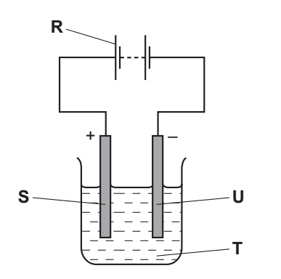
- The diagram below shows the apparatus used for the electrolysis of molten sodium bromide.

- Which letter R, S, T or U on the diagram represents the cathode? (1 mark)
………………………………………………………………………………………………………
- State and explain the observation made at the anode. (2 marks)
………………………………………………………………………………………………………………………………………………………………………………………………………………
- Which condition is missing in the set-up? ……………………………………(1 mark)
- The grid below is part of the periodic table. The elements are not represented by their actual symbols. Use the information to answer the questions that follow.
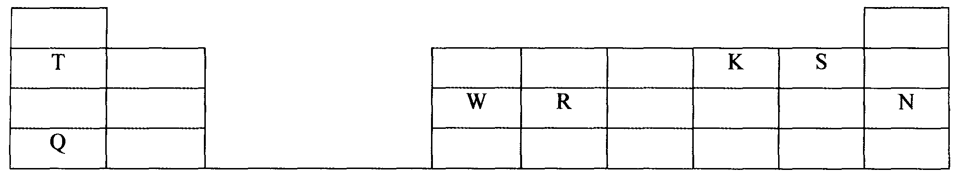

a) (i) Which is the most reactive non — metal? Explain. (2marks) ………………………………………………………………………………………………………………………………………………………………………………………………………………
(ii) Write an equation for the reaction between elements Q and K (1 mark)
………………………………………………………………………………………………………
- The apparatus below was set – up to show the catalytic oxidation of ammonia. Study the
diagram and answer the questions that follow.
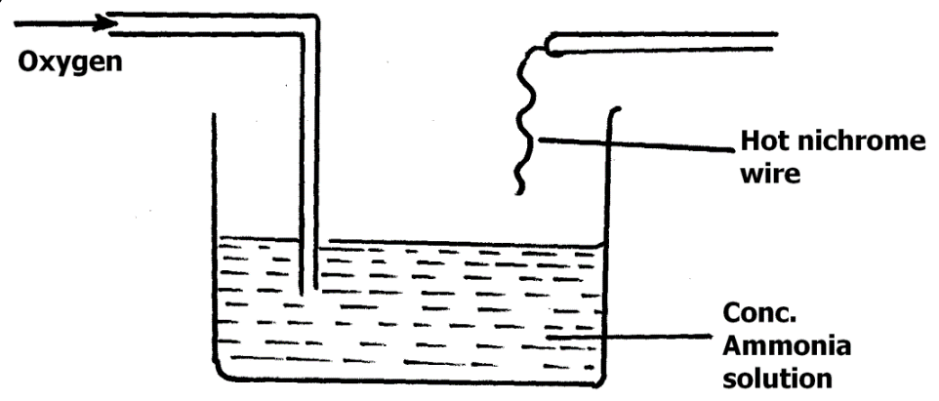
a) State what would be observed in the experiment above. Explain. (2 marks)
………………………………………………………………………………………………………………………………………………………………………………………………………………
b) Write the equation for the reaction that takes place during oxidation of ammonia. (1mark)
……………………………………………………………………………………………………
………………………………………………………………………………………………
- A heavy metal X was dissolved in dilute nitric acid to form a solution of compound X(NO₃)₂.
Portions of the resulting solution were treated as follows:
  - To the first portion a solution of dilute hydrochloric acid is added, where a white precipitate (S) is formed, which dissolves on warming.
  - The second portion is treated with two drops of 2M Sodium hydroxide solution where a white precipitate T is formed. The white precipitate dissolved in excess sodium hydroxide to form a colourless solution.
  - A solution of potassium iodide is added to the third portion where a yellow precipitate (U) is formed.
  - When the resulting solution is evaporated to dryness and heated strongly a yellow solid (V) is formed and a brown gas (W) and a colourless gas (X) are formed.
    - Identify the substances X, S, T, U, V, W (3 marks)
............................................................................................................................................................
............................................................................................................................................................
    - Write an ionic equation of the reaction that occurs in part (iii) (1 mark)
………………………………………………………………………………………………………………………………………………………………………………………………………………
- The diagram below shows industrial manufacture of hydrochloric acid.

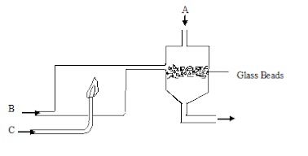

- Name the substance: (3 marks)
A..........................................................................................................................................
B.............................................................................................................................................
C…………………………………………………………………………………………….
- State the function of the glass beads in the above process. (1 mark)
……………………………………………………………………………………………..
- (a) What do you understand by the term recycling? (1 mark)
………………………………………………………………………………………………………………………………………………………………………………………………
- Describe how a mixture of iron filings and sulphur. (2 marks)
………………………………………………………………………………………………………………………………………………………………………………………………

- An organic compound P contains 68.9% carbon, 13.5% hydrogen and 21.6% oxygen. The relative formula mass of P is 74. Determine its molecular formula (C=12, H=1, O=16). (3 marks)
………………………………………………………………………………………………………………………………………………………………………………………………………………………………………………………………………………………………………………………………………………………………………………………………………………………………
- Calculate the molarity of phosphoric (V) acid (H₃PO₄) that is obtained by dissolving 13g of phosphoric (V) acid in 250 cm³ of solution. (H=1, P=31, O=16). (2 marks)
………………………………………………………………………………………………………………………………………………………………………………………………………………………………………………………………………………………………………………………………………………………………………………………………………………………………
- Study the reaction scheme below and answer the following questions:
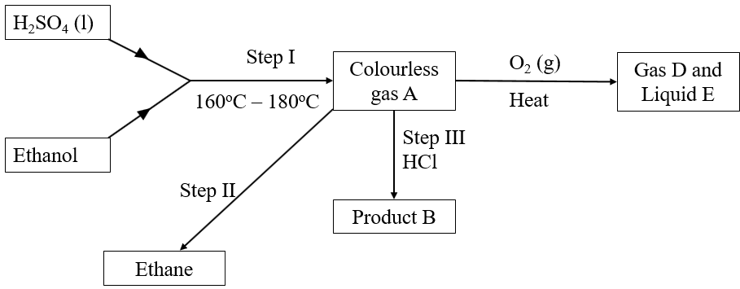

      - Write the equation for step I. (1 mark)
……………………………………………………………………………………………………
      - What is the name of gas D and Liquid E? (1 mark)
Gas D…………………………………………………………………..
Liquid E……………………………………………………………….
      - Name the process taking place in step II. (1 mark)
…………………………………………………………………………………………………
- State the type of bonding in the following substances: (2 marks)
- Diamond
…………………………………………………………………………………………………
- Copper (I) oxide
…………………………………………………………………………………………………
- The set-up below was used to collect gas F produced by the reaction between sodium peroxide and water
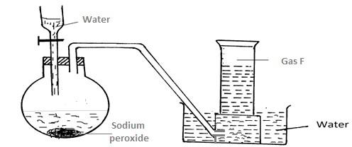
- Name gas F (1 mark)

………………………………………………………………………………………….
- At the end of the experiment, the solution in the round-bottomed flask was found to be a strong base. Explain why this was a strong base. (1 mark )
…………………………………………………………………………………………………………………………………………………………………………………………………………

- Which property of gas F makes it be collected by the method used in the set-up? (1 mark)
………………………………………………………………………………………………..
- Write the equation for the reaction taking place in the flask. ( 1 mark)
…………………………………………………………………………………………………………………………………………………………………………………………………………

- (a) Using an equation, explain the observation made when concentrated sulphuric (IV) acid is added to sugar crystals. (2 marks)
……………………………………………………………………………………………………………………………………………………………………………………………………………………………………………………………………………………………………………………………………………………………………………………………………………………
(b) What property is displayed by the acid in (a) above. (1mark)
………………………………………………………………………………………………………………………………………………………………………………………………………………

- Carbon (II) oxide was passed over heated copper (II) oxide in a combustion tube as shown in the diagram below.
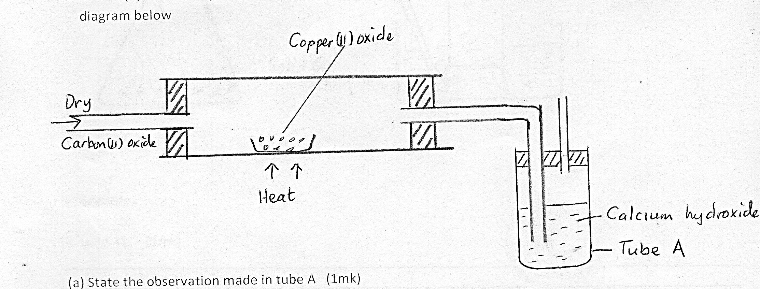
Copper (II)oxide
Dry

Carbon (II)oxide
Calcium Hydroxide
Heat
Tube A

- State and explain the observation made in tube A. (2 marks)
………………………………………………………………………………………………………………………………………………………………………………………………………………
- Write a chemical equation for the reaction that took place in the combustion tube.
(1 mark)
………………………………………………………………………………………………………………………………………………………………………………………………………………

- (a) What is isomerism ? (1 mark)
………………………………………………………………………………………………………………………………………………………………………………………………………………

(b) Draw and name any two isomers of C₄ H₈ (2 marks)

- Liquids A and R are immiscible. (Density of A – 1.6gcm⁻³ and density of R = 1.9gcm⁻³).
- Draw a diagram to illustrate the most suitable method of separation that would be used to separate the two liquids. (3 mark)

- Chlorine gas was passed over heated iron wire. On cooling the set-up, a solid X was formed. All the solid X was dissolved in water to form solution X. Sodium hydroxide solution was added to about 2 ml of solution X, little by little until in excess.
- Write the equation for the reaction of chlorine and iron. (1 mark)
……………………………………………………………………………………………………..
- Calculate the number of volume of chlorine that reacted with 1.4g of iron. (Fe = 56, Cl = 35.5, Molar gas volume = 24dm³). (3 marks)

- State the observation that was made when sodium hydroxide was added to solution X drop by drop until in excess. (1 mark)
………………………………………………………………………………………………
- Draw a well-labelled diagram to show how nitrogen (I) oxide can be prepared and collected in the laboratory. (3 marks)

- Name the two types of bonds within a molecule of ammonia. (2 marks)
……………………………………………………………………………………………………………………………………………………………………………………………………

…………………………..THIS IS THE LAST PRINTED PAGE……………………………...

