Term 1 - 2026
CHEMISTRY (233/1)
FORM FOUR (4)
Time: 2 Hours

MARKING SCHEME

- (a) What is the meaning of the term homologous series? (1 mark)

A homologous series is a group of organic compounds that have similar chemical properties and structural features, with each successive member of the series differing from the previous one by a specific unit, such as a -CH₂- group.
(b) Describe the procedure of preparing a soapless detergent from dodecene (4 marks)
Dodecene is reacted with benzene to form alkylbenzene. The alkylbenzene is reacted with sulphuric (VI) acid to form alkylbenzene sulphonate. The alkylbenzene sulphonate is reacted with sodium hydroxide to form a soapless detergent.
- State three factors that affect the rate of a chemical reaction. (3 marks)
- Concentration
- Temperature
- Catalyst
- Light
- Surface area

- In an industrial process, ammonia is produced by reacting nitrogen gas and hydrogen gas in the presence of a catalyst.
- Sate Le Chatelier's principle. (1 mark)
When a change is applied to a system at equilibrium, the system moves so as to oppose that change.
- Write the equation for the formation of ammonia gas. (1 mark)

- State how an increase in temperature affects the position of equilibrium. (1 mark)
The reaction is exothermic. An increase in temperature favours the endothermic reaction which is the reverse reaction. The equilibrium shifts to the left.
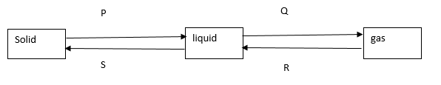
- The diagram below shows the relationship between the physical states of matter. Study it and answer the questions that follow.
- Identify energy changes represented by the letters:
P Latent heat of fusion and Q Latent heat of vaporisation (2 marks)
- Explain why there is no change in temperature during each of the processes shown in the diagram. (2 marks)
The heat energy is used to break or weaken the bonds during the processes and hence no changein temperature.
- State two methods that can be used to determine the purity of a substance. (2 marks)
Melting and boiling points
Refractive index
- The volume of a fixed mass of a gas at a pressure of 550mmHg and 45ºC is 220 cm³. What would be the volume of the gas if the pressure and temperature are raised to 700mmHg and 40ºC respectively? (3 marks)

- Study the information below and use it to answer the questions that follow.
bond | Bond energy kJ/mol
H-H | 435
C-H | 413
C-C | 346
C=C | 611
C≡ C | 835

(i) Calculate the energy released during the hydrogenation of prop-1-ene to propane. (3 marks)

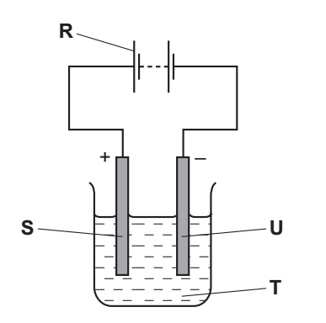
- The diagram below shows the apparatus used for the electrolysis of molten sodium bromide.

- Which letter R, S, T or U on the diagram represents the cathode? (1 mark)
S
- State and explain the observation made at the anode. (2 marks)
A brown gas is formed. Bromide ions migrate to the anode, they lose electrons to form bromine atoms which combine to form bromine gas.
- Which condition is missing in the set-up? Heat (1 mark)

- The grid below is part of the periodic table. The elements are not represented by their actual symbols. Use the information to answer the questions that follow.
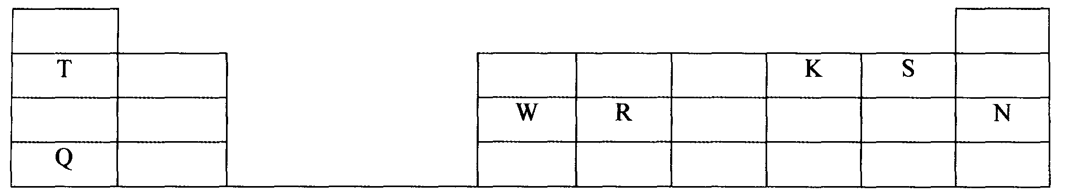

a) (i) Which is the most reactive non — metal? Explain. (2marks)
S – It is the most electronegative or it most readily gains electrons.
(ii) Write an equation for the reaction between elements Q and K (1 mark)

- The apparatus below was set – up to show the catalytic oxidation of ammonia. Study the
diagram and answer the questions that follow.
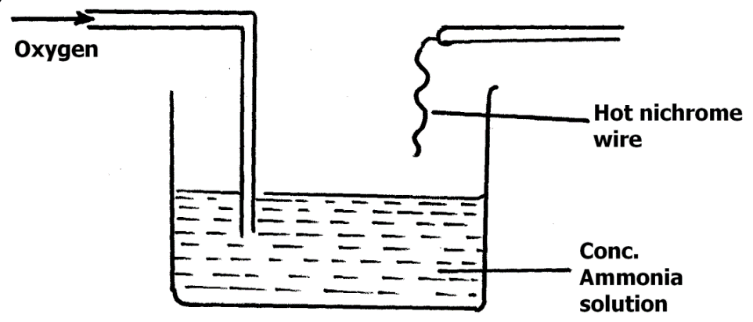
a) State what would be observed in the experiment above. Explain. (2 marks)
Brown fumes are seen. Ammonia reacts with oxygen to form nitrogen (II) oxide gas which is oxidised to brown nitrogen (IV) oxide.
b) Write the equation for the reaction that takes place during oxidation of ammonia. (1mark)

- A heavy metal X was dissolved in dilute nitric acid to form a solution of compound X(NO₃)₂.
Portions of the resulting solution were treated as follows:
  - To the first portion a solution of dilute hydrochloric acid is added, where a white precipitate (S) is formed, which dissolves on warming.
  - The second portion is treated with two drops of 2M Sodium hydroxide solution where a white precipitate T is formed. The white precipitate dissolved in excess sodium hydroxide to form a colourless solution.
  - A solution of potassium iodide is added to the third portion where a yellow precipitate (U) is formed.
  - When the resulting solution is evaporated to dryness and heated strongly a yellow solid (V) is formed and a brown gas (W) and a colourless gas (X) are formed.
    - Identify the substances X, S, T, U, V, W (3 marks)
S – lead (II) chloride
T – lead (II) hydroxide
U – lead (II) iodide
V – lead (II) oxide
W – nitrogen (IV) oxide
X - oxygen
    - Write an ionic equation of the reaction that occurs in part (c) (1 mark)

- The diagram below shows industrial manufacture of hydrochloric acid.

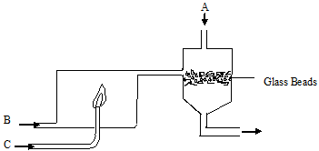

- Name the substance: (3 marks)
A - water
B – Dry chlorine
C – Dry hydrogen
- State the function of the glass beads in the above process. (1 mark)
To increase the surface area
- (a) What do you understand by the term recycling? (1 mark)
The re-processing of used products into new products.
- Describe how a mixture of iron filings and sulphur. (2 marks)
Spread the mixture on a flat surface, pass a magnet over the mixture several times to attract all the iron filings leaving sulphur on the flat surface.

- An organic compound P contains 68.9% carbon, 13.5% hydrogen and 21.6% oxygen. The relative formula mass of P is 74. Determine its molecular formula (C=12, H=1, O=16). (3 marks)

- Calculate the molarity of phosphoric (V) acid (H₃PO₄) that is obtained by dissolving 13g of phosphoric (V) acid in 250 cm³ of solution. (H=1, P=31, O=16). (2 marks)

- Study the reaction scheme below and answer the following questions:
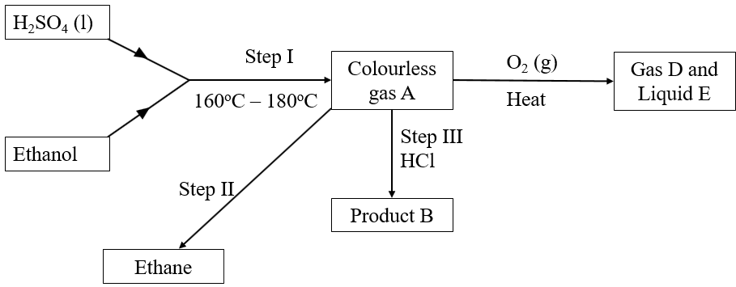

      - Write the equation for step I. (1 mark)
……………………………………………………………………………………………………
      - What is the name of gas D and Liquid E? (1 mark)
Gas D – carbon (IV) oxide
Liquid E - water
      - Name the process taking place in step II. (1 mark)
Hydrogenation
- State the type of bonding in the following substances: (2 marks)
- Diamond
Covalent bonding
- Copper (I) oxide
Ionic bonding
- The set-up below was used to collect gas F produced by the reaction between sodium peroxide and water.
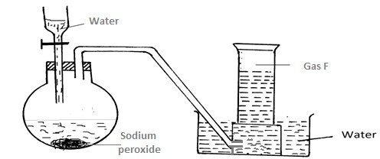
- Name gas F (1 mark)

Oxygen
- At the end of the experiment, the solution in the round-bottomed flask was found to be a strong base. Explain why this was a strong base. (1 mark )
The reaction forms sodium hydroxide and oxygen gas. Sodium hydroxide is a strong base.

- Which property of gas F makes it be collected by the method used in the set-up? (1 mark)
It is slightly soluble in water.
- Write the equation for the reaction taking place in the flask. ( 1 mark)
…………………………………………………………………………………………………………………………………………………………………………………………………………

- (a) Using an equation, explain the observation made when concentrated sulphuric (IV) acid is added to sugar crystals. (2 marks)
A black charred mass is formed. Concentrated sulphuric (VI) acid removes elements of water from sugar to form carbon and water.

(b) What property is displayed by the acid in (a) above. (1mark)
Dehydrating property

- Carbon (II) oxide was passed over heated copper (II) oxide in a combustion tube as shown in the diagram below.
Copper (II)oxide
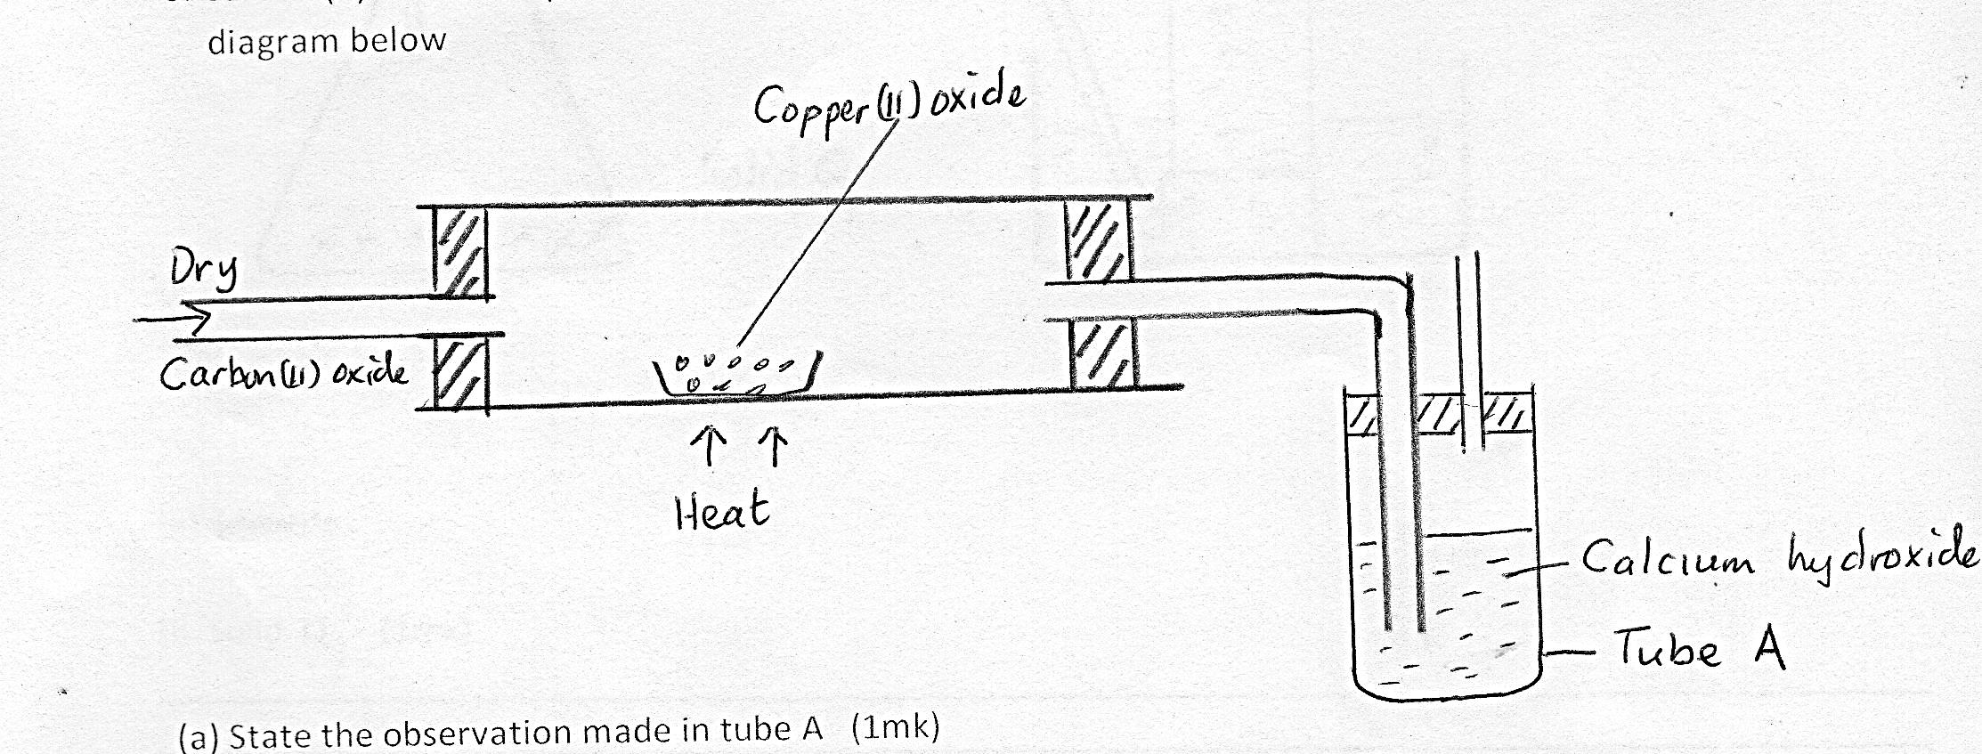
Dry

Carbon (II)oxide
Heat
Calcium Hydroxide
Tube A

- State and explain the observation made in tube A. (2 marks)
A white precipitate is formed. Carbon (II) oxide is reduces copper (II) oxide to copper metal while it is oxidized to carbon (IV) oxide which reacts with calcium hydroxide to form insoluble calcium carbonate.
- Write a chemical equation for the reaction that took place in the combustion tube.
(1 mark)
………………………………………………………………………………………………………………………………………………………………………………………………………………
- (a) What is isomerism ? (1 mark)
It is the existence of compounds with same molecular formula but different structural formulae.
(b) Draw and name any two isomers of C₄ H₈ (2 marks)

- Liquids A and R are immiscible. (Density of A – 1.6gcm⁻³ and density of R = 1.9gcm⁻³).
- Draw a diagram to illustrate the most suitable method of separation that would be used to separate the two liquids. (3 mark)

- Chlorine gas was passed over heated iron wire. On cooling the set-up, a solid X was formed. All the solid X was dissolved in water to form solution X. Sodium hydroxide solution was added to about 2 ml of solution X, little by little until in excess.
- Write the equation for the reaction of chlorine and iron. (1 mark)
……………………………………………………………………………………………………..
- Calculate the volume of chlorine that reacted with 1.4g of iron. (Fe = 56, Cl = 35.5, Molar gas volume = 24dm³). (3 marks)

- State the observation that was made when sodium hydroxide was added to solution X drop by drop until in excess. (1 mark)
A brown precipitate that does not dissolve in excess NaOH is formed.
- Draw a well labelled diagram to show how nitrogen (I) oxide can be prepared and collected in the laboratory. (3 marks)

- Name the two types of bonds within a molecule of ammonia. (2 marks)
Covalent bonds and co-ordinate/ dative bonds.

…………………………..THIS IS THE LAST PRINTED PAGE……………………………...

