TERM 1 – 2026
BIOLOGY
PAPER 3 PRACTICAL (231/3)
FORM FOUR (4)
Time: 1¾ Hours
Name: …………………………………………………………. Adm No: ……………….
School: ……………………………………………………….. Class: …………………..
Signature: …………………………………………………….. Date: …………………...

INSTRUCTIONS TO CANDIDATES:
- Write your name, index number and school in the spaces provided above.
- Sign and write the date of examination in the spaces provided above.
- Answer all the questions in the spaces provided.
- You are required to spend the first 15 minutes of the 1¾ hours allowed for
- this paper reading the whole paper carefully before commencing your work.
- This paper has three questions.
- Students should check the question paper to ascertain that all the papers are printed as indicated and that no questions are missing.
- Candidates should answer the questions in English.
FOR EXAMINER’S USE ONLY:
Question | Maximum  Score | Candidate’s  Score
1 | 16
2 | 12
3 | 12
Total Score | 40

- You are provided with specimens W1, W2, W3 and W4. Examine them.

a) Draw and label specimens W1 in the space provided. (3mks)

Magnification (1mk)

…………………………………………………………………

b) Giving reasons, state the agent or method of dispersal of the specimens. (8mks)

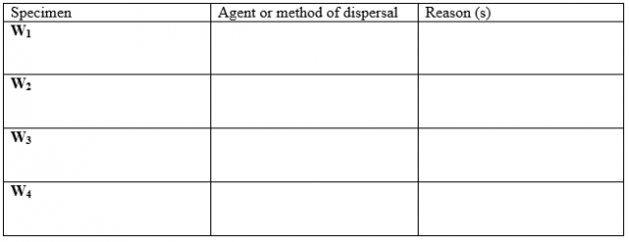

c) Open up specimen W4 to expose the longitudinal section, State the types of placentation and gynoecium.

- Placentation
(1mk)
………………………………………………………………………………………………….
Reason
(1mk)
………………………………………………………………………………………………………

(ii) Gynoecium
(1mk)
………………………………………………………………………………………………………

Reason
(1mk)
……………………………………………………………………………………………………….

- You are provided with specimen labelled K. Using a hand lens examine the specimen.

- State the phylum to which the specimen belongs. (1mk)

………………………………………………………………………………………………….

- Using observable features only, name the class to which the specimen belongs.

- Class………………………………………………………………………………….. (1mk)

Give two reasons for your answer in b(i) above. (2mks)

…………………………………………………………………………………………………………

………………………………………………………………………………………………………….

- Cut three of specimen K into tiny pieces. Place the pieces into boiling tube. Add 5ml of water. Boil for 5 minutes. Decant the extract into a clean test tube. Using the reagents provided, identify the food substances in the extract. Record the food substances being tested for, procedures, observations and conclusions in the table below. (8mks)

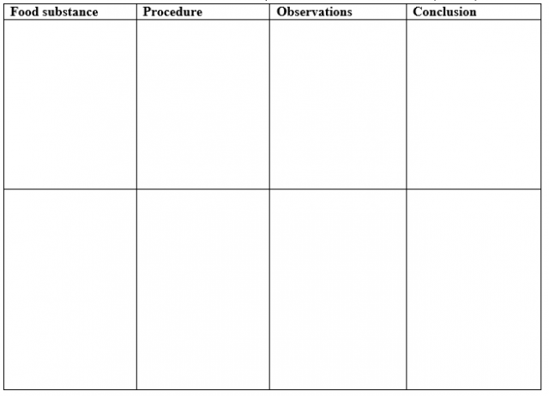

3. You are going to investigate the effect of the concentration of sugar solutions on a certain physiological process in a plant tissue.
Step 1 Cut each cylinder to exactly 30mm in length.
Step 2 Put one potato cylinder to each of solutions in test-tube A, B and C
Step 3 Leave the potato cylinders in the test-tubes for 20 minutes.
While you are waiting continue with the other questions.
Step 4 After 20 minutes use forceps to remove the potato cylinder from test-tube A onto the white tile.
Step 5 Measure the length of the potato cylinder from test-tube A and record this measurement in millimetres, in the table in, 3(a) below.
Step 6 Repeat steps 4 and 5 for the potato cylinder in test-tube B and C

Work out the change in length for cylinder A, B and C and record in the table, in 3(a) below.

Potato cylinders | Length at the beginning of the experiment | Length at the end of the experiment (in mm) | Change in length (in mm)
In solution A | 30mm
In solution B | 30mm
In test-tube C | 30mm
(3mks)
(i) Explain why it was important that the potato cylinders were all cut to the same length in
step 1. (1mk)
...........................................................................................................................................

...........................................................................................................................................
(ii) Suggest one improvement that you could make to the method you have used in this
investigation. (1mk)
........................................................................................................................................

...........................................................................................................................................
(iii) Describe one precaution you took while preparing the potato cylinders in steps 1-6.
(1mk)
...........................................................................................................................................
(iv) Explain the results obtained in table 3(a) above for cylinder A and B (3mks)

…………………………………………………………………………………………………………

…………………………………………………………………………………………………………

………………………………………………………………………………………………………….
(b) Potato cells contain starch grains. (2mks)
(i) State the reagent that would be used to test for the presence of starch and give the
result
Reagent ...............................................................................................................................

Result ...................................................................................................................................

(c) Suggest the purpose of cylinder C in the experiment. (1mk)

…………………………………………………………………………………………………………..

