TERM 1 – 2026
BIOLOGY
PAPER 2 (231/2)
FORM FOUR (4)
Time: 2 Hours
Name: …………………………………………………………. Adm No: ……………….
School: ……………………………………………………….. Class: …………………..
Signature: …………………………………………………….. Date: …………………...

Instructions to candidate
- Write your name, school, index number in the space provided at the top of the paper.
- Sign and write the date of examination in the space provided above.
- This paper consists of two sections, A and B.
- Answer all the questions in section A in the spaces provided.
- In section B answer question 6 (compulsory) and either question 7 or 8 in the answer booklet provided.
- Candidates should check the question paper to ascertain that all the pages are printed as indicated and that no questions are missing.
- Candidates should answer the questions in English.

For Examiner’s Use Only

Section | Question | Maximum Score | Candidate’s Score
A | 1 | 8
A | 2 | 8
A | 3 | 8
A | 4 | 8
A | 5 | 8
B | 6 | 20
B | 7 | 20
B | 8 | 20
 |  | 80

SECTION A (40 Marks)
Answer all the questions

1. The diagram below illustrates the first stage in the energy flow in the ecosystem.
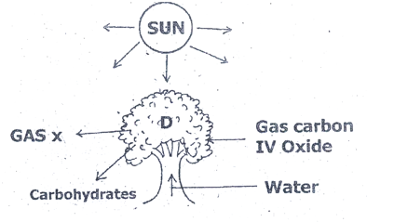
a) Identify:

- Organelle responsible for activity in D. (1mk)

………………………………………………………………………………………………..
- Gas x (1mk)

…………………………………………………………………………………………………
b) Suggest the roles played by each of the following in the processes illustrated above.

i) Light energy (1mk)

………………………………………………………………………………………………….

………………………………………………………………………………………………….
ii) Water (2mks)

…………………………………………………………………………………………………..

……………………………………………………………………………………………………

iii) Carbon (IV) oxide (1mk)

……………………………………………………………………………………………………
c) Give two ways in which the carbohydrates produced in the organelles at D is utilized in plants. (2mks)
……………………………………………………………………………………………………

……………………………………………………………………………………………………

2. The diagram below illustrates the role played by red blood cells in the transportation of carbon (IV) oxide.
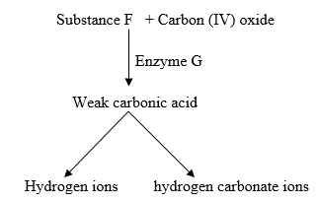
a) Other than the carbon (IV) oxide transportation in the red cells, name the other form of carbon (IV) oxide transportation in humans. (1mk)

…………………………………………………………………………………………………
b) Name substance F. (1mk)

………………………………………………………………………………………………...

c) Name enzyme marked G and state its role in the reaction. (2mks)

Enzyme ………………………………………………………………………………………

Role ………………………………………………………………………………………….

d) Explain why transportation of carbon (IV) oxide in red blood cells is advantageous.
(2mks)
………………………………………………………………………………………………..

……………………………………………………………………………………………….

……………………………………………………………………………………………….

e) Explain the role of calcium ions in blood clotting. (2mks)

……………………………………………………………………………………………….

……………………………………………………………………………………………….

3. The diagram below shows a section through the human ovary. Study it and answer the questions that follow.
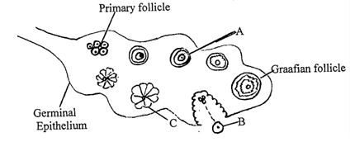
a) Name the part labeled A. (1mark)

………………………………………………………………………………………………………

b(i) Which part of the ovary divides to form the primary follicle. (1mark)

………………………………………………………………………………………………………

(ii) Which type of cell division is responsible for the production of primary follicles?
(1mk)
……………………………………………………………………………………….....................

c) Follicle stimulating hormone reaches the ovary so that part A begins to mature.

(i) Name the first hormone which is secreted by the ovary as a result of arrival of FSH
(1mk) ………………………………………………………………………………………………………

(ii) What is the role of this hormone in the menstrual cycle? (1mark)

……………………………………………………………………………………………………...
d) Structure B leaves the ovary.
(i) Where does structure B enter immediately after leaving the ovary? (1mark)

……………………………………………………………………………………………………...

(ii) Which hormone level peaks just before structure B leaves the ovary? (1 mark)

………………………………………………………………………………………………………

e) State the role of structure C. (1mark)

………………………………………………………………………………………………………

4. In an investigation, a variety of pea plants grown from seeds with smooth coats crossed with plants grown from seeds with wrinkled coats. All the seeds obtained in the First Filial (F1) generation had smooth seed coats.

a) Using the letter R to represent the gene for smooth seed coat, work out the genotype of the F1 generation. (Show your working.) (4mks)

b) If the F1 generation was selfed, determine the phenotypic ratio of the Second Filial (F2) generation. (Show your working.) (2mks)

c) If the total number of seeds in the F2 generation was 14640, calculate the number of seeds with wrinkled coats. (Show your working.) (2mks)
……………………………………………………………………………………………………
……………………………………………………………………………………………………
……………………………………………………………………………………………………
……………………………………………………………………………………………………

5. The chart below shows a feeding relationship in a certain ecosystem.
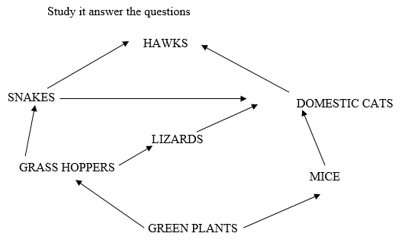
(a)i) Identify this feeding relationship. (1mk)

………………………………………………………………………………………………………
(i) Name the producers in this ecosystem. (1mk)

………………………………………………………………………………………………………
- Which organisms have the highest varieties of predators. (1mk)

………………………………………………………………………………………………………

b) Construct two food chains from this ecosystem ending with a tertiary consumer.
(2mks)
…………………………………………………………………………………………..…………

………………………………………………………………………………………..……………

c) Identify three phyla that the consumers in this ecosystem belong to. (3mks)
…………………………………………………………………………………………..………

…………………………………………………………………………………………….………

………………………………………………………………………………………………….

SECTION B (40 Marks)
Answer question 6 (compulsory and either question 7 or 8

6. In an experiment, several cubes of liver of same mass were put in separate test tubes each with equal amount of hydrogen peroxide.
Each test tube was placed in a water bath at various temperatures. The time taken for the hydrogen peroxide to decrease in each test tube was determined and recorded results are shown in table below.

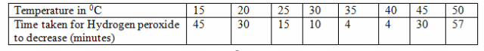

a) Using appropriate scale, plot a graph of duration of reaction against temperature.
(7mks)

b) From your graph, determine the optimum temperature for the decomposition of hydrogen peroxide. (1 mark) ……………………………………………………………………………………………………….
c) Account for the changes that occur between
(i) 15⁰C - 35⁰C (2 marks)
………………………………………………………………………………………………………

………………………………………………………………………………………………………

………………………………………………………………………………………………………

(ii) 35⁰C - 40⁰C (2 marks)

………………………………………………………………………………………………………

………………………………………………………………………………………………………

………………………………………………………………………………………………………

(iii) 40⁰C - 35⁰C (2 marks)

………………………………………………………………………………………………………

………………………………………………………………………………………………………

………………………………………………………………………………………………………

d) Name the enzyme in the liver that decomposes hydrogen peroxide. (1 mark)

………………………………………………………………………………………………………
e) Other than temperature, state three other factors that affect enzyme controlled reactions. (3 marks) ………………………………………………………………………………………………………

………………………………………………………………………………………………………

………………………………………………………………………………………………………
f) Name two types of enzyme inhibitors. (2 marks)
………………………………………………………………………………………………………

………………………………………………………………………………………………………

7.a) Explain how each of the following factors affects the rate of photosynthesis:
i) Temperature (3mks)
ii) Chlorophyll concentration. (2mks)
b) Describe the process of carbohydrates digestion in human beings. (15mks)

8.a) Describe the meaning of the following phrases as explained in the mechanism of Evolution:
(i) “Struggle for existence”. (2mks)
(ii) “Survival for the fittest”. (2mks)
b) Describe how comparative Anatomy explains the evidence for organic evolution.
(16mks)

