TERM 1 – 2026
BIOLOGY
PAPER 2 (231/2)
FORM FOUR (4)
Time: 2 Hours
MARKING SCHEME

Instructions to candidate
- Write your name, school, index number in the space provided at the top of the paper.
- Sign and write the date of examination in the space provided above.
- This paper consists of two sections, A and B.
- Answer all the questions in section A in the spaces provided.
- In section B answer question 6 (compulsory) and either question 7 or 8 in the answer booklet provided.
- Candidates should check the question paper to ascertain that all the pages are printed as indicated and that no questions are missing.
- Candidates should answer the questions in English.

For Examiner’s Use Only

Section | Question | Maximum Score | Candidate’s Score
A | 1 | 8
A | 2 | 8
A | 3 | 8
A | 4 | 8
A | 5 | 8
B | 6 | 20
B | 7 | 20
B | 8 | 20
 |  | 80

SECTION A (40 Marks)
Answer all the questions
1.
(a)
i) Chloroplast;
ii) Oxygen; Rej O2
(b)
i) Splits/breaks water molecules into oxygen and Hydrogen ions(atoms);
ii) Provides Hydrogen ions (atoms) for the reduction of carbon (iv) oxide;
Raw material; for photosynthesis;
iii) Undergoes carbon (iv) oxide fixation; to form simple sugars. Reduced by Hydrogen ions to form simple sugars; Raw material; for photosynthesis.
(c) -Directly utilized by the plant cells (respiration) to release energy;
-Excess is convert to starch; and stored;
8 marks
2.
(a) Carbonic Acid/ Carbominohaemoglobin/Hydrogen carbonate;
b)
i) Water;
c)Enzyme – carbonic anhydrase;
Role – catalyses the reaction between carbon (iv) oxide and water to form (weak) carbonic acid;
d) -Maintains PH of blood/prevents accumulation of acidity;
-Hydrogen ions combines with Haemoglobin (to form Haemoglobinic acid);
-It is faster; due to the catalytic effect of carbonic anhydrase;
e) -Activates Thromboplastin/Thrombokinase; enzymes.
-To neutralize Heparin/convert prothrombin to thrombin;
8 marks

3. (a) Primary oocytes;
(b)(i) Germinal epithelium;
(ii) Mitosis;
(c) (i) Oestrogen;
(ii) Healing and repair of the uterine wall following menstruations; stimulates the pituitary glands to secrete luteinizing hormone;
(d)(i) Funnel of fallopian tube/oviduct;
(ii) Luteinising hormone;
(e) Secretion of progesterone; 8 marks
4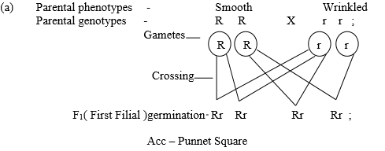
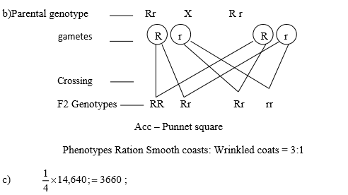
8 marks

5.
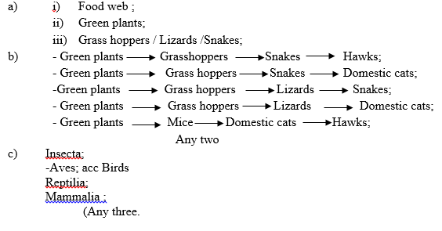
8 marks

SECTION B (40 Marks)
6.
(b) 37.5⁰C (1)
(c)
(i) 15⁰C -35⁰C
-As the temperature increases the enzymes became more active; it therefore took less time to decompose all the hydrogen peroxide; (2)
(ii) 35⁰ C-40⁰C –This is the optimum temperature for the enzyme because its rate of activity was its highest; hydrogen peroxide was decomposed within a very short time; (2)
(iii) 40⁰C -50⁰C -Temperature are too high; and cause the enzyme to get denatured; hence Hydrogen peroxides takes longer time to be decomposed; (3)
(d) Catalase enzymes
(e)
-Enzyme concentration;
-Substance concentration;
-Presence of inhabitation;
-pH.
(f) Competitive inhibitor;
Non- competitive inhibitors;
20 marks

7.
(a) (i) Temperature:-
-Reactions in photosynthesis are catalysed by enzymes;
-At optimum temperature photosynthesis proceeds faster;
-Below optimum temperature the rate of photosynthesis decreases because enzymes are in-activated by low temperatures/Above optimum temperatures the rate of photosynthesis decreases because enzymes are destroyed or denatured;
(ii) Chlorophyll concentration:-
-Chlorophyll traps energy from light for photosynthesis;
-The higher the chlorophyll concentration, the higher the rate of photosynthesis; Acc the converse.
b) In the mouth;
-Food is chewed; to increase surface area for enzyme activity; saliva (contain) salivary amylase or ptyalin; enzyme. Saliva (mixes with food and provides an alkaline; medium for the action of amylase/ ptyalin; enzyme.
-Salivary amylase/ptyalin acts on starch or amylase to maltose; In the duodenum;
-Food is mixed with bile; and pancreatic juice/Bile provides alkaline; medium for the activity of duodenal enzymes; and neutralizes acidic food/chime from the stomach;
-Acc sodium Hydrogen carbonate for bile.
-Rej sodium bicarbonate for bile.
-Pancreatic juice contains pancreatic amylase; which converts starch to maltose;
-In the Ileum; Reject Ilium.
-Epithelial cells in the ileum secrete succus entericus/interstine juice; which contain sucrose/invertase; enzyme which acts on sucrose and converts it to fructose and glucose;
-Lactose; which acts on lactose and converts it to galactose and glucose;
-Maltase; acts on maltose and converts it to glucose;
20 marks

8.
i) “ Struggle for existence” is a concept (of Charles Darwin )based on natural selection; whereby individuals in any given population struggle for survival against environmental pressures;
ii) “ Survival for the fittest” is a concept (of Charles Darwin) based on “Natural selection” whereby individuals in any given population struggle to acquire advantageous variations; to survive.
b)
-When comparing the form and structure of different organisms some groups show structural similarities; this suggests that the organisms have a common ancestral origin;
-Homologous structures; underwent divergent evolution; and adaptive radiation; this are structures of similar embryonic origin; but are modified to perform different functions; e.g.
-Pentadactyl timb in vertebrates; a basic pentadactyl (5- digits) structure is same; The forelimb in bats is modified for flight/Horse is elongated to enhance speed when running;
-Human beings for grasping/whale for swimming/mole for digging/zebra for running/Lizards for walking;
-Beaks; of birds show common embryonic descent/origin; but are modified for different functions; e.g. seed eaters/ flesh eaters/fruit eaters/nectar feeding/fish eaters or filter feeding/insect feeding; depending on size/shape (and ) length; of the beaks.
-Feet; of birds accepts foot have common embryonic origin but modified for various habitats; and functions; e.g. webbed for wading/ heavy-clawed for tearing flesh/grasping twigs /ground scratching;
-Analogous structures; underwent convergent evolution; These structures had different embryonic origin; but got modified to perform similar functions; due to exploitation of similar environments e.g. wings; of birds and insects; are endoskeleton (pentadactyl) and exoskeleton in origin/eyes; of vertebrates and molluscs/octopus;
-Vestigeal structures; structures reduced in size and have ceased to function during the course of evolution; because they lost their original function; e.g appendix /tail/coccyx in man/pelvic girdle in whales;
20 marks

