TERM 1 – 2026
BIOLOGY (231/1)
FORM FOUR (4)
Time: 2 Hours

Name: …………………………………………………………. Adm No: ……………….
School: ……………………………………………………….. Class: …………………..
Signature: …………………………………………………….. Date: …………………...

INSTRUCTIONS
- All Questions are Compulsory.
- Write your Answers in the Spaces Provided.
- Wrong Spelling of Technical Terms shall be Penalized.

Max  Score | Student’s Score
80

- a) Define the term Haemolysis (1mk
………………………………………………………………………………………………………………………………………………………………………………………………
b) State one way of reversing plasmolysis (1mk
………………………………………………………………………………………………

- Name the kingdom in which all members: (2mks
a) are Prokaryotic……….………………………………………………………………….
b) Have Cellulose Cell wall ………………………………………………………………..

- The diagram of a leaf shown below illustrates the photosynthesis process
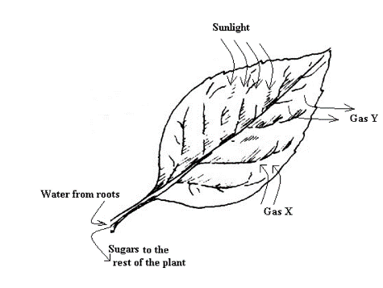
- State TWO roles of light during this process (2mks
………………………………………………………………………………………………………………………………………………………………………………………………………………………………………………………………………………
- Identify Gas Y in case a potted plant was placed in the dark for 2hours (1mk
…………………………………………………………………………………………..

- a) What is an enzyme? (1mk
………………………………………………………………………………………………………………………………………………………………………………………………

b) State TWO roles of muscles in the stomach (2mks
………………………………………………………………………………………………………………………………………………………………………………………………
- The diagram below is an illustration of changes in chromosomal association
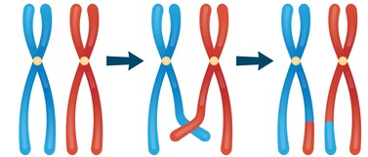
A B C
a) Which term is used to describe the association of chromosomes as shown in B
………………………………………………………………………………………...(1mk
- Explain how the process labelled C benefits the theory of evolution (3mks
………………………………………………………………………………………………………………………………………………………………………………………………………………………………………………………………………………………………

- a) Name TWO chemical forms in which Carbon (IV) oxide is transported by blood
………………………………………………………………………………………………………………………………………………………………………………………(2mks
b) Explain why increase in Carbon (IV) Oxide in the blood may be fatal
………………………………………………………………………………………………………………………………………………………………………………………(2mks

- Explain the importance of Gibberellin during the process of germination (2mks
………………………………………………………………………………………………………………………………………………………………………………………………

- James observed 10 cells along the diameter of the field of view of a light microscope measuring 3mm. If the actual diameter of a one cell was 0.3micrometers, determine the magnification used to observe the cells. (3mks
………………………………………………………………………………………………………………………………………………………………………………………………………………………………………………………………………………………………
- State the use of the following instruments in ecological studies (3mks
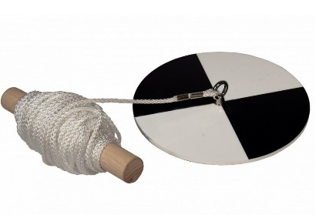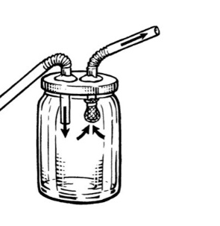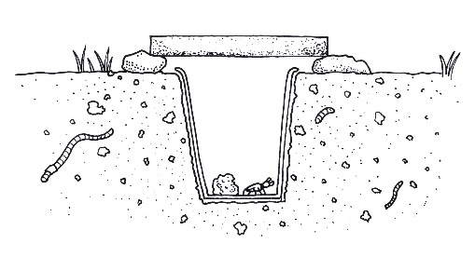
X Y Z
a) Y …………………………………………………………………………………………
b) Z ………………………………………………………………………………………...
c) X …………………………………………………………………………………………

- a) Name the sub-division of seeded plants that experience double fertilization (1mk
………………………………………………………………………………………………
b) State FOUR post-fertilization changes that takes place in a flower (4mks
………………………………………………………………………………………………………………………………………………………………………………………………………………………………………………………………………………………………………………………………………………………………………………………………

- Differentiate between heterozygous and homozygous genotypes (2mks
………………………………………………………………………………………………………………………………………………………………………………………………………………………………………………………………………………………………

- A group of researchers caught 350 fish from a pond, tagged them then released them back to the pond. 24 hours later, 300 fish were caught out of which 150 had tags. Determine the population of fish in the pond. (3mks
………………………………………………………………………………………………………………………………………………………………………………………………………………………………………………………………………………………………

- The set up shown below was used to study a physiological process
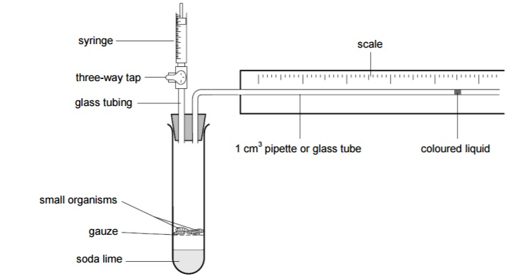
- What was the use of Soda lime? (1mk
………………………………………………………………………………………………
- Account for the observation on direction of movement of the coloured water after 1hour
………………………………………………………………………………………………………………………………………………………………………………………………………………………………………………………………………………………..(3mks
- Explain how the following affect rate of transpiration: (4mks
- Low humidity …………………………………………………………………………..
…………………………………………………………………………………………..
- Broad leaf surface …………………………...…………………………………………
…………………………………………………………………………………………..

- a) Why do herbivores need the following features? (2mks
i) Diastema …………………………………………………………………………………
ii) Long gut ………………..……………………………………………………………….
b) Explain how beneficial it is for some herbivores being grazers and others being browsers
………………………………………………………………………………………………………………………………………………………………………………………………………………………………………………………………………………………..(2mks
- The graph represented below shows how percentage of energy from carbohydrates and fats in the body of an athlete vary according to the intensity of exercise in the
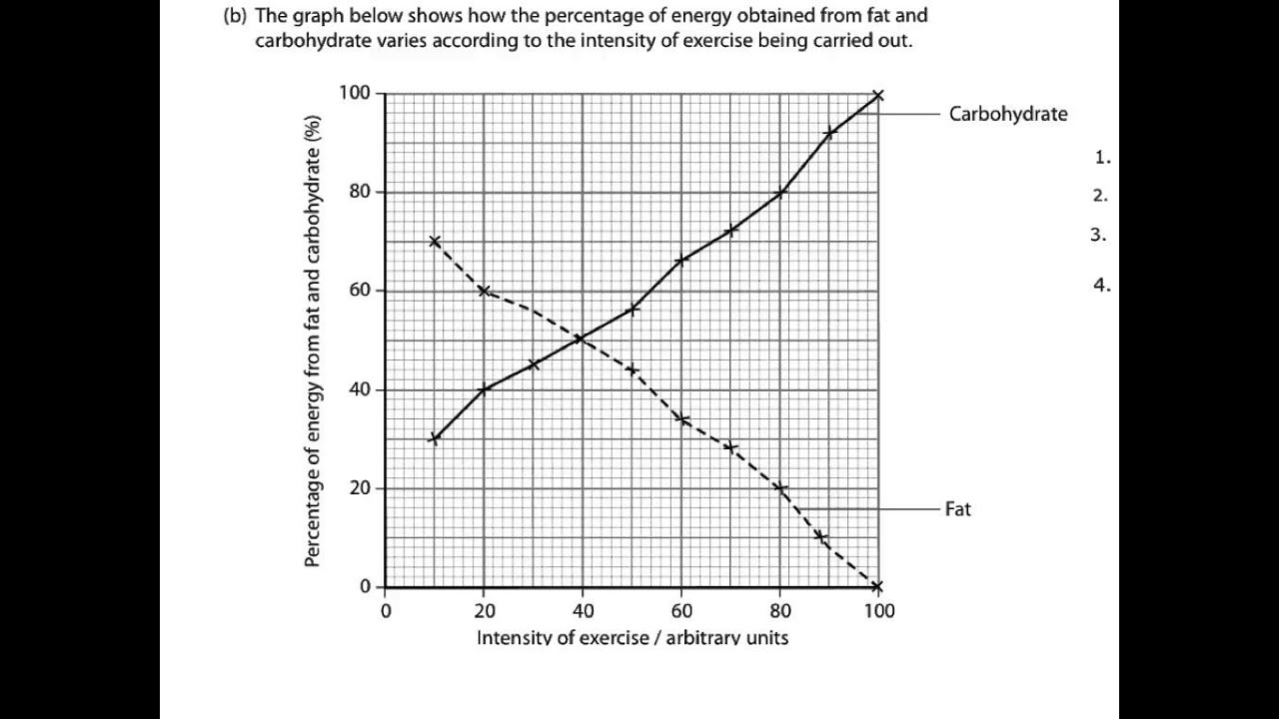
- Account for the change in percentage energy released when the intensity of exercise is at between 40 to 80 arbitrary units (3mks
………………………………………………………………………………………………………………………………………………………………………………………………………………………………………………………………………………………………
- State TWO properties of lipids (2mks
………………………………………………………………………………………………………………………………………………………………………………………………

- Explain the following observations
- A person of Blood group A cannot receive blood from a person of Blood group B
………………………………………………………………………………………………………………………………………………………………………………………………………………………………………………………………………………………..(2mks
- No Digestion of Starch occurs in the stomach
………………………………………………………………………………………………………………………………………………………………………………………………………………………………………………………………………………………..(2mks

- The following are types of flowers illustrated
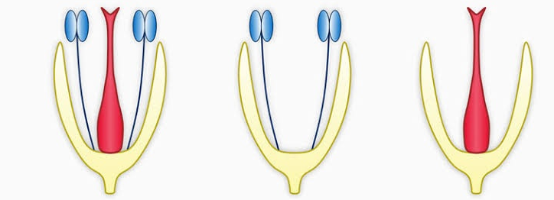
P Q R
a) Give the term that is used to identify each of the following flowers as per their sexes
i) P …………………………………………………………………………..…..……(1mk
ii) Q ………...…………………………………………………………….……..…....(1mk
b) Explain the advantage flower R has over flower P (2mks
………………………………………………………………………………………………………………………………………………………………………………………………

- Study the structures shown below and answer questions that follow
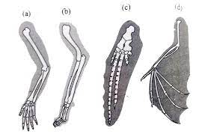
- Name the type of evolution represented above (1mk
………………………………………………………………………………………………
- How is the type of evolution named in a) above advantageous to organisms (2mks
………………………………………………………………………………………………………………………………………………………………………………………………

- John and Jane both have normal blood clotting but have a haemophiliac son and two daughters. Using ‘h’ for the recessive gene, determine the genotypes of their children. ……………………………………………………………………………………………………………………………………………………………………………………………………………………………………………………………………………………………………………………………………………………………………………………………………………………………………………………………………………………………………………………………………………………………………………………………………………………………………………………………………………………..…(4mks

- Give the economic importance of the following (2mks
- Colchicine
………………………………………………………………………………………………………………………………………………………………………………………………

- Quinine
………………………………………………………………………………………………………………………………………………………………………………………………

- a) State the differences between herbivores and carnivores in terms of the following dental features (3mks
Dental Feature | Carnivores | Herbivores
Canine
Carnassial Tooth
Molar

- Name the nutrient important in the following: (2mks
i) Impulse transmission ……………………………………………………………………..
ii) Haemoglobin formation …………………………………………………………………

- State TWO roles of the tongue in digestion process (2mks
………………………………………………………………………………………………………………………………………………………………………………………………………………………………………………………………………………………………………

- Use the diagram shown to answer questions that follow
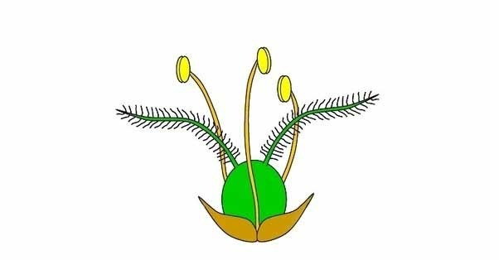
State how the following parts adapt the flower above to pollination by wind (3mks
Part | Adaptations
Bracts
Stigma
Filament

END

