TERM 1 – 2026
BIOLOGY (231/1)
FORM FOUR (4)
Time: 2 Hours
MARKING SCHEME

- a) Bursting of Red Blood Cells/Erythrocytes due to excessive gain of water molecules by osmosis from a hypotonic/dilute solution/Distilled water; REJ Animal cell/Cell
b) Dip the cell in distilled water/dilute/hypotonic solution (for some time).
- a) Monera; b) Plantae.
- a) Photolysis/Breakdown of water molecules to hydrogen ions and Oxygen; Generation of Energy.
b) Carbon (IV) Oxide: REJ CO₂/
- a) Biocatalyst/Substance that increases/catalyses rate of metabolic reactions;
b) Churning/Mixing of food and gastric/digestive juices; Peristalsis/Movement of food; Regulates movement of food/Acts as a valve; 1st TWO
- a) Synapsis; b) Crossing over/exchange/mixing of genes; leads to variation; whose accumulation over time may lead to emergence of new species/evolution.
- a) Carbaminohaemoglobin; Hydrogen Carbonate/Bicarbonate ions; Dissolved Carbon (IV) Oxide;
b) Dissolves to form carbonic acid that releases Hydrogen ions leading to decline in pH/Increase in acidity; that may denature enzymes;
- Activate enzymes that hydrolyse stored food which are oxidized to release energy used in cell division; Stimulate embryo growth/cell division;
- 10cells measure 3mm Thus 1 cell will measure (1 x 3mm)/10cells = 0.3mm
Magnification = Image length/actual length
= (0.3mm x1000micrometers÷1mm)/0.3micrometers;
= X1000;
- a) Y-Suck small animals; b) Z-Trap small crawling animals.
c) X-Determine the depth of light penetration in water body;
- a) Angiospermatophyta; b) zygote becomes seed; ovary becomes fruit; ovary wall develops into pericarp; style, petals dry off.
- Homozygous genotype is a case where alleles of the same kind occur in the same locus; while heterozygous genotype is a case where different alleles/variations of a gene occupy same locus;
- (350fish X 300fish)/150fish; = 700fish;
- a) Absorb Carbon (IV) Oxide;
b) coloured liquid moves towards the test tube; small organisms will utilize more of the oxygen for respiration thus reducing air volume; while the released Carbon (IV) Oxide will be absorbed by the soda lime (reducing the air volume further);
- a) Reduces saturation deficit; thus lowers rate of transpiration;
b) Increase surface area; thus high rate of transpiration;
- ai) Diastema-create more space for tongue to move when turning food during chewing;
ii) Increase surface area/Offer more time to process food;
b) Reduce competition for food/vegetation; thus enhance survival;
- a) More energy generated from carbohydrates than fats; since carbohydrates are being oxidized more than fats given that carbohydrates are more soluble and easy to transport to respiratory sites than fats; carbohydrates also need less Oxygen (which is scarce during exercise) than fats to oxidise;
b) Insoluble in water; soluble in organic solvents to form emulsions; Are inert; fats are solid at room temperature while oils are liquid at same temperature; 1st 2
- a) A person of Blood Group A has anti-B antibodies/b which will react with antigen B on surface of Red Blood Cells (RBCs); Leading to Agglutination/Clumping of RBCs (that may be fatal);
b) No starch-digesting enzyme is secreted in the stomach; Acidic pH denatures the amylase in the food coming from the mouth;
- a) i) P – Bisexual/Hermaphrodite; ii) Q-Staminate;
b) Encourages cross pollination; that may lead to advantageous variations;
- a) Divergent evolution
b) Leads organisms to develop adaptations; for exploitation of different niches;

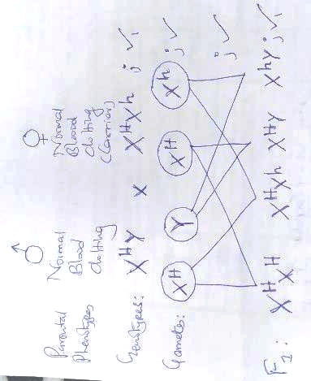

- a) Genetic research/Induce Polyploidy; Cancer therapy;
b) Malaria treatment/Manufacture anti-malarial drugs/Anti-malarial;
- l
Dental Feature | Carnivores | Herbivores
Canine | Long and curved; Larger | Smaller;
Carnassial Tooth | Present | Lacks;
Molar | Sharply edged | Flat;

- i) Potassium and Sodium; ii) Iron;
- Turn food during chewing; Bolus formation; Push Bolus to the back of the mouth; 1st 2

Part | Adaptations
Bracts | Small/Reduced to ensure stigma and anthers exposed to wind;
Stigma | Feathery to increase surface area to trap pollen grains in the air;
Filament | Long to expose anthers to wind for pollen grains to be easily carried away;

END

