TERM 1 – 2026
ART AND DESIGN (442/1)
PAPER 1
FORM FOUR (4)
Time: 2 Hours

Name: …………………………………………………………. Adm No: ……………….
School: ……………………………………………………….. Class: …………………..
Signature: …………………………………………………….. Date: …………………...

INSTRUCTIONS TO CANDIDATES

Write your name and index number in the spaces provided above
Sign and write the date of the examination in the spaces provided above.

This question paper consists of two sections A, and

Answer all questions in section A and B and any one question in section C

Answers to all the questions must be written in the spaces provided in this booklet.

Do not remove any paper from this booklet.

For Official Use Only

Section |  | Question | Maximum score | Candidates’ Score
A |  |  | 25
B |  |  | 35
c |  |  | 15
Total Score: |  |  | 70

SECTION A (25MARKS)

Answer all the questions in this section in the spaces provided.
1.

a) What is meant by the term layout in design? (1mk)
___________________________________________________________________________
___________________________________________________________________________
___________________________________________________________________________
___________________________________________________________________________

b)i) Define dabbing in art(2mks)
___________________________________________________________________________
___________________________________________________________________________
___________________________________________________________________________

(ii) Give two types of wash as a technique used in art (2mks)

c) Give two characteristics of asymmetrical balance(2mks)
___________________________________________________________________________

___________________________________________________________________________
___________________________________________________________________________
___________________________________________________________________________
___________________________________________________________________________

d,) Define the term foreshortening(use an illustration)-3mks ……………………………………………………………………………………………………………………………………………………………………………………………………….

e) Identify any two characteristics of cool colours (2mks)
___________________________________________________________________________
__________________________________________________________________________

f)(i) Identify the type of repeat used in the illustration below(1mks)

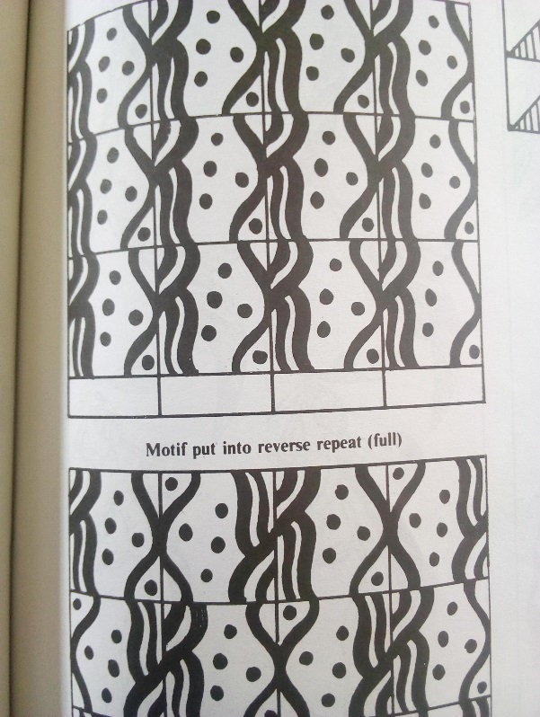

(f)ii Give any other two types of repeats apart from the one named above.(2mks)

---------------------------------------------------------------------------

g) Distinguish between twilling and twinning (2mks)
___________________________________________________________________________

___________________________________________________________________________
____________________
___________________________________________________________________________
___________________________________________________________________________
____________________

h) Explain the term AXIS as used in art and design. (2mks)
___________________________________________________________________________
___________________________________________________________________________
___________________________________________________________________________
______________________________

i) Describe any two types of eye levels I n drawing art works (2mks)

j) Using illustrations, Explain any two tapestry techniques (2marks)

k) Give any two cooperate identities (2mks)

………………………………………………………………………………………………………………..

…………………………………………………………………………………………………………………..

SECTION B (35 MARKS)

Answer ALL the questions in this section in the spaces provided.
2 a) Explain the term ‘pigment (1mk)?
___________________________________________________________________________
___________________________________________________________________________
______________________________________

b) State any two components of a letter head. (2mks)
___________________________________________________________________________

___________________________________________________________________________
___________________________________________________________________________

c) Describe stippling as a process in art. (2mks)
___________________________________________________________________________
___________________________________________________________________________
___________________________________________________________________________

3. Study the form below and answer the questions that follow:

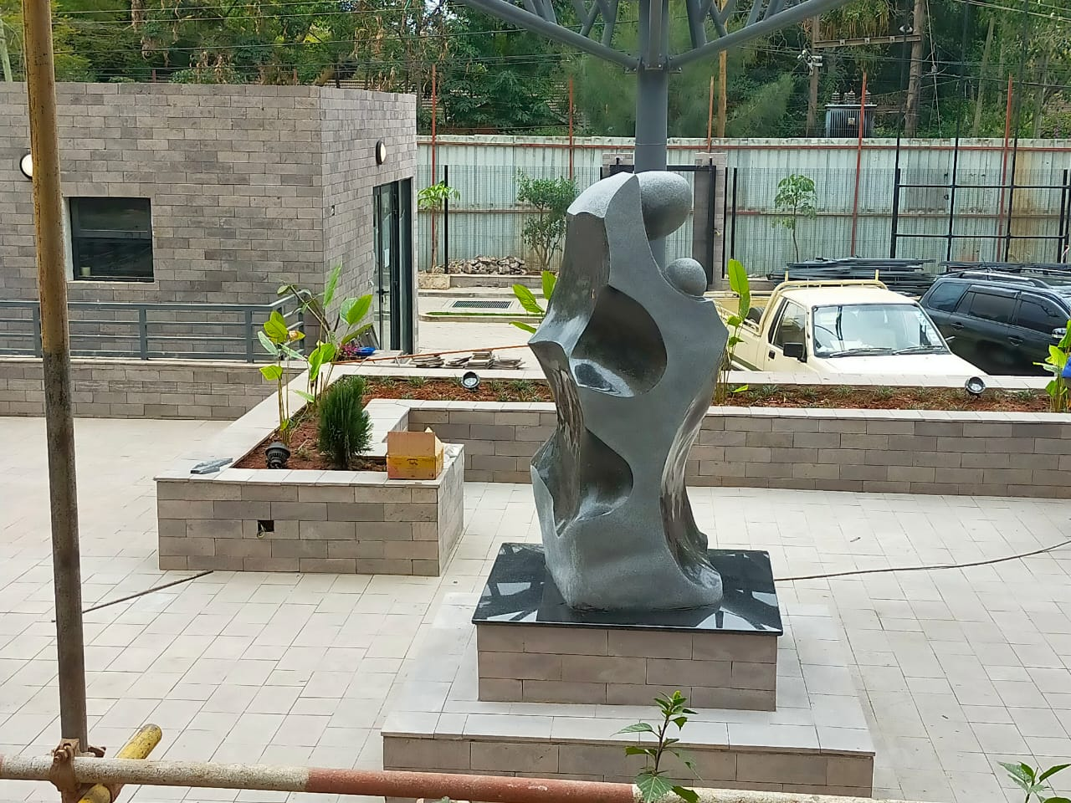
(i)State the type of the artwork above. (1mk)

(ii)The technique used to create the artwork above (1mk

(iii) Identify any two outstanding elements and how they have been portrayed/ achieved (2mks)
………………………………………………………………………………….
……………………………………………………………………………………
(iv)Give a suitable subject matter/theme of the artwork above (1mk)
……………………………………………………………………….

4) (a) In colour relationships, differentiate between analogous and complimentary colours, giving examples of each (4mks
………………………………………………………………………………………………………………………………………………………………………………………………………………………………………………………………………………………………………………………………………………………………………………………………………………………………………………………………………………………………………………………………………………………………………………………………………………………………………………………………………………………………………………………………………………………………………..

(b) Fill in by writing/labeling all the missing triadic colours X, Y and Z in the chart above (3mks))

RO=Red Orange

X……………………………………………………….

Y………………………………………………………..

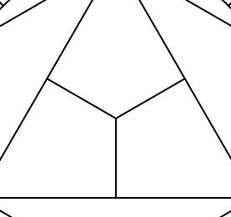
Z……………………......................................
Green
Purple
X
Y
Z
RO Ora
(5)a (Give any two tapestry techniques (2mks)
………………………………………………………………………………………………………………………………………………………………………………………………………………………………………………………………………………………………………… (b)Give an three techniques of finishing oven items (3mks) ………………………………………………………………………………………………………………………………………………………………………………………………………………………………………………………………………………………………………………………………………………………………………………………………………………………………………………………………
6(a) Outline five clay preparation processes (5mks)
……………………………………………………………………………………………………..
…………………………………………………………………………………………………….
…………………………………………………………………………………………………….
……………………………………………………………………………………………………..
………………………………………………………………………………………………………

(b) Differentiate Grog from Slip. (2mks)
…………………………………………………………………………………………………………………………………………………………………………………………………………………………………………………………………………………………………………………………………………………………………………………………………………………………………………………………………………………………………………………………………………………………………………………………………….
7 (a) what is an Easel and what is its function (1mks)
………………………………………………………………………………………………………………………………………………………………………………………………………………………………………………………………………………………………………………………………………………………………………………………………………………………………………………..
(b) Explain any two painting techniques (2mks)

…………………………………………………………………………………………………………………………………………………………………………………………………………………………………………………………………………………………………………
(c) Define registration as an art technique and how it is used. (3mks)
…………………………………………………………………………………………………………………………………………………………………………………………………………………………………………………………………………………………………………………………………………………………………………………………………………………………………………………………………………………………………………………………………………………………………………………………………….

___ SECTION C: (15 Marks)
Answer any ONE question in this section. Write your answer in the space after Question 10.
8. (a) Define weaving” (1mark)
(b) Describe 3 types of plain weave (6mks)
(c) Mention 4 tools used in weaving (4mks)
(d) Explain the weaving defects (4mks)

9(a) With reference to ornaments, what is incising? (1 mark)
(b) Identify 3 factors to consider while designing clay necklaces (6 mks)
(c) Describe the process of making beads using papier mache (8mks)

10. a) State and describe the stages of graphic design process. (10 marks)
b) Using the word DAY, Name and label the counters, cross bar apex and stem. (4 marks)
c) What are illustrations in graphic design? (1 mark)

……………………………………………………………………………………………………………………………………………………………………………………………………………………………………………………………………………………………………………………………………
………………………………………………………………………………………………………………………………………………………………………………………………………………………………………….…………………………………………………………………………………………
…………………………………………………………………………………………………………………………………………………………………………………………………………………………………………………………………………………………………………………………….………
……………………………………………….…………………………………………………………………………………………………………………………………………………………………..…………………………………………………………………………………………………………..……
………………………………………………….………………………………………………………………………………………………………………………………………………………………….………………………………………………………………………………………………………………
……………………………………………………………………………………………………………………………………………………………………………………………………………………………………………………………………………………………………………………………………
………………………………………………………………………………………………………………………………………………………………………………………………………………………………………….…………………………………………………………………………………………
…………………………………………………………………………………………………………………………………………………………………………………………………………………………………………………………………………………………………………………………….………
……………………………………………….…………………………………………………………………………………………………………………………………………………………………..…………………………………………………………………………………………………………..……
………………………………………………….………………………………………………………………………………………………………………………………………………………………….………………………………………………………………………………………………………………
……………………………………………………………………………………………………………………………………………………………………………………………………………………………………………………………………………………………………………………………………
………………………………………………………………………………………………………………………………………………………………………………………………………………………………………….…………………………………………………………………………………………
…………………………………………………………………………………………………………………………………………………………………………………………………………………………………………………………………………………………………………………………….………
……………………………………………….…………………………………………………………………………………………………………………………………………………………………..…………………………………………………………………………………………………………..……
………………………………………………….………………………………………………………………………………………………………………………………………………………………….………………………………………………………………………………………………………………
………………………………………………………………………………………………………………………………………………………………………………………………………………………………………………………………………………………………………………………………………………………………………………………………………………………………………………………………………………………………………………………………………………………………………………………………………………………………………………………………………………………………………………………………………………………………………………………………………………………………………………………………………………………………………………………………………………………………………………………………………………………………………………………………………………………………………………………………………………………………………………….

……………………………………………………………………………………………………………………………………………………………………………………………………………………………………………………………………………………………………………………………………
………………………………………………………………………………………………………………………………………………………………………………………………………………………………………….…………………………………………………………………………………………
…………………………………………………………………………………………………………………………………………………………………………………………………………………………………………………………………………………………………………………………….………
……………………………………………….…………………………………………………………………………………………………………………………………………………………………..…………………………………………………………………………………………………………..……
………………………………………………….………………………………………………………………………………………………………………………………………………………………….………………………………………………………………………………………………………………
……………………………………………………………………………………………………………………………………………………………………………………………………………………………………………………………………………………………………………………………………
………………………………………………………………………………………………………………………………………………………………………………………………………………………………………….…………………………………………………………………………………………
…………………………………………………………………………………………………………………………………………………………………………………………………………………………………………………………………………………………………………………………….………
……………………………………………….…………………………………………………………………………………………………………………………………………………………………..…………………………………………………………………………………………………………..……
………………………………………………….………………………………………………………………………………………………………………………………………………………………….………………………………………………………………………………………………………………
………………………………………………………………………………………………………………………………………………………………………………………………………………………………………………………………………………………………………………………………………………………………………………………………………………………………………………………………………………………………………………………………………………………………………………………………………………………………………………………………………………………………………………………………………………………………………………………………………………………………………………………………………………………………………………………………………………………………………………………………………………

