TERM 1 – 2026
ART AND DESIGN (442/1)
PAPER 1
FORM FOUR (4)
Time: 2 Hours
MARKING SCHEME

INSTRUCTIONS TO CANDIDATES

Write your name and index number in the spaces provided above
Sign and write the date of the examination in the spaces provided above.

This question paper consists of two sections A, and

Answer all questions in section A and B and any 0ne in section C.

Answers to all the questions must be written in the spaces provided in this booklet.

Do not remove any paper from this booklet.

For Official Use Only
SECTION A (25MARKS)

Answer all the questions in this section in the spaces provided.
1.

a) layout in design-The arrangement of elements of art/design such as colour ,shapes, lines etc. on a composition/in a working space (1mk)

b )i) Dabbing- Apply by tapping gently with a brush, sponge or rug.
-The technique of using edge of a sponge or piece of soft material to create a texture in a painting (2mks)

(ii) Types of wash as a technique used in art (2mks)
Graded wash
Plain wash

c) Two characteristics of asymmetrical balance(2mks)
-The elements on either side of the axis are not identical
-It brings a feeling of instability and arouses curiosity.
-There’s no monotony since elements on either side are different

d,) Foreshortening -A technique of drawing in art that shows illusion/perspective where by the shape closest to the eye level appears bigger, wider and more clear than those quite a distant.-well explained with illustration-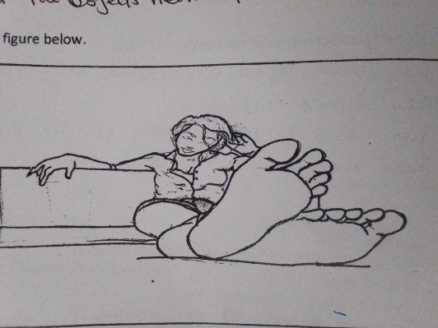(3mks )
e) Any two characteristics of cool colours (2mks)
_Are associated with coldness, water and life
-They tend to recede away from the viewer
-They appear restful.
(f)The type of repeat used in the illustration bellow –Full repeat (1mk)
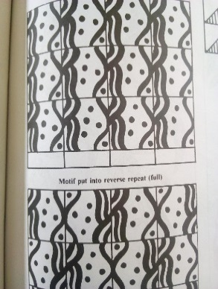
(f) ii Any other two types of repeats apart from the one named above.
Full drop
Half drop
Inverse
Progression (Any 2=2mks)

g) Twilling-A weaving technique where two warp threads are interlaced with two wefts, or three over 1 warp threads while twinning is a weaving technique where two wefts wind over one warp thread (2mks)

h) The term AXIS as used in art and design refers to a central imaginary vertical line that divides a form/shape and their elements into two equal parts. (2mks)

- Any two types of eye levels I n drawing art works
Worm’s eye level-The viewer looks at the object from bellow
Bird’s eye level-The viewer looks at the objects from above
-Normal eye level-The viewer looks at the objects neither from below nor from above –Any =2mks)

j) Any two any two tapestry techniques (2marks)
Dove tailing
Slit
Angular
Interlocking (Any 2 well explained/illustrated =2marks)

k) Any two cooperate identities
Envelopes, Carrier bags, Business cards, flyers, Brochures, letterheads, calendars, complimentary slips, memo cards, (Any 2=2mks)

SECTION B (35 MARKS)

Answer ALL the questions in this section in the spaces provided.
2 a) Pigment-The natural colouring matter that gives an object/ surface its color (1mk)?

b) Any two components of a letter head.
-Name of the company
-Company logo
-Company address, contacts, mail (2mks)

c) Stippling as a process in art-A technique of creating patterns of varying degrees of tone or texture to create 3D surface by use of small dots while drawing/painting/engraving. (2mks)

3 (i) The type of the art work above. (1mk)

Abstract sculpture
(ii)The technique used to create the art work above (1mk

Subtraction/curving
(iii) Two outstanding elements and how they have been portrayed/ achieved
-Voids -The hollow parts are more pronounced by curving them further deep
Contours-The edges between the planes are more visibly emphasized
Planes-Areas with flat and less alterations are clearly seen and smoothly textured (any 2=2mks)

(iv)Suitable subject matter/theme of the artwork above (1mk)
Embrace/Parental care/love.

4)(a) In colour relationships, differentiate between analogous and complimentary colours, giving examples of each (4mks
Analogous colours are close/next to each other on the colour wheel
Complimentary colours are directly opposite the other on the colour wheel.
(b) Fill in by writing/labeling all the missing triadic colours X, Y and Z in the chart above (3mks))

RO=Red Orange

X=Orange

Y=Yellow Green

Z=Blue purple

(5)a (Any two tapestry techniques
-Dovetailing
-slit
Angular
Interlocking (any 2-2ms)
(b)Any three techniques of finishing oven items
-Knotting
-Hemming
Twisting/plaiting
Fraying
-Beading (any =3mks)

6(a) five clay preparation processes
-Mining/extraction
-Crushing, sieving
-Mixing, Slaking
-Kneading/wedging
-Storing
(5 chronologically stated processes=5mks)

(b) Grog-Crushed/ground fired ceramic broken pieces in a bisque powder form used as a hardener/stiffener while working with clay, while Slip is very soft porridge –like clay used for various purposes such as joining slabs, coils and trailing in ceramic decoration and finishing while in a leather hard state. (2mks)

7 (a) An Easel and its function
-A wooden stand/frame for holding an artist’s work during drawing and painting usually reaching at a slightly raised/elevated angle. (1mk)

(b) Any two painting techniques
-Pellet Knife
-Brush stroke
-Dry brush
-Dabbing-Apply by tapping gently with a brush, sponge or rug
-Washout-Applying light paint to the entire background graded or plainly
-Air brushing-use of small jets such as spray gun or spray paints, or compressed air {any two well explained=2mks]
(c) Registration and here it is used
-Drawing using grids which guide the artist/printer in accurate placement of the image/pattern on a drawing/printing surface so that the final outcome is repeated accurately.
Used in drawing, painting and printing.
Use of grids (3mks)

___ SECTION C: (15 Marks)
Answer any ONE question in this section. Write your answer in the spaces provided.
8. (a) weaving-The process of interlacing a set of vertical threads(warps) with another set of horizontal threads(wefts) to create a fabric/woven article. (1mark)
(b) 3 types of plain weave
Balanced
Open work
Warp faced
Weft faced (6mks)
(c) 4 tools used in weaving
Looms, Shuttle, shed stick, heddle, beater (4mks)
(d) Weaving defects
Sagging
Waisting (Well explained=4mks)
9(a) With reference to ornaments, what is incising-Use of sharp tools to scratch patterns on a leather hard /greenware (1 mark)
(b) 3 factors to consider while designing clay necklaces
Weight
Size
Design/shape, texture, colour
Function/purpose/Tools and materials/Technique and process (Any 3 well explained=6mks)
(c) Describe the process of making beads using papier mache
-Design the sketch of the beads
-Get a bucket and soak the news prints and soft chopped papers/pulp for some days (2-3)
-Squeeze out/drain the water and mash them to a paste/pulp
- add adhesive such as wheat flour or wood glue
-Create shapes according to the design
-Create holes in the beads
-Let them dry and sand paper to smoothen
-Paint according to the required design and varnish after drying
Let in a fishing wire or strong thread/string and fix the edges with a stopper/knot and put to use. (8 mks)

10.a) Stages of graphic design process.
- Design brief getting information from the client [the designer meets with the client to discuss the need/problem i.e. theme/topic, time frame, budget, tools and materials, etc
- Research and gathering /experimenting with related media and tools-observation, analysis, interviews and discussion with relevant persons
- Lay out composition/arranging visual elements such as typos, letters, illustrations, etc by making preliminary sketches
-Client presentation-the client may suggest some changes, alterations and makes approvals, while guided by the designer as a professional, determining or selection of the final sketch(es)
-Final presentation (10 marks)
b) Using the word DAY, Name and label the counters, cross bar apex and stem. 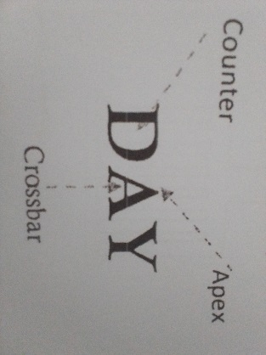 (4 marks)
STEM
c) Illustrations in graphic design-Visual/pictorial designs used to visually communicate/convey the message effectively. Can be pictorial, typographic, textural, or pictorial with text. (1 mark)

