Term 1 - 2026
AGRICULTURE (443/2)
PAPER 2
FORM FOUR (4)
TIME: 2 HOURS
Name: …………………………………………………………. Adm No: ……………….
School: ……………………………………………………….. Class: …………………..
Signature: ……………………………………………………..Date: …………………….

INSTRUCTIONS TO CANDIDATES:
- Write your name, class and admission number in the spaces provided above
- This paper consists of three section A, B and C
- Answer all the questions in section A and B
- Answer any two questions in section C.
- Answers should be written in the spaces provided in this booklet.

For Examiner’s Use Only:

SECTION | QUESTIONS | MAXIMUM SCORE | CANDIDATES SCORE
A |  | 30
B |  | 20
C |  | 20
 |  | 20
 | TOTAL | 90

This paper consists of 16 printed pages. Candidates should check to ascertain that all papers are printed as indicated and that no questions are missing.

SECTION A (30 MARKS)
1. List three types of calf pens (1 ½ mks)
…………………………………………………………………………………………………………..
…………………………………………………………………………………………………………..
…………………………………………………………………………………………………………..
2. Name four systems of a tractor engine (2 mks)
…………………………………………………………………………………………………………..
…………………………………………………………………………………………………………..
…………………………………………………………………………………………………………..
…………………………………………………………………………………………………………..
3. Give two reasons for using litter in a poultry house (2mks)
…………………………………………………………………………………………………………..
…………………………………………………………………………………………………………..
4. Name two diseases of poultry that are controlled by vaccination (1 mk)
…………………………………………………………………………………………………………..
…………………………………………………………………………………………………………..
5. State two factors that could lead to failure to conceive in sows after service (1 mk)
…………………………………………………………………………………………………………..
…………………………………………………………………………………………………………..
6. Give two causes of scouring in calves (2 mks)
…………………………………………………………………………………………………………..
…………………………………………………………………………………………………………..
7. State three factors that would determine the amount of concentrate fed to dairy cattle (1 ½ mks)
…………………………………………………………………………………………………………..
…………………………………………………………………………………………………………..
…………………………………………………………………………………………………………..
8. Give three ways of stimulating milk let down in a dairy cow (1 ½ mks)
…………………………………………………………………………………………………………..
…………………………………………………………………………………………………………..
…………………………………………………………………………………………………………..
9. List two equipments used in handling cattle during an Agricultural exhibition (1 mk)
…………………………………………………………………………………………………………..
…………………………………………………………………………………………………………..
10. State three signs of anthrax injection disease observed in the carcass of a cattle (1 ½mks)
…………………………………………………………………………………………………………..
…………………………………………………………………………………………………………..
…………………………………………………………………………………………………………..
11. Give any two effects of external parasites that are harmful to livestock (2 mks)
…………………………………………………………………………………………………………..
…………………………………………………………………………………………………………..
12. Name four breeds of dairy goats (2 mks)
…………………………………………………………………………………………………………..
…………………………………………………………………………………………………………..
…………………………………………………………………………………………………………..
…………………………………………………………………………………………………………..
13. Give one function of the clutch (1 mk)
…………………………………………………………………………………………………………..
14. State two adjustments that should be carried out on a tractor – mounted mould board plough
in preparation for ploughing (2 mks)
…………………………………………………………………………………………………………..
…………………………………………………………………………………………………………..
15. List the methods of selection in livestock (1 ½ mks)
…………………………………………………………………………………………………………..
…………………………………………………………………………………………………………..
…………………………………………………………………………………………………………..
16. Differentiate between active immunity and acquired passive immunity (2 mks)
…………………………………………………………………………………………………………..
…………………………………………………………………………………………………………..
…………………………………………………………………………………………………………..
…………………………………………………………………………………………………………..
17. Define the following terms as used in livestock breeding (2 mks)
i) Heterosis
…………………………………………………………………………………………………………..
…………………………………………………………………………………………………………..
ii) Epistasis
…………………………………………………………………………………………………………..
…………………………………………………………………………………………………………..
18. State three signs of heat in Does (Female Rabbits) (1 ½ mks)
…………………………………………………………………………………………………………..
…………………………………………………………………………………………………………..
…………………………………………………………………………………………………………..

19. Give the gestation period of the following: (1 ½ mks)
i) Cow …………………………………………………………………………………
ii) Sow ………………………………………………………………………………….

SECTION B (20 MARKS)
Answer all the questions in this section in the space provided
20. Study the diagram below and answer the questions that follow;
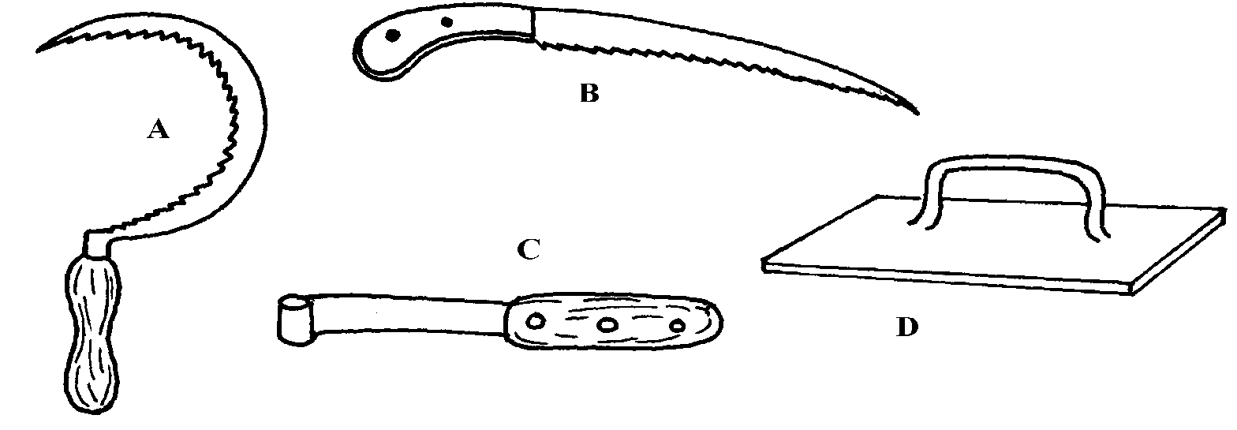

i) Identify the tools (2 mks)
A………………………………………………………………………………………………...
B ………………………………………………………………………………………………..
C ………………………………………………………………………………………………..
D ………………………………………………………………………………………………..

ii) Give the use of each of the tools named above (4 mks)
A………………………………………………………………………………………………...
B ………………………………………………………………………………………………..
C ………………………………………………………………………………………………..
D ………………………………………………………………………………………………..

iii) State two maintenance practices that should be carried out on tool D (2 mks)
…………………………………………………………………………………………………………..
…………………………………………………………………………………………………………..

21. Study the illustration of a farm structure below and answer the questions that follow
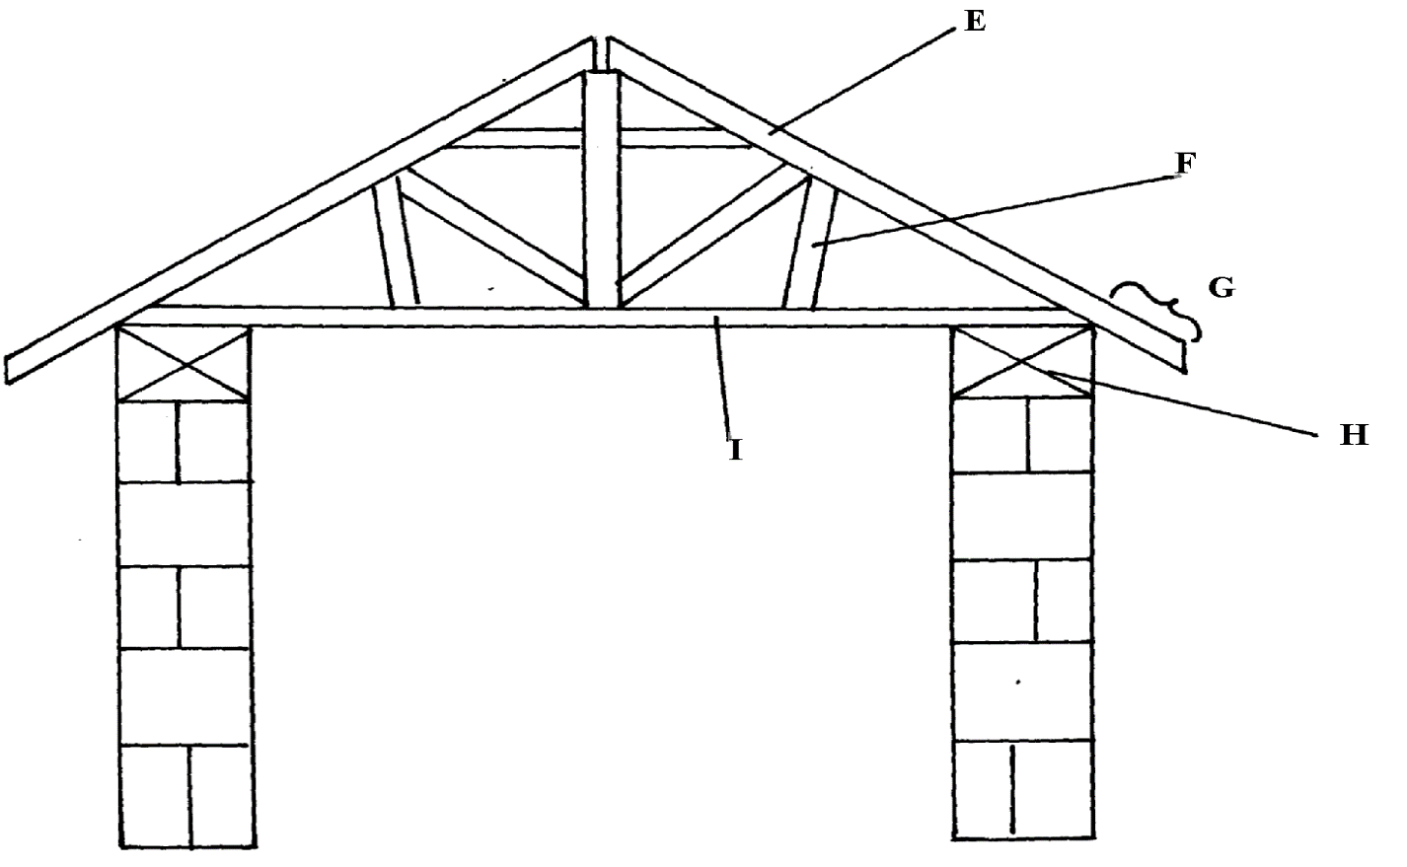

i) Name the parts labeled (2 mks)
E ……………………………………………………………………………………………….
F ………………………………………………………………………………………………...
G ………………………………………………………………………………………………..
H ………………………………………………………………………………………………..
ii) State the function of the parts labeled
E ……………………………………………………………………………………………….
F ………………………………………………………………………………………………...
G ………………………………………………………………………………………………..
H ………………………………………………………………………………………………..

iii) Name two chemicals preservatives used to treat the wooden parts of the structure against
insects and fungal damage (1 mk)
…………………………………………………………………………………………………………..
…………………………………………………………………………………………………………..

22. Below is a diagram of a fish pond, study it and answer the questions that follow
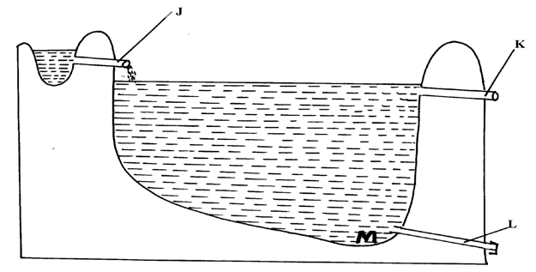

i) Label the parts marked K and L (1 mk)
…………………………………………………………………………………………………………..
…………………………………………………………………………………………………………..
ii) Give a reason why part M is usually deeper than the rest of the pond (1 mk)
…………………………………………………………………………………………………………..
…………………………………………………………………………………………………………..
iii) State three maintenance practices carried out in the pond (3 mks)
…………………………………………………………………………………………………………..
…………………………………………………………………………………………………………..
…………………………………………………………………………………………………………..
…………………………………………………………………………………………………………..

23. Outline the procedure followed when hand-spraying cattle to ensure effective use of acaricides
to control ticks (5 mks)
…………………………………………………………………………………………………………..
…………………………………………………………………………………………………………..
…………………………………………………………………………………………………………..
…………………………………………………………………………………………………………..

24. The diagram below illustrates a farm implement. Study it and answer the questions that follow
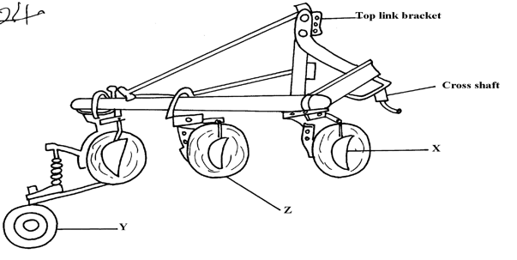

a) Identify the implement (½mks)
…………………………………………………………………………………………………………..
b) Name the parts labeled X, Y and Z (1 ½ mks)
X ………………………………………………………………………………………………..
Y ………………………………………………………………………………………………..
Z ……………………………………………………………………………………………...
c) State three maintenance practices that are carried out on a disc plough (3 mks)
…………………………………………………………………………………………………………..
…………………………………………………………………………………………………………..
…………………………………………………………………………………………………………..
SECTION C (40 MARKS)
Answer any two questions only in the spaces provided after the last question
25. a) Explain five factors to consider when siting a fishpond (8 mks)
b) Explain the measures used to control livestock diseases (12 mks)

26. a) Describe the operational differences of a disc plough and mould board plough (10 mks)
b) Explain six marketing problems affecting dairy farming in Kenya (6 mks)
c) State four reasons for culling a boar (4 mks)

27. a) A boar gained 90Kg live weight after eating 360Kg pig finisher meal over a period of
time. Calculate the feed conversion ratio (2 mks)
b) Describe digestion in the four stomachs of the ruminant animal (14 mks)
c) Give the significance of lubrication system (4 mks)
…………………………………………………………………………………………………………..
…………………………………………………………………………………………………………..
…………………………………………………………………………………………………………..
…………………………………………………………………………………………………………..
…………………………………………………………………………………………………………..
…………………………………………………………………………………………………………..
…………………………………………………………………………………………………………..
…………………………………………………………………………………………………………..
…………………………………………………………………………………………………………..
…………………………………………………………………………………………………………..
…………………………………………………………………………………………………………..
…………………………………………………………………………………………………………..
…………………………………………………………………………………………………………..
…………………………………………………………………………………………………………..
…………………………………………………………………………………………………………..
…………………………………………………………………………………………………………..
…………………………………………………………………………………………………………..
…………………………………………………………………………………………………………..
…………………………………………………………………………………………………………..
…………………………………………………………………………………………………………..
…………………………………………………………………………………………………………..
…………………………………………………………………………………………………………..
…………………………………………………………………………………………………………..
…………………………………………………………………………………………………………..
…………………………………………………………………………………………………………..
…………………………………………………………………………………………………………..
…………………………………………………………………………………………………………..
…………………………………………………………………………………………………………..
…………………………………………………………………………………………………………..
…………………………………………………………………………………………………………..
…………………………………………………………………………………………………………..
……..……………………………………………………………………………………………………
……..……………………………………………………………………………………………………
……..……………………………………………………………………………………………………
……..……………………………………………………………………………………………………
…………………………………………………………………………………………………………..

