Term 1 - 2026
AGRICULTURE (443/1)
PAPER 1
FORM FOUR (4)
TIME: 2 HOURS
Name: …………………………………………………………. Adm No: ……………….
School: ……………………………………………………….. Class: …………………..
Signature: ……………………………………………………..Date: …………………….

INSTRUCTIONS TO THE CANDIDATES
- Write your name and index number in the spaces provided above.
- This paper consists of three sections: -A, B and C.
- Answer all questions in section A and B and any two questions in section C
- All answer must be written in the spaces provided.
- This paper consists of 14 printed pages.
- Candidates should check the question papers to ascertain that all the pages are printed as indicated and that no questions are missing.
- Candidates should answer the question in English.

FOR EXAMINER'S USE ONLY
SECTION | QUESTIONS | MAX SCORE | CANDIDATE’S SCORE
A | 1-17 | 30
B | 18-22 | 20
C | 23-25 | 40
TOTAL |  | 90

SECTION A (30 MARKS)

Answer ALL the questions in the spaces provided.

1. Give four factors which characterize large scale farming. (2marks)
………………………………………………………………………………………………………...…
………………………………………………………………………………………………………...…
………………………………………………………………………………………………………...…
………………………………………………………………………………………………………...…
………………………………………………………………………………………………………...…
………………………………………………………………………………………………………...…

2. Name four methods used for clearing land. (2marks)
………………………………………………………………………………………………………...…
………………………………………………………………………………………………………...…
………………………………………………………………………………………………………...…
………………………………………………………………………………………………………...…
………………………………………………………………………………………………………...…
………………………………………………………………………………………………………...…

3. What is the importance of taking a farm inventory? (1mark)
………………………………………………………………………………………………………...…
………………………………………………………………………………………………………...…
………………………………………………………………………………………………………...…

4. State two effects of aphids on plants. (2marks)
………………………………………………………………………………………………………...…
………………………………………………………………………………………………………...…
………………………………………………………………………………………………………...…
………………………………………………………………………………………………………...…

5. Give four reasons why it is undesirable to carry out minimum soil tillage operations before
planting. (2marks)
………………………………………………………………………………………………………...…
………………………………………………………………………………………………………...…
………………………………………………………………………………………………………...…
………………………………………………………………………………………………………...…
………………………………………………………………………………………………………...…
………………………………………………………………………………………………………...…
………………………………………………………………………………………………………...…

6. Why is it advisable to apply straight nitrogeneous fertilizer to a crop of maize at a height of
30-45 cm? (2marks)

………………………………………………………………………………………………………...…
………………………………………………………………………………………………………...…
………………………………………………………………………………………………………...…
………………………………………………………………………………………………………...…

7. List four different problems brought by water in the farm. (2marks)
………………………………………………………………………………………………………...…
………………………………………………………………………………………………………...…
………………………………………………………………………………………………………...…
………………………………………………………………………………………………………...…
………………………………………………………………………………………………………...…
………………………………………………………………………………………………………...…

8. Give four reasons why the use of herbicides is discouraged during land clearing. (2marks)

………………………………………………………………………………………………………...…
………………………………………………………………………………………………………...…
………………………………………………………………………………………………………...…
………………………………………………………………………………………………………...…
………………………………………………………………………………………………………...…
………………………………………………………………………………………………………...…

9. State four management practices carried out on Agroforestry trees from planting to ageing of
the same tree. (2marks)
………………………………………………………………………………………………………...…
………………………………………………………………………………………………………...…
………………………………………………………………………………………………………...…
………………………………………………………………………………………………………...…
………………………………………………………………………………………………………...…
………………………………………………………………………………………………………...…

10. List four environmental conditions that may lead to low crop yields. (2 marks)
………………………………………………………………………………………………………...…
………………………………………………………………………………………………………...…
………………………………………………………………………………………………………...…
………………………………………………………………………………………………………...…
………………………………………………………………………………………………………...…
………………………………………………………………………………………………………...…

11. State two activities carried out during hardening-off of tomato plants in the nursery. (1mark)
………………………………………………………………………………………………………...…
………………………………………………………………………………………………………...…
………………………………………………………………………………………………………...…
………………………………………………………………………………………………………...…

12. Outline two ways through which rain drop erosion initiates the process of soil erosion. (2marks)
………………………………………………………………………………………………………...…
………………………………………………………………………………………………………...…
………………………………………………………………………………………………………...…
………………………………………………………………………………………………………...…

13. State two reasons for carrying out soil conservation in the farm. (1mark)
………………………………………………………………………………………………………...…
………………………………………………………………………………………………………...…
………………………………………………………………………………………………………...…
………………………………………………………………………………………………………...…

14. Name four factors that determine the depth of planting seeds in crop production C. (2marks)
………………………………………………………………………………………………………...…
………………………………………………………………………………………………………...…
………………………………………………………………………………………………………...…
………………………………………………………………………………………………………...…
………………………………………………………………………………………………………...…
………………………………………………………………………………………………………...…
………………………………………………………………………………………………………...…

15. Give four conditions that have led to fragmentation and sub-division of agricultural land in Kenya. (2marks)
………………………………………………………………………………………………………...…
………………………………………………………………………………………………………...…
………………………………………………………………………………………………………...…
………………………………………………………………………………………………………...…
………………………………………………………………………………………………………...…
………………………………………………………………………………………………………...…

16. State two advantages of organic farming. (1marks)
………………………………………………………………………………………………………...…
………………………………………………………………………………………………………...…
………………………………………………………………………………………………………...…
………………………………………………………………………………………………………...…

17. State four advantages of a good crop rotational programmed. (2marks)
………………………………………………………………………………………………………...…
………………………………………………………………………………………………………...…
………………………………………………………………………………………………………...…
………………………………………………………………………………………………………...…
………………………………………………………………………………………………………...…

SECTION B (20MARKS)
Answer ALL questions in this section

18. Diagram X and Y represent two weeds

(i) Identify weeds:
X ………………………………………………………………………… (1mark)

Y.………………………………………………………………………………… (1mark)

(ii) Give two economic importances of each of the weeds above. (1mark)
………………………………………………………………………………………………………...…
………………………………………………………………………………………………………...…
………………………………………………………………………………………………………...…

(iii) Name two kinds of herbicides used to control the above weeds C. (1mark)
………………………………………………………………………………………………………...…
………………………………………………………………………………………………………...…
………………………………………………………………………………………………………...…

19. The diagram shows a method of conserving forage.

(a) Identify the structure shown above. (1mark)
…………………………………………………………………………………………………………

(b) Outline two qualities of a good quality silage. (2marks)
………………………………………………………………………………………………………...…
………………………………………………………………………………………………………...…
………………………………………………………………………………………………………...…

(c) Briefly explain the two main categories of silage losses. (2marks)
………………………………………………………………………………………………………...…
………………………………………………………………………………………………………...…
………………………………………………………………………………………………………...…
………………………………………………………………………………………………………...…
………………………………………………………………………………………………………...…
………………………………………………………………………………………………………...…
………………………………………………………………………………………………………...…
20. A farmer has a piece of land on which he can produce wheat, maize, and barley.
The yields and selling prices of the three crops as shown below:
Crop | Yield 90 kg bag | Selling price Kshs. Per bag
Maize | 2000 | 750
Wheat | 1400 | 900
Barley | 1500 | 1200

The farmer decides to produce barley. Assuming the cost of producing any of the crops is the same.

(i) Calculate the farmer’s opportunity cost. Show your working. (1½marks)
………………………………………………………………………………………………………...…
………………………………………………………………………………………………………...…
………………………………………………………………………………………………………...…
………………………………………………………………………………………………………...…

(ii) Give reasons for your answer in (i) above. (½mark)
………………………………………………………………………………………………………...…
………………………………………………………………………………………………………...…

21. Study the illustration below of a tomato fruit and answer the questions that follow

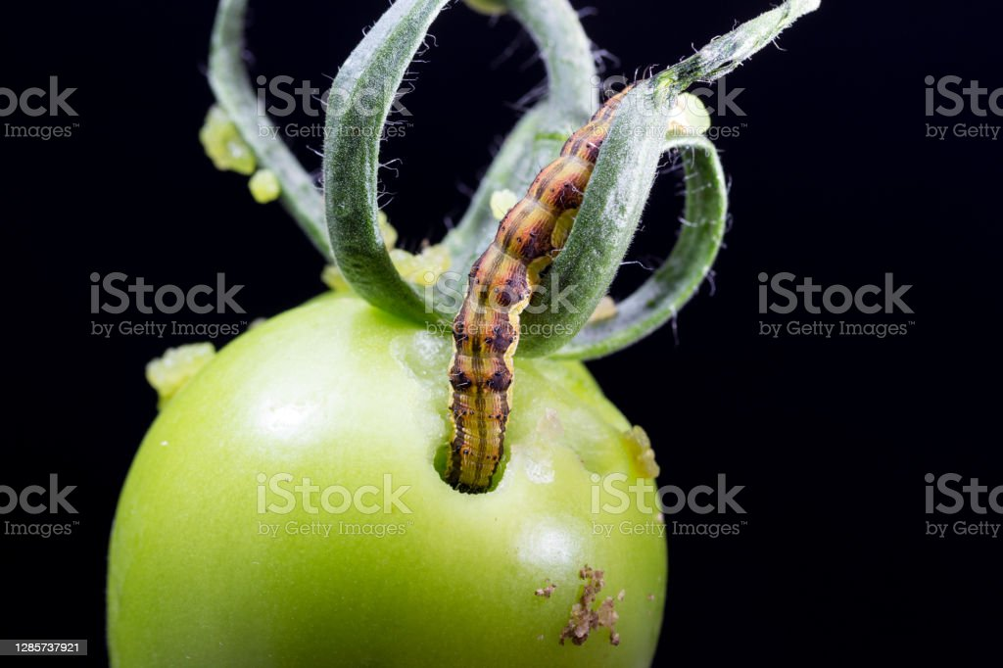

Z

(a) Name the pest labelled Z. (1mark)
…………………………………………………………………………………………………………

(b) State two characteristics symptoms of attack by the pest named in (a) above. (2marks)
………………………………………………………………………………………………………...…
………………………………………………………………………………………………………...…
………………………………………………………………………………………………………...…
………………………………………………………………………………………………………...…
(c) State two cultural control measures of the pest named in (a) above. (2marks)
………………………………………………………………………………………………………...…
………………………………………………………………………………………………………...…
………………………………………………………………………………………………………...…
………………………………………………………………………………………………………...…

(d) Apart from pest Z identified above name two insect pests of tomatoes. (2marks)
………………………………………………………………………………………………………...…
………………………………………………………………………………………………………...…
………………………………………………………………………………………………………...…
………………………………………………………………………………………………………...…

22. Describe the procedure used during harvesting of sugarcane. (2marks)
………………………………………………………………………………………………………...…
………………………………………………………………………………………………………...…
………………………………………………………………………………………………………...…
………………………………………………………………………………………………………...…

SECTION C (40 MARKS)
Answer any TWO questions from this section in the foolscaps
provided after question 25.

23.
(a) What are the uses of farm records. (6 marks)

(b) Explain the problems farmers face in marketing agricultural produce. (9marks)

(c) Describe various agencies and institutions involved in the marketing of agriculture
produce. (5marks)

24.
(a) Describe the methods used in preparing planting materials in readiness for planting.
(8marks)

(b) Explain the factors that may determine spacing of crops in the farm. (8 marks)

(c) Briefly explain the factors that influence timely planting. (4 marks)
25.
(a) Describe the establishment of grass pasture from the time the land is ploughed using a
mould board plough to the time the pasture is ready for grazing. (10marks)

(b) What are the advantages of a mixed grass legume pasture over a pure grass pasture?
(10marks)

This is the last printed page.

