PHYSICS FORM THREE
END OF TERM 1 EXAM 2026
TIME: 2 HOURS

NAME: ___________________________ ADMISSION NO: _________ CLASS: ________

INSTRUCTIONS TO CANDIDATES

- Write your name, admission number, and class in the spaces provided above.
- This paper consists of two sections: Section A and Section B.
- Answer all questions in Section A and Section B.
- All working must be clearly shown where necessary.

SECTION A (25 MARKS)

Answer all questions in this section.

- State what is studied under Mechanics as a branch of Physics. (1 mark)

- Figure 1 below shows a graph of velocity against time for a car moving in a straight line.
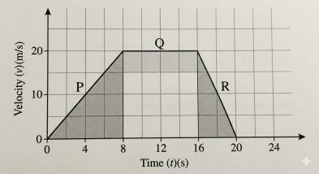
- Describe the motion of the car in the section labeled P. (1 mark)

- Determine the total distance covered by the car in the 20 seconds. (2 marks)

- A student walking home from school covers a distance of 300 m in 60 seconds. Calculate his speed in km/h. (2 marks)

- State the principle of conservation of linear momentum. (1 mark)

- A bullet of mass 20 g is fired from a gun of mass 2 kg with a muzzle velocity of 200 m/s. Calculate the recoil velocity of the gun. (2 marks)

- Distinguish between elastic collision and inelastic collision. (2 marks)

- Figure 2 shows a ray of light traveling from glass to air.
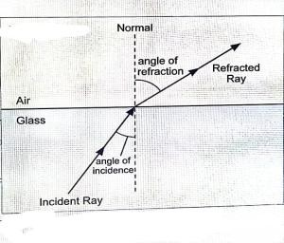
- State what happens to the speed of light as it moves from glass to air. (1 mark)

- Name the optical phenomenon illustrated in Figure 2. (1 mark)

- State Snell's Law. (1 mark)

- The refractive index of diamond is 2.4. Calculate the critical angle of diamond. (2 marks)

- State Newton's first law of motion (Law of Inertia). (1 mark)

- Give a reason why a high jumper should land on soft ground. (2 marks)

- A force of 40 N is applied on a spanner at a perpendicular distance of 0.5 m from the pivot.
Calculate the moment of the force. (2 marks)

- State the law of floatation. (1 mark)

SECTION B (55 MARKS)

Answer all questions in this section.

14. (a) Define the term refractive index of a material. (2 marks)

(b) In an experiment to determine the refractive index of a glass block, a student drew a diagram as shown in Figure 3.
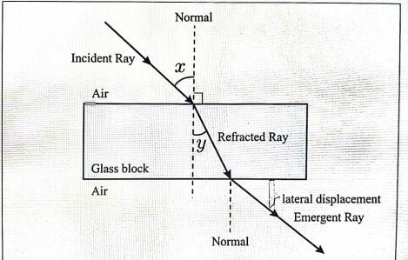
- Name the angles labeled x and y. (2 marks)
x: __________________________________________________________________ y: __________________________________________________________________
- If the angle x is 45° and the angle y is 28°, calculate the refractive index of the glass block. (3 marks)

- State two applications of total internal reflection. (2 marks)

- Explain why a stick partially immersed in water appears bent. (3 marks)

15. (a) A minibus of mass 2000 kg traveling at 30 m/s collides head-on with a stationary car of mass 1000 kg. If the two vehicles move together after collision, calculate: (i) The common velocity after collision. (3 marks)

- State two factors that affect the braking distance of a vehicle. (2 marks)

- Explain why passengers in a vehicle tend to lurch forward when the vehicle stops suddenly. (2 marks)

- (a) A block of wood of mass 5 kg is pulled along a horizontal surface by a force of 20 N. If the frictional force between the block and the surface is 5 N, calculate: (i) The net force acting on the block. (2 marks)

- (a) A machine with a velocity ratio of 5 is used to lift a load of 500 N through a height of 2 m. If an effort of 125 N is applied, calculate:
(i) The mechanical advantage of the machine. (2 marks)

18. (a) Define the term current in electricity. (1 mark)

(b) A current of 0.5 A flows through a circuit for 2 minutes. Calculate the quantity of charge that passes through the circuit. (2 marks)

END

