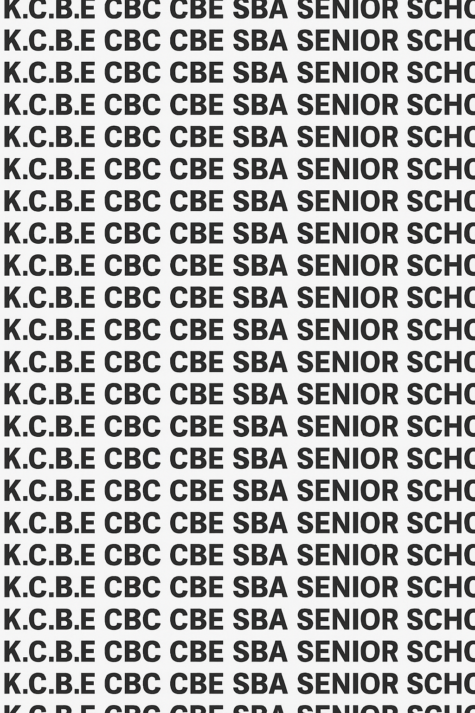
KENYA CERTIFICATE OF BASIC EDUCATION (K.C.B.E)

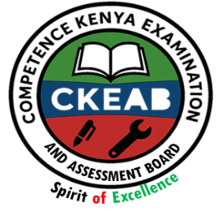
GRADE 10 BIOLOGY (Theory) TERM 1 JANUARY 2026
Time: 1 Hour 30 Minutes
COMPETENCE ASSESSMENT EXAMINATION CKEAB 001

LEARNER’S DETAILS
Name: _______________________________________________________________________________________.
School: ______________________________________________________________________________________.
Assessment Number: ________________________________. Date: __________________________________.
School Code: _______________________________. Signature: ________________________________.

INSTRUCTIONS TO LEARNERS
- Write your name, assessment number, class and date on all the answer sheets provided.
- Answer all the questions in the spaces provided.
- Use a blue or black pen for writing. Pencils should be used only for drawings and diagrams.
- Make your drawings neat, clear, and large, and label them correctly using ruled lines.
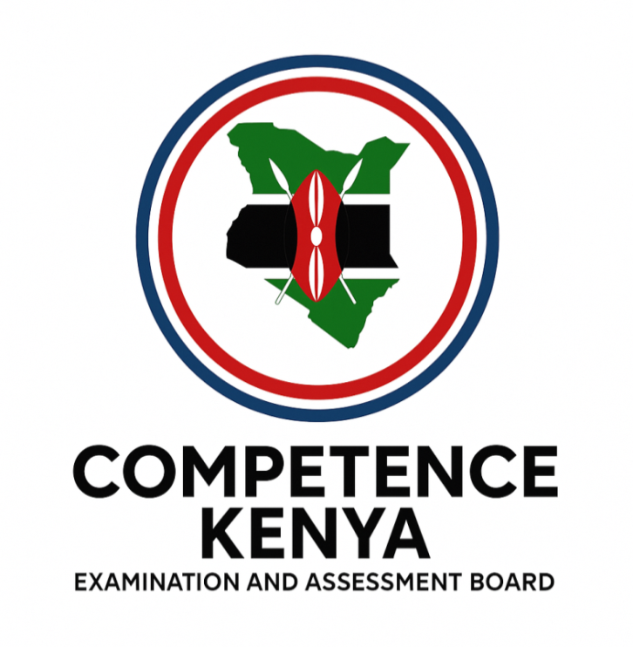
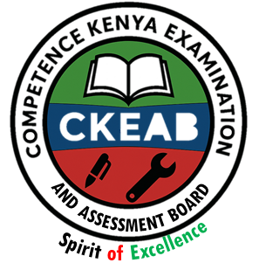
- Section A requires short answers – be brief and precise.
- Section B requires longer explanations and reasoning – write clearly and in detail.
-Biology- -001- -Senior School-

SECTION A: (30 Marks)
Question | Q1 | Q2 | Q3 | Q4 | Q5 | Q6 | Q7 | Q8 | Q9 | Q10 | TOTAL (30)
Maximum score | 2 | 2 | 3 | 4 | 4 | 2 | 2 | 3 | 2 | 2 | 30
Learners score

SECTION B: (40 Marks)
Question | Q11 | Q12 | Q13 | Q14 | TOTAL (40) | GRAND TOTAL
Maximum score | 10 | 8 | 12 | 10 | 40 | 70
Learners score

Performance Levels Grid
Level | Level | % Range | Points | Learner’s score
Exceeding (EE) | EE1 | 90–100% | 8
Exceeding (EE) | EE2 | 75–89% | 7
Meeting (ME) | ME1 | 58–74% | 6
Meeting (ME) | ME2 | 41–57% | 5
Approaching (AE) | AE1 | 31–40% | 4
Approaching (AE) | AE2 | 21–30% | 3
Below (BE) | BE1 | 11–20% | 2
Below (BE) | BE2 | 1–10% | 1
This paper has 6 printed pages. Please check out to ensure all pages are printed
Turn over

SECTION A: (30 Marks)
Answer all questions in this section.
- During a lesson, the teacher explained that Biology is the foundation of careers such as medicine, agriculture, and veterinary science.
Define Biology. (2 marks)
……………………………………………………………………………………………………………………………………………………………………………………
……………………………………………………………………………………………………………………………………………………………………………………
- A student researching Biology found that it can be divided into major fields of study.
State two broad branches of Biology.(2 marks)
- ………………………………………………………………………………………………………………………………………………………………………

- ………………………………………………………………………………………………………………………………………………………………………
- The diagram below shows some simple apparatus used in collecting small insects.
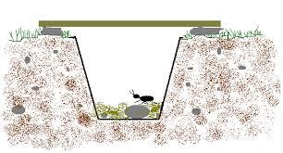
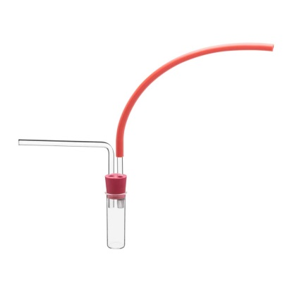

A B

- identify the apparatus labelled A and B
A: …………………………………………………………………………….
B: …………………………………………………………………………….

- Name one apparatus that can be used to collect small flying insects. (1 marks)
…………………………………………………………………………………………………………

- A school career guidance teacher advised learners to choose courses wisely and gave examples of jobs requiring Biology knowledge.
List four careers one can pursue after studying Biology. (4 marks)
- ……………………………………………………………………………...…
- …………………………………………………………………………………
- …………………………………………………………………………………
- …………………………………………………………………………………
- Name the branch of Biology that deals with:
a) Study of microorganisms……………………………………………………………………………… (1 mark)
b) Study of heredity and variation………………………………………………………………….. (1 mark)
c) Study of insects ………………………………………………………………………………………………(1 mark)
d) Study of classification of living things………………………………………………………. (1 mark)
- During a field trip, learners collected grasshoppers and leaves. The teacher emphasized proper storage to avoid decay.
State two reasons why it is important to preserve specimens properly. (2 marks)
- ……………………………………………………………………………………………………………………………………………………………………
- …………….…………………………………………………………………………………..…………………………………………………………………
- A student compared a motor vehicle and a living organism. Give two characteristics of living things that motor vehicles lack. (2 marks)
- ………………………………………………………………………………………………………………………………………………………………………
- ………………………………………………………………………………………………………………………………………………………………………
- Match each of the following apparatus with its correct use: (3 marks)
Apparatus | Use
(a) Pooter | Used for trapping ground-dwelling insects or small animals
(b) Pair of Forceps | Used for collecting small crawling insects without harming them
(c) Pitfall trap | Used for picking up small delicate animals without direct hand contact

- During a field collection of insects, the teacher reminded students to be careful.
State any two precautions that should be taken when collecting specimens. (2 marks)
- ……………………………………………………………………………………………………………………………………………………………………
- …………….……………………………………………………………………………………………………………………………………………………
- A Biology teacher asked students to explain how different branches of Biology specialize.
Differentiate between Zoology and Botany.(2 marks)
……………………………………………………………………………………………………………………………………………………………………………………
……………………………………………………………………………………………………………………………………………………………………………………
……………………………………………………………………………………………………………………………………………………………………………………
……………………………………………………………………………………………………………………………………………………………………………………
SECTION B: (40 Marks)
Answer all questions in this section.
- Biology plays an important role in society.
(a) Explain four reasons why the study of Biology is important in everyday life. (8 marks)
……………………………………………………………………………………………………………………………………………………………………………………
……………………………………………………………………………………………………………………………………………………………………………………
……………………………………………………………………………………………………………………………………………………………………………………
……………………………………………………………………………………………………………………………………………………………………………………
……………………………………………………………………………………………………………………………………………………………………………………
(b) Outline two international conventions that have benefited from biological knowledge. (2 marks)
(10 marks)
……………………………………………………………………………………………………………………………………………………………………………………
……………………………………………………………………………………………………………………………………………………………………………………
……………………………………………………………………………………………………………………………………………………………………………………
……………………………………………………………………………………………………………………………………………………………………………………

- A group of students collected a plant specimen during a field trip for further study in the laboratory.
(a) Describe the steps taken in processing and preserving the plant specimen. (6 marks)
……………………………………………………………………………………………………………………………………………………………………………………
……………………………………………………………………………………………………………………………………………………………………………………
……………………………………………………………………………………………………………………………………………………………………………………
……………………………………………………………………………………………………………………………………………………………………………………
(b) Explain why only the required number of specimens should be collected. (8 marks)

……………………………………………………………………………………………………………………………………………………………………………………
……………………………………………………………………………………………………………………………………………………………………………………
……………………………………………………………………………………………………………………………………………………………………………………
……………………………………………………………………………………………………………………………………………………………………………………
- During practical lessons, learners develop important life skills.
(a) Discuss five scientific skills that are developed through the study of Biology. (10 marks)
……………………………………………………………………………………………………………………………………………………………………………………
……………………………………………………………………………………………………………………………………………………………………………………
……………………………………………………………………………………………………………………………………………………………………………………
……………………………………………………………………………………………………………………………………………………………………………………
……………………………………………………………………………………………………………………………………………………………………………………
……………………………………………………………………………………………………………………………………………………………………………………
(b) Explain two ways Biology is useful in agriculture. (2 marks)
……………………………………………………………………………………………………………………………………………………………………………………
……………………………………………………………………………………………………………………………………………………………………………………
……………………………………………………………………………………………………………………………………………………………………………………
……………………………………………………………………………………………………………………………………………………………………………………

- A student in Grade 9 is confused about which career path to choose.
(a) List and explain four positive factors that may influence choice of a Biology-related career. (8 marks)
……………………………………………………………………………………………………………………………………………………………………………………
……………………………………………………………………………………………………………………………………………………………………………………
……………………………………………………………………………………………………………………………………………………………………………………
……………………………………………………………………………………………………………………………………………………………………………………
……………………………………………………………………………………………………………………………………………………………………………………
……………………………………………………………………………………………………………………………………………………………………………………
……………………………………………………………………………………………………………………………………………………………………………………
……………………………………………………………………………………………………………………………………………………………………………………
(b) Suggest why negative factors such as gender stereotypes should not determine career choice.
(10 marks)
……………………………………………………………………………………………………………………………………………………………………………………
……………………………………………………………………………………………………………………………………………………………………………………
……………………………………………………………………………………………………………………………………………………………………………………
……………………………………………………………………………………………………………………………………………………………………………………

©2026
All rights reserved
©COMPETENCE KENYA EXAMINATION AND ASSESSMENT BOARD
THIS IS THE LAST PRINTED PAGE

