GEOGRAPHY FORM THREE
END TERM 1 EXAM 2026
TIME: 2 HOURS 30 MINUTES

NAME: ___________________________________________ ADM NO: ____________ DATE: ________________________ SIGN: ________________

INSTRUCTIONS TO CANDIDATES:

- This paper consists of two sections: A and B.
- Answer ALL the questions in section A.
- Answer ANY FOUR questions in section B.
- All answers must be written in the answer booklet provided.

SECTION A (25 MARKS)

Answer all the questions in this section.

1. (a) What is an isotherm? (1 mark)
(b) Name two instruments used to measure humidity. (2 marks)
- Distinguish between a normal fault and a reverse fault. (2 marks)
- The diagram below shows the internal structure of the Earth. Name the parts marked W, X, and Y. (3 marks)
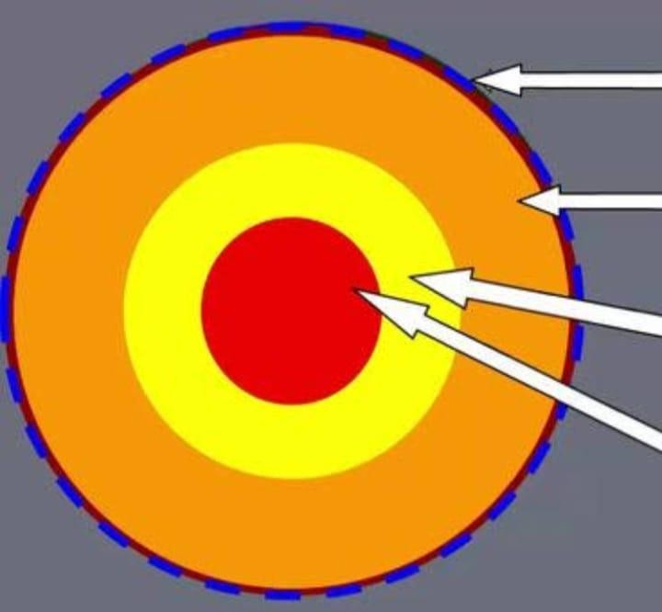

- Give three reasons why the study of Geography is important. (3 marks)
- (a) State two characteristics of sedimentary rocks. (2 marks)
(b) Apart from sedimentary rocks, name two other classes of rocks. (2 marks)
- Identify three processes of chemical weathering. (3 marks)
- (a) What is a composite volcano? (2 marks)
(b) Name two examples of fold mountains in Africa. (2 marks)
8. State three factors that determine the rate of mass wasting. (3 marks)

SECTION B (75 MARKS)

Answer any four questions from this section. All questions carry equal marks.

9. (a) (i) Name two branches of physical geography. (2 marks)
(ii) Explain three factors that influence the distribution of climatic elements on the Earth's surface. (6 marks)
(b) Your class intends to carry out a field study on the effects of air pollution in the local industrial area.
- State three methods you would use to collect data. (3 marks)
- Give four follow-up activities you would engage in after the field study. (4 marks)
10. (a) (i) Define the term faulting. (2 marks)
(ii) Describe how compressional forces may lead to the formation of a Rift Valley. (5 marks)
(b) Explain five positive influences of faulting on human activities. (8 marks)
11. (a) (i) What is soil creep? (2 marks)
(ii) Describe three processes through which weathering occurs. (6 marks)
(b) The table below shows the tonnage of fish caught in three Kenyan lakes between the years 2019 and 2022 in tonnes. Use it to answer the questions below.
LAKE | 2019 | 2020 | 2021 | 2022
VICTORIA | 120,000 | 115,000 | 130,000 | 145,000
TURKANA | 5,000 | 6,500 | 7,000 | 6,000
NAIVASHA | 1,500 | 2,000 | 1,800 | 2,200

- Using a scale of 1 cm to represent 20,000 tonnes, draw a compound bar graph to represent the data for the years 2020, 2021, and 2022. (7 marks)

- Calculate the percentage increase in fish catch from Lake Victoria between 2020 and 2022. (2 marks)

12. (a) Describe how a river captures another river. (5 marks)
(b) Explain five characteristics of the old stage of a river. (10 marks)
13. (a) (i) Identify three types of lakes that are formed by tectonic movements. (3 marks)
(ii) Describe how Lake Victoria was formed. (5 marks)
(b) Explain six economic benefits of lakes to East Africa. (12 marks)

END

