AGRICULTURE FORM THREE
END OF TERM 1 EXAM 2026
TIME: 2 HOURS

NAME: _________________________ADMISSION NO: ____________ CLASS: ________

INSTRUCTIONS TO CANDIDATES

- Write your name, admission number, and class in the spaces provided above.
- This paper consists of three sections: Section A, Section B, and Section C.
- Answer all questions in Section A and Section B.
- Answer any two questions from Section C.
- All answers should be written in the answer booklet provided.

SECTION A (30 MARKS)

Answer all questions in this section.

- State four problems that hinder agricultural development in Kenya. (2 marks)

- Give two characteristics of shifting cultivation. (1 mark)

- List three aspects of rainfall that are important in crop production. (1½ marks)

- State two roles of micro-organisms in the soil. (2 marks)

- Name three types of water pumps used on a farm. (1½ marks)

- Give three factors that influence the quality of farmyard manure. (1½ marks)

- State two advantages of using certified seeds for planting. (2 marks)

- Differentiate between olericulture and pomoculture as used in crop production. (2 marks)

- Name three common camel species found in Kenya. (1½ marks)

- What is meant by the following terms?
  - Pruning (1 mark)

  - Rouging (1 mark)

- State three reasons for maintaining livestock in good health. (3 marks)

- Give three uses of water in the body of a farm animal. (3 marks)

- List two methods of testing soil pH in agriculture. (1 mark)

- State two disadvantages of mono-cropping in crop production. (2 marks)

- Name four farm records that should be kept by a poultry farmer. (2 marks) SECTION B (20 MARKS)
Answer all questions in this section.

- An experiment was carried out with three different soils. The soils were put in different capillary tubes of equal sizes. The capillary tubes were placed in a water trough containing water. The results after six hours are shown in the diagram below. Study it and answer the questions that follow.
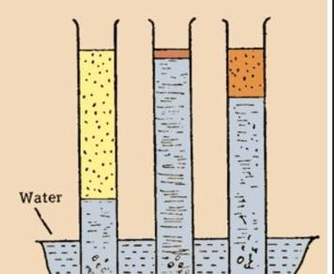

- What was the aim of this experiment? (1 mark)

- Identify the soil types in tubes A, B, and C. (3 marks)
A: ___________________________________________________________________
B: ___________________________________________________________________
C: ___________________________________________________________________
- State two ways of improving soil C for the growth of crops. (2 marks)

17. A member of the Young Farmers Club in a certain school was advised to apply fertilizer
30:20:10 on a tomato plot measuring 10 m by 5 m at the rate of 300 kg per hectare. (1 hectare = 10,000 m²)
(a) State the percentage of:
- P₂O₅ in the complete fertilizer. (1 mark) ___________________________________________________________________
- K₂O in the complete fertilizer. (1 mark)
___________________________________________________________________
(b) Calculate the amount of fertilizer the member would require for the plot. Show your working. (3 marks)

18. The diagram below illustrates a nursery practice. Study it and answer the questions that follow.
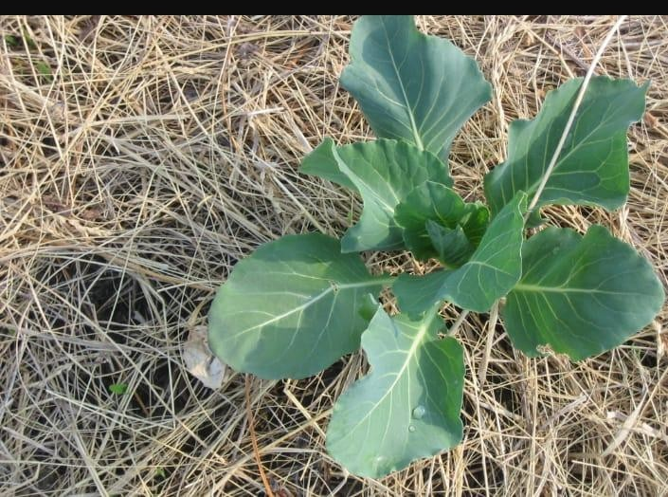
- Name the practice illustrated above. (1 mark)

- Give a reason why the practice illustrated is important in the nursery. (2 marks)

- Give two activities that ensure the illustrated practice is carried out successfully. (2 marks)

19. The diagram below shows the digestive system of a ruminant animal. Study it and answer the
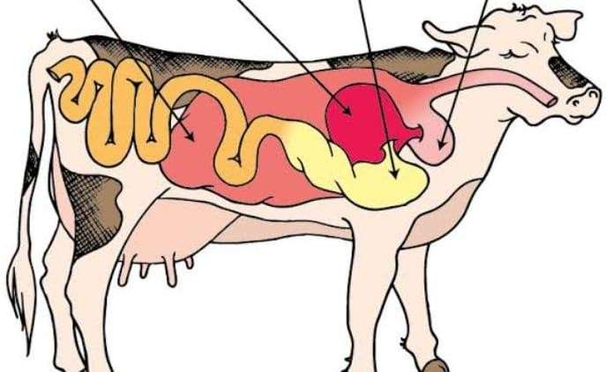
questions that follow.

(a) Identify the parts labeled P, Q, R, and S. (4 marks)
P: __________________________________________________________________
Q: __________________________________________________________________
R: __________________________________________________________________
S: __________________________________________________________________

SECTION C (30 MARKS)
Answer any two questions from this section.

20. (a) Describe the production of kales (Sukuma wiki) under the following sub-headings: (i) Nursery preparation (4 marks)

- Management of seedlings in the nursery (4 marks)

- Transplanting (3 marks)

(b) State five effects of strong winds in crop production. (4 marks)
(Total 15 marks)

21. (a) Explain eight environmental conditions that may lead to low crop yields. (8 marks) (b) State four advantages of irrigation farming. (4 marks)

(c) Describe three signs of ill health in livestock. (3 marks)

(Total 15 marks)
22. (a) Describe five farming practices that help to achieve minimum tillage. (5 marks) (b) Describe the procedure of soil sampling using the zigzag method. (5 marks)

(c) Explain five factors that influence the choice of tools for primary cultivation. (5 marks) (Total 15 marks)

END

