NAME: ______________________________________________ADM NO: __________CLASS: ________
DATE: _______________________________ SIGN: _______________________
TARGET_____________________________
GEOGRAPHY 312
FORM: 4
MID TERM 1 2026
TIME: 1 ¼ Hours

- (a) Outline three divisions of physical geography. (3 marks)
(b) State two ways in which geography relates to agriculture. (2marks)
- a) Differentiate between latitude and longitude. (2marks)
b) If the local time in New York 74⁰ West is 08:00am, what is the time at Kitale 35⁰ East? (3marks)
3. The diagram below represents the structure of the earth. Use it to answer question
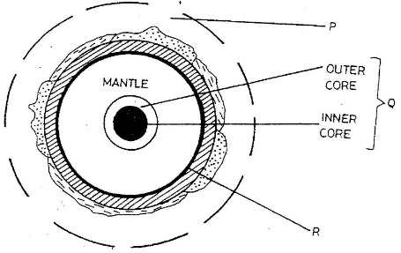

Name;
- The parts marked P and Q (2marks)
- The discontinuity marked R (1mark)

- What is a mineral? (2 marks)
- Give three ways used to classify rocks. (3 marks)
- Suppose you were to carry out a field study on rocks in the area surrounding your school
(i) State three characteristics that you would look for while identifying different rock types (3 marks)
(ii) State three follow up activities for the field study (3 marks)

- (a) What is a Karst Scenery? (2 marks)
(b) Describe how a stalactite is formed. (4 marks)
6. (a) (i) What is a lake? (2marks)
(ii) Give four processes that lead to formation of Lakes (4marks)
(b) Explain two factors why some Lakes in the Rift Valley in Kenya are saline. (4marks)
7. a) (i) What is a glacier? (2 marks)
ii) Name two mountains in East Africa where glaciers are found. (2marks)
(iii) Give two reasons why there are no ice sheets in Kenya (2marks)

8. i) Give two factors that determine the colour of soil (2marks)
ii) What is soil erosion? (2marks)

