NAME _____________________________________________________________ CLASS_______________
ADMNO_____________________________ SIGN _______________DATE____________________________
COMPUTER STUDIES
FORM FOUR
MID TERM 1 2026
TIME: 1 HOUR
Instruction to Candidates. Answer all questions
1.(a) Explain the emerging trends in Microcomputer technology in relation to size. (1mrk)
__________________________________________________________________________________________________________________________________________________________________________________________________________
(b) Give two reasons why smaller computers like Laptops tend to be more expensive than
Desktop computers. (1mrks)
__________________________________________________________________________________________________________________________________________________________________________________________________________
3. Identify three facilities that will ensure proper ventilation in a room. (3mrks)
__________________________________________________________________________________________________________________________________________________________________________________________________________
__________________________________________________________________________________________________________________________________________________________________________________________________________
4. Explain the following software terms: (3mrks)
(i) Authenticity.
__________________________________________________________________________________________________________________________________________________________________________________________________________
(ii) Portability.
__________________________________________________________________________________________________________________________________________________________________________________________________________
(ii) Modularity.
__________________________________________________________________________________________________________________________________________________________________________________________________________
5. Differentiate between bolding and highlighting text. (2mrks)
__________________________________________________________________________________________________________________________________________________________________________________________________________
6. Describe the procedure to be followed when entering (3mrks)
- a negative number in a cell
__________________________________________________________________________________________________________________________________________________________________________________________________________
_____________________________________________________________________________________________________
(b) a fraction in a cell.
__________________________________________________________________________________________________________________________________________________________________________________________________________
_____________________________________________________________________________________________________
7. The cells K3 to K10 of a worksheet contain remarks on students’ performance such as Very
good, Good, Fair and Fail depending on the average marks. Write a formula that can be used
to count all students who have the remark “Very good”. (3mrks)
__________________________________________________________________________________________________________________________________________________________________________________________________________
8. A student’s database comprises of students’ details table and fees received table as shown below:
Students’ details table Fees Received table
Surname
Middle Name
First Name
Admission Number
Course
Date
Amount
Receipt Number

(i) State the primary key field for each table. (2mrks)
__________________________________________________________________________________________________________________________________________________________________________________________________________
(ii) State the field which should serve as the linking field for the two tables. (2mrks)
__________________________________________________________________________________________________________________________________________________________________________________________________________
(iii) Highlight the name of the relationship formed when the 2 tables are linked (1mrk)
__________________________________________________________________________________________________________________________________________________________________________________________________________
9. Explain the following as used in DTP: (3mrks)
(a) Master pages.
__________________________________________________________________________________________________________________________________________________________________________________________________________
- Tracking.
__________________________________________________________________________________________________________________________________________________________________________________________________________
- Kerning
__________________________________________________________________________________________________________________________________________________________________________________________________________
10. Give four examples of search engines you know. (2mrks)
__________________________________________________________________________________________________________________________________________________________________________________________________________

11. State five possible ways of preventing data loss from a computer. (5mrks)
__________________________________________________________________________________________________________________________________________________________________________________________________________
__________________________________________________________________________________________________________________________________________________________________________________________________________
__________________________________________________________________________________________________________________________________________________________________________________________________________
12. Write out what A, B, C and D represent in the table below. (4mrks)
Number System  A  B  C  D | Values  0, 1  1, 2, 3, 4, 5, 6, 7 8, 9  0, 1, 2, 3, 4, 5, 6, 7,  0, 1, 2, 3, 4, 5, 6, 7, 8, 9, A, B, C, D, E,F
__________________________________________________________________________________________________________________________________________________________________________________________________________
__________________________________________________________________________________________________________________________________________________________________________________________________________
b). Use Two’s compliment to perform the following Binary subtraction: (2mrks)
10111₂ – 10001 ₂

13. In Real-time systems, Front-End Processors are quite useful. State any three reasons why you
think they are important. (3mrks)
_____________________________________________________________________________________________________
__________________________________________________________________________________________________________________________________________________________________________________________________________
14. What does the following abbreviations stand for: (2mrks)
i) FORTRAN ____________________________________________________________
ii) COBOL ____________________________________________________________
iii) OOP ____________________________________________________________
iv) BASIC ____________________________________________________________
b) Define the following types of computer program errors: (2mrks)
(i) Syntax error.
_____________________________________________________________________________________________________
_____________________________________________________________________________________________________
(ii) Logical error
_____________________________________________________________________________________________________
_____________________________________________________________________________________________________
14. The flowchart below was designed by a form three student.
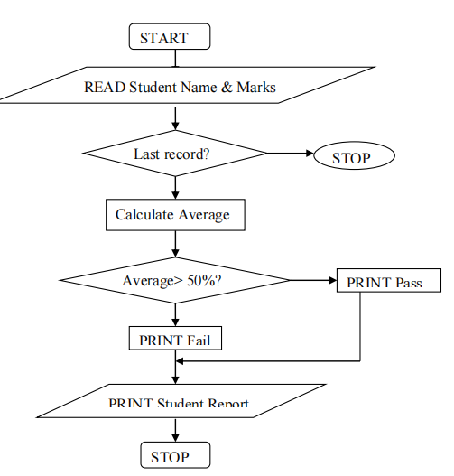
14. Identify three problems in this flowchart (3mrks)
_____________________________________________________________________________________________________
__________________________________________________________________________________________________________________________________________________________________________________________________________
b. Describe briefly what this program is supposed to do. (2mrks)
_____________________________________________________________________________________________________
__________________________________________________________________________________________________________________________________________________________________________________________________________
15. State and explain two purposes of information systems in organizations. (2mrks)
_____________________________________________________________________________________________________
__________________________________________________________________________________________________________________________________________________________________________________________________________

