NAME: _______________________________ADM NO: __________CLASS: ________
DATE: ______________________________ SIGN: _______________________
CHEMISTRY
FORM: 4
MID TERM 1 2026

INSTRUCTIONS: Answer all the Questions
TIME: 1 HR 15 MIN
- Name the process which takes place when:
(i) A red litmus paper turns white when dropped into chlorine water. (1mk)

(ii) Propene gas molecules are converted into a giant molecule. (1mk)

- The table below gives some elements in the periodic table. Use it to answer the questions that follow. The letters do not represent the actual symbols of the elements.
Element | A | B | C | D | E
Atomic number | 12 | 13 | 14 | 15 | 16
Which of the above letters represent:
a) A metallic element which forms ions with the smallest ionic radius? Explain. (1mk)

b) A non-metallic element with the largest atomic size? Explain. (1mk)

- A hydrocarbon compound Z has two carbon atoms and two hydrogen atoms. Name and draw the structural formula of the eighth member of this homologous series. (3mks)

- Draw the open structures of: (2mks)
(i) 3-chlorohex-l-ene

(ii) 2,2-dimethylpentane

- a. What is meant by isomerism? (1mk)

(b) Draw and name two isomers of butene. (2mks)

- Calculate the oxidation number of Cr in K₂Cr₂O₇. (1mk)

- State the most suitable apparatus that can measure 15.4ml of a dilute HCl acid. (1mk)

- Using equations differentiate between the bleaching action of chlorine and sulphur (IV) oxide gases. (2mks)

- Determine the number of moles of carbon (IV) Oxide gas produced when sodium carbonate reacted with dilute sulphuric (VI) acid (Molar gas volume =24dm³) (2mks)

- (a) The diagram below shows the set up used to investigate the effect of an electric current on molten lead (II) bromide

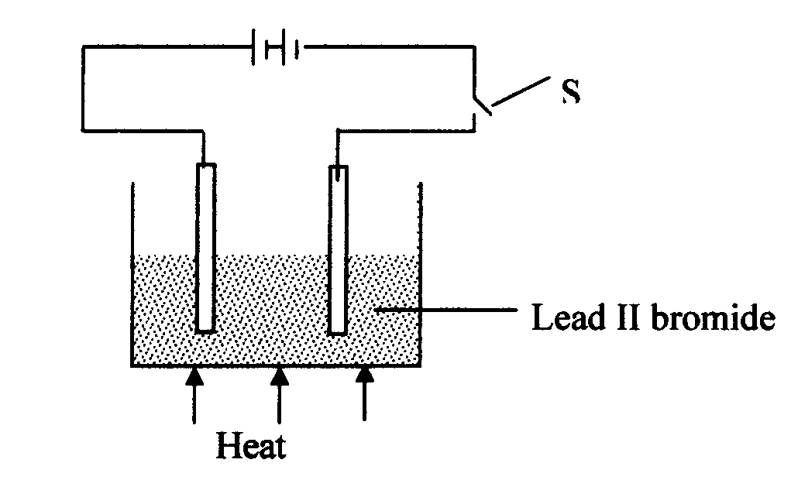

- Explain what happens to the lead II bromide during electrolysis. (2mks)

- Why is it important to carry out the experiment in a fume chamber? (1mk)

- a) What is chromatography? (1mk)

b) Give two applications of chromatography (2mks)

- (a) Two reagents that can be used to prepare chlorine gas are manganese (IV) oxide and concentrated hydrochloric acid.
i. Write an equation for the reaction above. (1mk)

ii. Give the formula of another reagent that can be reacted with concentrated hydrochloric acid to produce chlorine gas. (1mk)

- Below is part of a flow diagram for the contact process:
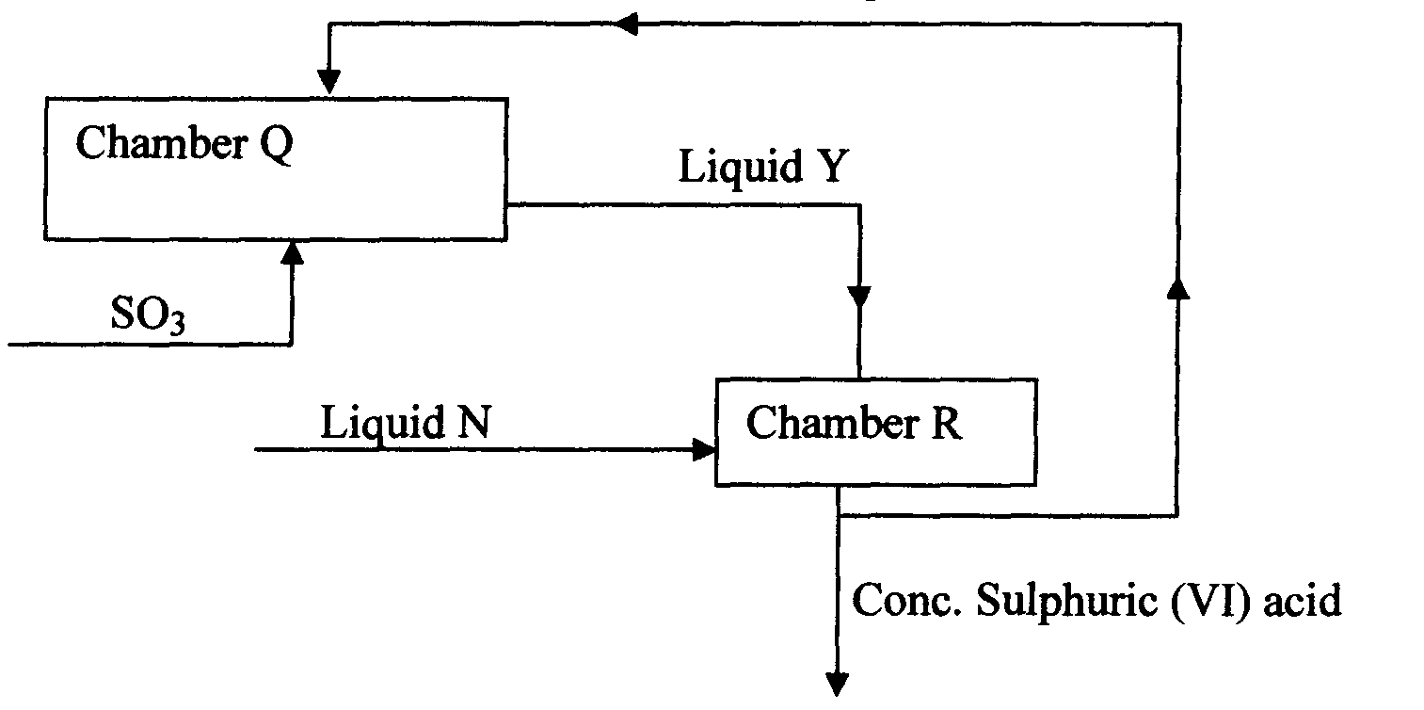

(a) Name : (2mks)

I. Liquid Y ……………………………………………………….

II. Liquid N………………………………………………………….

(b) Write the equation for the reaction taking place in; (2mks)
I. Chamber Q

II. Chamber R

- a) Sketch a graph that represents Charles’ law. (2mks)

b) A gas occupied a volume of 250cm³ at -23ºC and 1 atmosphere. Determine its volume at 127ºC when pressure is kept constant. (3mks)

- How many chloride ions are present in 1.7g of magnesium chloride crystals? (Avogadro’s constant = 6.0 x 10²³, Mg = 24, Cl = 35.5) (3mks)

- a. Name one reagent that can be reacted with dilute hydrochloric acid to produce Sulphur (IV) oxide (1mk)

- What would be observed if moist blue litmus paper is dropped into a gas jar of sulphur (IV) oxide? Explain. (2mks)
- (a) State two properties that vulcanized rubber possess as a result of vulcanization. (2mks)

- During Frasch process molten sulphur flows out through the middle pipe but not
through the outer pipe. Give a reason. (1mk)

7. (a) Give two reasons why during the manufacture of sulphuric (VI) acid, sulphur (VI) oxide,
is dissolved in concentrated Sulphuric (VI ) acid instead of dissolving in water. (2mks)

b) State one use of sulphuric (VI) acid. (1mk)

8. Carbon (IV) Oxide, methane, nitrogen (I) Oxide and trichloromethane are green-house gases
(i) State one effect of an increased level of these gases to the environment. (1mk)

(ii) Give one source from which each of the following gases is released to the environment; (2mks)
- Nitrogen (I) Oxide

(b) Tricholomethane

