AGRICULTURE
FORM 4 MID TERM 1 2026 OUT OF 50
- Define the following terms as used in livestock breeding (2mks)

- Hybrid Vigor (Heterosis)

- Epistasis

- Outbreeding

- Close breeding

- List any four signs of heat in cattle (2mks)

- Just before birth, a farmer noticed that the hind legs and the tail of a calf were showing at the vulva.
What name is given to this type of presentation? (1mks)

- Differentiate between the following Livestock management practices (2mks)

1) Crutching and Ringing

ii) Flushing and steaming-up

- a) Name two types of castration (1mk)

b Name any two kinds of livestock where a rubber ring can be used for castration (1mk

6) The diagram below shows the reproductive system of a hen.
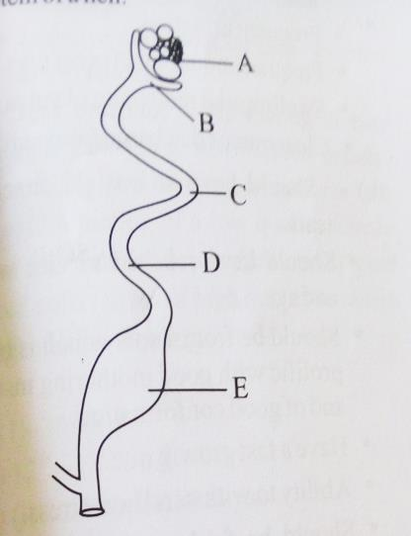
- Name the parts labeled B, C , D and E (2mks)

b)In which part does fertilization of the ova take place ( 1mk)

c)State the roles of C and E in egg formation (2mk)

7) State the advantages of using organic mulch in farming (4mks)

8) Give four reasons that would cause swarming of bees (4mks)

9) Calculate the amount of K₂O that would be contained in 600kg of a compound fertilizer, 30:20:10(N: P₂O₅: K₂O respectively) (3mks)

10). Below is a method of identifying a cow
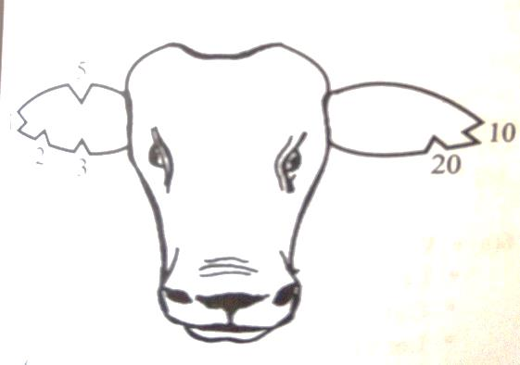
- Name the method of identification illustrated above (1mk)

- name the tool used to carry out the practice ( 1mk)

- From the diagram state the number of the animal (1mk)

- . Using the diagram, illustrate how you would identify an animal number 18

- State any four reasons for carrying out identification of animals. (2mks)

11) Why is the use of manure discouraged in carrot production? (1mk

12) State FOUR characteristics of nitrogenous fertilizers (2mks)

13)) Diagram M, N, P and Q represent some farm tools

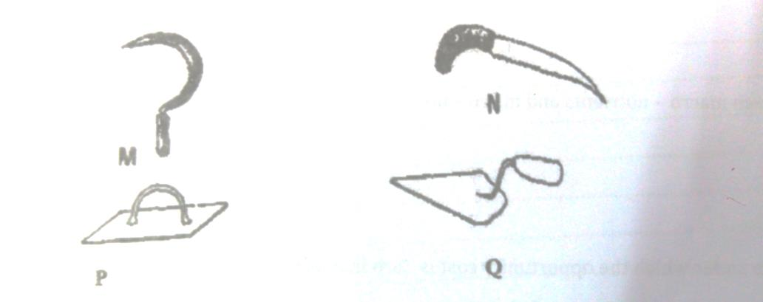
a) Identify the tools, M, N, P, and Q (2mks)

b)Give the uses of the tools named above (2mks
14)) State two soil sampling methods (1mk)

14) Name two dairy breed of goat (1mks)

15) State four advantages of using seeds as planting materials (4mks)

16) Differentiate between seed dressing and seed inoculation (2mks)

17)) A student was to apply a compound fertilizer 5:20:10 at the rate of 200 kg per hectare on her Agriculture project plot measuring 3 by 4 meters.
a) What do the figures 5 and 20 in the compound fertilizer above stand? (1mk)

b) Calculate the amount of fertilizer she would require for the plot (3mks)

