


b

Answer all questions
SECTION A(25 Mrks)
1. The figure 2 below shows two plane mirrors inclined at an angle X from each other. A viewer counts
a total of seven images from looking directly from each of the object O. Determine the value of X.
M₁
(3 marks)
X
M₂
Figure 1
…………………………………………………………………………………………………………………………
…………………………………………………………………………………………………………………………
…………………………………………………………………………………………………………………………
2. Two pins are hanging from a magnet as shown in the diagram below.
S
N
Figure 2
Explain why they do not hang vertically downwards.
(2 marks)
………………………………………………………………………………………………………………
……………………………………………………………………………………………………................
3. State two similarities of images formed by a plane mirror and a convex mirror.
(2 marks)
…………………………………………………………………………………………………………………………
2
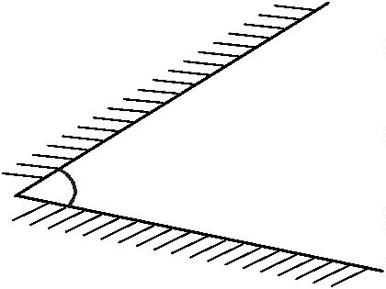
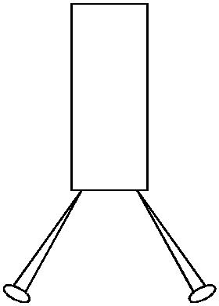


S

…………………………………………………………………………………………………………………………
…………………………………………………………………………………………………………………………
………………………………………………………………………………………………………………………..
4. State one Law of reflection
1 marks)
……………………………………………………………………………………………………………………
……………………………………………………………………………………………………………………
……………………………………………………………………………………………………………………
……………………………………………………………………………………………………………………
5. Calculate the angle of refraction for a ray of light from air striking an air-glass interface, making an
angle of 60⁰ with the interface. ( n = 1.5)
(2 marks)
a
g
…………………………………………………………………………………………………………
…………………………………………………………………………………………………………
…………………………………………………………………………………………………………
…………………………………………………………………………………………………………
…………………………………………………………………………………………………………
6. A student was investigating the brightness of bulbs when set up in different circuits. He used identical
bulbs and cells. He set up circuits A and B as shown in figure (A) and (B) below.
Figure 3
A
B
State and explain which set up had the bulbs light brightest.
(2 marks)
…………………………………………………………………………………………………………………………
………………………………………………………………………………………………………………………
………………………………………………………………………………………………………………………
………………………………………………………………………………………………………………………
…………………………………………………………………………………………………………………......
7. A radio signal of 30MHz is received by an aerial whose length is 1/8 ^{th} of its wavelength. If
the speed of light is 3.0x10⁸ m/s determine the length of the aerial.
(3 marks)
…………………………………………………………………………………………………
3
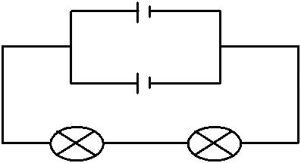
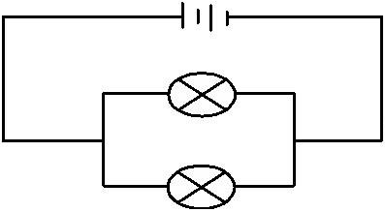

…………………………………………………………………………………………………
…………………………………………………………………………………………………
…………………………………………………………………………………………………
…………………………………………………………………………………………………
8. A boy stood 3m from a large concave mirror of focal length 5m. State two characteristics of
his image.
(2 marks)
………………………………………………………………………………………………….
………………………………………………………………………………………………….
………………………………………………………………………………………………….

9 (a) Define the term echo as used in physics (1mks)

(b) A girl standing some distance from a high wall clapped her hands .State two measurements that
Need to be taken in order to determine the speed of sound (2mks)

10.A negatively charged object was brought near a charged electroscope. The leaf was observed
to fall then rose.
a) State the charge of the electroscope …………………………………….. (1 mark)
b) Compare the magnitude of charge of the object with that of the electroscope.(1 mark)
……..…………………………………………………………………………………………
……..…………………………………………………………………………………………
11. Three capacitors are connected as shown in the figure below with a battery of e.m.f 6V and
1µF
zero internal resistance.
12µ
2µF
4
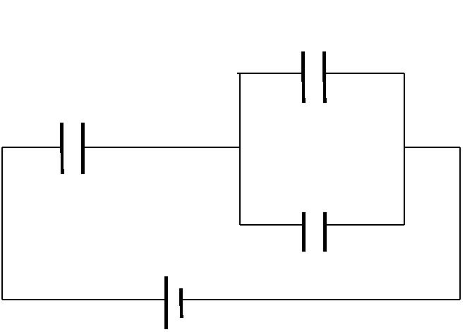

Figure 4
Determine the voltage across 2µF capacitor.
(3marks)
………………………………………………………………………………………………………
………………………………………………………………………………………………………
………………………………………………………………………………………………………
SECTION B (55 MKS)
Answer all questions in the spaces provided
12. (a) Define total internal reflection.
(1 mark)
5

………………………………………………………………………………………………………
………………………………………………………………………………………………………
………………………………………………………………………………………………………
………………………………………………………………………………………………………
(b) A ray of light makes a glancing angle of 60º with a flat glass surface as shown in the
diagram below.
60º
r
Figure 5

Given that the critical angle is 42º, determine the angle of refraction r. (3marks)
………………………………………………………………………………………………………
………………………………………………………………………………………………………
………………………………………………………………………………………………………
………………………………………………………………………………………………………
(c)A point object X is located 3m in front of a pin- hole camera of length 30cm.
Figure 6
Calculate the magnification of the object x.
(3 marks)
………………………………………………………………………………………………………
………………………………………………………………………………………………………
………………………………………………………………………………………………………
6
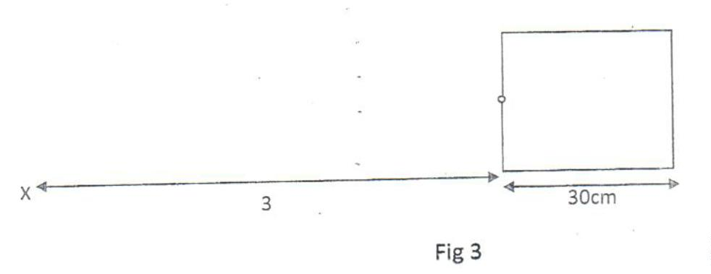
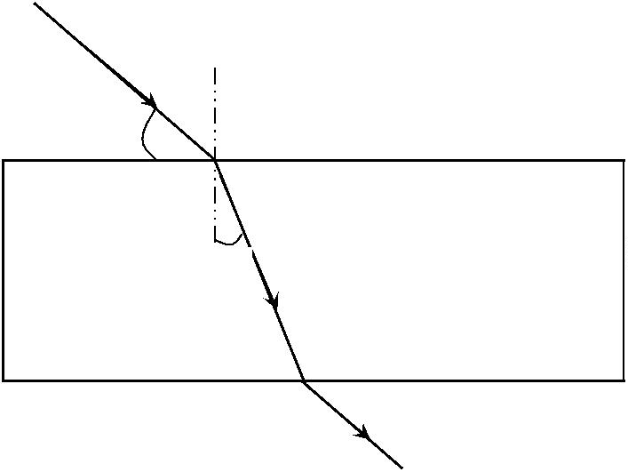

………………………………………………………………………………………………………
(d) State two conditions necessary Total Internal reflection. (2 marks)
…………………………………………………………………………………………………………………
…………………………………………………………………………………………………………………
…………………………………………………………………………………………………………………
…………………………………………………………………………………………………………………
(e) State two areas total internal reflection can be applied.
(2 marks)
………………………………………………………………………………………………………
………………………………………………………………………………………………………
……………………………………………………………………………………
13. (a) Study the diagram below on electromagnet and then answer the questions after it.
Figure 7
(i)
Give a reason for winding the wire into a coil.
(1 mark)
…………………………………………………………………………………………………………………
…………………………………………………………………………………………………………………
…………………………………………………………………………………………………………………
(ii)State ways in which electromagnet can be made stronger.
7
(2 marks)
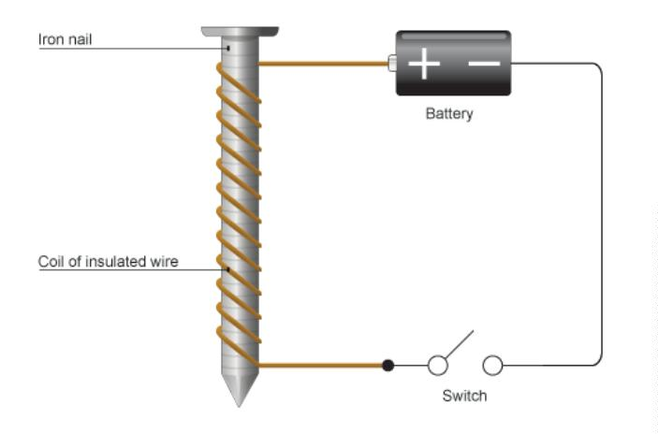

…………………………………………………………………………………………………………………
…………………………………………………………………………………………………………………
…………………………………………………………………………………………………………………
(b) The figure below shows an electric bell
Figure 8
Figure 8
Briefly explain how it functions
(4 marks)
………………………………………………………………………………………………………
………………………………………………………………………………………………………
………………………………………………………………………………………………………
(c) The Figure below shows an arrangement that may be used to investigate how electromagnetic
force varies with current. Explain how the arrangement may be used for this investigation.
(3 marks)
8
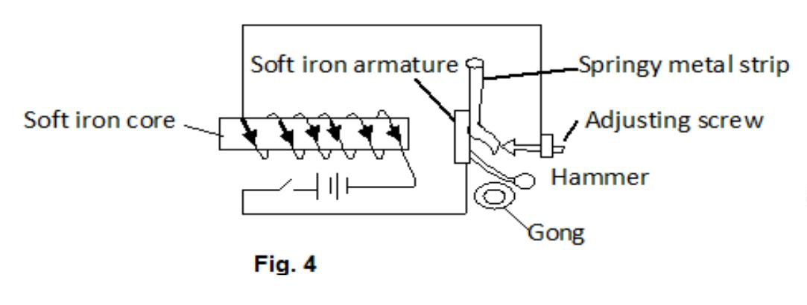

Figure 9
………………………………………………………………………………………………………
………………………………………………………………………………………………………
………………………………………………………………………………………………………
14. (a) The graph below shows a displacement versus time graph for a vibrating object. Use it to
answer questions that follow.
Figure 10
(i) Find the amplitude, period and frequency for the vibrating system.
(4 marks)
…………………………………………………………………………………………………………………
…………………………………………………………………………………………………………………
9
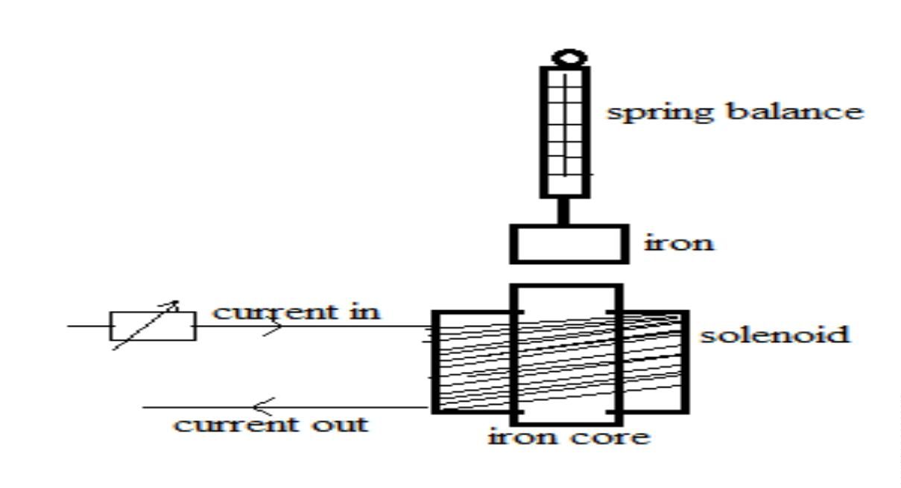
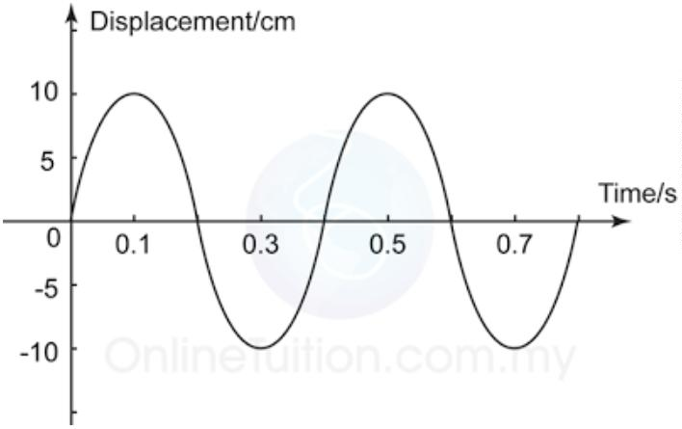

…………………………………………………………………………………………………………………
…………………………………………………………………………………………………………………
(ii) What is the displacement of the object at t = 0.3 s?
(1 mark)
…………………………………………………………………………………………………………………
…………………………………………………………………………………………………………………
…………………………………………………………………………………………………………………
(iii)Sketch in the same axis above, a graph of a wave which the frequency and amplitude are half
of the wave in the figure above.
(2 marks)
(b) Wambua strikes a steel super bridge with a hammer. If the speed of sound in steel is 5,200
m/s, determine the time taken for the sound to reach another Samuel 2.6 km far off the bridge
with his ear on the rail. (3 marks)
………………………………………………………………………………………………………
………………………………………………………………………………………………………
………………………………………………………………………………………………………
………………………………………………………………………………………………………
( c )The figure below shows experiment to show the interference of waves
10

Figure 11
What is observed on the screen when the sizes of the slits are increased beyond the size of
wavelength of waves produced by the light source.
(1mark)
………………………………………………………………………………………………
……………………………………………………………………………………………..
15. (a) State the purpose of manganese (iv) oxide in a dry cell.
(1mark)
……..…………………………………………………………………………………………
(b)Figure 4 below shows an electric circuit.
11
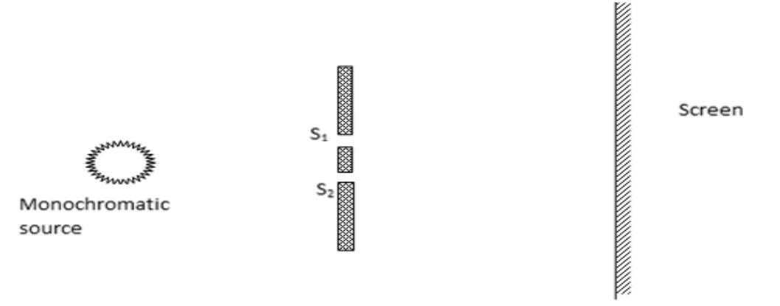

Figure 12
i )Determine the resistance of the circuit
(3 marks)
………………………………………………………………………………………………
………………………………………………………………………………………………
………………………………………………………………………………………………
………………………………………………………………………………………………
……………………………………………………………………………………………..
ii) What is the ammeter reading?
(2 marks)
………………………………………………………………………………………………
………………………………………………………………………………………………
………………………………………………………………………………………………
iii) Calculate
I)The current through 2Ω resistor
(3 marks)
………………………………………………………………………………………………
………………………………………………………………………………………………
………………………………………………………………………………………………
………………………………………………………………………………………………
II) Hence or otherwise determine the potential difference across the 2Ω resistor.(2mks)
12
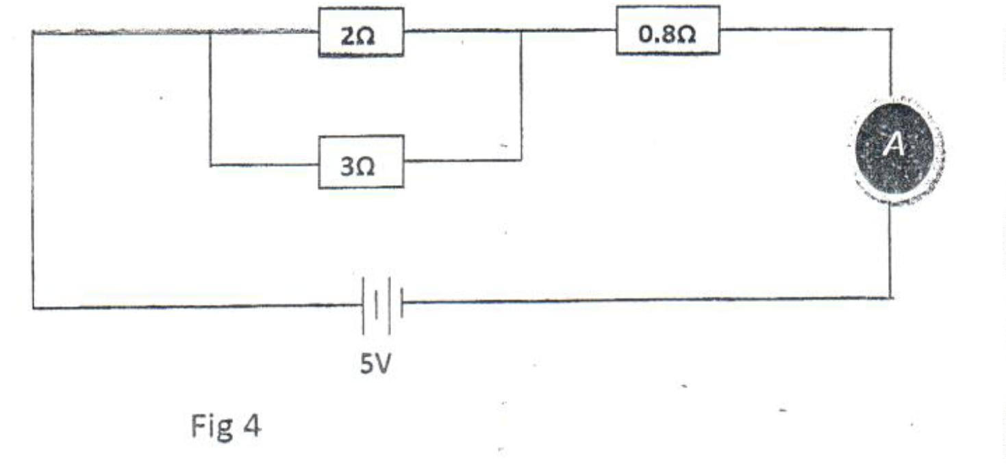

16
a) (i) Define principal axis as used in diverging lenses.
(1mark)
……………………………………………………………………………………………
……………………………………………………………………………………………
…………………………………………………………………………………………...
(ii) The figure 8 below shows an object in front of a lens.
Using rays locate the image of the object.
(3 marks)
b) In an experiment to determine the focal length of a converging lens, the following
graph of magnification M against image distance V (cm) was drawn.
Figure 9
From the graph, calculate the focal length of the lens.
(3marks)
………………………………………………………………………………………………………
Page 13
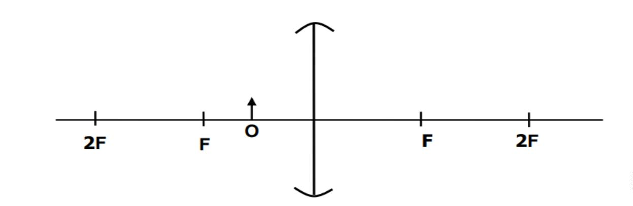
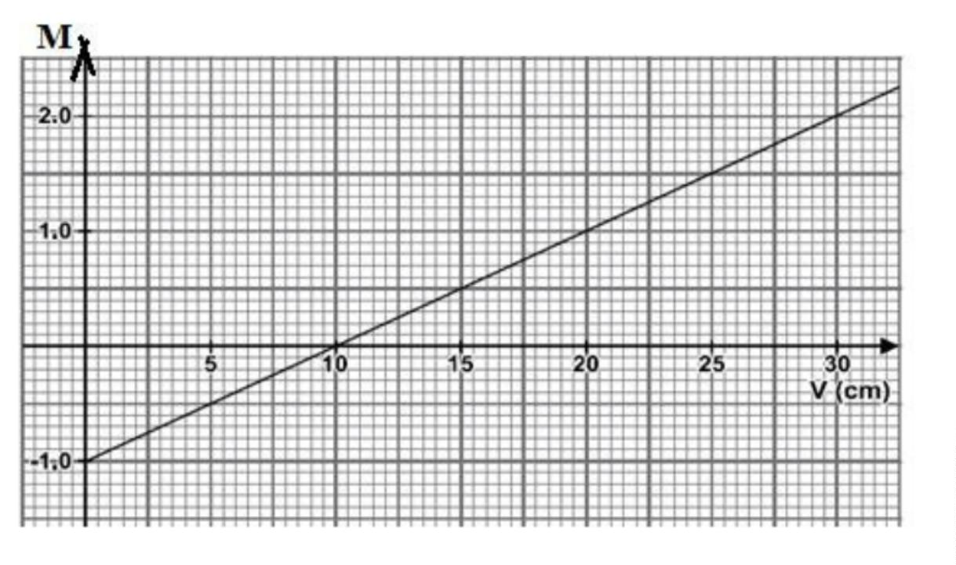

………………………………………………………………………………………………………
………………………………………………………………………………………………………
………………………………………………………………………………………………………
c) A lens has focal length of 12.5cm. Determine its power.
(3mks)

d) State two differences between the camera and the human eye.
(2 marks)

