NAME: …………………………………………CLASS: ……..… ADM NO: …………… SIGNATURE: ………………SCHOOL: ………………………….……DATE………………
232/1
Physics Paper 1

FORM FOUR
Time:2 Hours

SULIMO MOCK EXAMINATION – 2025
Kenya Certificate of Secondary Education (KCSE)

Instructions to candidates

- This paper consists of two sections A and B.
- Answer all the questions in the two sections in the spaces provided after each question
- All working must be clearly shown.
- Electronic calculators and KNEC Mathematical tables may be used.
- All numerical answers should be expressed in the decimal notations.
- Candidates should answer the questions in English.

For Examiner use only
SECTION | QUESTION | MAX MARKS | CANDIDATE’S SCORE
A | 1 – 12 | 25
B | 13 | 11
B | 14 | 11
B | 15 | 12
B | 16 | 10
B | 17 | 11
TOTAL |  | 80
This paper consists of 16 printed pages. Candidates should check to ascertain that all pages are printed as indicated and that no questions are missing.

SECTION A (25 MARKS)

INSTRUCTION: Answer all the questions in this section

- Figure 1 below shows part of the thimble scale of a screw gauge of 50 divisions.
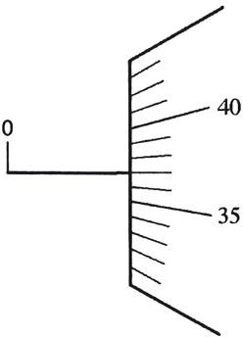

Figure 1
On the diagram, draw the sleeve scale to show a reading of 3.87mm. (1mark)

- Explain why the mass of a body does not change from place to place. (1mark)
........................................................................................................................................................ ……………………………………………………………………………………………………………………………………………………………………………………………………
- Figure 2 below shows a bimetallic strip made of metals A and B at room temperature. Given that A has a higher linear expansivity rate;

A

B

Figure 2

Sketch the appearance of the strip when the temperature is lowered to -10⁰c (1mark)

- Figure 3 below shows a uniform rod of length 3m and mass 5kg balanced by two forces and a string tied to one of its ends.
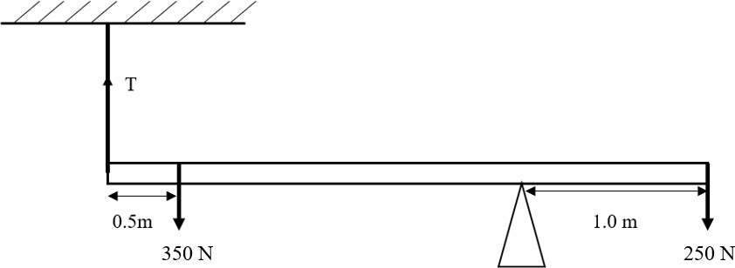

Figure 3

Determine the tensional force in the string. (3 marks)
……………………………………………………………………………………………………………………………………………………………………………………………………………………………………………………………………………………………………………………………………………………………………………………………………………………………………………………………………………………………………………
- Figure 4 below shows a beaker placed on a bench. A block of ice is placed in the beaker as shown.
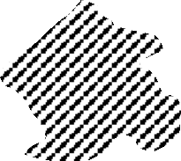
Beaker
Ice

Figure 4

State and explain the change in the stability of the beaker when the ice melts. (2 marks)
…………………………………………………………………………………………………………………………………………………………………………………………………………………………………………………………………………………………………………………………………………………………………………………………

- Figure 5 below shows a spherical ball moving in a viscous liquid in a tall measuring cylinder



Spherical ball
Measuring cylinder

Viscous liquid

Figure 5

  - Other than upthrust force, show on the diagram two other forces acting on the ball.
(2 marks)

  - Sketch a graph showing the variation of velocity with time and show on the sketch the terminal velocity Vt. (1mark)
Velocity (m/s)

Time (s)

- A mass of 1kg is attached to a cord of length 50cm. It is whirled in a circle in a vertical plane at 10 revolutions per second as shown in figure 6 below. Find the tension in the cord when the mass is at the lowest point at B. (3 marks)
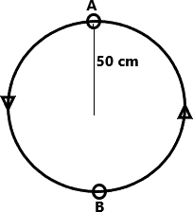

Figure 6

- Figure 7 below shows a setup of pulley system.
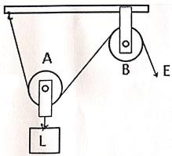

Figure 7
- State the purpose of the pulley labelled В. (1 mark)
......................................................................................................................................................
......................................................................................................................................................
- State two ways in which the efficiency of the system be improved? (2 marks)
......................................................................................................................................................
......................................................................................................................................................
......................................................................................................................................................
- Figure 8 below shows the motion of a pollen grain placed on the surface of still water and observed using a hand lens.

Figure 8 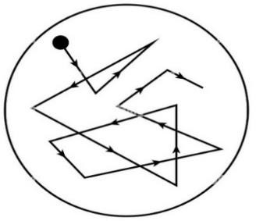

- State the function of the hand lens. (1 mark)
…………………………………………………………………………………………………
- State and explain the effect on the motion of the pollen grain when the temperature of water is decreased. (2 marks)
…………………………………………………………………………………………………
…………………………………………………………………………………………………
…………………………………………………………………………………………………
…………………………………………………………………………………………………

- The diagram in figure 9 below shows a gas trapped by a mercury thread with the mouth of the tube facing down in (a) and the same set-up with the mouth facing upwards in (b)
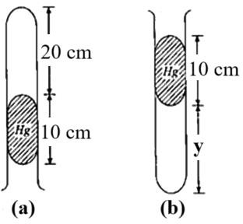

Figure 9
Given that the atmospheric pressure is 76 cmHg, determine the height labelled y.
(2 marks)
…………………………………………………………………………………………………
…………………………………………………………………………………………………
…………………………………………………………………………………………………
…………………………………………………………………………………………………
…………………………………………………………………………………………………
- State one way in which surface tension of water can be reduced. (1mark)
…………………………………………………………………………………………………
- Figure 10 shows a spiral spring fixed on a bench vertically. A mass of 0.5kg is placed on top as shown in the figure below.

6cm

4cm
0.5kg

(a) (b)
Figure 10

In (a) the height of the spring is 6cm while in (b) the height is 4cm. find the energy stored in the spring in figure (b) (2 marks)

SECTION B (55 MARKS)

INSTRUCTION: Answer all the questions in this section
- (a) State Pressure Law for an ideal gas. (1 mark)
…………………………………………………………………………………………………
…………………………………………………………………………………………………
…………………………………………………………………………………………………
…………………………………………………………………………………………………
- State one basic assumption of the Kinetic Theory of gases. (1mark)
…………………………………………………………………………………………………
…………………………………………………………………………………………………
- Figure 11 below shows a set up that may be used to verify Pressure Law.
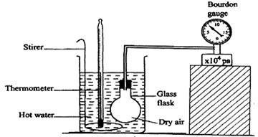

Figure 11
  - State the measurements that may be taken in the experiment. (2 marks)
…………………………………………………………………………………………………
…………………………………………………………………………………………………
…………………………………………………………………………………………………
  - Explain how the measurement in (i) above may be used to verify Pressure Law.
(4 marks)
…………………………………………………………………………………………………
…………………………………………………………………………………………………
…………………………………………………………………………………………………
…………………………………………………………………………………………………
…………………………………………………………………………………………………
…………………………………………………………………………………………………
…………………………………………………………………………………………………
- A car tyre is at an air pressure of 4.0 × 10⁵Pa at a temperature of 27 0C. While the car is moving, the temperature of the tyre rises to 750C. Calculate the new pressure in the tyre assuming the tyre does not expand. (3 marks)

…………………………………………………………………………………………………
…………………………………………………………………………………………………
…………………………………………………………………………………………………
…………………………………………………………………………………………………
…………………………………………………………………………………………………
- (a) Define the term ‘atmospheric pressure’ (1 mark)
…………………………………………………………………………………………………
…………………………………………………………………………………………………
…………………………………………………………………………………………………
- Figure 12 below shows an accurate simple mercury barometer.
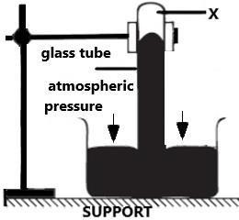

Figure 12

  - Identify the part labelled X . (1 mark)
....................................................................................................................................................
  - Explain how you would test for the X. (2 marks)
......................................................................................................................................................
......................................................................................................................................................
......................................................................................................................................................
......................................................................................................................................................
- The figure 13 below shows a U-tube filled with water, mercury and another liquid
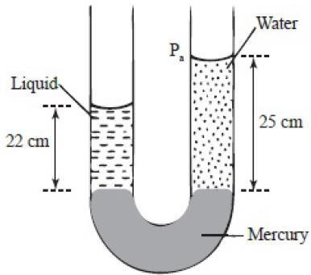

Figure 13

Determine the density of the liquid. (2 marks)
......................................................................................................................................................
......................................................................................................................................................
......................................................................................................................................................
......................................................................................................................................................
......................................................................................................................................................
......................................................................................................................................................
- Give one reason why mercury is used for this experiment. (1 mark)
......................................................................................................................................................
......................................................................................................................................................
......................................................................................................................................................
- The diagram in figureb14 below shows water in a long pipe with parts A and B
as shown



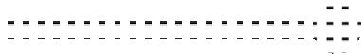
Figure 14
A
B

- Show on the diagram, the likely levels of water in section A and B. (1 mark)

- Explain your answer above. (1 mark)
…………………………………………………………………………………………………
…………………………………………………………………………………………………
…………………………………………………………………………………………………
…………………………………………………………………………………………………
…………………………………………………………………………………………………
- State two assumptions made when deriving equation of continuity. (2marks)
…………………………………………………………………………………………………
…………………………………………………………………………………………………
…………………………………………………………………………………………………
…………………………………………………………………………………………………

- a) Figure 15 below shows two trolleys of mass 6kg and 8kg traveling towards each other at
10m/s and 5m/s respectively. The trolleys combine on collision.

10m/s 5m/s

Figure 15
6kg
8kg

  - Calculate the velocity of the combined trolleys after collision. (3 marks)
…………………………………………………………………………………………………
…………………………………………………………………………………………………
…………………………………………………………………………………………………
…………………………………………………………………………………………………
…………………………………………………………………………………………………
  - Given that the collision time was 2 seconds, determine the impulsive force (3 marks)
……………………………………………………………………………………………………
……………………………………………………………………………………………………
……………………………………………………………………………………………………
…………………………………………………………………………………………
    - An object is projected horizontally at a velocity of 50m/s from a cliff 45m high. Calculate:

- The time taken to hit the ground (2 marks)
…………………………………………………………………………………………………
…………………………………………………………………………………………………
…………………………………………………………………………………………………
…………………………………………………………………………………………………
ii) The distance from the foot of the cliff when the object hits the ground. (2 marks)
…………………………………………………………………………………………………
…………………………………………………………………………………………………
…………………………………………………………………………………………………
…………………………………………………………………………………………………

    - The graph below shows the displacement time graph of the motion of a particle

Displacement (m)
C
A
B

Time (s) D

State the nature of the motion of the particle between
i. A and B (1 mark)
………………………………………………………………………………………………
………………………………………………………………………………………………
- B and C (1mark)
………………………………………………………………………………………………
………………………………………………………………………………………………
- (a) State Archimedes’ Principle. (1 mark)
……………………………………………………………………………………………………
……………………………………………………………………………………………………
……………………………………………………………………………………………………
…………………………………………………………………………………………
- An object weights 1.04N in air, 0.64N when fully immersed in water and 0.72N when fully immersed in a liquid. If the density of water is 1000kgm-3, determine the density of the liquid. (3 marks)

…………………………………………………………………………………………………
…………………………………………………………………………………………………
…………………………………………………………………………………………………
…………………………………………………………………………………………………
…………………………………………………………………………………………………
…………………………………………………………………………………………………
…………………………………………………………………………………………………
…………………………………………………………………………………………………

- Figure 16 below shows a buoy, B, of volume 40 litres and mass 10 kg. It is held in position in sea water of density 1.04gcm-3 by a light cable fixed to the bottom so that ¾ of the volume of the buoy is below the surface of the sea water.

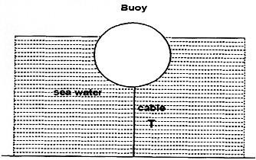
Figure 16
Determine the tension T in the cable. (3 marks)
…………………………………………………………………………………………………
…………………………………………………………………………………………………
…………………………………………………………………………………………………
…………………………………………………………………………………………………
…………………………………………………………………………………………………
…………………………………………………………………………………………………
- Figure 17 shows a diagram of a hydrometer which is suitable for measuring the densities of liquids varying between 1.0gcm-3 and 1.2gcm-3.

A

Stem

bulb

Figure 17
B

Lead shots

  - On the diagram, indicate the label corresponding to 1.0 and 1.2g/cm3. (1 mark)

  - State how the sensitivity of the above instrument be increased. (1 mark)
…………………………………………………………………………………………………
…………………………………………………………………………………………………
- A ship made of steel floats in water yet steel is denser than water. Give a reason. (1 mark)
……………………………………………………………………………………………
……………………………………………………………………………………………
……………………………………………………………………………………………
……………………………………………………………………………………………
- (a) Figure 18 below shows a block of ice with two heavy weights hanging such that the copper wire connecting them passes over the block of ice.



Ice block

Copper wire

Wooden support

Figure 18
Weights

  - It is observed that the wire gradually cuts its way through the ice block, but leaves it as one piece. Explain this observation. (2marks)

…………………………………………………………………………………………………
…………………………………………………………………………………………………
…………………………………………………………………………………………………
…………………………………………………………………………………………………
…………………………………………………………………………………………………
…………………………………………………………………………………………………
  - State the change that would be observed if the copper wire used in the experiment was replaced by a cotton thread. (1mark)
......................................................................................................................................................

- Define the term specific latent heat of vaporization. (1 mark)
…………………………………………………………………………………………………
…………………………………………………………………………………………………
…………………………………………………………………………………………………
…………………………………………………………………………………………………
…………………………………………………………………………………………………

- An electric heat rated 6000W is used to heat 2kg of ice initially at -5°C until all the mass turns to steam. Given that, the specific Latent heat of fusion of ice = 334000JKgˉ¹ Specific heat capacity of ice = 2100JKgˉ¹Kˉ¹ Specific heat capacity of water = 4200JKgKˉ¹ Specific latent heat of vaporization of steam = 226000JKgˉ¹. Determine:

  - The amount of heat required to convert ice into water at O°C. (2 marks)
…………………………………………………………………………………………………
…………………………………………………………………………………………………
…………………………………………………………………………………………………
…………………………………………………………………………………………………
…………………………………………………………………………………………………
  - The amount of heat required to convert water to steam at 100°C. (2 marks)
…………………………………………………………………………………………………
…………………………………………………………………………………………………
…………………………………………………………………………………………………
…………………………………………………………………………………………………
…………………………………………………………………………………………………
  - The minimum time required in minutes for activity in (i) and (ii) to take place.
(2 marks)
…………………………………………………………………………………………………
…………………………………………………………………………………………………
…………………………………………………………………………………………………
…………………………………………………………………………………………………

- Figure 19 below shows a set-up that was used to determine the specific heat capacity of aluminium block. Study the diagram and answer the questions that follow

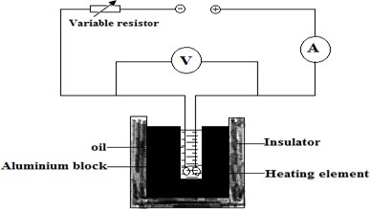

Figure 19
Apart from voltage, current and temperature, state any other quantity that is required for the determination of the specific capacity of the aluminium block. (1 mark)
………………………………………………………………………………………………
………………………………………………………………………………………………

