KENYA CERTIFICATE OF SECONDARY EDUCATION(KCSE)
SULIMO-JOINT EVALUATION TEST
121/1
Paper 1
MATHEMATICS
JULY. 2025 -2 $\frac{1}{2}$hours
Name......................................................................Admno.......................Class.........................
Candidate’ssignature...........................................Date..............................................................
Instructions to candidates
- Write your name and admission number in the spaces provided above
- Sign and write your name, admission number, class and the date of examination in the spaces provided above
- This paper consists of two sections: Section I and section II.
- Answer all questions in Section I and ONLY 5 questions in section II
- Show all the steps in your calculations, giving your answers at each stage in the spaces provided below each question.
- Marks may be given for correct working even if the answer is wrong
- Non programmable silent electronic calculator and KNEC Mathematical tables may be used, except where stated otherwise
- This paper consists of 15 printed pages
- Candidates should check the question paper to ascertain that all the pages are printed as indicated and that no questions are missing.
- Candidates should answer the questions in English

For Examiner’s Use Only
Section I

1 | 2 | 3 | 4 | 5 | 6 | 7 | 8 | 9 | 10 | 11 | 12 | 13 | 14 | 15 | 16 | Total

Section II
17 | 18 | 19 | 20 | 21 | 22 | 23 | 24 | Total
Grand Total

SECTION I (Answer ALL the questions in this section)
- Evaluate without using a calculator. (3 marks)
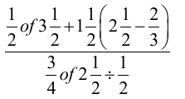

- A steel company wishes to make nails from steel rods of length 5.12m, 7.60 m and 9.28 m. Find the least number of nails that can be obtained from the three steel rods.(3 marks)

- Factorise completely; $\left(a+b\right)\left(3a-4b\right)-{(a+b)}^{2}$ (3 marks)

- Solve the equation: ${27}^{x}+ 3^{3x-1}$ - 4 =104 (4 marks)

- Find the obtuse angle $θ$ that line $-3x+4y$ = 12 makes with the x-axis (3 marks)
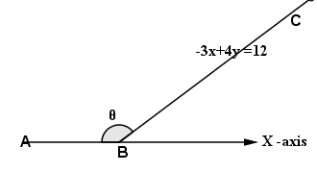

- The figure below shows wooden pentagonal prism of side 10cm and length 45cm. If it weighs 3.5kg, find its density in kg/cm³. (3 marks)
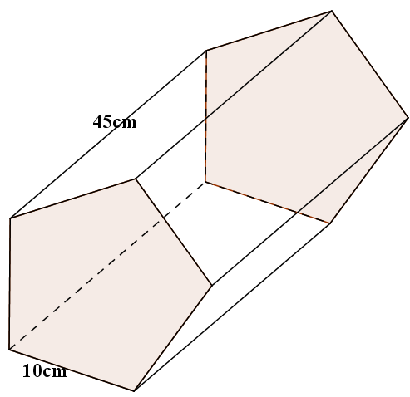

- Two interior angles of an irregular polygon each measures${90}^{0}$. All the other remaining interior angles each measure ${150}^{0}$. Determine the number of sides of the polygon. (3 marks)

- Generate the inequalities that define region R in the figure below: (3 marks)
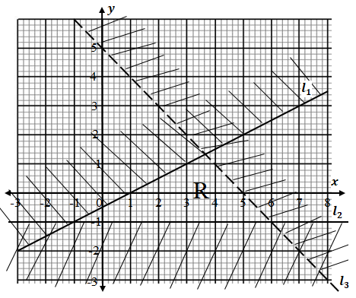

- The distance between towns T and S is 418km. At 9.45a.m a truck left town T and travelled towards town S. At the same time a car left town S and travelled towards town T along the same road. Given that the car travels 30km/h faster than the truck and that the two vehicles meet at 1:33p.m, find the speed of each vehicle. (3 marks)

- Given that OP = $-6i-3j$, $OQ = -2i-j$ and $OR = 6i+3j$, express PQ and QR as column vectors and hence show that the points P,Q and R lie on a straight line.(4 marks)

- From the foot of a tower, the angle of elevation of the lower frame of a window is $\frac{2π^{c}}{15}$. From the top of the tower, the angle of depression of the top frame of the same window is 0.2π^{c}. If the tower 7m tall and 5m away from the building, determine the height of the window. (3 marks)

- The figure below shows a circle centre O and AOC is its diameter. Chords BD and AC intersect at F. Given that angle AOB =68⁰ and angle ACD = 70⁰, find the size of angles; (3 marks)
- DAC
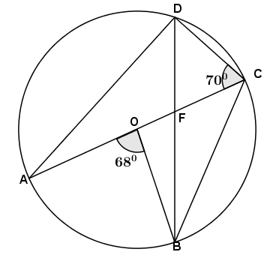

- BFC

- Using a ruler and a pair of compasses only, construct a trapezium ABCD in which AB=5cm, AD=6cm, DC=10cm ∠BAD=105⁰ and AB is parallel to DC. Draw a perpendicular from B to DC hence measure the height of the trapezium. (3 marks)

- A sales agent is paid a commission of $x$% on sales over sh.80000. During a particular month he received a commission of sh. 14680 after selling 50 bicycles at a discount of 12%. If the marked price of a bicycle was sh. 18500, determine the value of $x$. (3 marks)

- Use tables of reciprocal to evaluate $\frac{1}{0.0247}$ hence evaluate $\frac{\sqrt{30.25}}{2.47×{10}^{-2}}$ (3 marks)

- Use mid-ordinate rule with 6 strips to estimate the area bounded by the curves and lines $x=-3$ and $x=3$ (3 marks)
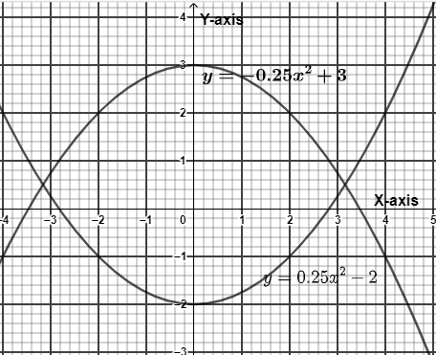

SECTION II: (Answer ONLY 5 questions in this section)
- (a) A rectangular piece of cardboard measuring 40cm by 30cm is to be made into an open box with a base of 936cm² by cutting equal squares from the four corners and then binding up the sides. Find the length of the side of the square that must be cut from each corner. (4 marks)

(b). A shopkeeper purchases a certain number of books for $1200. If the cost per book was $10 less, the number of books that could be purchased for $1200 would be 4 more. Find the original cost of each book. (3 marks)

(c) The sum of squares of two consecutive even integers is 244. Find the numbers.
(3 marks)

- At noon two ships Q and R leave for port P and sail out to sea. Ship Q sails at a steady speed of 50km/h on a bearing of ${060}^{0}$ while ship R sails at a steady speed of 30km/h on a bearing of${150}^{0}$. At 1600h both ships radio back to the port giving their positions. At the same time a third ship T gives its position at 300km due east of P.
- Using a ruler and compasses only, construct a scale drawing showing the positions of P, Q, R and T at 1600h. (Scale 1cm=40km) (4 marks)

- Use your scale drawing to determine the distance
- Q from R (2 marks)

- T from R (2 marks)

- R from T (2 marks)

- The figure below shows quadrilateral ABCD( not drawn to scale) with AB = 8cm, AD = 7cm, CD = 14cm and angle ADC = 70⁰.
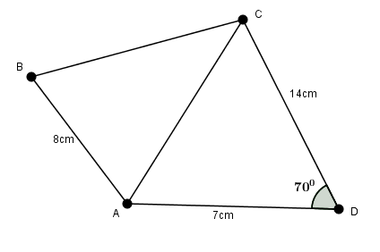
- Calculate to 4 significant figures, the length of side AC (3 marks)

- Calculate to 2 decimal places, the size of angle ACD (2 marks)

- Given that angle ABC is 110⁰ find to 1 decimal place
- Length BC (3 marks)

- A circle is drawn through points A,B and C. Find the length of the largest chord of the circle (2 marks)

- (a). Find the inverse of $\left(\begin{matrix}16 & 5 \\ 4 & 3\end{matrix}\right)$ (2 marks)

(b). In a certain day, a business man total sales from 16 blouses and 5 pairs of trousers was sh.8000. On the following day, his total sales went down by 57.5% . If he had sold 4 blouses and 3 pairs of trousers during the second day, determine by the matrix method, the price of each item. (4 marks)

(c). On the third day, the businessman reduced the price of a pair of trouser by 8% and increased that of a blouse by 12%. As a result he sold twice as many trousers as blouses. If the day’s total sales were sh.10512, determine the number of blouses and pairs of trousers that he sold on the third day. (4 marks)

- The masses in kilograms of patients who attended clinic on a certain day were recorded as follows:
69 54 48 26 53 33 50 39 21
54 30 46 72 50 63 28 51 36
23 25 53 45 59 37 52
(a) Complete the frequency distribution table below for the above information. (2 marks)

Mass (kg) | No.of patients | Frequency density
20 – 24
25 – 34
35 – 49
50 – 54
- – 74

(b).Use the grid below to represent the above information on a histogram (3 marks)
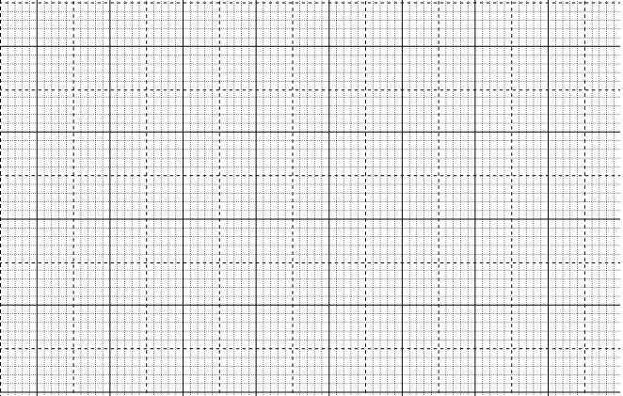
(c) Use the histogram to
- estimate the median mass (3 marks

- determine the number of patients whose mass is between 36kgs and 56kgs (2 marks)

- (a) On the grid provided below draw triangle ABC with vertices A($1,4$),B($4,3$) and C($3,2$) (1 mark)
(b).On the same grid draw $∆$A^{I}B^{I}C^{I} with vertices A^{I}($2,-5$),B^{I}($3,-2$) and C^{I}($4,-3$) hence describe fully the transformation that maps $∆$ABC onto $∆$A^{I}B^{I}C^{I}. (4 marks)

(c).On the same grid draw $∆$A^{II}B^{II}C^{II}, the image of $∆$A^{I}B^{I}C^{I} under enlargement scale factor $-2$, centre ($1, -2$). State the coordinates of $∆$A^{II}B^{II}C^{II}. (3 marks)

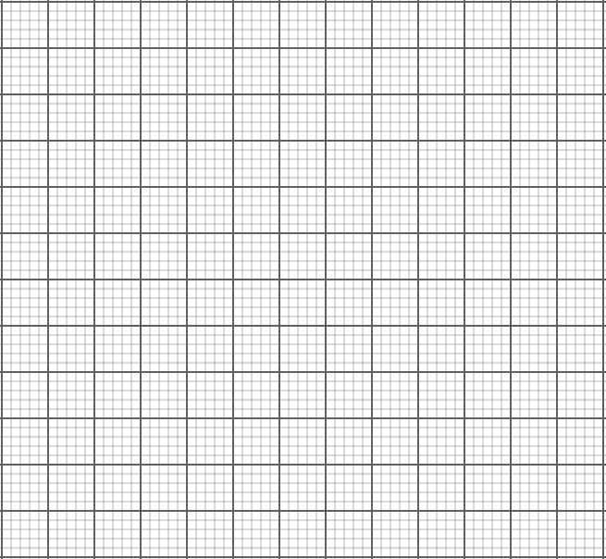

(d). If $∆$A^{III}B^{III}C^{III} is the image of $∆$A^{II}B^{II}C^{II} under translation vector $\left(\begin{matrix}1 \\ -2\end{matrix}\right)$, without drawing determine the coordinates the image. (2 marks)

- The displacement, S metres, of a particle moving along a straight line from point O, after t seconds is given by$S=5+8t+t^{2}-\frac{1}{3}t^{3}$
(a) Find displacement of the particle during the 5th second. (4 marks)

(b) Determine:
(i) The time when the particle is momentarily at rest. (3 marks)

(ii) The maximum velocity attained by the particle. (3 marks)

- A solid frustum of a cone with base radius 10.5 cm and top radius 7 cm is made of a material whose density is 10 g/cm³.The mass of the solid is 58.52 kg.
- Determine the volume of:
- The frustum in cm³. (2 marks)

- The cone that was cut off to obtain the frustum in cm³. (3 marks)

(b) Find the height of:
(i) The cone that was cut off to obtain the frustum. Take$π=\frac{22}{7}$ (3 marks)

(ii) The frustum. (2 marks)

