312/2
GEOGRAPHY
Paper 2
July, 2025
Time 2 hours 45 min

SULIMO JOINT EXAMINATION
Kenya Certificate of Secondary Education
312/2
Paper 2
GEOGRAPHY

INSTRUCTIONS TO STUDENTS
- This paper has two sections A and B
- Answer ALL the questions in section A. In section B answer questions 6 and any other TWO questions.

SECTION A

1 a) Define the term Environment. (2 marks)
b) List three physical environmental hazards experienced in Kenya.
(3 marks)

2 a) State three characteristics of the tropical hardwood forest. (3 marks)
b) Name two species of softwood trees mainly grown in Canada.
(2 marks)

3 Use the map of north- west Atlantic ground to answer questions (i) and (ii).
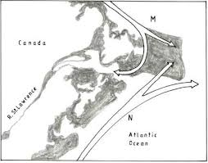
- Name the two ocean currents labelled N and M. (2 marks)
- State three physical factors favoring fishing in the above fishing
grounds. (3 marks)
4 a) Give two types of energy. (2 marks)
b) State three causes of energy crisis. (3 marks)

5 (a) State two ways in which communication contributes to economic
development in Kenya. (2 marks)
(b) Highlight three problems facing railway transport in Africa.
(3 marks)

SECTION B

6. (a) The photograph below shows an equipment used in alluvial mining.
Use it to answer the questions that follow.

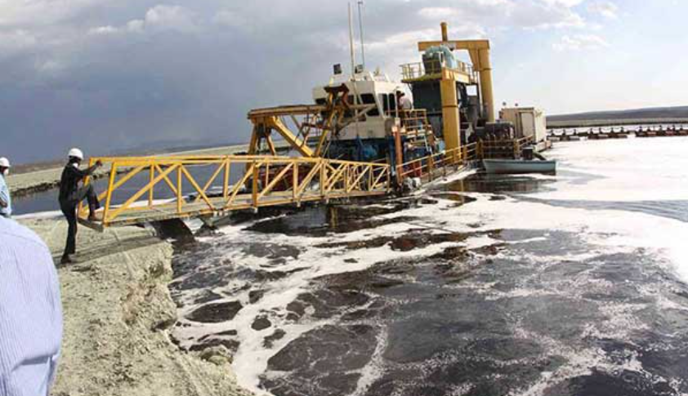

- Name the method of mining shown in the photograph. (1mark)
- Identify the mineral mined using this method. (1 mark)

b) (i) Draw a rectangle measuring 12 cm by 8 cm to represent the
area covered by the graph (2 marks)
(ii) On the rectangle, mark and label three main features.
(3 marks)
c) Describe how the mineral is extracted and processed using the
equipment shown in the photograph. (6marks)
d) State two processes which lead to mineral occurrence (2marks)
e) Explain the following problems of mining: -
i) Land dereliction (2 marks)
ii) Loss of biodiversity (2 marks)
f) Explain three ways in which mining promotes industrialization.
(6 marks)

- a i) Apart from Ghana, name two countries in Africa where cocoa
is grown. (2 marks)
- State five physical conditions that favor cocoa farming in
Ghana. ( 5 marks)
b i) Describe the process of cocoa cultivation in Ghana. (6 marks)
ii) Give three uses of cocoa (3 marks)
c i) Explain three human problems faced by cocoa farmer in G
(6 marks)

ii) Give ways in which cocoa farming has benefited the
government of Ghana. (3 marks)

8. a) (i) Define land Rehabilitation (2marks)
(ii) State four benefits of land Rehabilitation in Kenya (4marks)
b) (i) Explain four factors that led to the successful establishment of
Pekerra irrigation scheme. (8marks)
(ii) State three problems facing Pekerra irrigation scheme (3marks)
(iii) List four main crops grown in Pekerra irrigation scheme.
(4 marks)
c) State four advantages of irrigation farming to the economy of
Kenya. (4marks)

9. a) Differentiate between a national park and a game reserve. (2marks)
- (i) State four reasons for establishing national parks in Kenya.
(4marks)
- Identify two examples of game sanctuaries in Kenya. (2marks)
- (i) Define domestic tourism. (2 marks)
- State four factors that hinder domestic tourism in Kenya.
- marks)
- State three problems associated with tourism in Kenya.
(3marks)
- Explain four factors that make Switzerland receive more tourists than Kenya . (8marks)

10. Use the population pyramid below to answer the questions that follow:
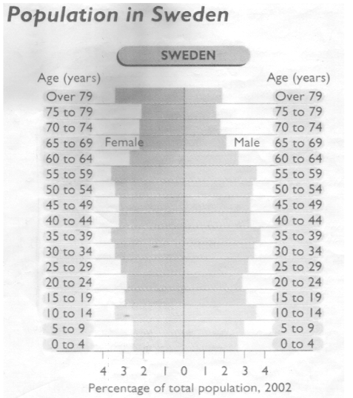
- i. Briefly describe the population structure represented by
the age-sex pyramid above. (4 marks)
ii. State any two advantages of the method of data
representation shown above. (2 marks)
iii. List any three methods that could have been used to
acquire the data above. (3 marks)
iv. State two implications of such a structure to the
country’s economy. (2 marks)

- i. What is population explosion? (1 mark)
ii. Explain three effects of rural-urban migration in East Africa.
(6 marks)
iii. List three factors that influence population distribution in
Kenya. (3 marks)
iv. State four factors leading to the reduction of fertility rate in
Kenya. (4 marks)

