312/1
GEOGRAPHY
PAPER 1
JULY 2025
TIME: 2¾ HOURS

SULIMO JOINT EXAMINATION
312/1
Paper 1
GEOGRAPHY
_____________________________________________________________________
Name……………………………………… Adm. No…………
Class………. Signature…………… Date: …………………
___________________________________________________________________________________

INSTRUCTIONS TO CANDIDATES
- Write your name and index number in the spaces provided.
- Sign and write the date of examination in the spaces provided.
- This paper has two sections A and B
- Answer ALL the questions in section A. In section B answer questions 6 and any other TWO questions.

For examiners use only.

Section | Question | Maximum Score | Candidate’s Score
A | 1 - 5 | 25
B | 6 | 25
B |  | 25
 |  | 25
 | Total Score

SECTION A (25 MARKS)

- (a) Differentiate between asteroids and meteors. (2 marks)

(b) State three characteristics of the sun (3 marks)

- (a) Identify two types of earthquakes. (2 marks)

(b) Give three ways in which earthquakes affect human activities. (3marks)

- (a) What is climax vegetation? (2 marks)

- State two ways through which climate influences the distribution of vegetation. (2 marks)

- (a) What is river rejuvenation? (2marks)

(b) State three conditions for river capture to occur. (3marks)

- (a) Give two features of deposition that result from action of water in arid areas. (2 marks)

  - State three positive effects of desert features. (3 marks)

- Use the map of Tambach 1:50000, sheet 90/3 to answer question 6.

- (i) List two physical features on grid 8260. (2 marks)

(ii) Measure the distance of the road D36 the north of Northing 70, Give
your answer in Kilometers. (2 marks)

(iii) Calculate the area of Kaptagat Forest. (2 marks)

- (i) Give three indicators which shows that the western part of the area
covered by the map receive high rainfall. (3 marks)

(ii) Describe the drainage of the area covered by the map. (6 marks)

- (i) Enlarge by 2 the area from easting 89 to easting 92 and northing 69 to
72. on the square mark and label the following features.
- Lake kamanorok
- River kerio
- Seasonal swamp
- Air photo principal point No. 80.

(ii) Calculate the new scale of the area drawn.

(d) A straight road is to be built from Tambach town to Muchukwo. State four problems that would be experiences during the construction. (4 marks)

- (a) Differentiate between a mineral and a rock. (2 marks)

(b) i) A part from igneous rocks, give two other types of rocks according to
mode of formation. (3 marks)
ii) Describe how extrusive igneous rocks are formed. (4 marks)
iii) State three characteristics of intrusive igneous rocks. (3marks)
(c) Explain three ways in which rocks are significant to human activities.
(6marks)
(d) Form four students of Highland High school conducted a field study on rocks within their school vicinity.
(i) State how they prepared for the field study. (4 marks)
(ii) State three methods they used to collect statistical data. (3 marks)

- a) (i) Outline three elements of Climate. (3marks)
(ii) Describe two ways in which distance from water body influence climate.
(2marks)
(b) Use the outline of the world map provided to answer the questions that
follow.
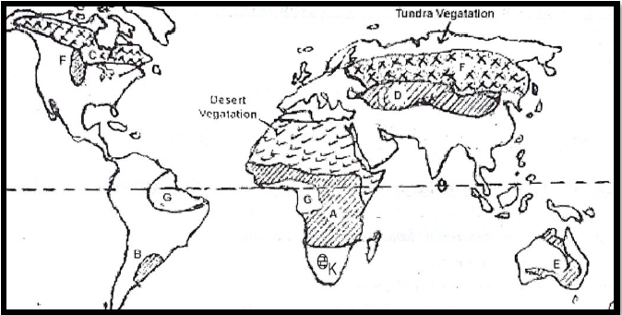

- Name the Climatic regions marked A and G. (2marks)
- Describe the characteristics of the Desert vegetation. (5marks)
- Explain three ways in which climatic conditions influence the Tundra vegetation in the region shown. (6marks)

(c) You carried out a field study on Vegetation in a nearby forest.
(i) Name three ways you would use to identify the vegetation types.
(3marks)
(ii) Apart from a Camera, list two equipment you would require during your study. (2marks)
(iii) State three problems you are likely to experience during your study.
(3marks)

- (a) Define a Coast. (2marks)

(b) (i) Describe the following processes of wave erosion.
- Solution (2marks)
- Abrasion (2marks)

(ii) State three factors that influence that rate of wave erosion. (3marks)
(c) (i) State two causes of Emerged Coasts. (2marks)
(ii) State the conditions necessary for the formation of Coral polyps.
(3marks)
(ii) Using a well labelled diagram, describe how a blow hole is formed.
(5marks)
(d) Explain three economics benefits of coastal features to human activities.
(6marks)

10. (a) (i) What is a Karst Scenery? (2 marks)
(ii) Explain three factors which are necessary for formation of Karst
Scenery. (6 marks)
(b) Describe how the following features are formed;
- Underground caves (5 marks)
  - The diagram below represents surface features, use them to answer the questions that follows.

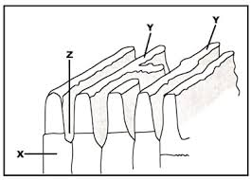

- Name the parts marked Y and Z. (2 marks)
- Explain how the above feature was formed. (4 marks)

(d) Explain the significance of Karst landscape. (6 marks)

