SULIMO JOINT EXAMINATION
Kenya Certificate of Secondary Education
451/1
COMPUTER STUDIES
PAPER 1
MOCK EXAM – JULY 2025
TIME: 2 ½ hours

Name …………………………………………………..…… Index Number ….………….………

Candidate`s Signature .…………………………………… Date …….…….……………………

Instructions to Candidates
- Write your name and index number in the spaces provided above.
- Sign and write the date of examination in the spaces provided above.
- This paper consists of two sections: Section I and Section II.
- Answer all the questions in Section I
- Answer Question 16 then any other three from section B.
- Show all the steps in your calculation, giving your answers at each stage in the spaces provided below each question.
- Non-programmable silent electronic calculators and KNEC mathematical tables may be used, except where stated otherwise.
- This paper consists of 14 printed pages.
- Candidates should check the questions paper to ascertain that all the pages are printed as indicated and that no questions are missing.
- Candidates should answer the questions in English.

For Examiner’s Use Only

SECTION A
1 | 2 | 3 | 4 | 5 | 6 | 7 | 8 | 9 | 10 | 11 | 12 | 13 | 14 | 15

16 | 17 | 18 | 19 | 20

SECTION A: (40 MARKS)

Answer ALL questions in the spaces provided
1. Define the term Datum? Give an example. (2 marks)
__________________________________________________________________________________________________________________________________________________________________
2. Give three reasons why an IT manager would reject a request by a database administrator to replace his desktop with a laptop? (3 marks)

__________________________________________________________________________________________________________________________________________________________________
_________________________________________________________________________________
3. a) Define the term normalization? (2 marks)
__________________________________________________________________________________________________________________________________________________________________
b) Mention two objectives of normalization (2 marks)
__________________________________________________________________________________________________________________________________________________________________
- Speech or voice input is rapidly developing means of input to a computer.
List two advantages and two disadvantages of speech input technology. (4 marks)
__________________________________________________________________________________________________________________________________________________________________
__________________________________________________________________________________________________________________________________________________________________
- Give two ways in which irrelevance can corrupt the integrity of data. (2 marks)
__________________________________________________________________________________________________________________________________________________________________
- Give two purposes of an Information System. (2 marks)
__________________________________________________________________________________________________________________________________________________________________
_________________________________________________________________________________
- Other than cost and compatibility, state two factors to consider when selecting an input device for an organization (2 marks)
__________________________________________________________________________________________________________________________________________________________________
_________________________________________________________________________________
- State the importance of the cache memory to the computer (1mark)
__________________________________________________________________________________________________________________________________________________________________
- List any four properties an OS adds to a computer file . (2 marks)
___________________________________________________________________________________________________________________________________________________________________________________________________________________________________________________
_________________________________________________________________________________
- a) One type of component within the CPU is an address bus. Identify two other types of bus and state what each is responsible for transmitting in the CPU. (2 marks)
Bus 1
______________________________________________________________________________________________________________________________________________________
Bus 2 (2 marks) ___________________________________________________________________________
___________________________________________________________________________
- a) State any two disadvantages of printing documents using thermal printers (2marks)
__________________________________________________________________________________________________________________________________________________________________
_________________________________________________________________________________
- Falyaz has created a diary using word processing software. The diary entry for 17th May 2020 is shown. 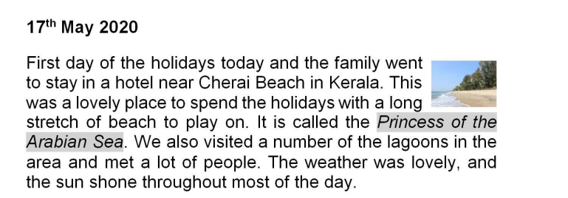

Write down four formatting features of the word processing software used to make this diary entry. (4 marks)
__________________________________________________________________________________________________________________________________________________________________
__________________________________________________________________________________________________________________________________________________________________
13. Geography students have access to course materials on their college website. A web browser is used to access these materials. Describe three features of a web browser which would be suitable for this application. (3 marks)
__________________________________________________________________________________________________________________________________________________________________
__________________________________________________________________________________________________________________________________________________________________
14. Motiso, an accountant, has a bank account with Light International Bank. After logging into his account, the bank sends a onetime passcode (OTP) through his personal mobile phone as shown in the figure below.
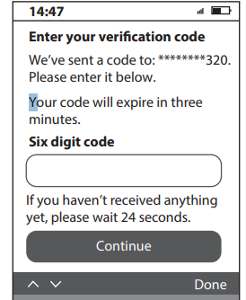

- Name the method of data security described above (1 mark)
__________________________________________________________________________________________________________________________________________________________________
b) State two benefits of the method of data security identified above (2 marks)
__________________________________________________________________________________________________________________________________________________________________
__________________________________________________________________________________________________________________________________________________________________
15. The following statements relate to careers in ICT. Complete the table below by naming each of the following job descriptions with the most appropriate ICT career title: (2 marks)

Description | ICT career title
a) Designs and maintains websites for organizations.
b) Protects computer systems and networks from security breaches.
c) Analyzes business problems and designs technology solutions.
d) Writes and tests code to develop software applications.

SECTION B (60 marks)
Answer Question 16 and any other three questions from this section
- Study the flowchart below and answer the following questions 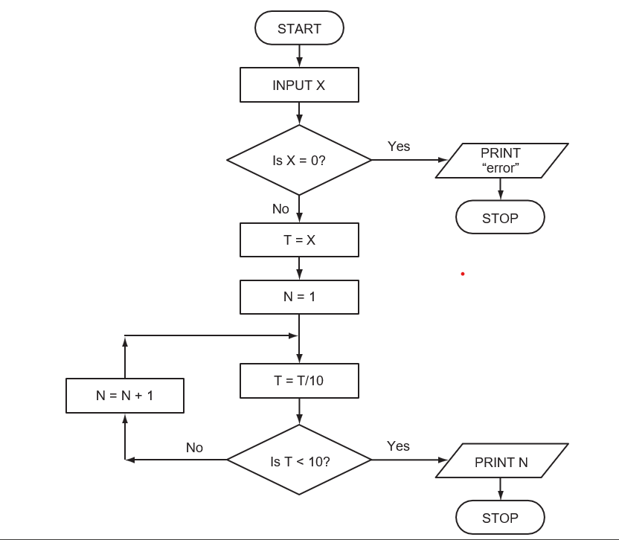

- Identify the errors in the flowchart above. (2 marks)
__________________________________________________________________________________________________________________________________________________________________
__________________________________________________________________________________________________________________________________________________________________
- Suggest solutions for the errors identified above (2 marks)
_________________________________________________________________________________
__________________________________________________________________________________________________________________________________________________________________
- What output would you expect if the following data was input into the flowchart? (3marks)
- X = -150 _______________________
- X = 540______________________
- X = 0 ________________________
- Write the pseudocode for the corrected version of flowchart above. (8marks)

- a) The emergence of Gen-Z popular ‘maandamano’ has led to many organizations in major cities
in Kenya to embrace teleworking approach

- Differentiate between the term teleworking and teleconferencing (2 marks)
_________________________________________________________________________________
__________________________________________________________________________________________________________________________________________________________________
- State two benefits that the organization gained by using this approach. (2marks)
__________________________________________________________________________________________________________________________________________________________________
_________________________________________________________________________________

b). State three ways of transforming a picture embedded in a Desktop Publishing programme in order to fit in a designated space on a document. (3marks) ___________________________________________________________________________________________________________________________________________________________________________________________________________________________________________________
_________________________________________________________________________________

c). You are given the following Spreadsheet file showing sales data for a hair salon's clients. Use this data to answer the questions below

 | A | B | C | D | E
1 | Client_Name | Gender | Date_Birth | Hair_Style | AmountPaid
2 | Ann Mwende | F | 2024-03-15 | Bob Cut | 450
3 | Brian Okoth | M | 2023-11-22 | Fade | 3050
4 | Carla Kamau | F | 2025-01-10 | Layered Cut | 5500
5 | Daudi Ahmed | M | 2025-06-05 | Pompadour | 4000

i). State the difference between the following two expressions: (2 marks)
=IF (C1>10,” Yes”, “No”)
=IF (AND(C1>10, C3>10),” Yes”, “No”))
________________________________________________________________________________________________________________________________________________________________________________________________________________________
ii). Write a function to count the number of "F" in the Gender column.
________________________________________________________________ (2 marks)
iii). Write an appropriate expression to determine the age of the client as at today
________________________________________________________________ (2 marks)
iv). In a new column named gift value, an expression is entered that calculates the 10% of the amount paid. Write this expression. _________________________________ (2 marks)

- A multinational organisation has offered to donate computers to your school.
The Board of Governors has requested you to advise on the operating system to be used by providing answers to the following questions.

- What is an operating system? (1 mark)
__________________________________________________________________________________________________________________________________________________________________
_________________________________________________________________________________

- State two classifications of operating system giving one example of each. (4 marks)
__________________________________________________________________________________________________________________________________________________________________
_________________________________________________________________________________
- List any three functions of Network Operating system (3 marks)
___________________________________________________________________________________________________________________________________________________________________________________________________________________________________________________
_________________________________________________________________________________
d) Study the following diagram

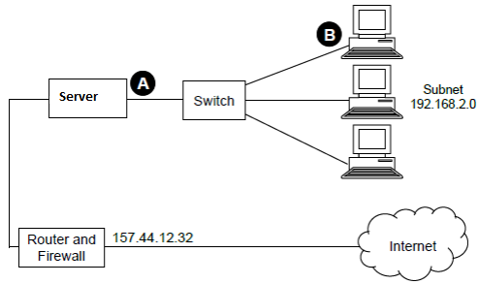

i). Name the physical topology used in the above shown network (1 mark)
________________________________________________________________________________________________________________________________________________
ii). State two functions of the device named server (2 marks)
________________________________________________________________________________________________________________________________________________________________________________________________________________________________________________________________________________________________

iii). Clearly explain what would happen if the device named switch fails (2 marks)
________________________________________________________________________________________________________________________________________________________________________________________________________________________
iv).What is the importance of the subnet mask address shown on the diagram above? (2marks)

19. (a) State three standard coding schemes used in computing (3marks)
___________________________________________________________________________
___________________________________________________________________________
___________________________________________________________________________
- The hexadecimal error code AC8 means ‘insufficient memory’. Convert the hexadecimal error codes AC8 to denary values. (2 marks)

(c). Use eight-bit ones complement to perform the following and leave the answer in decimal notation (4 marks)

100001₂ - 111010₂

(d). Arrange the following numbers in order from smallest to largest (3marks)
110011₂, 1FH, 67₈ and 4510

(e). Convert $\frac{12}{32} base 10 to binary number system$ (3mrks)

- The tables below were extracted from jobu’s enterprise database. Use them to answer the questions that follows

CUSTOMER TABLE
CUSTOMER ID | ID NUMBER | NAME | ADDRESS | TOWN

ORDER TABLE
ORDER ID | CUSTOMER ID | ORDER DATE | PARTICULARS | QUANTITY | UNIT COST

(a). Identify the most appropriate primary keys in both tables (1mark)
__________________________________________________________________________________________________________________________________________________________________

(b). Identify a candidate key in any of the tables (1mark)
__________________________________________________________________________________________________________________________________________________________________

(c). Describe the relationship formed between the two tables (2marks)
__________________________________________________________________________________________________________________________________________________________________
- Feasibility studies play a key role in determining whether a system project should proceed. Give two reasons why conducting a feasibility study is important in system development. (2 marks)

___________________________________________________________________________________________________________________________________________________________________________________________________________________________________________________
_________________________________________________________________________________

- Describe any two types of feasibility study. (2marks)
____________________________________________________________________________________________________________________________________________________________________
- The V-shaped model is one of the linear system development strategies.
Describe the main characteristic of the V-shaped model in system development. (2 marks)
______________________________________________________________________________________________________________________________________________________________________________________________________________________________________________________
__________________________________________________________________________________

- A company uses robots in its factory to manufacture large pieces of furniture. One characteristic of a robot is that it is programmable. State two other characteristics of a robot. (2 marks)

_____________________________________________________________________________________________________________________________________________________________________________________________________________________________________________________

- Give three advantages to company employees of using robots to manufacture large pieces of furniture. (3 marks)

__________________________________________________________________________________________________________________________________________________________________
__________________________________________________________________________________________________________________________________________________________________

