Class: …………………………………………..…….....Date: ……………………

School: …………………………………………..……ADM NO: ……………………

SULIMO JET- July 2025
Kenya Certificate of Secondary Education
231/2
BIOLOGY
Paper 2
TIME: 2HRS
INSTRUCTIONS TO CANDIDATES
- Write your name, Admission number and name of your school in the spaces provided above
- Answer all the questions in section A in the spaces provided a question 6 (COMPULSORY) in the spaces provided and either question 7 or 8 in the spaces provided after question 8.
- Candidates should check to ascertain that all pages are printed as indicated and that no questions are missing.

For Examiners Use Only
Question | Maximum score | Candidate’s score
1 | 8
2 | 8
3 | 8
4 | 8
5 | 8
6 | 20
7/8 | 20
Total Score | 80

- The figure below represents a feeding relationship

Lizard
Praying Mantis
Moth
Green plants
Grasshopper
Herbivorous bug
Predatory bug

(a) What is the difference between a food chain and a food web? (2marks)
………………………………………………………………………………… …………………………………………………………………………………
(b) Construct two food chains ending with a tertiary consumer. (2marks)
…………………………………………………………………………………
…………………………………………………………………………………
(c) Name one secondary consumer in the food web. (1mark)
…………………………………………………………………………………
(d) Name one organism through which energy from the sun enters the food web. (1mark)
…………………………………………………………………………………
(e) Suggest two ways in which the ecosystem would be affected if there was prolonged drought. (2marks)

…………………………………………………………………………………
…………………………………………………………………………………
- An experiment to investigate a certain physiological process was set up as shown in the diagram below

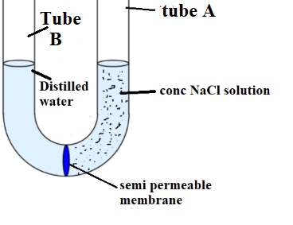
- Name the physiological process that was being investigated (1mark)
…………………………………………………………………………………
- What are the expected observation after 30minutes of the experiment. ( 1mark)
…………………………………………………………………………………
…………………………………………………………………………………
- Account for your observation in 1(c) above. ( 2marks)
…………………………………………………………………………………
…………………………………………………………………………………
…………………………………………………………………………………
- State the significance of the process you have named in 1( a) above
( 2marks)
…………………………………………………………………………………
…………………………………………………………………………………
…………………………………………………………………………………
- Suggest what would be the effect if the experiment was set up and placed on a fridge. Explain? ( 2marks)

…………………………………………………………………………………
…………………………………………………………………………………
…………………………………………………………………………………
…………………………………………………………………………………
- The photograph below shows components of blood from a ruptured blood vessel. Study it and answer the questions that follow.
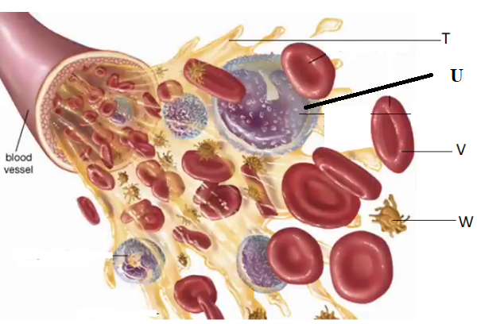

- Suggest the identity of the above blood vessel if a lot of digested food substances were found dissolved in part T. (1mark)

……………………………………………………………………………………

(b) Identify cell U and suggest its function. (2marks)
Identity
…………………………………………………………………………………
…………………………………………………………………………………
Function
…………………………………………………………………………………
…………………………………………………………………………………
(c) (i) Name three types of antigens that are likely to be present on the surface of the membrane of cell V (3marks)
……………………………………………………………………………………………………………………………………………………………………………………
(ii) Where in the human body is cell V produced? (1mark)
…………………………………………………………………………………………
(iii) What role does structure W play in blood clotting? (1mark)
……………………………………………………………………………………………………………………………………………………………………………………
- Albinism is a genetic disorder that is carried by a recessive gene on autosomal chromosomes. Jacky is normal for albinism and her mother is an albino while the father is normal. Jacky is married to Shady who is heterozygote for the disorder

- What is the probable genotype for Jacky and Shady ( 2marks)
…………………………………………………………………………………
…………………………………………………………………………………
- Using a punnet square work the phenotypic ratio of the offspring of Jacky and shady (3marks)

…………………………………………………………………………………
…………………………………………………………………………………
…………………………………………………………………………………
…………………………………………………………………………………
…………………………………………………………………………………
…………………………………………………………………………………
………………………………………………………………………………….

- State the differences between normal haemoglobin and abnormal haemoglobin. (3marks)
Normal haemoglobin | Abnormal haemoglobin

- An experiment was set up as shown below, shoot B tip was decapitated while agar block in shoot C contains auxins .

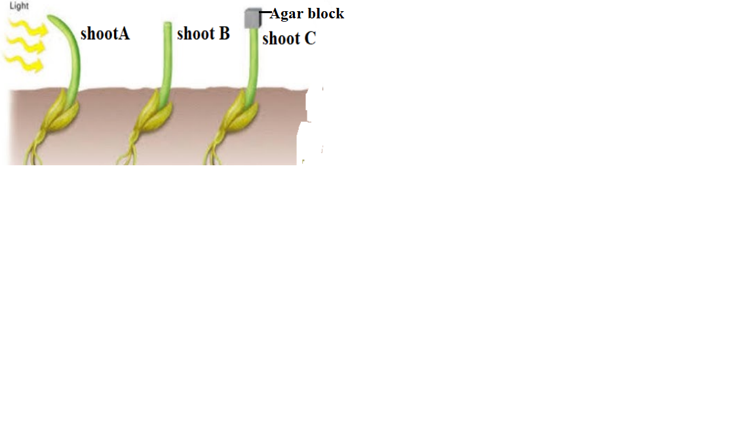
- Name the type of plant response being investigated ( 1 mark)
…………………………………………………………………………………
…………………………………………………………………………………
- What are the expected observation of shoot B and shoot C after 4 days of the experiment ( 6marks)

Shoot | Observation | Reason
B

C
- Why shoot A included in the experiment A ( 1mark)
…………………………………………………………………………………
………………………………………………………………………………….
SECTION B (40 MARKS)
Answer any 6 (COMPULSORY) in the spaces provided and either question 7 or 8 in the spaces provided after question 8.
- Form three students of Sulimobu academy were investigating the rate of growth in individuals at different ages .They tabulated their findings showing height and weight measurements in the table below

Ages in years | Height in cm | Weight in Kg
Birth | 55.5 | 3.8
1 | 78 | 12.3
2 | 80.1 | 14.6
3 | 98.0 | 16.5
4 | 108.0 | 18.8
5 | 113.0 | 20.4
6 | 118.5 | 24.0
7 | 124 | 27.0
8 | 135 | 29.4
9 | 138.5 | 32.0
10 | 144 | 36.0

- Draw two graphs using the same axes to show height and weight against different ages ( 8marks)


- Calculate the percentage growth in height between:
- Year 1 and 2 ( 2marks)
…………………………………………………………………………………
…………………………………………………………………………………
…………………………………………………………………………………
…………………………………………………………………………………
- Year 2 and 3 ( 2marks)
…………………………………………………………………………………
…………………………………………………………………………………
…………………………………………………………………………………
…………………………………………………………………………………
- In which period was there the highest percentage ( 1 mark)
…………………………………………………………………………………
…………………………………………………………………………………
- What are the factors that affects the rate of growth ( 2marks)
…………………………………………………………………………………
…………………………………………………………………………………
…………………………………………………………………………………
…………………………………………………………………………………
- Name a hormone that influences growth in human beings ( 1 mark)
…………………………………………………………………………………
…………………………………………………………………………………
- Growth in plants occurs in meristematic tissues.State two characteristics of a mersistematic tissue. ( 2marks)
…………………………………………………………………………………
…………………………………………………………………………………
…………………………………………………………………………………
…………………………………………………………………………………
- Name two factors that induce seed dormancy ( 2 marks)
…………………………………………………………………………………
…………………………………………………………………………………
…………………………………………………………………………………
…………………………………………………………………………………
7 a) Explain how the various photosynthetic cells are adapted to their function (6marks)
b) Explain how the human skin is adapted to its function (14 marks)

8 a) Explain the functions of the following parts of the brain:
- Cerebrum (3marks)
- Medulla oblongata ( 2marks)
- Hypothalanus ( 3marks)
- Cerebellum ( 2marks)

b) Describe the stages of mitosis in living organism ( 10 marks)

……………………………………………………………………………………………………………………………………………………………………………………
…………………………………………………………………………………………
…………………………………………………………………………………………
…………………………………………………………………………………………
…………………………………………………………………………………………
…………………………………………………………………………………………
…………………………………………………………………………………………
…………………………………………………………………………………………
…………………………………………………………………………………………
…………………………………………………………………………………………
…………………………………………………………………………………………
…………………………………………………………………………………………
…………………………………………………………………………………………
…………………………………………………………………………………………
…………………………………………………………………………………………
…………………………………………………………………………………………
…………………………………………………………………………………………
…………………………………………………………………………………………
…………………………………………………………………………………………
…………………………………………………………………………………………
…………………………………………………………………………………………
…………………………………………………………………………………………
…………………………………………………………………………………………
…………………………………………………………………………………………
…………………………………………………………………………………………
…………………………………………………………………………………………
…………………………………………………………………………………………
…………………………………………………………………………………………
…………………………………………………………………………………………
…………………………………………………………………………………………
…………………………………………………………………………………………
…………………………………………………………………………………………
…………………………………………………………………………………………
…………………………………………………………………………………………
…………………………………………………………………………………………
…………………………………………………………………………………………
…………………………………………………………………………………………
…………………………………………………………………………………………
…………………………………………………………………………………………
…………………………………………………………………………………………
…………………………………………………………………………………………
…………………………………………………………………………………………
…………………………………………………………………………………………
…………………………………………………………………………………………
…………………………………………………………………………………………
…………………………………………………………………………………………
…………………………………………………………………………………………
…………………………………………………………………………………………
…………………………………………………………………………………………
…………………………………………………………………………………………
…………………………………………………………………………………………
…………………………………………………………………………………………
…………………………………………………………………………………………
…………………………………………………………………………………………
…………………………………………………………………………………………
…………………………………………………………………………………………
…………………………………………………………………………………………
…………………………………………………………………………………………
…………………………………………………………………………………………
…………………………………………………………………………………………
…………………………………………………………………………………………
…………………………………………………………………………………………
…………………………………………………………………………………………
…………………………………………………………………………………………
…………………………………………………………………………………………
…………………………………………………………………………………………
…………………………………………………………………………………………
…………………………………………………………………………………………
…………………………………………………………………………………………
…………………………………………………………………………………………
…………………………………………………………………………………………
…………………………………………………………………………………………
…………………………………………………………………………………………
…………………………………………………………………………………………
…………………………………………………………………………………………
…………………………………………………………………………………………
…………………………………………………………………………………………
…………………………………………………………………………………………
…………………………………………………………………………………………
…………………………………………………………………………………………
…………………………………………………………………………………………
…………………………………………………………………………………………
…………………………………………………………………………………………
…………………………………………………………………………………………
…………………………………………………………………………………………
…………………………………………………………………………………………
…………………………………………………………………………………………
…………………………………………………………………………………………
…………………………………………………………………………………………
…………………………………………………………………………………………
…………………………………………………………………………………………
…………………………………………………………………………………………
…………………………………………………………………………………………

