SULIMO JOINT EXAM
Kenya Certificate of Secondary Education

231/1
BIOLOGY PAPER 1
(THEORY)
JULY 2025
TIME : 2 HOURS

Name…………………………………………………..…… Class….………….……………….
Candidate`s Signature.…………………………………… Date…….…….……………………

Instructions to candidates
- Write your name and index number in the spaces provided above.
- Sign and write the date of the examination in the spaces provided above.
- All questions are compulsory
- Candidates should answer the questions in English.
- This paper consists of 11 printed pages. Candidates should check the question paper to ascertain that all the pages are printed as indicated and that no questions are missing

FOR EXAMINER’S USE ONLY.
Question | Maximum Score | Candidate’s score
1 - 27 | 80

Name the taxonomic unit grouping that contains individuals with most similarities

(1 mark)

........................................................................................................................................
- Give two rules of binomial nomenclature (2 marks)
……………………………………………………………………………………………………………………………………………………………………………………………………
- A marine amoeba does not burst when transferred into fresh water. Explain. (2 marks)
……………………………………………………………………………………………………………………………………………………………………………………………………………………………………………………………………………………………………….
- Explain what would happen to red blood cells if they are placed in a concentrated salt solution (2 marks)
……………………………………………………………………………………………………………………………………………………………………………………………………
- Briefly describe the events of the dark stage of photosynthesis (2 marks)
………………………………………………………………………………………………………………………………………………………………………………………………………………………………………………………………………………………………………
- a) What characteristic of living organism is shown when;
    - A cat produce kittens (1 mark)
…………………………………………………………………………………………….
    - A girl drops a hot plate (1 mark)
…………………………………………………………………………………………….
  - State the functions of the following cell organelles: (2 marks)
    - Ribosomes
…………………………………………………………………………………………….
    - Nucleus
…………………………………………………………………………………………….
- a) State two ways in which the stomach is prevented from digestion by protein digesting
enzymes (2 marks)
………………………………………………………………………………………………………………………………………………………………………………………………………………………………………………………………………………………………
b) Name two enzymes secreted in inactive form (2 marks)
(i)………………………………………………………(ii)………………………………
- a) Define the term ‘‘field of view’ ’as used in microscopy. (1 mark)
………………………………………………………………………………………………………………………………………………………………………………………………
b) State two functions of the body tube of a light microscope. (2 marks)
………………………………………………………………………………………………………………………………………………………………………………………………
c) Give a reason why it is not advisable to use water in cleaning a microscope (1 mark)
………………………………………………………………………………………………………………………………………………………………………………………………
- Explain why transfer of energy from one trophic level to another is not 100% efficient
(2 marks)
……………………………………………………………………………………………………………………………………………………………………………………………………
- State the causative agents of the following diseases (2 marks)
  - Syphilis
………………………………………………………………………………………………
  - Trichomoniasis
……………………………………………………………………………………………
- During a 10000m race, a biological process took place in an athlete muscles as shown by the following equation:
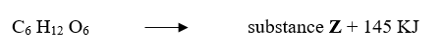
- What is the name of this process? (1 mark)
………………………………………………………………………………………………
- Name the substance Z (1 mark)
………………………………………………………………………………………………
- How would the athlete body deal with accumulated substance Z? (2 marks)
………………………………………………………………………………………………………………………………………………………………………………………………………………………………………………………………………………………………
- a) State two factors that affect enzyme controlled reaction (2 marks)
………………………………………………………………………………………………………………………………………………………………………………………………
b) State two properties of disaccharides (2 marks)
………………………………………………………………………………………………………………………………………………………………………………………………
- State the roles of each of the following hormones in the process of reproduction in human male;
  - Follicle stimulating hormone. (1 mark)
………………………………………………………………………………………………………………………………………………………………………………………………
  - Testosterone (1 mark)
………………………………………………………………………………………………………………………………………………………………………………………………
- What is the meaning of each of the following terms;
  - Deamination (1 mark)
………………………………………………………………………………………………………………………………………………………………………………………………
  - Detoxification (1 mark)
………………………………………………………………………………………………………………………………………………………………………………………………
- a)What is cell specialization? (1 mark)
………………………………………………………………………………………………………………………………………………………………………………………………
  - Name the tissues that primarily protect plants and animals respectively against entry of pathogens and mechanical injury. (2 marks)

……………………………………………………………………………………………………………………………………………………………………………………………...

- The figure below shows the changes in the concentration of various substances at Nairobi dam following the discharge domestic effluents from Kibera slams. Study it and answer the questions that follow
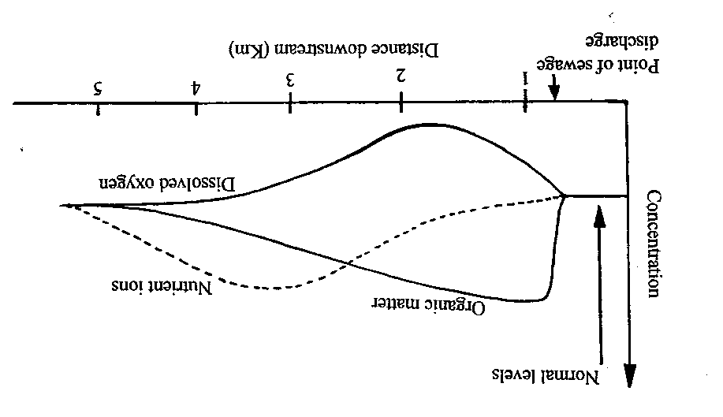
- Account for the changes in the concentration of:
  - Nutrient ions (2 marks)
………………………………………………………………………………………………………………………………………………………………………………………………………………………………………………………………………………………
  - Dissolved oxygen (2 marks)
……………………………………………………………………………………………………………………………………………………………………………………………………………………………………………………………………………………….
- What is the likely effect on the dam after the discharge of the effluents? (1 mark)
………………………………………………………………………………………............
- Below are diagrams of plant leaves P, Q and R. Construct a two-step dichotomous key which can be used to identify each of them. (3 marks)
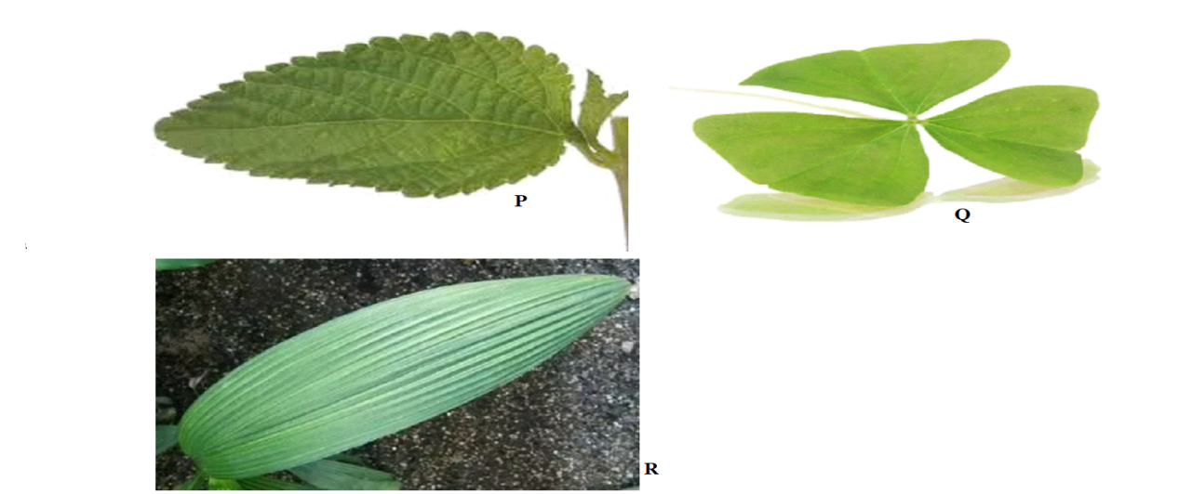
Use the following to construct the key:
Type of leaf
Type of venation
………………………………………………………………………………………………………………………………………………………………………………………………………………………………………………………………………………………………………………………………………………………………………………………………………….
- a) Name one locomotory structure in unicellular organisms (1 mark)
………………………………………………………………………………………………
b) Name two divisions of the plant kingdom whose members reproduce by means of spores (2 marks)
………………………………………………………………………………………………………………………………………………………………………………………………
- The diagram below is a longitudinal section of a young root
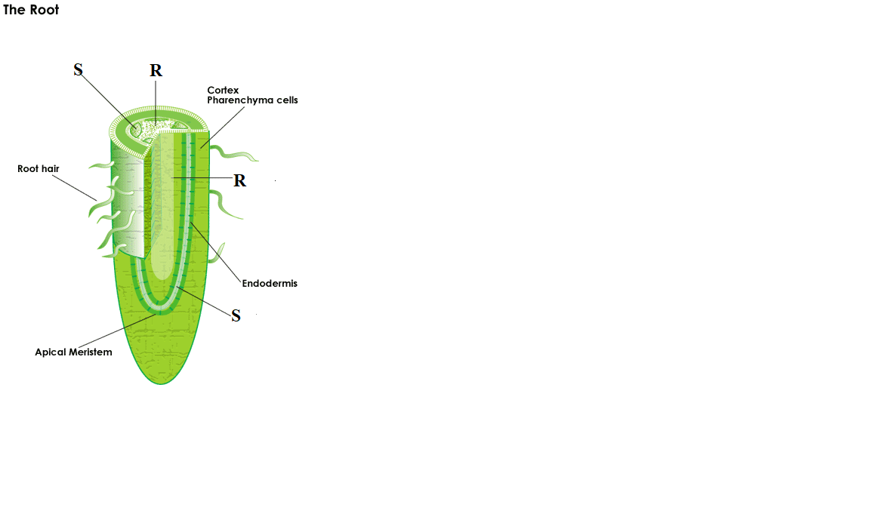
- Name the vascular tissues represented by letters R and S (2 marks)
- ………………………………………………………………………………………..
- …………………………………………………………………………………………...
- State the roles of the tissue labelled R (2 marks)
………………………………………………………………………………………………………………………………………………………………………………………………………………………………………………………………………………………………
- Name a structure in the endodermis that enables it control root pressure (1 mark)
………………………………………………………………………………………………
- a) State two functions of DNA molecule (2 marks)
……………………………………………………………………………………………………….……………………………………………………………………………………………………………………………………………………………………………………
b) What is DNA replication? (1 mark)
……………………………………………………………………………………………………….……………………………………………………………………………………..
c) A DNA strand had the following base sequence
-T-A-C-G-C-T
What is the sequence of the M-RNA strand copied from this DNA portion? (1 mark)
…………………………………………………………………………………………………

- The figure below shows feet of various birds. Study the diagram and answer the questions that follow.
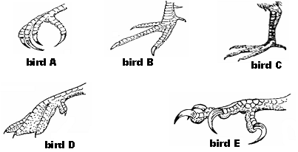
  - Name the type of evolution represented by the diagrams. (1 mark)
………………………………………………………………………………………………
  - Give a reason for your answer in (i) above (1 mark)
…………………………………………………………………………………………………………………….………………………………………………………………………..
  - Evolution is an ongoing process and is still going on even today. State two pieces of evidence which suggests that evolution is still taking place. (2 marks)
………………………………………………………………………………………………………………………………………………………………………………………………
- The diagram below shows how the iris and pupil of a human eye appear under different light conditions.
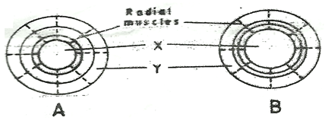
  - Name the structures labeled X and Y (2 marks)
X…………….……………………..……………………………………………………..
Y………………….………………………………………..……………………………….
  - What is the significance of the change described in (b) (ii) above? (1 mark)
…………………………..…………………………………………………………………………………….……………………………..……………………………………………
- Explain how skeletal muscles bring about the movement at the elbow (3 marks)
………………………………………………………………………………………………………………………………………………………………………………………………………………………………………………………………………………………………………………………………………………………………………………………………………….
- The length from the tail tip to the anus of a certain tilapia fish is 12cm. The length from the tail tip to the mouth is 48cm. Calculate the tail power of the fish. Show your working. (2 marks)
…………………………………………………………………………………………………………………………………………………………………………………………………………………………………………………………………………………………………………………………………………………………………………………………………………
- The petal cells of a certain plant have 32 chromosomes. State the number of chromosomes present in plants (2 marks)
  - Endosperm
………………………………………………………………………………………………
  - Egg cell
………………………………………………………………………………………………
- The table below shows blood composition of Joab, Jane and Joan
Person | Joab | Jane | Joan
Red blood cells (mm³) | 8900 | 5000 | 3,100
White blood cells (mm³) | 4000 | 6,500 | 5,000
Platelets | 230,000 | 220,000 | 550

- Which person is likely to live at high altitudes (1 mark)
….…………………………………………………………………………………………..
Reason (1 mark)
….………………………………………………………………………………….……………………………………………………………………………………………………..
- Which person’s blood is likely to have an iron deficiency in his diet. (1 mark)
….………………………………………………………………………………………….
- a) What is etiolation? (1 mark)
………………………………………………………………………………………………………………………………………………………………………………………………
  - What is the significance of etiolation? (2 marks)
………………………………………………………………………………………………………………………………………………………………………………………………………………………………………………………………………………………………

