NAME ……………………………………..………………………ADM NO ……………………

DATE …………….……….……STREAM..……….CANDATES SIGNITURE………………...

443/2
AGRICULTURE
PAPER 2 (THEORY)
TIME: 2 HOURS

SULIMO JOINT EXAM - JULY 2025
AGRICULTURE
PAPER 2 (THEORY)

INSTRUCTIONS TO CANDIDATES
- Write your name and index number in the spaces provided above.
- This paper has THREE sections: A , B and C
- Answer ALL the questions in section A and B and any TWO questions in section C
- ALL answers MUST be written in the spaces provided.
- Do not remove any pages from this booklet.
- This paper consists of 13 printed pages. Candidates should check to ensure that all pages are printed as indicated and no questions are missing

FOR EXAMINER’S USE ONLY

Section | Questions | Maximum score | Candidate’s score
A | 01 - 18 | 30 marks
B | 19 - 22 | 20 marks
C | 23 - 25 | 40 marks
Total score |  | 90

SECTION A (30 Marks)

Answer all questions in this section in the spaces provided.

1. Name two dairy goats breeds reared in Kenya. (1 mark)
………………………………………………………………………………………………………………………………………………………………………………………………………………………………………………………………………………………………………………
2. Give two reasons why Jersey breed of cattle are better suited to arid areas than Friesians cattle. (1 mark)
………………………………………………………………………………………………………………………………………………………………………………………………………………………………………………………………………………………………………………
3. State two maintenance practices of milking equipment s. (1 mark)
………………………………………………………………………………………………………………………………………………………………………………………………………………………………………………………………………………………………………………
4. State FOUR factors that may influence the amount of water intake by a farm animal (2marks)
……………………………………………………………………………………………………………………………………………………………………………………………………………………………………………………………………………………………………………………………………………………………………………………………………………………
5. State four advantages of treating timber before construction. (2 marks)
……………………………………………………………………………………………………………………………………………………………………………………………………………………………………………………………………………………………………………………………………………………………………………………………………………………
6. Give three ways of stimulating milk let down in a dairy cow. (1½ marks)
………………………………………………………………………………………………………………………………………………………………………………………………………………………………………………………………………………………………………………
7. List four functions of calcium in dairy cows. (2 marks)
……………………………………………………………………………………………………………………………………………………………………………………………………………………………………………………………………………………………………………………………………………………………………………………………………………………
8. Name two practices aimed at keeping birds busy in a deep litter system. (1 mark)
…………………………………………………………………………………………………………………………………………………………………………………………………………
9. Give four symptoms of mastitis visible on the black plate in a strip cup. (2 marks)
……………………………………………………………………………………………………………………………………………………………………………………………………………………………………………………………………………………………………………………………………………………………………………………………………………………
10. State any four signs of parturition in a cow. (2 marks)
…………………………………………………………………………………………………………………………………………………………………………………………………………………………………………………………………………………………………………………………………………………………………………………………………………………………………………………………………………………………………………………………
11. Name two points of attachment of the tractor drawn implements. (1 mark)
………………………………………………………………………………………………………………………………………………………………………………………………………………………………………………………………………………………………………………
12. Outline four effects of stick fast fleas on poultry (2 marks)
……………………………………………………………………………………………………………………………………………………………………………………………………………………………………………………………………………………………………………………………………………………………………………………………………………………
……………………………………………………………………………………………………
13. a) List two farm structures which would assist to control livestock parasites. (1 mark) ……………………………………………………………………………………………………………………………………………………………………………………………………………………………………………………………………………………………………………………
b) State four structural requirements of a rabbit hutch. (2 marks)
…………………………………………………………………………………………………………………………………………………………………………………………………………………………………………………………………………………………………………………………………………………………………………………………………………………………………………………………………………………………………………………………

14. State four causes of stress in a flock of chicken. (2 marks)
……………………………………………………………………………………………………………………………………………………………………………………………………………………………………………………………………………………………………………………………………………………………………………………………………………………
……………………………………………………………………………………………………
15. State four major characteristics of succulent roughages. (2 marks)
……………………………………………………………………………………………………………………………………………………………………………………………………………………………………………………………………………………………………………………………………………………………………………………………………………………………………………………………………………………………………………
16. Name the farm tool and equipment used for the practices mentioned below. (2marks)
i) Deworming livestock orally using tablets.
……………………………………………………………………………………………………
ii) Cutting off wolf –teeth in piglets.
……………………………………………………………………………………………………
iii) Weighing farm produce and inputs.
……………………………………………………………………………………………………
iv) Measuring distances and length
……………………………………………………………………………………………………
17. List two advantages of out breeding. (1 mark)
…………………………………………………………………………………………………………………………………………………………………………………………………………
……………………………………………………………………………………………………
18. List down three roofing materials commonly used by farmers. (1½ mark)
……………………………………………………………………………………………………………………………………………………………………………………………………………………………………………………………………………………………………………………………………………………………………………………………………………………

SECTION B (20MARKS)

Answer all questions in this section

- The following is an illustration of the digestive system of a ruminant.
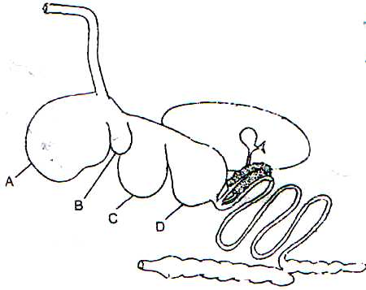

- Name the parts labelled A, B, C and D. (2 marks)
A-...……………………………………………………………………………
B-………………………………………………………………………………
C-………………………………………………………………………………
D-………………………………………………………………………………
(b) Name the part of the system where microbial activity takes place. (1 mark)
...…………………………………………………………………………………………………………… ………………………………………………………………………………………
(c) State two microbial activities that take place in the part named in (b) above. (2 marks)
...………………………………………………………………………………………………………………………………………………………………………………………………………
20. The diagram below shows a plunge dip.

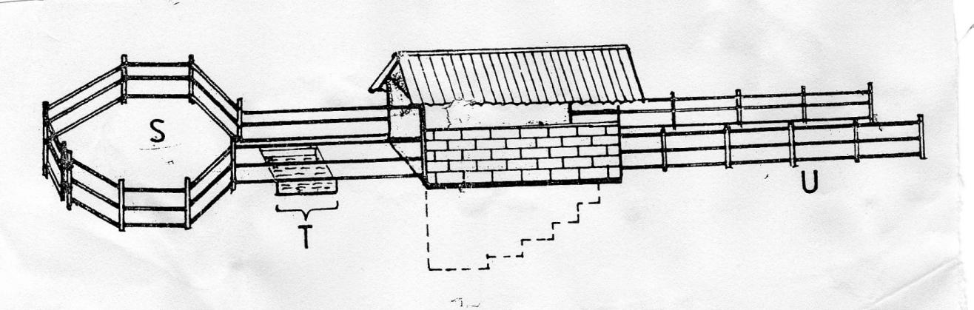
L
K
J

a) State one use of each of the parts of the dip labeled S and K (2 marks)
S……………………………………………………………………………………………
K………………………………………………………………………………………….
b) State two precautions a farmer should take on the dip wash to ensure effective dipping.
(2 marks)
………………………………………………………………………………………………………………………………………………………………………………………………………………………………………………………………………………………………………………………………………………………………………………………………
c) State two uses of the roof of the dip. (1 mark)
………………………………………………………………………………………………………………………………………………………………………………………………………………………………………………………………………………………………………………………………………………………………………………………………
21. The diagram below shows a tractor drawn implement.
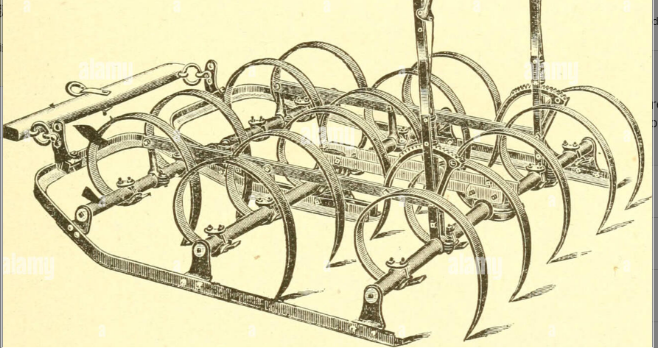

(a)Identify the implement. (1 mark)
….……………………………………………………………………………………………………………
b) Give two uses of the implement above (2 marks)
……………………………………………………………………………………………………
c) State two maintenance practices carried out on the above implement. (2marks)
………………………………………………………………………………………………………………………………………………………………………………………………………………………………………………………………………………………………………………
d) State three control measures of the parasite labeled F in livestock production.
(1½mks)
……………………………………………………………………………………..………………………………………………………………………………..……………………………………………………………………………………..……………………………………………
22. The diagram below illustrates a calf rearing practice.
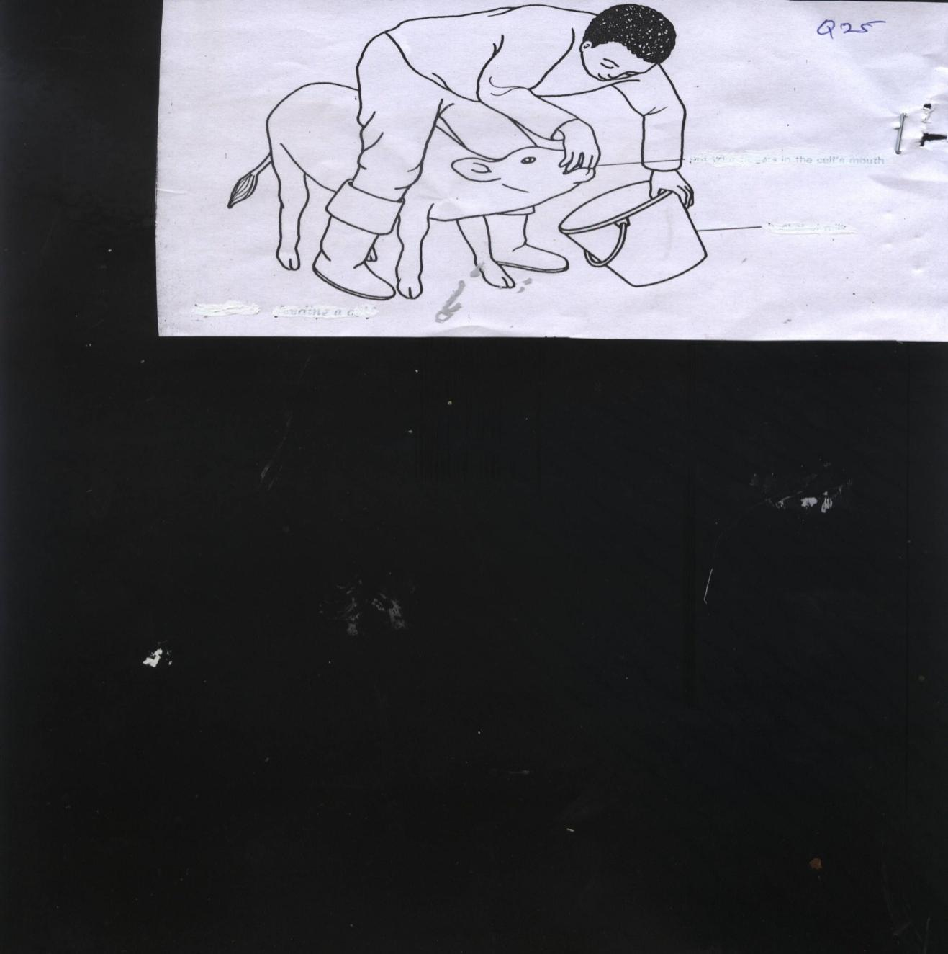

a) Identify the practice illustrated above. ( ½ mk)
……………………………………………………………………………………..……………
b) (i) Describe the procedure followed in the feeding practice named in (a) above. (2 ½ mks)
……………………………………………………………………………………..………………………………………………………………………………..……………………………………………………………………………………..……………………………………………………………………………………..………………………………………………………………………………..………………………………………………………………………………………………………………………………………………………………………………………………………..……………………………………………………………………………
(ii) Give two precautions taken while using the rearing practice stated in (a) above. (1mark)
……………………………………………………………………………………..………………………………………………………………………………..…………………………………………………………………………………………………..…………………………………………………………………………………………………..………………………………

SECTION C (40MARKS)
Answer two questions in this section

23. a) Describe the difference between diesel and petrol engines (5marks)
b) Explain the factors one would consider to ensure fast and effective cultivation by oxen.
(5marks)
c) Explain seven management practices carried out to ensure maximum harvest of fish.
(5marks)
d) State five disadvantages of natural mating. (5marks)

24. (a) Describe the management of day old chicks in a deep litter system from preparation of
brooder up to eight weeks old (10marks)
- Describe Coccidiosis disease under the following sub- headings
- Animals attacked (2marks)
- Causal organism (1mark)
- Symptoms (4marks)
- Control measures (3marks)

25. (a) State four maintenance practices carried out on a wheel barrow (4marks)
(b) State the importance of farm fences (6marks)
(c) State four cycles of four stroke cycle engine. (4marks)
(d) Describe the life cycle of two-host tick. (6marks)

……………………………………………………………………………………………………………………………………………………………………………………………………………………………………………………………………………………………………………………………………………………………………………………………………………………………………………………………………………………………………………………………………………………………………………………………………………………………………………………………………………………………………………………………………………………………………………………………………………………………………………………………………………………………………………………………………………………………………………………………………………………………………………………………………………………………………………………………………………………………………………………………………………………………………………………………………………………………………………………………………………………………………………………………………………………………………………………………………………………………………………………………………………………………………………………………………………………………………………………………………………………………………………………………………………………………………………………………………………………………………………………………………………………………………………………………………………………………………………………………………………………………………………………………………………………………………………………………………………………………………………………………………………………………………………………………………………………………………………………………………………………………………………………………………………………………………………………………………………………………………………………………………………………………………………………………………………………………………………………………………………………………………………………………………………………………………………………………………………………………………………………………………………………………………………………………………………………………………………………………………………………………………………………………………………………………………………………………………………………………………………………………………………………………………………………………………………………………………………………………………………………………………………………………………………………………………………………………………………………………………………………………………………………………………………………………………………………………………………………………………………………………………………………………………………………………………………………………………………………………………………………………………………………………………………………………………………………………………………………………………………………………………………………………………………………………………………………………………………………………………………………………………………………………………………………………………………………………………………………………………………………………………………………………………………………………………………………………………………………………………………………………………………………………………………………………………………………………………………………………………………………………………………………………………………………………………………………………………………………………………………………………………………………………………………………………………………………………………………………………………………………………………………………………………………………………………………………………………………………………………………………………………………………………………………………………………………………………………………………………………………………………………………………………………………………………………………………………………………………………………………………………………………………………………………………………………………………………………………………………………………………………………………………………………………………………………………………………………………………………………………………………………………………………………………………………………………………………………………………………………………………………………………………………………………………………………………………………………………………………………………………………………………………………………………………………………………………………………………………………………………………………………………………………………………………………………………………………………………………………………………………………………………………………………………………………………………………………………………………………………………………………………………………………………………………………………………………………………………………………………………………………………………………………………………………………………………………………………………………………………………………………………………………………………………………………………………………………………………………………………………………………………………………………………………………………………………………………………………………………………………………………………………………………………………………………………………………………………………………………………………………………………………………………………………………………………………………………………………………………………………………………………………………………………………………………………………………………………………………………………………………………………………………………………………………………………………………………………………………………………………………………………………………………………………………………………………………………………………………………………………………………………………………………………………………………………………………………………………………………………………………………………………………………………………………………………………………………………………………………………………………………………………………………………………………………………………………………………………………………………………………………………………………………………………………………………………………………………………………………………………………………………………………………………………………………………………………………………………………………………………………………………………………………………………………………………………………………………………………………………………………………………………………………………………………………………………………………………………………………… ………………………………………………………………………………………………………………………………………………………………………………………………………………………………………………………………………………………………………………………………………………………………………………………………………………………………………………………………………………………………………………………………………………………………………………………………………………………………………………………………………………………………………………………………………………………………………………………………………………………………………………………………………………………………………………………………………………………………………………………………………………………………………………………………………………………………………………………………………………………………………………………………………………………………………………………………………………………………………………………………………………………………………………………………………………………………………………………………………………………………………………………………………………………………………………………………………………………………………………………………………………………………………………………………………………………………………………………………………………………………………………………………………………………………………………………………………………………………………………………………………………………………………………………………………………………………………………………………………………………………………………………………………………………………………………………………………………………………………………………………………………………………………………………………………………………………………………………………………………………………………………………………………………………………………………………………………………………………………………………………………………………………………………………………………………………………………………………………………………………………………………………………………………………………………………………………………………………………………………………………………………………………………………………………………………………………………………………………………………………………………………………………………………………………………………………………………………………………………………………………………………………………………………………………………………………………………………………………………………………………………………………………………………………………………………………………………………………………………………………………………………………………………………………………………………………………………………………………………………………………………………………………………………………………………………………………………………………………………………………………………………………………………………………………………………………………

