Name: …………………………..….......................................................... Adm No: ……….......

Stream: ....…............ Date: …………................... School:…………………………………………

Candidate’s signature: ………………………………………………………………………………

SULIMO JOINT EXAM 2025

443/1
AGRICULTUIRE PP1(Theory)
2 hours

Instructions to candidates

(a) Write your name and Adm. number in the spaces provided above.
(b) Sign and write the date of examination in the spaces provided above.
(c) This paper consists of three sections; A, B and C.
(d) Answer all the questions in section A and B.
(e) Answer any two questions in section C.
(f) Candidates to confirm that all pages are printed as indicated and that no questions are missing.
(g) Candidates should answer all the questions in English.

For Examiners Use Only

Section | Questions | Maximum score | Candidate’s score
A | 01 - 14 | 30 marks
B | 15 - 18 | 20 marks
C | 19 - 21 | 40 marks
Total score |  | 90 marks

This paper consists of 11 printed pages.

Section A(30Marks).
Answer all questions in this section.
1. Distinguish between aquaculture and apiculture. (1mark)
…………………………………………………………………………………………………………………………………………………………………………………………………………………………………………………………………………………………………………………………………….......................................................................................................................................................
2. State four benefits of mixed farming. (2marks)
……………………………………………………………………………………………………………………………………………………………………………………………………………………………………………………………………………………………………………………………………………………………………………………………………………………………………………………………………………………………………………………………………………………
3. State three ways in which nutrients phosphorous is lost in the soil. ( (1½marks)
…………………………………………………………………………………………………………………………………………………………………………………………………………………………………………………………………………………………………………………………………………………………………………………………………………………………………………
- A member of Young Farmers Club was advised to apply complete fertilizer 30:20:10 in a tomato plot measuring 10m long by 5m wide at a rate of 300kg per hectare

- State the percentage of P2O5 in the complete fertilizer . (1marks)
……………………………………………………………………………………………………………………………………………………………………………………………………………………
- Calculate the amount of fertilizer the member would require for the plot. (2 marks)
…………………………………………………………………………………………………………………………………………………………………………………………………………………………………………………………………………………………………………………………………………………………………………………………………………………………………………
5. Give four advantages associated with communal land ownership. (2marks)
……………………………………………………………………………………………………………………………………………………………………………………………………………………………………………………………………………………………………………………………………………………………………………………………………………………………………………………………………………………………………………………………………………………
6.(a) What are the functions of the following in the preparation of compost manure. ( (1½marks)
i) Top soil
. …………………………………………………………………………………………………………............................................................................................................................................................
ii) Wood ash
. …………………………………………………………………………………………………………............................................................................................................................................................
iii) Layer of manure
. …………………………………………………………………………………………………………............................................................................................................................................................
7. (a) List two methods of frame formation in tea production (1mark)
……………………………………………………………………………………………………………………………………………………………………………………………………………………
(b) State four ways of improving labour productivity in the farm . (2marks)
…………………………………………………………………………………………………………………………………………………………………………………………………………………………………………………………………………………………………………………………………………………………………………………………………………………………………………
8. State four factors considered in designing a crop rotation programme. (2marks)
…………………………………………………………………………………………………………………………………………………………………………………………………………………………………………………………………………………………………………………………………………………………………………………………………………………………………………………………………………………………………………………………………………………………………………………………………………………………………………………………………………………………………………………………………………………………………………
9. Outline four precautions observed in harvesting of cotton. (2marks)
…………………………………………………………………………………………………………………………………………………………………………………………………………………………………………………………………………………………………………………………………………………………………………………………………………………………………………………………………………………………………………………………………………………………………………………………………………………………………………………………………………………………………………………………………………………………………………
10. Cal J variety of tomato is spaced at 90cm by 45cm. Calculate the plant population in a 0.4 ha piece of land. (2marks)

………………………………………………………………………………………………………………………………………………………………….........................................................................……………………………………………………………………………………………………………………………………………………………………………………………………………………
11. State four methods of controlling damping off disease in cabbage (2marks)
……………………………………………………………………………………………………………………………………………………………………………………………………………………………………………………………………………………………………………………………………………………………………………………………………………………………………………………………………………………………………………………………………………………
12. Outline four sites for growing Agroforestry trees (2marks)
…………………………………………………………………………………………………………………………………………………………………………………………………………………………………………………………………………………………………………………………………………………………………………………………………………………………………………
13. State four benefits of draining a swampy land for cabbage production. (2marks)
……………………………………………………………………………………………………………………………………………………………………………………………………………………………………………………………………………………………………………………………………………………………………………………………………………………………………………………………………………………………………………………………………………………
14. (a) List two causes of forking in carrots (1marks)
………………………………………………………………………………………………………………………………………………………………………………………………………………………………………………………………………………………………………………………………
(b) Give four benefits of early seedbed preparation. (2marks)
……………………………………………………………………………………………………………………………………………………………………………………………………………………
(c) State two diseases that affect tomatoes. (1mark)
………………………………………………………………………………………………………………………………………………………………………………………………………………………………………………………………………………………………………………………………
Section B (20Marks).
Answer all questions in this section.
15.The diagrams below show types of weeds.
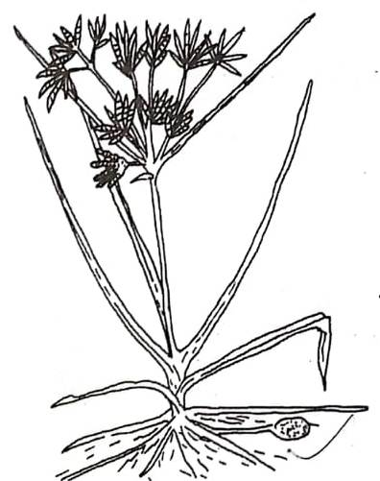
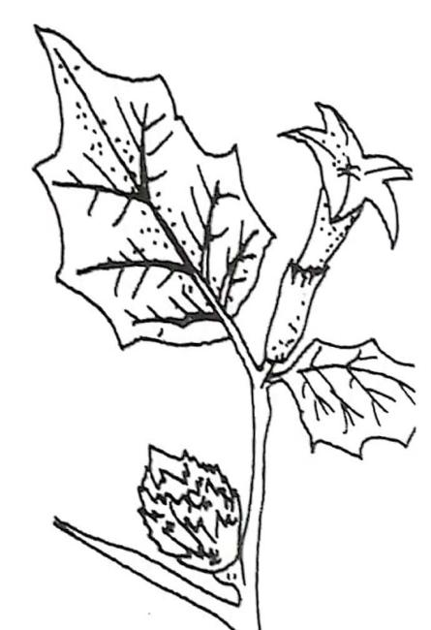
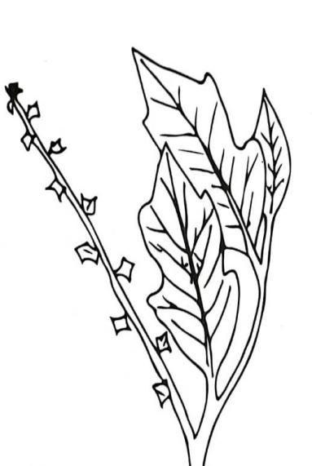

A B C

- Identify weeds labeled. (2marks)
A …………………………………………………………………………………………
B …………………………………………………………………………………………
(b) Classify the weeds the weeds above based on plant morphology. (2marks)
B ……………………………………………………………………………………………
C ……………………………………………………………………………………………
(c) State one effect of weed A in livestock production. (1mark)
……………………………………………………………………………………………………………………………………………………………………………………………………………………
16. A farmer owns a piece of land on which he can grow maize, cabbages, and beans. The expected yields and selling prices of the crops are as shown below:

Crop | Yield (kg) | Selling Price (Ksh/kg)
Maize | 4000 | 40
Cabbages | 2800 | 60
Beans | 3000 | 80

If the cost of producing maize, cabbages, and beans is the same:

(a) Which crop should the farmer grow? Show your working clearly. (2 marks)
…………………………………………………………………………………………………………
…………………………………………………………………………………………………………
(b) (i) What is the farmer’s opportunity cost? (1 mark)
….…………………………………………………………………………………………………
(ii) Give a reason for your answer in (b)(i) above. (1 mark)
….…………………………………………………………………………………………………………
(c) Give a reason why farmers make a choice on the enterprise to be implemented on the farm. (1 mark)
……………………………………………………………………………………………………………………………………………………………………………………………………………………

17. The diagram below shows a soil borne pest that attacks plant roots.
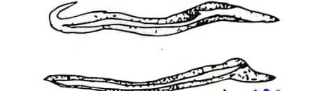

(a) Identify the pest. (1mark)
…………………………………………………………………………………………………………
(b) Give two symptoms of attack by the pest in tomato production. (2marks)
………………………………………………………………………………………………………………………………………………………………………………………………………………………………………………………………………………………………………………………………
(c) State two control measures for the above pest. (2marks)
………………………………………………………………………………………………………………………………………………………………………………………………………………………………………………………………………………………………………………………………
18. The diagrams below is a nursery bed. Study them and answer the questions that follow.
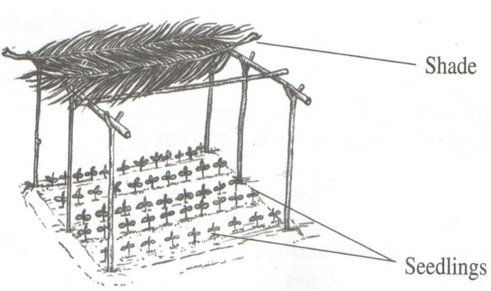
- State two advantages of having the part labeled C (2marks)
………………………………………………………………………………………………………………………………………………………………………………………………………………........
- State two ways of hardening off seedlings in the structure above. (2marks)
……………………………………………………………………………………………………………………………………………………………………………………………………………………………………………………………………………………………………………………………...
(c) State the recommended width for a nursery bed (1 mark)
………………………………………………………………………………………………………………………………………………………………………………………………………………………………………………………………………………………………………………………………

Section C( 40Marks).
Answer only two questions in this section.
19.(a) Outline four advantage of silage making. .(4marks)
(b) Describe the process of chemical water treatment (8 marks)
(c) State three causes of land fragmentation and subdivision. (5marks)
(d) State three effects of early defoliation in pastures. (3 marks)

20. (a) Explain five factors that determine number secondary tillage operations are done (5marks)
(b) Outline five reasons for training in crop production (5 marks)
(c) State and explain five cultural methods of soil and water conservation. (10 marks)

21. (a) Explain six ways in which biotic factors influence Agricultural production. (6 marks)
(b) State three advantages of row planting (3 marks)
(c) Describe the harvesting of sorghum (3 marks)
(d) (i) The following information is a farm record Mrs. Sanda had kept as at 31st June 2006.
Study it and prepare and prepare a balance sheet from the information below. (6 marks)
Cash at hand 20000
Cash at bank 66000
Buildings 50000
Disc ploughs 16000
Debtors 16000
Working tools 12000
Bank overdraft 24000
Creditors 20000
Loan 50000
Cattle 40000
Land 80000

- Is Sanda’s farm solvent or insolvent? Give a reason. (2 marks)
……………………………………………………………………………………………………………………………………………………………………………………………………………………………………………………………………………………………………………………………………………………………………………………………………………………………………………………………………………………………………………………………………………………………………………………………………………………………………………………………………………………………………………………………………………………………………………………………………………………………………………………………………………………………………………………………………………………………………………………………………………………………………………………………………………………………………………………………………………………………………………………………………………………………………………………………………………………………………………………………………………………………………………………………………………………………………………………………………………………………………………………………………………………………………………………………………………………………………………………………………………………………………………………………………………………………………………………………………………………………………………………………………………………………………………………………………………………………………………………………………………………………………………………………………………………………………………………………………………………………………………………………………………………………………………………………………………………………………………………………………………………………………………………………………………………………………………………………………………………………………………………………………………………………………………………………………………………………………………………………………………………………………………………………………………………………………………………………………………………………………………………………………………………………………………………………………………………………………………………………………………………………………………………………………………………………………………………………………………………………………………………………………………………………………………………………………………………………………………………………………………………………………………………………………………………………………………………………………………………………………………………………………………………………………………………………………………………………………………………………………………………………………………………………………………………………………………………………………………………………………………………………………………………………………………………………………………………………………………………………………………………………………………………………………………………………………………………………………………………………………………………………………………………………………………………………………………………………………………………………………………………………………………………………………………………………………………………………………………………………………………………………………………………………………………………………………………………………………………………………………………………………………………………………………………………………………………………………………………………………………………………………………………………………………………………………………………………………………………………………………………………………………………………………………………………………………………………………………………………………………………………………………………………………………………………………………………………………………………………………………………………………………………………………………………………………………………………………………………………………………………………………………………………………………………………………………………………………………………………………………………………………………………………………………………………………………………………………………………………………………………………………………………………………………………………………………………………………………………………………………………………………………………………………………………………………………………………………………………………………………………………………………………………………………………………………………………………………………………………………………………………………………………………………………………………………………………………………………………………………………………………………………………………………………………………………………………………………………………………………………………………………………………………………………………………………………………………………………………………………………………………………………………………………………………………………………………………………………………………………………………………………………………………………………………………………………………………………………………………………………………………………………………………………………………………………………………………………………………………………………………………………………………………………………………………………………………………………………………………………………………………………………………………………………………………………………………………………………………………………………………………………………………………………………………………………………………………………………………………………………………………………………………………………………………………………………………………………………………………………………………………………………………………………………………………………………………………………………………………………………………………………………………………………………………………………………………………………………………………………………………………………………………………………………………………………………………………………………………………………………………………………………………………………………………………………………………………………………………………………………………………………………………………………………………………………………………………………………………………………………………………………………………………………………………………………………………………………………………………………………………………………………………………………………………………………………………………………………………………………………………………………………………………………………………………………………………………………………………………………
……………………………………………………………………………………………………………………………………………………………………………………………………………………………………………………………………………………………………………………………………………………………………………………………………………………………………………………………………………………………………………………………………………………………………………………………………………………………………………………………………………………………………………………………………………………………………………………………………………………………………………………………………………………………………………………………………………………………………………………………………………………………………………………………………………………………………………………………………………………………………………………………………………………………………………………………………………………………………………………………………………………………………………………………………………………………………………………………………………………………………………………………………………………………………………………………………………………………………………………………………………………………………………………………………………………………………………………………………………………………………………………………………………………………………………………………………………………………………………………………………………………………………………………………………………………………………………………………………………………………………………………………………………………………………………………………………………………………………………………………………………………………………………………………………………………………………………………………………………………………………………………………………………………………………………………………………………………………………………………………………………………………………………………………………………………………………………………………………………………………………………………………………………………………………………………………………………………………………………………………………………………………………………………………………………………………………………………………………………………………………………………………………………………………………………………………………………………………………………………………………………………………………………………………………………………………………………………………………………………………………………………………………………………………………………………………………………………………………………………………………………………………………………………………………………………………………………………………………………………………………………………………………………………………………………………………………………………………………………………………………………………………………………………………………………………………………………………………………………………………………………………………………………………………………………………………………………………………………………………………………………………………………………………………………………………………………………………………………………………………………………………………………………………………………………………………………………………………………………………………………………………………………………………………………………………………………………………………………………………………………………………………………………………………………………………………………………………………………………………………………………………………………………………………………………………………………………………………………………………………………………………………………………………………………………………………………………………………………………………………………………………………………………………………………………………………………………………………………………………………………………………………………………………………………………………………………………………………………………………………
END

