NAME…………………………………….……..…ADMNO…………….CLASS…………

END TERM EXAMS-2025
PHYSICS PAPER 3 PRACTICAL
FORM - 3 TIME: 2 ½ HOURS

INSTRUCTIONS TO CANDIDATES

1. You are provided with the following apparatus:
- A metre rule
- A 250 ml plastic beaker
- 4 pieces of cotton thread each 30cm long
- A piece of cellotape
- 100ml measuring cylinder
- Complete stand
- A 50g mass
- Water in a beaker
Proceed

- Suspend the metre rule using the thread and ensure it balances horizontally (the point of balance schould remain unchanged throughout the experiment.
- Suspend the empty plastic beaker at the 10cm mark and hang the 50g mass on the other side of the metre rule.
- Move the 50g mass along the metre rule until the set-up balances horiztontally as shown in the figure
below.
Figure 1
Plastic beaker
K
0
t
10
100cm
50g mass
Metre rule

- - Record the distances K and t (1 mark)
K __________________cm
T __________________ cm
(Use the cellotape to fix the position of 50g mass)
- The 50g mass should remain at this position throughout the experiment.
- Using the measuring cylinder, measure 20cm³ of water and pour it into the pastic beaker. Adjust the position of the beaker until the metre rule balances horizontally again. Record the distance K in table 1 below.
- Repeat the procedure (d) above for the other value of V shown. (6 Marks)
Table 1
Volume, V (cm³) | 0 | 20 | 40 | 60 | 80 | 100 | 120
Distance, K, (cm)
$\frac{1}{k}$ (cm⁻¹)

- Plot a graph of volume, V (y – axis) against $\frac{1}{k}$ (5 Marks)
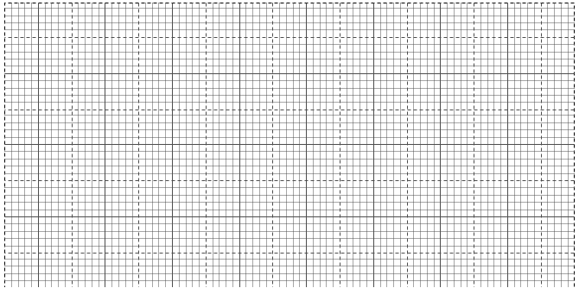

- Determine the slope, S, of the graph. (2 Marks)

- Given that V = 1000 $\left(\frac{50t}{dk}\right)$ - $\frac{1000m}{d}$
Use your graph to determine the values of
(i) d = ( 3 marks)
…………………………………………………………………………………………………
…………………………………………………………………………………………………
…………………………………………………………………………………………………
…………………………………………………………………………………………………
(ii) m = (3 marks)
…………………………………………………………………………………………………
…………………………………………………………………………………………………
…………………………………………………………………………………………………

QUESTION 2
- You require;
- Two dry cells (size D)
- A two cell holder
- A voltmeter
- An ammeter
- Mounted resistance wire on a mm scale
- 7 connecting wires (3 with crocodile clops)
- Vernier calipers (to be shared among five students

Proceed as follows
- Set the circuit as shown in figure below
V
A

P
Wire
L

- With the crocodile clip at P (i.e. L= 100cm) take the voltmeter reading V and the ammeter reading I. Repeat the procedure for values of L=90, 70, 50, 40 and 20cm respectively
Record your reading in table below

L (cm) | L(m) | V | I | V/I
100
90
70
50
40
20

- a) With the same apparatus design a circuit to determine the e.m.f of the two cells (1mk)

- Measure the e.m.f of the cells ______________________ (volts) (1mk)

- Plot a graph V/I (ohms) against L (metres)

\

- Calculate the slope S of the graph (3mks)

- Measure the diameter d of the mounted resistance wire (1mk)
d= ……………………mm=………………………..metres
- Given that S = $π$d² /4h. Calculate the value of h (2mks)

