NAME:……………………………………..…………………………………..CLASS:………..ADM NO:…………….…
PHYSICS PAPER 1 FORM 3 – TERM 3 2025
END OF YEAR EXAM TIME : 2 HOURS

SECTION A (25MARKS)
INSTRUCTIONS.
Answer all the questions in the spaces provided.
- State the reading shown on the scale of a vernier calipers in the diagram below. (1mk)
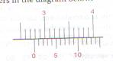
- State the reason why electricity transmission cables are left sagging between the pylons. (1mk)

- The reading on a mercury barometer at the foot of a hill. Density of air = 1.25kg/m³, density of mercury = 1.36 x 10⁴kg/m³. (3mks)

- The figure below shows the displacement time graph for the motion of an object.

Displacement(m)

Time (s)
Sketch the velocity time graph for the object. (2mks)

- State two factors that would raise the boiling point of water. (2mks)

- The level of water in a burette is 25cm³. 40 drops each of volume 0.05cm³ are added to the burette, what would be its new reading. (2mks)

- Explain how the efficiency of a vacuum flask us affected if the double-walled glass surface is replaced with a double-walled metal surface. (2mks)

- A body moving at 50m/s decelerates uniformly at 2m/s² until it comes to rest. What distance does it cover from the time it starts to decelerate to the time it comes to rest. (3mks)

- Sketch a graph of pressure versus volume for an ideal gas at constant temperature.(3mks)

- Three identical springs A, B, and C are used to support 25.5N weight as shown below.
The weight of the horizontal bar is 2.5N, determine the extension on each spring given that 6N causes an extension of 2cm. (2mks)

25.5 N

C

A

B

- State the property of Freon that makes it useful as a refrigerant liquid. (1mk)

- The diagram below shows a spinning ball as it moves through air in the direction shown.

Direction of
spinning ball
movement

Draw the streamlines of air around the ball and show the direction in which it spins such that an upward force is created. (2mks)

- State the law of conservation of energy. (1mk)

SECTION B (55 MARKS)
- State one renewable source of energy. (1mk)

b. An electric crane lifts a load of 2000kg through a vertical distance of 3m in 6 seconds. Determine:
i. The work done. (2mks)

ii. The power developed by the crane. (2mks)

iii. The efficiency of the crane if operated by an electric meter rated 12.5kw. (2mks)

c. A pulley system has two pulleys on the lower block and one pulley on the upper block. Sketch the system showing the direction of the robe, the load and the effort. (3mks)

- Define the term friction. (1mk)

b. A spherical steel ball is released from rest just above the surface of a column of oil which is in a long wide tube.

- State three forces affecting the movement of the ball as it falls in the oil. (3mks)

- Explain which of the forces in b (i) above varies as the ball falls. (1mk)

- What is the net force acting on the ball that is moving at terminal velocity?(1mk)

- Sketch a graph to show the variation of resultant force on the ball with velocity from the moment it was released. (2mks)

c. State the principle of movements. (1mk)

- The diagram below shows a uniform metre rule in equilibrium under the forces shown.
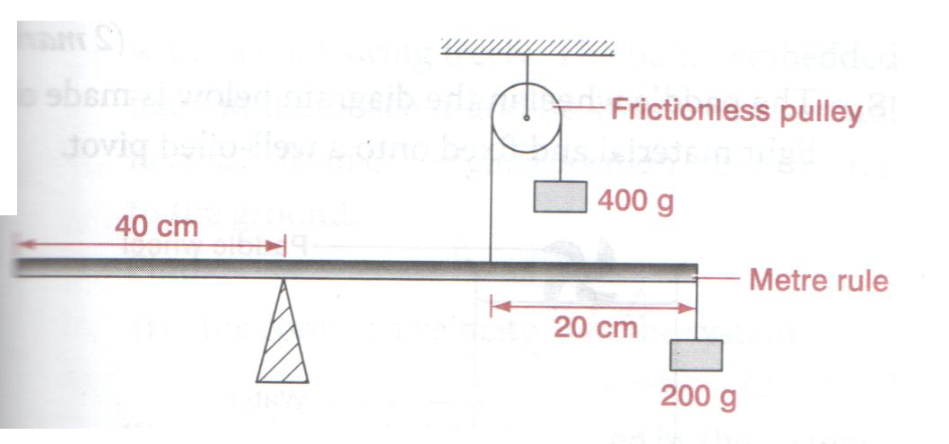
- Determine the weight of the metre rule. (3mks)

- A 4kg mass is receiving heat at a rate of 100KJ per minute and its temperature at various times recorded as follows.
Temp (ºC) | 230 | 250 | 270 | 270 | 270 | 270 | 310 | 350 | 390 | 390 | 390
Time t (min) | 0 | 1 | 2 | 6 | 9 | 13 | 18 | 23 | 28 | 29 | 30
- Plot a graph of temperature against time. (5mks)

- Use you graph to determine:
- Specific heat capacity of the substance in solid state. (3mks)

- Specific heat capacity in its liquid state. (3mks)

- Its melting point (1mk)

- Its boiling point (1mk)

- Specific latent heat of fusion. (2mks)

- In an experiment to demonstrate Brownian motion, smoke was put in a smoke cell and observed under a microscope.
- State and explain the observation made. (2mks)

- Give a reason for using small particles like smoke particles in the experiment. (1mk)

- What observation would be made if the temperature of the smoke cell is raised? (1mk)

b. An oil drop of average diameter 0.7mm spreads out into a circular patch of diameter 75cm on the surface of water in a trough.
- Calculate the thickness of the molecule. (3mks)

- State any two sources of error in b (i) above. (2mks)

- At 30ºC , the pressure of a gas is 100cmHg. At what temperature would the pressure of the gas fall by 20cm of mercury. Give the temperature in ºC. (3mks)

b. A hole of area 4.0cm² at the bottom of a tank 5m deep is closed with a cork. Determine the force on the cork when the tank is filled with water. (g=10m/s², density of water = 1000kg/m³).(4mks)

- A measuring cylinder of height 25cm is filled to a height at 15cm with water and the rest is occupied by kerosene. Determine the pressure acting on its base. (Density of water = 1g/cm³, density of kerosene = 0.8g/cm³ atmospheric pressure = 103,000 Pa) (3mks)

