Name: …………………………………………………………………… Index No: ……………………….
Candidate’s Signature:…………………… Date: ……………….…………..…

232/3
PHYSICS
(PRACTICAL)
PAPER 3
Time: 2 1/2 Hours
JULY 2025

Kenya Certificate of Secondary Education

INSTRUCTIONS TO THE CANDIDATES:
- Write your name and index number in the spaces provided above.
- Sign and write the date of the examination in the spaces provided above.
- You are supposed to spend the first 15 minutes of the 2 ½ hours allowed for this paper reading the whole paper carefully.
- Marks are given for a clear record of the observation actually made, their suitability, accuracy and the use made of them.
- Candidates are advised to record their observations as soon as they are made
- All working must be clearly shown
- Mathematical tables, and electrical calculators may be used

FOR EXAMINER’S USE ONLY
Question | Maximum Score | Candidate’s Score
1 | 20
2 | 20
TOTAL | 40

This paper consists of 8 printed pages. Candidates should check to ascertain that all pages are printed as indicated and that no questions are missing
- Question 1
PART A
You are provided with the following
- A metre rule.
- a knife edge
- One 50g mass and a 100g mass
- Some thread
- Some water in a beaker
- Liquid l in a beaker
- Tissue paper.
Proceed as follows
- Balance the metre rule on the knife edge and record the reading at this point.
Balance point ……………………………..cm (1 mark)
For the rest of the experiment the knife edge must be placed this position.
(b) Set up the apparatus as shown in the figure 1. Use the thread provided to hang the masses such that the positions of the support can be adjusted.
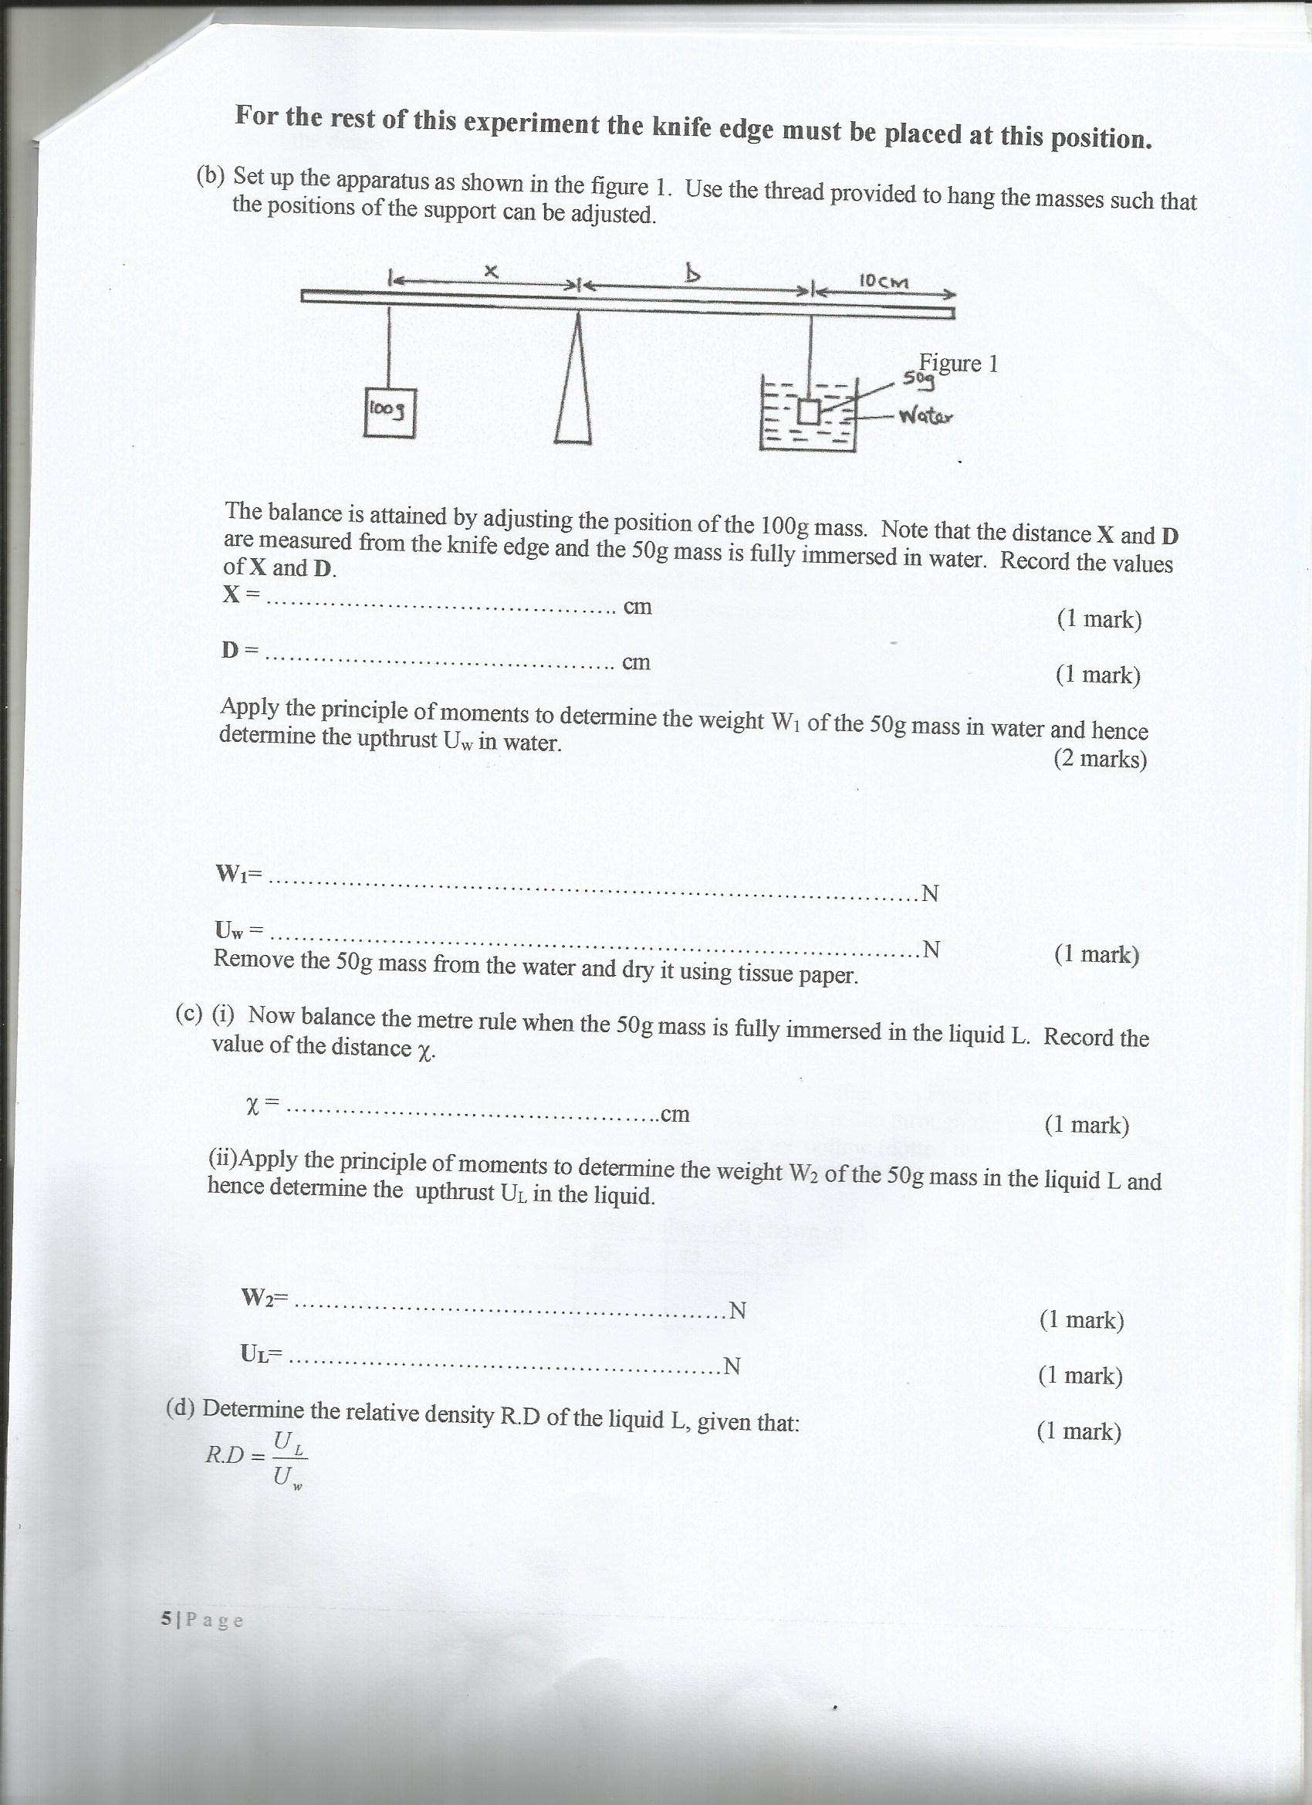
The balance is attained by adjusting the position of the 100g mass. Note that the distance X and D are measured from the knife edge and the 50g mass is fully immersed in water. Record the values of X and D.
X = ………………………………………………….cm (1 mark)

D = ………………………………………………..cm (1mark)

Apply the principle of moments to determine the wright W₁ of the 50g mass in water and hence determine the upthrust U_{W} in water.

W₁ = ……………………………………………………………….N (1 mark)

U_{W} =…………………………………………………………………N (1 mark)

Remove the 50g mass from the water and dry it using tissue paper.
(c) (i) Now balance the metre rule when the 50g mass is fully immersed in the liquid L. Record the value of the distance X.
X = ………………………………………………..cm (1 mark)

- Apply the principle of moments the weight W₂ of the 50g mass in the liquid Land hence determine the upthrust U_{L} in the liquid.
W2 =……………………………………………………..N (1 mark)

UL = ………………………………………………………N (1 mark)

(d) Determine the relative density R.D of the liquid L, given that ; (1 mark)
R.D = U_{L}
U_{W}

(e) Find the density of liquid L in kg/m³. (Given that density of water in 1000kg/m³) . (1mark)

PART B
You are provided with the following;
- A rectangular glass block
- Four optical pins
- A piece of soft board
- A plain sheet of paper
- Cello tape.
- You are required to have your own mathematical set.

Proceeds as follows.

(f) Place the plain sheet of paper on the soft board and fix it using it using the cello tape provided. Place the glass block at the centre of the sheet, draw its outline. Remove the glass block.

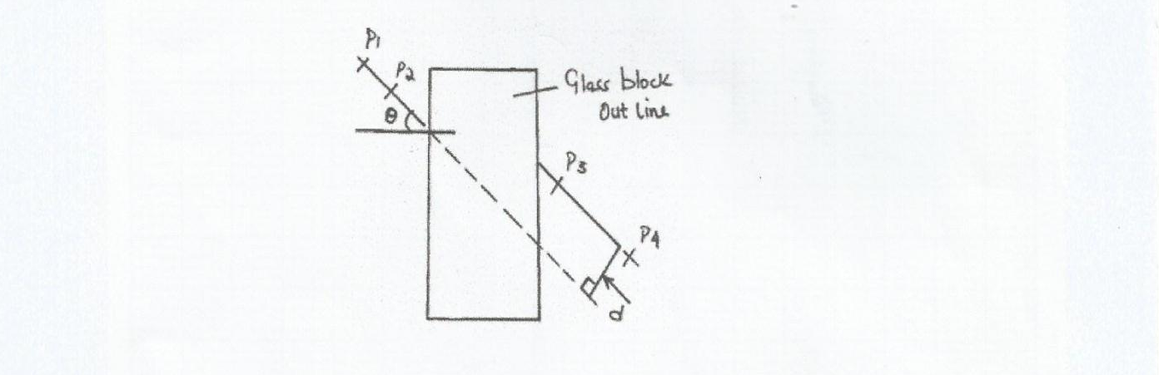

(g) Draw a normal at a point 2cm from the end of one of the longer side of the block outline. This normal line will be used for the rest of the experiment. Draw a line at an angle Ɵ from the normal. Stock two pins P₁ and P₂ vertically on this line.

(h) By viewing through the glass from the opposite side, stick two other pins P₃ and P₄ vertically such that they are in line with the images of the first two pins. Draw a line through the marks made by P₃ and P₄ to touch the outline. Extend the line P₁P₂ through the outline (dotted line). Measure and record in the table the perpendicular distance d between the extended line and the lien P₃ P₄. Record this value in the table.
(i) Repeat the procedure in (g) and (h) for other values of Ɵ shown in the table. (3marks)

Ɵ(deg) | 25 | 35 | 40 | 45 | 55 | 60 | 56
d(cm)

- (i) Plot a graph of d against Ɵ. (5mks)



- Use the graph to estimate the value of d when Ɵ = 0. (1mark)
d = …………………………………………….cm
Question 2 (20 marks)
You are provided with the following
- A voltmeter, a galvanometer and an ammeter
- Two dry cells and a cell holder
- A switch
- Eight connecting wires each with a crocodile clip at one end
- A resistance wire labelled X
- A resistance wire labelled AB mounted on a millimeter scale
- Six 10 Ω carbon resistors
- A jockey/crocodile

Proceed as follows
- Set up the circuit with the cells in parallel as shown in the figure below
NB-ensure X is connected at its ends
Voltmeter

S

Ammeter

X
(b) With the switch open, record the reading E of the voltmeter

E = _____________________________ (1mk)
(c)Close the switch and record the current I flowing through the circuit and the potential difference V across the cells
I = _____________________________________ (1mk)

V = ___________________________________ (1mk)

(d) Given that E = V + Ir and V = IX, determine the internal resistance r of the combined cells and the resistance of the wire labelled X (2mks)

(e) Now set up the circuit as shown in the figure below. Z is one of the 10 carbon resistors.

X Z

G

A B
P a

S

(f) Close the switch. Tap the jockey at various points along the wire AB and locate a point P at which the galvanometer shows zero deflection. Measure and record in the table below the length ‘a’ where a = PB
(g) Repeat the procedure in (f) using two resistors in parallel, three resistors in parallel, four resistors in parallel, five resistors in parallel, and six resistors in parallel. Record your readings in the table below. R is the effective resistance for the parallel combination. (6mks)

Number of 10Ω resistors | One | Two | Three | Four | Five | Six
^{I}/_{R}(Ω⁻¹)
¹/_{a} (cm⁻¹)

(h) Plot a graph of ^{I}/_{a} (y-axis) against ^{I}/_{R} (5mks)

(i) Determine the slope m, of the graph (2mks)

(j) Given that I/a = ώ/kR + 1/k, where k = 100cm, Use the graph to determine ώ (2mks)

